Selective Oxidation of Furfural to Succinic Acid Over Lewis Acidic Sn-Beta
Yayati Naresh Palai,†,‡ Abhijit Shrotri,†* Atsushi Fukuoka†*
†Institute for Catalysis, Hokkaido University, Kita 21 Nishi 10, Kita-ku, Sapporo, Hokkaido 001-0021, Japan, ashrotri@cat.hokudai.ac.jp, fukuoka@cat.hokudai.ac.jp
‡Graduate School of Chemical Sciences and Engineering, Hokkaido University, Kita 13 Nishi 8, Kita-ku, Sapporo, Hokkaido 060-8628, Japan

Table of contents
Additional experimental details | 2-4
Figure S1-S12 | 4-11
Table 1-2 | 12
References | 13

NMR and MS of reaction products
Liquid phase ESI-MS of reaction products was recorded in LCMS-2020 mass spectrometer attached to a Shimadzu HPLC system using 5 mM aqueous trifluoroethane sulphonic acid as mobile phase. Gas phase mass spectrometry was done by performing the reaction in the presence of dichloromethane (DCM) as extracting solvent. The reaction conditions are as follows: furfural 1 mmol (96 mg), catalyst 50 mg, 15 % H₂O₂ solution 10 mL, DCM 5 mL, 50 $°$C, 1 h. After the reaction the extracting solvent was taken out, and GC-MS was recorded using a Shimadzu GC-MS 2010. For NMR, instead of DCM deuterated DCM was used and analysis was done using a JEOL 600 MHz instrument.
Procedure for pyridine adsorption IR experiment
For the pyridine adsorption IR experiment, the catalysts were pressed into self-supported wafers of 1 cm diameter of approximately 40 mg cm⁻² wafer density. A pretreatment procedure of heating to 150 $°$C at 10$°$ min⁻¹ with vacuum was followed to make sure there is no physisorbed moisture or other possible contaminants. Pyridine was dosed at room temperature until the spectrum showed shoulder peaks to the major peaks (which is a sign of saturation). Initial desorption was done with vacuum until no desorption was observed. Finally, desorption was done via heating up to 150 $°$C.
Quantitative calculation of number of acid sites were done using the following equation:
N = $\frac{A}{ϵ×ρ}$ (1)
Where N is density of acid sites in $μ$mol g⁻¹, A is the integrated peak area in cm⁻¹, $ϵ$ is the integrated molar extinction coefficient (cm μmol⁻¹) and ρ is the wafer density (mg cm⁻²). Peak deconvolution was performed using Fityk curve fitting program. The value of integrated molar extinction coefficient was taken from Datka et. al¹.

Procedure for DRIFTS analysis of adsorbed furfural
Prior to DRFTS experiment the catalyst was dehydrated at 150 °C for 1 hour. Furfural was introduced by dropping 10 mg of furfural to the sample using a Gilson Pipetman micropipette. After making sure of adsorption, from the spectrum, desorption process was carried out by flowing 30 mL/ min He gas along with heating. DRIFTS analysis was done using a Perkin Elmer Spectrum 100 FTIR spectrometer equipped with MCT detector cooled with liquid N₂.

Detailed procedure of TMB oxidation reaction
The reactions were carried out at room temperature in a glass tube. In a typical reaction 1 mL TMB solution (10 mg per mL in DMSO) was added to 4 mL pH 4 buffer solution, followed by 5 mL H₂O₂. 50 mg Catalyst was used (5 mg per mL dispersion). Once the catalyst was added the time was marked as 0 and sampling was done at 5-minute intervals, filtered with 0.22 μm syringe filter and the UV Vis measurement was done against that of deionized water.
Procedure for synthesis of 2(3H)-furanone
To synthesize 2(3H)-furanone, 1 g of furfural was added to 30 mL dichloromethane (DCM), to which 10 mL of Hv₂O₂ solution and 100 mg of 2Sn-Beta catalyst was added. The reaction was carried out at room temperature for 12 hours to make sure all the furfural is consumed. The DCM portion was separated using a separating funnel. Formic acid and small quantity of other acids formed was separated by addition of NaHCO₃, followed by extraction with water. Finally, the DCM was evaporated with rotary evaporator and 50 mL water was added to the remaining mixture containing 2(3H)-furanone and 2(5H)-furanone for further quantification and reaction.
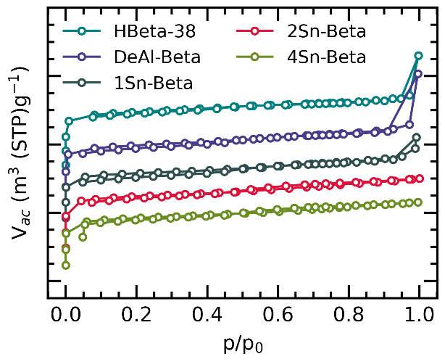
Figure S1. N₂-adsorption isotherm of various catalysts.

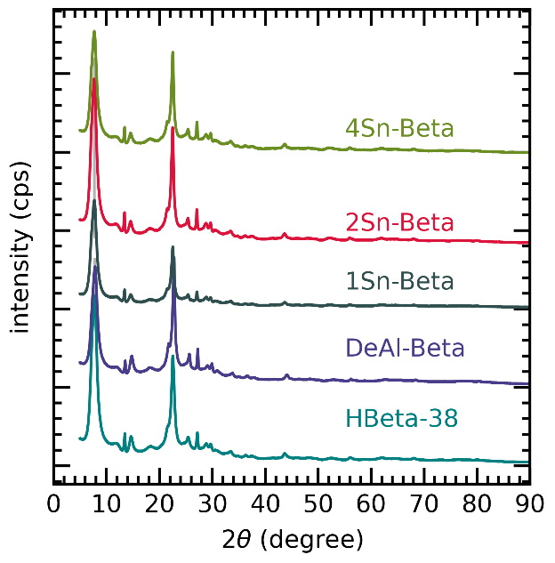
Figure S2. Powder XRD of zeolite (HBeta-38) (SiO₂/Al₂O₃ = 38), Dealuminated Beta (DeAl-Beta) and different amount of Sn incorporated Sn-Beta

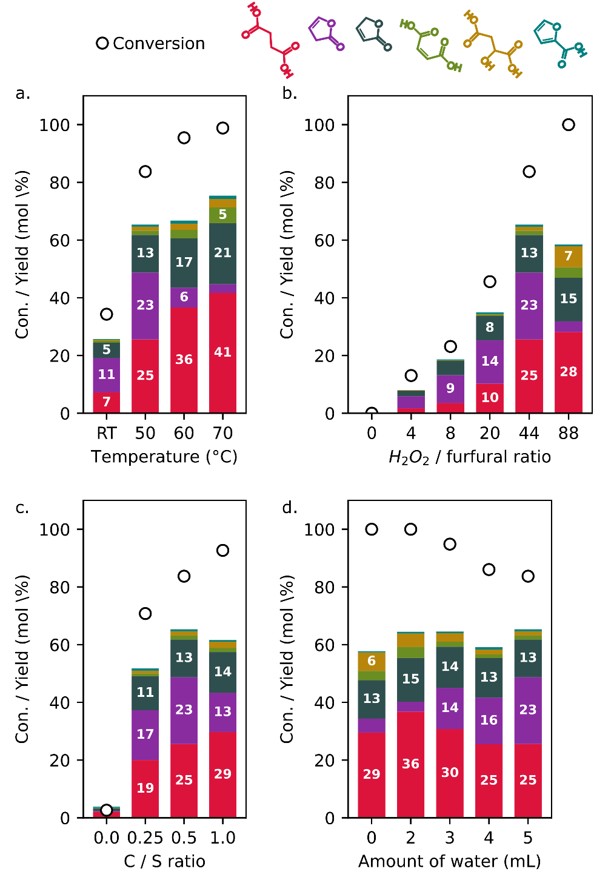
Figure S3. Optimization of reaction conditions to maximize succinic acid yield with 2Sn-Beta catalyst. Reaction conditions: a) Furfural 1 mmol (96 mg), catalyst 50 mg, 15 % H₂O₂ solution 10 mL, 1 h. Temperature was varied between room temperature and 70 °C. (b) Furfural 1 mmol (96 mg), catalyst 50 mg,50 °C, 1 h, H₂O₂ to furfural molar ratio was varied from 0 – 88. (c) Furfural 1 mmol (96 mg), 15 % H₂O₂ solution, catalyst to substrate ratio in weight/weight was varied from 0 to 1, by varying catalyst amount from 0 mg to 96 mg). (d) Furfural 1 mmol (96 mg), 50 mg catalyst, 30 % H₂O_{2,} 50 °C, 1h, amount of added water was varied between 0 to 5 mL.
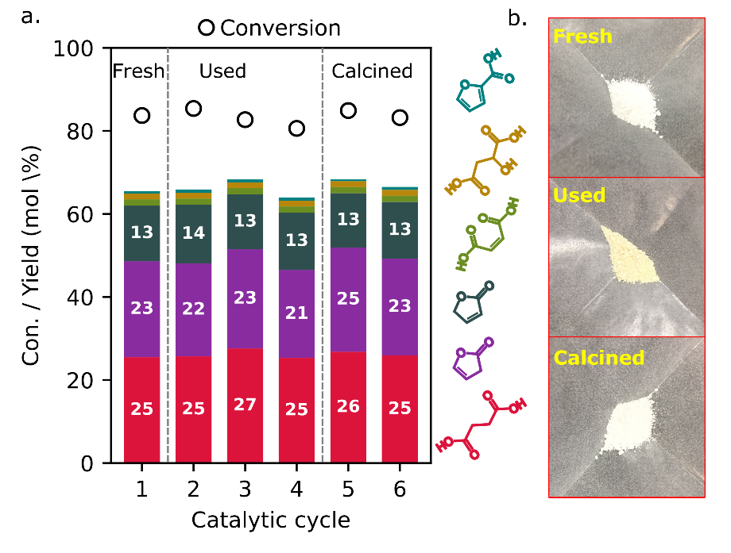
Figure S4. (a) Recyclability of 2Sn-Beta catalyst. Reaction conditions: furfural 1 mmol (96 mg), catalyst 50 mg, 15 % H₂O₂ solution 10 mL, 50 °C, 1 h. (b). Picture of fresh catalyst (Fresh), used catalyst (Used) after 4 runs and after calcining the used catalyst (Calcined)

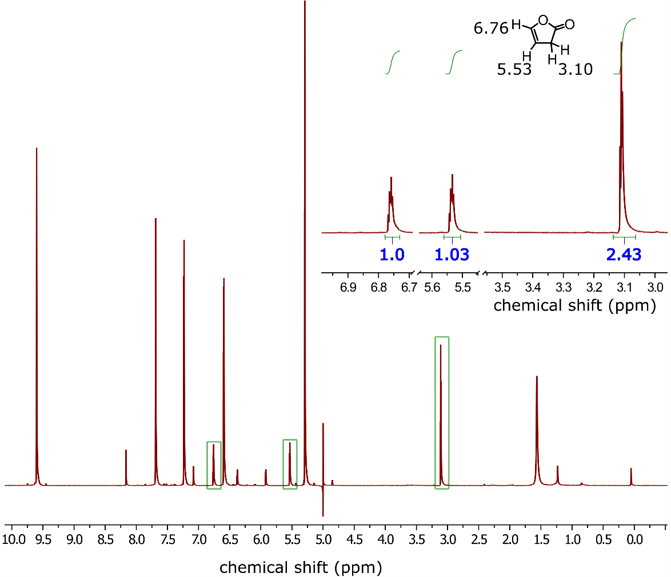
Figure S5. Ex-situ 1D NMR detection of 2(3H)-furanone.
Figure S6. Ex-situ 2D NMR detection of 2(3H)-furanone.

Figure S7. EI-MS of 2(3H)-furanone in GC-MS extracted from reaction mixture with dichloromethane
Figure S8. ESI-MS in LC-MS of 2(3H)-furanone in the reaction mixture to confirm the peak position in LC.
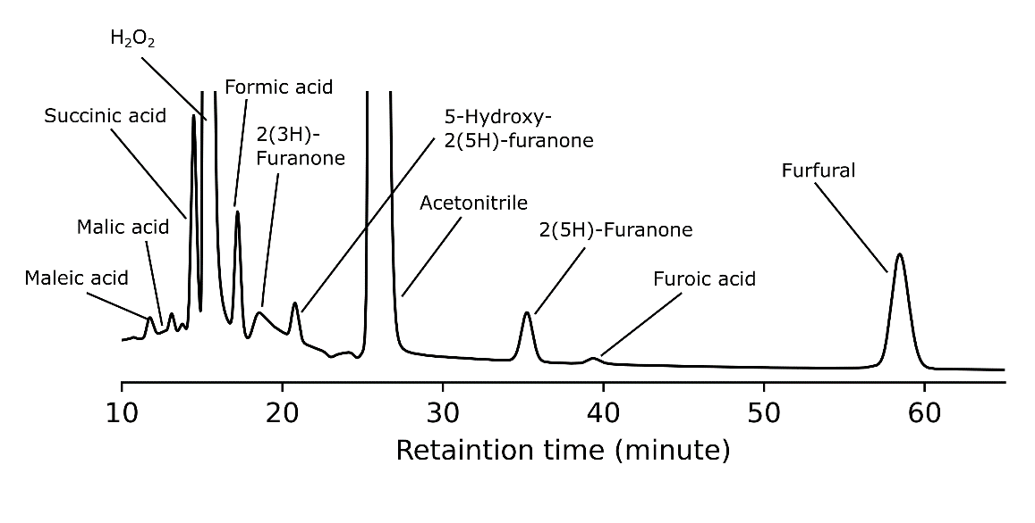
Figure S9. Representative HPLC profile with Sn-Beta catalyst. Reaction conditions : Furfural 1 mmol (96 mg), 2Sn-Beta 50 mg, 15 % aq. H₂O₂ 10 mL, 50 °C, 1 h.

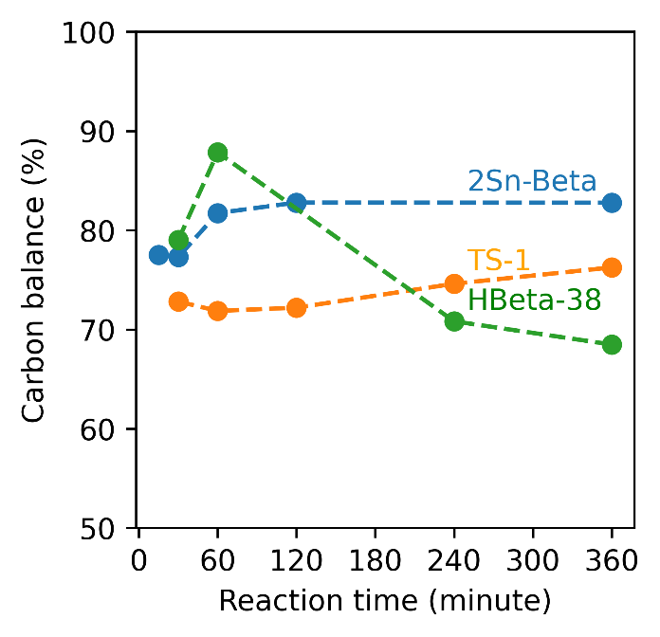
Figure S10. Variation of carbon balance with time with different catalysts. Reaction conditions - furfural 1 mmol (96 mg), catalyst 50 mg, 15 % H₂O₂ solution 10 mL, 50 °C.

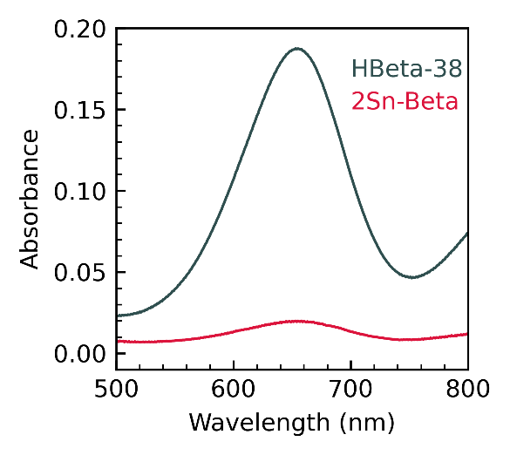
Figure S11. UV-Vis spectra of TMB oxidation reaction after 35 min.
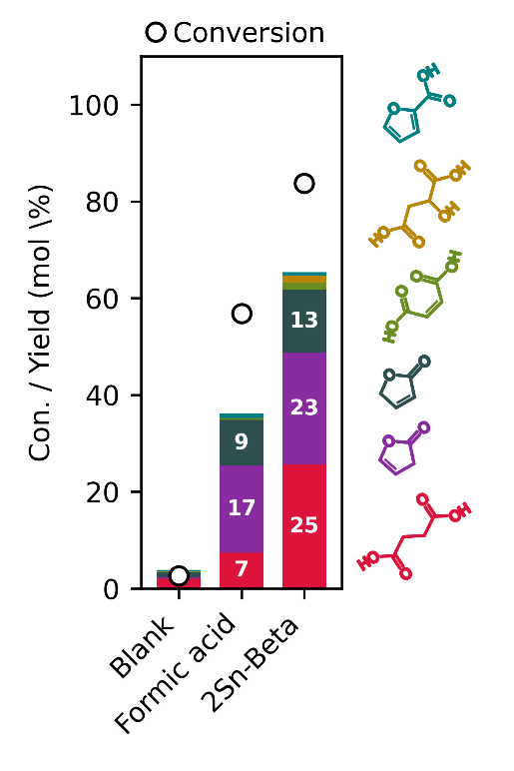
Figure S12. Furfural oxidation reaction with different catalyst showing role of formic acid during the reaction. Reaction conditions: furfural 1 mmol (96 mg), 2Sn-Beta (50 mg), formic acid 1 mmol (46 mg)(when used), 15 % H₂O₂ solution 10 mL, 50 °C, 1 h.

Scheme S1. Reaction pathway for formation of maleic acid via furfural epoxidation.

Table S1. Physicochemical characterization of different materials used in the study.
Sample | Surface area (m²/ g) | Total pore volume  (cm³/g) | Pore size  (nm)
HBeta-38 | 579 | 0.2119 | 1.11
DeAl-Beta | 565 | 0.2048 | 1.11
1Sn-Beta | 561 | 0.1702 | 1.11
2Sn-Beta | 557 | 0.1507 | 1.11
4Sn-Beta | 553 | 0.1471 | 1.11

Table S2. Effect of 2Sn-Beta and formic acid on conversion of 2(3H)-furanone and 2(5H)-furanone to succinic acid. Reaction conditions: 5 mL aqueous solution containing 0.12 mmol of 2(3H)-furanone and 0.07 mmol of 2(5H)-furanone, 50 mg 2Sn-Beta or formic acid 1 mmol (46 mg) as catalyst, 30 % H₂O₂ solution 5 mL, 50 °C, 1 h
Catalyst | Detected products after reaction (mmol)
 | 2(3H)-furanone | 2(5H)-furanone | Succinic acidª
2Sn-Beta | 0 | 0.04 | 0.12 (100)
2Sn-Beta + formic acid | 0 | 0.04 | 0.11 (91)
Formic acid | 0 | 0.07 | 0.09 (75)
No catalyst | 0 | 0.08 | 0.08 (66)
ªValue in parenthesis shows succinic acid selectivity based on 2(3H)-furanone conversion.

Reference
(1) Datka, J.; Turek, A. M.; Jehng, J. M.; Wachs, I. E. Acidic Properties of Supported Niobium Oxide Catalysts: An Infrared Spectroscopy Investigation. J. Catal. 1992, 135 (1), 186–199.

