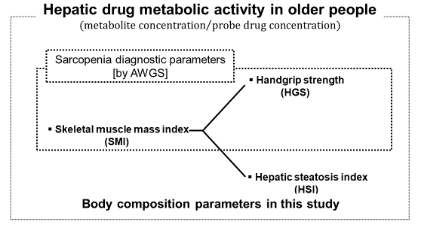
A reduction in skeletal muscle mass index (SMI) and handgrip strength (HGS) below the sarcopenia diagnostic criteria was found to be correlated with a decline in CYP2C19 and CYP3A4 metabolic activity in male older patients, whereas, for older female patients, fatty liver disease was shown to influence a decline in CYP2C19 metabolic activity.

