Table S1: Probe drugs

 | CYP2C19 | CYP3A4
Probe drug (Substrate) | Lansoprazole  (LPZ)  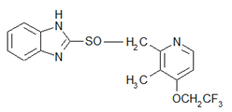 | Nifedipine  (NIF)  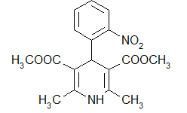
Metabolite | 5-Hydroxy lansoprazole  (5OH-LPZ)  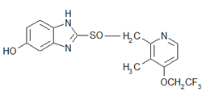 | Dehydronifedipine  (DNIF)  