**Supplemental Material**

**Assessment of LeadCare® II analysis for testing of a wide range of blood lead levels in comparison with ICP–MS analysis**

Hokuto Nakata, Shouta M.M. Nakayama, John Yabe, Kaampwe Muzandu, Haruya Toyomaki, Yared Beyene Yohannes, Andrew Kataba, Golden Zyambo, Yoshinori Ikenaka, Kennedy Choongo, Mayumi Ishizuka

**Table of Contents**

**Supplementary Table S1. Heating program of sample digestion using Microwave equipment.**

**Supplementary Table S2. Operating conditions for ICP-MS analysis.**

**Supplementary Table S3. Characteristics of the studied population.**

**Supplementary Figure S1. Map of sampling points widely distributed across the whole Kabwe town (Yabe et al., 2020).**

**Supplementary Figure S2. Passing–Bablok regression analysis between BLLLC and BLLIM in the BLLLC ranges of 3.3 to 4.9 µg/dL (A), 5.0 to 9.9 µg/dL (B), 10.0 to 19.9 µg/dL (C), 20.0 to 44.9 µg/dL (D), 45.0 to 64.9 µg/dL (E), and >65.0 µg/dL (F). Parts of BLLLC (Yabe et al., 2020) and BLLIM (Nakata et al., 2020) data were reported in earlier papers and cited.**

**Supplementary Figure S3. Deming regression analysis between log BLLLC and log BLLIM in the BLLLC ranges of 3.3 to 4.9 µg/dL (A), 5.0 to 9.9 µg/dL (B), 10.0 to 19.9 µg/dL (C), 20.0 to 44.9 µg/dL (D), 45.0 to 64.9 µg/dL (E), and >65.0 µg/dL (F). Parts of BLLLC (Yabe et al., 2020) and BLLIM (Nakata et al., 2020) data were reported in earlier papers and cited.**

**Supplementary Table S1. Heating program of sample digestion using Microwave equipment.**

|  |  |  |  |
| --- | --- | --- | --- |
| Step | 1 | 2 | 3 |
| Ramp (min) | 5 | 1 | 0 |
| Time (min) | 5 | 10 | 10 |
| Temperature (℃) | 160 | 190 | 75 |

**Supplementary Table S2. Operating conditions for ICP-MS analysis.**

|  |  |
| --- | --- |
| Parameter | Value |
| Radiation frequency power | 1500 W |
| Argon gas pressure | 600 kPa |
| Cell gas (Helium) | 100 kPa |
| Peak pattern | 3 |
| Replicates | 10 |
| Sweeps/replicate | 1000 |
| Integration time/mass | 9.00 sec |
| Stabilization time | 30 sec |

**Supplementary Table S3. Characteristics of the studied population.**

|  |  |  |  |  |  |  |  |
| --- | --- | --- | --- | --- | --- | --- | --- |
|  |  | Sample size | Age | | | | |
|  |  | Mean | SD | Median | min | max |
| All area |  | 1208 | 24.0 | 20.8 | 21 | 0 | 96 |
|  | Female | 660 | 26.3 | 19.6 | 26 | 0 | 90 |
|  | Male | 548 | 21.3 | 21.7 | 9 | 0 | 96 |
| Bwacha |  | 109 | 26.6 | 21.5 | 24 | 1 | 72 |
|  | Female | 55 | 30.2 | 21.8 | 36 | 1 | 71 |
|  | Male | 54 | 22.9 | 20.6 | 10 | 1 | 72 |
| Chowa |  | 103 | 18.1 | 17.4 | 10 | 0 | 80 |
|  | Female | 50 | 22.8 | 15.6 | 23.5 | 2 | 57 |
|  | Male | 53 | 13.7 | 18.0 | 6 | 0 | 80 |
| Hamududu |  | 101 | 25.1 | 20.2 | 25 | 0 | 82 |
|  | Female | 54 | 24.7 | 19.1 | 24 | 0 | 71 |
|  | Male | 47 | 25.5 | 21.6 | 27.5 | 1 | 82 |
| Kang'omba |  | 99 | 25.1 | 19.1 | 24 | 0 | 67 |
|  | Female | 52 | 26.5 | 18.0 | 26 | 0 | 67 |
|  | Male | 47 | 23.5 | 20.3 | 21 | 0 | 63 |
| Kasanda |  | 203 | 24.7 | 21.2 | 11 | 1 | 86 |
|  | Female | 120 | 24.0 | 18.6 | 24.5 | 1 | 68 |
|  | Male | 83 | 25.9 | 24.7 | 10 | 1 | 86 |
| Katondo |  | 40 | 32.9 | 24.7 | 27 | 3 | 77 |
|  | Female | 25 | 29.9 | 22.5 | 23 | 3 | 72 |
|  | Male | 15 | 37.9 | 28.1 | 38 | 5 | 77 |
| Mahatma Ghandi |  | 24 | 25.6 | 21.1 | 21.5 | 1 | 69 |
|  | Female | 13 | 30.8 | 22.5 | 35 | 3 | 69 |
|  | Male | 11 | 19.5 | 18.6 | 9 | 1 | 51 |
| Makululu |  | 373 | 25.2 | 21.9 | 23 | 0 | 96 |
|  | Female | 213 | 27.5 | 21.3 | 27 | 0 | 90 |
|  | Male | 160 | 22.0 | 22.2 | 9 | 0 | 96 |
| Mpima prison |  | 46 | 19.7 | 17.8 | 9 | 0 | 72 |
|  | Female | 23 | 27.1 | 18.4 | 25 | 4 | 72 |
|  | Male | 23 | 12.3 | 13.9 | 7 | 0 | 47 |
| Natuseko |  | 45 | 15.8 | 14.7 | 8 | 0 | 49 |
|  | Female | 21 | 22.3 | 12.9 | 25 | 0 | 49 |
|  | Male | 24 | 10.2 | 14.1 | 4 | 0 | 49 |
| Ngungu |  | 38 | 18.0 | 19.4 | 9 | 1 | 70 |
|  | Female | 16 | 27.0 | 18.1 | 26 | 2 | 67 |
|  | Male | 22 | 11.4 | 18.0 | 7 | 1 | 70 |
| Pollen |  | 16 | 24.4 | 19.9 | 29 | 0 | 62 |
|  | Female | 13 | 26.2 | 20.6 | 31 | 0 | 62 |
|  | Male | 3 | 16.7 | 17.8 | 9 | 4 | 37 |
| Railway |  | 11 | 23.1 | 17.0 | 27 | 1 | 52 |
|  | Female | 5 | 25.6 | 15.1 | 28 | 6 | 47 |
|  | Male | 6 | 21.0 | 19.6 | 18.5 | 1 | 52 |

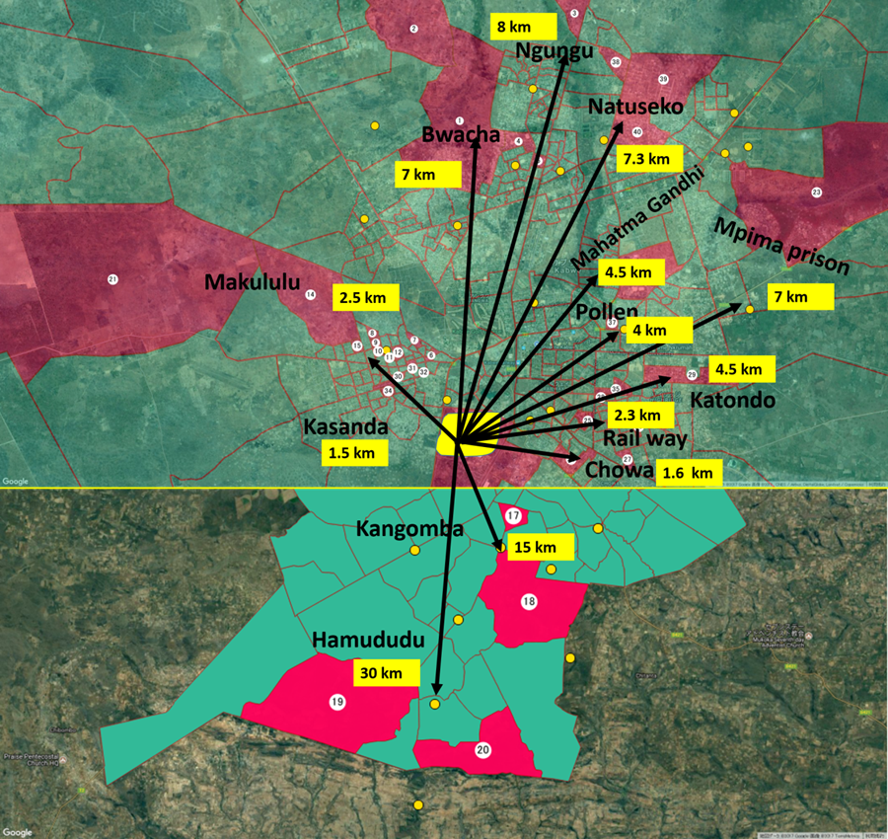

**Supplementary Figure S1. Map of sampling points widely distributed across the whole Kabwe town (Yabe et al., 2020).**



**Supplementary Figure S2. Passing–Bablok regression analysis between BLLLC and BLLIM in the BLLLC ranges of 3.3 to 4.9 µg/dL (A), 5.0 to 9.9 µg/dL (B), 10.0 to 19.9 µg/dL (C), 20.0 to 44.9 µg/dL (D), 45.0 to 64.9 µg/dL (E), and >65.0 µg/dL (F). Parts of BLLLC (Yabe et al., 2020) and BLLIM (Nakata et al., 2020) data were reported in earlier papers and cited.**



**Supplementary Figure S3. Deming regression analysis between log BLLLC and log BLLIM in the BLLLC ranges of 3.3 to 4.9 µg/dL (A), 5.0 to 9.9 µg/dL (B), 10.0 to 19.9 µg/dL (C), 20.0 to 44.9 µg/dL (D), 45.0 to 64.9 µg/dL (E), and >65.0 µg/dL (F). Parts of BLLLC (Yabe et al., 2020) and BLLIM (Nakata et al., 2020) data were reported in earlier papers and cited.**