Article title: Integrative taxonomy of Zeuxo (Crustacea: Peracarida: Tanaidacea) from Japan, with the description of a new species
Journal name: Biologia
Author names: Nobuya Okamoto · Keiichi Kakui
Corresponding author: Keiichi Kakui. Department of Biological Sciences, Faculty of Science, Hokkaido University, Sapporo 060-0810, Japan. E-mail. kakui@eis.hokudai.ac.jp

Online Resource 3 Dorsal pigmentation pattern on two Japanese Zeuxo species, Zeuxo molybi sp. n. and Zeuxo ezoensis Okamoto et al., 2020.

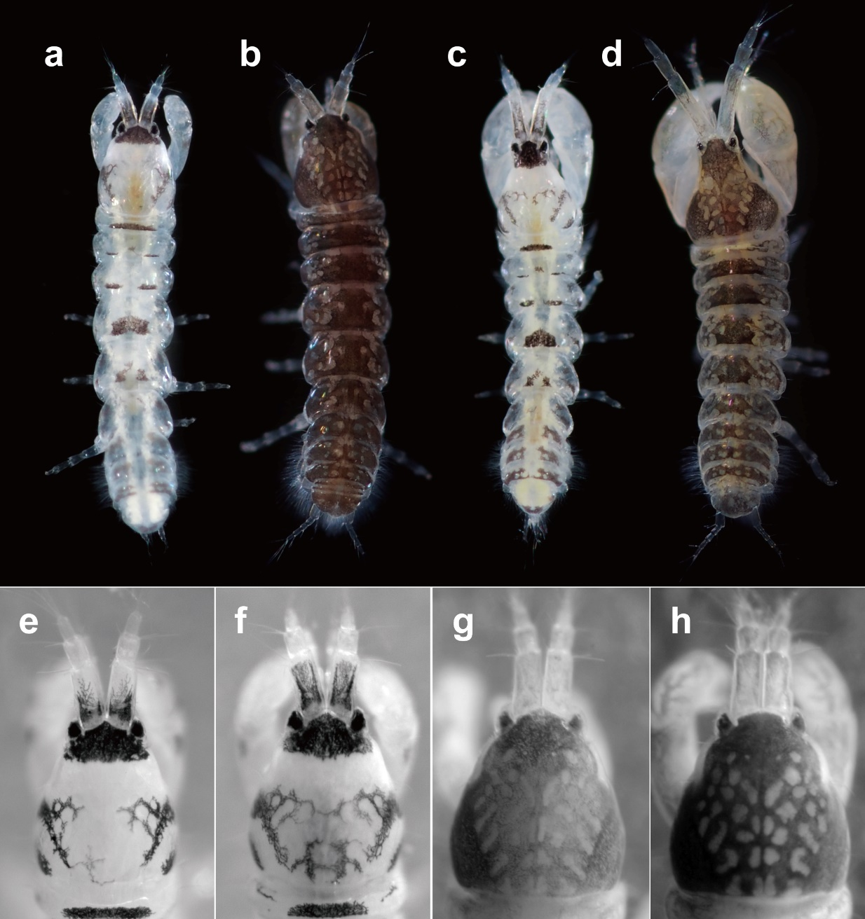
Fig. S1 Dorsal pigmentation pattern on Zeuxo molybi sp. n. (a, c, e, f) and Zeuxo ezoensis Okamoto et al., 2020 (b, d, g, h). a, b, f–h, females; c, d, e, males. a–d, color images; e–h, gray scale images.

