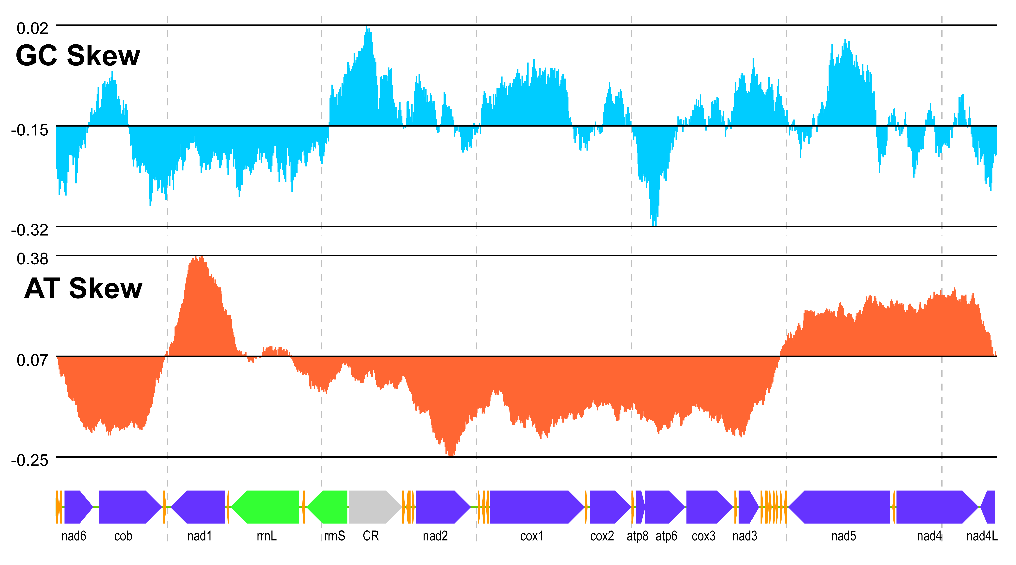

SM.01 The GC- and AT-skew plots and gene order for Heterocypris spadix mitogenome. Window size in ratio = 0.05; Step size in ratio = 0.001. The labels for transfer RNA genes are omitted. CR, putative control region.

