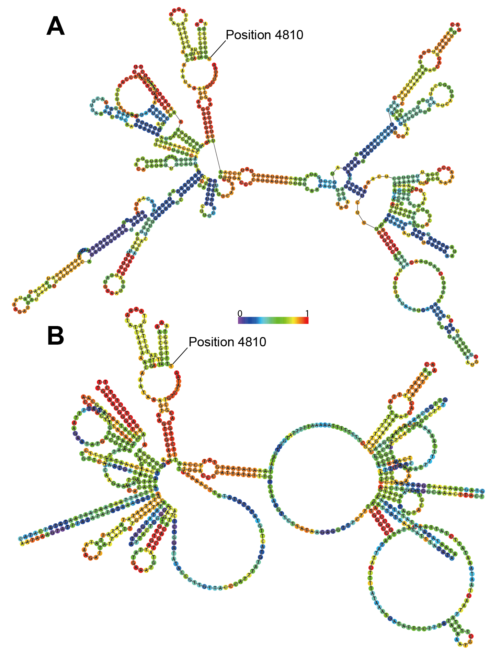

SM.05 Secondary structure of the putative control region in the Heterocypris spadix mitogenome, predicted with the RNAfold WebServer (Gruber et al., 2008; Lorenz et al., 2011); colors indicate the base-pairing probability. A, Structure from a minimum free energy prediction with a partition function. B, Structure from a thermodynamic ensemble prediction. The scale indicates probability levels between 0 and 1 for the various colors.

Reference
Gruber AR, Lorenz R, Bernhart SH, Neuböck R, Hofacker IL. 2008. The Vienna RNA Websuite. Nucleic Acids Research 36: W70–W74
Lorenz R, Bernhart SH, Höner zu Siederdissen C, Tafer H, Flamm C, Stadler PF, Hofacker IL. 2011. "ViennaRNA Package 2.0". Algorithms for Molecular Biology 6: 26.

