**Supplementary Figure 1.**

**Le et al.**

AN02770_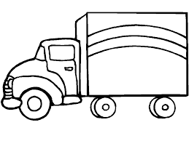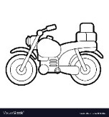AN02770_AN02770_AN02770_

Major pathway

Minor pathway

Farm #1

Farm #2

Poultry delivery station

LBM #1(≤ 10km)

Farm #3

Big vehicle

Small vehicle

LBM #2 (≤ 10km)

LBM #3 (≤ 100km)

