Supporting information

The structure of atomically dispersed Pt in a SnO₂ thin film under reaction conditions – Origin of its high performance in MEMS gas sensor catalysis

Naoyoshi Murata¹, Takuya Suzuki¹, Yunli Lin ², Hiroaki Nitani³, Yasuhiro Niwa³, Takahiro Wada⁴, Motohiro Uo⁴ and Kiyotaka Asakura*²

1. Corporate R & D Headquarters, Fuji Electric Co., Ltd., Tokyo 191-8502, Japan
2. Institute for Catalysis, Hokkaido University, Sapporo 001-0021, Japan
3. Photon Factory, Institute of Structure Material Science, High Energy Accelerator Research Organization (KEK-PF), Oho 1-1, Tsukuba 305-0811, Japan
4. Graduate School of Medical and Dental Sciences, Tokyo Medical and Dental University, Yushima 1-5-45, Bunkyo-ku, Tokyo 113-8549, Japan
Contents
SI-1. Gas response properties of the sensor
SI-2. Pt L₃ and Sn K edge EXAFS oscillations in Pt-SnO₂
SI-3. The second and the third shell analysis of Pt-SnO₂

SI-1 Gas response properties of the sensor
Figure S1(a) shows the response curve of the conductivity under the 4000 ppm CH₄ flow with a 100 cc / min flow rate. At time 0 s, 3 V was suddenly applied to the heater at the bottom of Si substrate and the sample temperature reached the operating temperature of 723 K by the heater within 40 ms. The temperature was measured by the infrared thermography and the heater resistivity.(1) The heater power at 723 K was 30 mW At the same time the conductivity of the sensor reached equilibrium. Thus the sensor is heated with 100 ms pulse with 60 s interval, which guarantees a longer life time than 5 years. Figure S1(b) shows sensitivity (Resistance ratio under air to under the reducing gases.) of the sensor against heater powers (or temperature). At higher temperature, H₂ is combusted in the Pd/Al₂O₃ layer covering the Pt-SnO₂ layer. Consequently, high CH₄ sensitivity is achieved if the power is applied more than 25 mW (vertical line). Figure S1(c) shows the sensor structure.
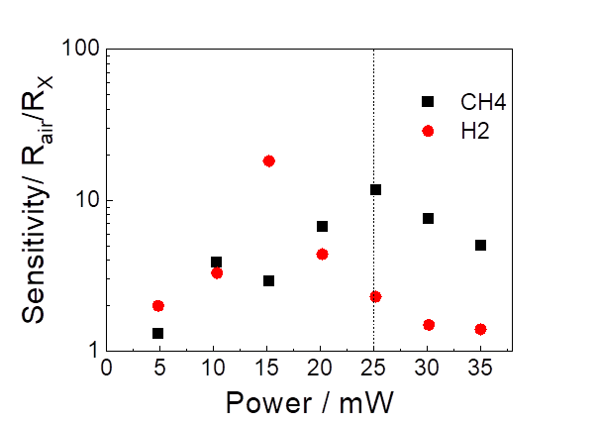
(c)
(b)
(a)
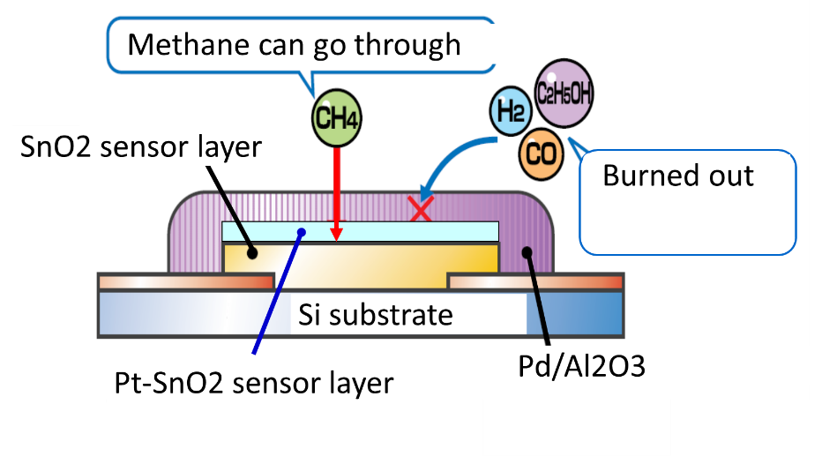
Heater
Figure S 1 (a) Conductivity response of Pt-SnO₂ empowered SnO₂ sensor under the 4000 ppm CH₄ flow with 100 cc / min flow rate. (b) The sensitivity of the sensor as a function of applied power (or temperature) reproduced from ref.（）(c)The structure of MEMS sensor.

Table S1 Response time and type of sensor

Response Time | Type | Literature | Device
60 s | Semiconductive metal oxide (SMO), SnO₂ particle |  | MEMS
110 s | SMO, SnO₂(Pt doped) |  | MEMS
20 s | SMO, SnO₂(Pd superficially doped |  | MEMS
500 ms | Themocatalysis(TC), (NiCo₂O₄) |  | MEMS
500 ms | TC,Pt,Pd/Al₂O₃ |  | MEMS
8s | SMO, Rh₂O₃/Al₂O₃ |  | MEMS
100 s | SMO , Co₃O₄ NP
10-20 s | SMO, ZnO +Pd-Ag catalyst
100 ms | SMO, SnO₂(Pt-SnO₂) | This work, 1 | MEMS

SI-2 Pt L₃ and Sn K edge EXAFS oscillations in Pt-SnO₂
Figure S2 shows the Pt L₃ edge EXAFS and Sn K-edge EXAFS. Since the L₃ and K-edge oscillations are π-radian difference, the phase of the Pt L₃ edge EXAFS is added by π radian or multiplied by -1. The good agreement of the oscillation indicates the Pt and Sn have the similar local structure.

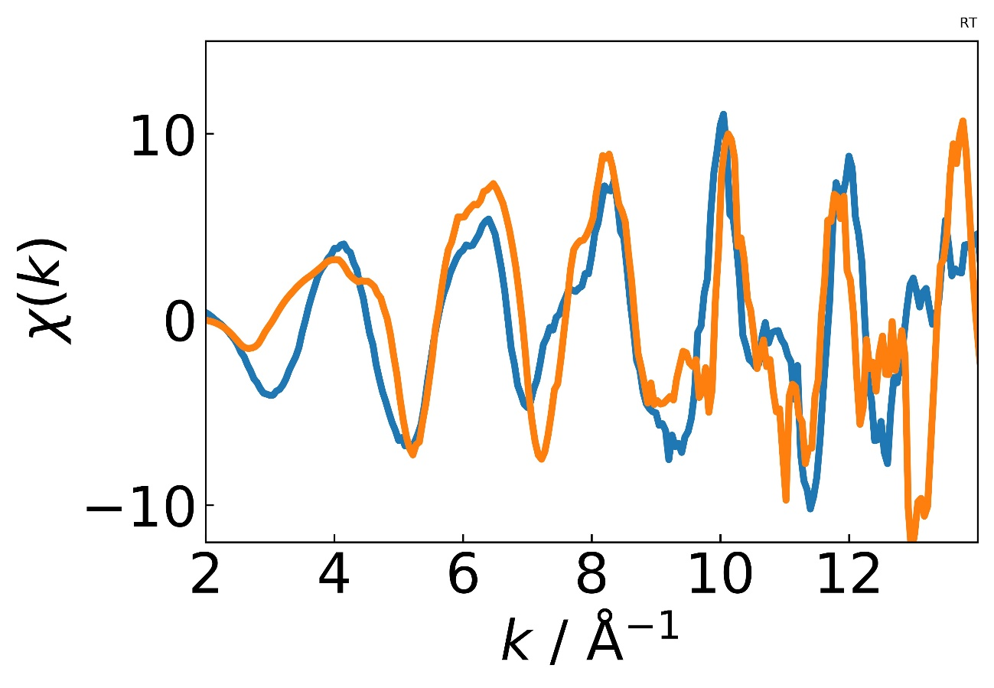

Figure S2 Pt L₃ edge and Sn K-edge of 7.5 wt % Pt-SnO₂ sample.
Since the L₃ edge EXAFS is π rad different from that of K-edge, the oscillation is multiplied by -1. The Pt L₃-edge EXAFS oscillation is shifted by 6 eV. Consequently, the oscillation is in good agreement with each other indicating the Pt and Sn are mostly at the same lattice position.

SI-3 The second and the third shell analysis of Pt-SnO₂
SnO₂ has a rutile structure where one Sn is at the center and eight Sn atoms are at the corner of the tetragonal unit cell with Sn-Sn distance of 3.76 Å. Two other neighbor Sn atoms at 3.16 Å are located at the center of the neighboring tetragonal unit cells along the c-axis. There are totally two shorter and eight longer Sn-Sn bonds as shown in Table S1. To confirm the random distribution of Pt in the SnO₂, curve fitting analyses in the second and the third shells are carried out. However, we need a total of 16 fitting parameters for 4 shells of two Pt–Sn(Sn–Sn) and two Pt–Pt(Sn–Pt). The amount of information, M, can be calculated as $2Δk∙Δr/π+2=2*11\left(10.8\right)*1.8/3.14+2≈15<16$. Thus, the analyses of 2nd and 3rd shells are impossible for Pt–SnO₂. However, if two edges are simultaneously analyzed and the following constraints are applied, it is possible to analyze the data by curve fitting.
- r_{PtSn} = r_{SnPt} and C_{Pt}·CN_{PtSn} = C_{Sn} ·CN_{SnPt} should be satisfied. The composition ratio is C_{Pt}:C_{Sn} = 1:3.5.
- The ΔE for Sn–Sn in Sn K-edge of Pt–SnO₂ must be equal to those of SnO₂.
- All Pt atoms are located at the substitution site of Sn in the SnO₂ lattice.
The total number of information (M) is 30 (=15×2 for Sn K-edge and Pt L₃-edge). The number of fitting parameters (ν) is 32 (=4× 4 for Sn K-edge and 4× 4 for Pt L₃-edge) with 6 constraints (C). Consequently, $M-ν+ C =4>0$. Table S1 provides the results. The fitting showed the bond distances around Pt atoms are shorter than those of SnO₂ corresponding to the smaller lattice constants in Pt–SnO₂ than those of SnO₂ as shown in XRD. The total coordination numbers around Pt and Sn (N_{total}) for the second and third nearest neighbors are 1.6 (=1.3+0.3) and 7.2 (=5.6+1.6) for Sn edge and 1.5 (=1.05+0.45) and 7.2 (=5.6+1.6) for Pt L₃-edge, respectively. The total coordination numbers around Sn and Pt agree well, indicating that Pt atoms are not on the surface but in the bulk. The ratio of homo bond (Pt–Pt and Sn–Sn) to hetero bond (Pt–Sn) at the corresponding shells is roughly 3.5, indicating the Pt should be randomly distributed in the SnO₂ lattice. We have concluded that the Pt is located at the Sn site in the SnO₂ lattice and randomly distributed in the thin film layer.

Table S1. Curve fitting results for the higher shell peaks to Sn K-edge and Pt L₃-edge FT-EXAFS of SnO₂ and Pt–SnO₂ using FEFF
 |  | r / Å | ΔE / eV | σ² / Å² | $$N$$ | shell | $$N_{Total}$$
SnO₂ |  | 3.16 ± 0.02 | -4.1 | 0.0014 ± 0.0005 | (2)
 |  | 3.76 ± 0.02 | 4.1 | 0.0019 ± 0.0006 | (8)
SnO₂ film Sn-Sn |  | 3.16 ± 0.02 | (-4.1) | 0.0007 ±0.0005 | 1.6 ± 0.4
 |  | 3.72 ± 0.02 | (4.1) | 0.0012 ± 0.0006 | 7.2 ± 0.7
Pt-SnO₂  Sn K-edge | Sn-Sn | 3.14 ± 0.03 | (-4.1)* | 0.0011 ± 0.0010 | 1.3± 0.5 | 2nd | 1.6±  0. 5
 |  | 3.73 ± 0.04 | (4.1)* | 0.003 ± 0.001 | 5.6 ± 1.0
 | Sn-Pt | 3.06* ± 0.04 | -15 ± 5 | 0.0009 ± 0.0007 | 0.3* ± 0.1 | 3rd | 7.2±  1.1
 |  | 3.71* ± 0.04 | 15 ± 5 | 0.0081 ± 0.0015 | 1.6* ± 0.5
Pt-SnO₂  Pt L₃-edge | Pt-Sn | 3.06* ± 0.04 | -15 ± 5 | 0.0008 ± 0.001 | 1.05* ± 0.3 | 2nd | 1.5±  0.4
 |  | 3.71* ± 0.04 | 15 ± 5 | 0.0051 ± 0.001 | 5.6* ± 1.5
 | Pt-Pt | 3.03 ± 0.04 | 10 ± 5 | 0.0006 ± 0.0004 | 0.45 ± 0.2 | 3rd | 7.2±  1.6
 |  | 3.61 ± 0.04 | 5 ± 5 | 0.0009 ± 0.0007 | 1.6 ± 0.6
* means the values are corresponding to the 6 constraints shown in text.
Parentheses mean the fixed parameters.
$N_{Total} =N_{Pt\left(Sn\right)-Sn}+N_{Pt\left(Sn\right)-Sn}$ for each shell.

Suzuki, T.; Kunihara, K.; Kobayashi, M.; Tabata, S.; Higaki, K.; Ohnishi, H., A Micromachined Gas Sensor Based on a Catalytic Thick Film/SnO₂ Thin Film Bilayer and Thin Film Heater: Part 1, CH₄ Sensing, Sens. Actuator B Chem: 2005, 109, 185-189.
Chen, Y.; Xu, P.; Zhang, P.; Li, X. In Long-Term Stability Improvement of Micro-Hotplate Methane Sensor Product, 2020 IEEE 33rd International Conference on Micro Electro Mechanical Systems (MEMS), IEEE: 2020; pp 1300-1303.
Das, I.; Bhattacharyya, R.; Saha, H.; Ghosh, S., Enhanced Response of Co-Planar Mems Microheater-Based Methane Gas Sensor. IEEE Sens., J. 2020, 20, 14132-14140.
⁴ Pisliakov, A. V.; Sokolov, A. V.; Polovko, O. V.; Guarnieri, V.; Lorenzelli, L.; Samotaev, N. N.; Kujawski, W.; Kujawska, A.; Vasiliev, A. A.; Legin, A. V., Pervaporation Unit with Mems Gas Sensor for the Measurement of Methane Concentration in Water. 2015 IEEE Workshop on Environmental, Energy, and Structural Monitoring Systems (EESMS) Proceedings, 2015; pp 136-140.
Das, I.; Bhattacharyya, R.; Saha, H.; Ghosh, S., Enhanced Response of Co-Planar Mems Microheater-Based Methane Gas Sensor. IEEE Sens., J. 2020, 20, 14132-14140.
Pisliakov, A. V.; Sokolov, A. V.; Polovko, Samotaev, N.; Dzhumaev, P.; Oblov, K.; Pisliakov, A.; Obraztsov, I.; Ducso, C.; Biro, F., Silicon Mems Thermocatalytic Gas Sensor in Miniature Surface Mounted Device Form. Chemosensors 2021, 9. 340(1)-(10)
Su, J.; Cao, L.; Li, L.; Wei, J.; Li, G.; Yuan, Y., Highly Sensitive Methane Catalytic Comb Bierer, B.; Grgić, D.; Yurchenko, O.; Engel, L.; Pernau, H.-F.; Jägle, M.; Reindl, L.; Wöllens
tein, J., Low-Power Sensor Node for the Detection of Methane and Propane. J. Sens. Sens. Sys. 2021, 10, 185-191. ⁸ Shaalan, N. M.; Rashad, M.; Moharram, A. H.; Abdel-Rahim, M. A., Promising Methane Gas Sensor Synthesized by Microwave-Assisted Co3o4 Nanoparticles. Mater. Sci. Semicond. Proces. 2016, 46, 1-5.
Bhattacharyya, P.; Basu, P. K.; Saha, H.; Basu, S., Fast Response Methane Sensor Using Nanocrystalline Zinc Oxide Thin Films Derived by Sol–Gel Method. Sens. Actuator B: Chemical 2007, 124, 62-67.
Murata, N.; Suzuki, T.; Kobayashi, M.; Togoh, F.; Asakura, K., Characterization of Pt-Doped SnO₂ Catalyst for a High-Performance Micro Gas Sensor. Phys. Chem. Chem. Phys 2013, 15, 17938-17946.

