Supplementary materials

Fig. S6 Neighbor-joining tree constructed using the Jukes–Cantor model based on a gap1 (860 bp), b gltA (573 bp), c gyrB (910 bp) and d rpoD (804 bp) sequences from the present isolates and related bacterial species and pathovars. T, type strain of the species; PT, pathotype strain of the pathovars. Accession numbers of the sequences from the DDBJ, EMBL, and GenBank databases are in parentheses. Numbers at nodes are bootstrap values (≥50%) expressed as percentages of 1000 replicates. Bar: 0.01 substitutions per nucleotide position

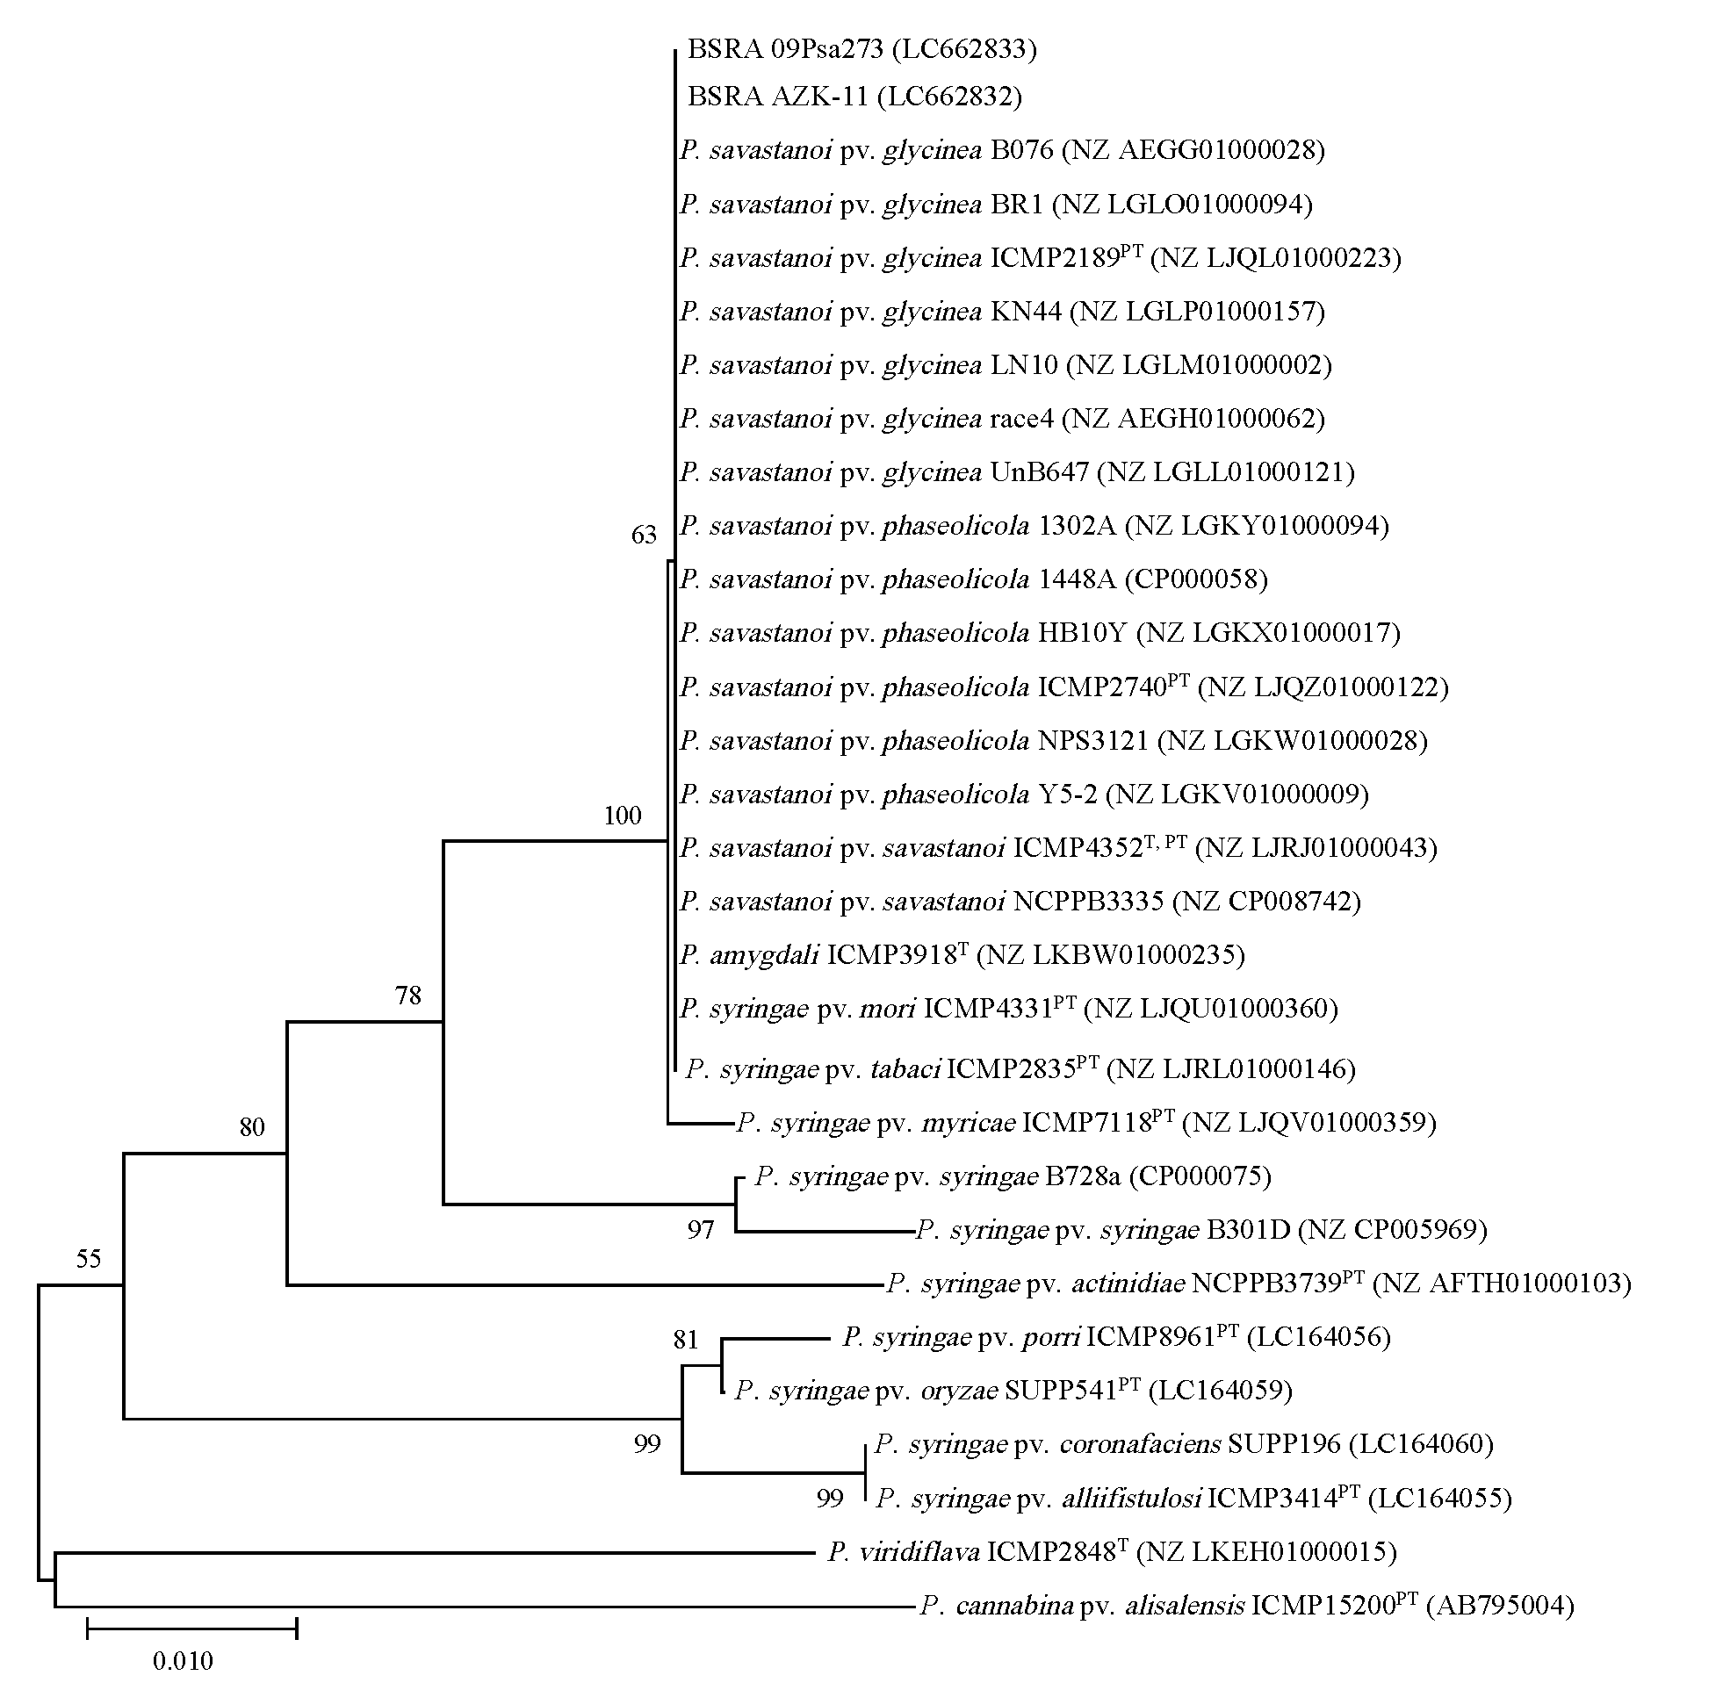
a
b

d
c
Fig. S6

