Supplementary data

Electrocatalytic activity and volatile product selectivity for nitrate reduction at tin-modified Pt(100), Pd(100) and Pd–Pt(100) single crystalline electrodes in acidic media

Masaru Kato,^{a,b*} Yuki Unuma,^{b} Manabu Okui,^{b} Yunteng Qu,^{c†} Jinhang Zheng,^{b} Satoshi Taguchi,^{e} Fumiya Kiguchi,^{d} Mashu Torihata,^{d} Yunzhi Gao,^{c} Nagahiro Hoshi,^{d} Ichizo Yagi ^{a,b*}

ªFaculty of Environmental Earth Science and ^{b}Graduate School of Environmental Science, Hokkaido University, N10W5, Kita-ku, Sapporo 060-0810, Japan
^{c}School of Chemistry and Chemical Engineering, Harbin Institute of Technology, No. 92 West-Da Zhi Street, Harbin 150001, People’s Republic of China
^{d}Department of Applied Chemistry and Biotechnology, Graduate School of Engineering, Chiba University, Yayoi-cho 1-33, Inage-ku, Chiba 256-8522, Japan
^{e}Laboratory of Chemistry, Hokkaido University of Education Sapporo, Ainosato 5-3-1, Kita-ku, Sapporo 002-8502, Japan

†Present address: State Key Laboratory of Photoelectric Technology and Functional Materials, International Collaborative Center On Photoelectric Technology and Nano Functional Materials, Institute of Photonics and Photon-Technology, Northwest University, Xi’an 710069, People’s Republic of China

*Corresponding authors:
masaru.kato@ees.hokudai.ac.jp (to MK); iyagi@ees.hokudai.ac.jp (to IY)

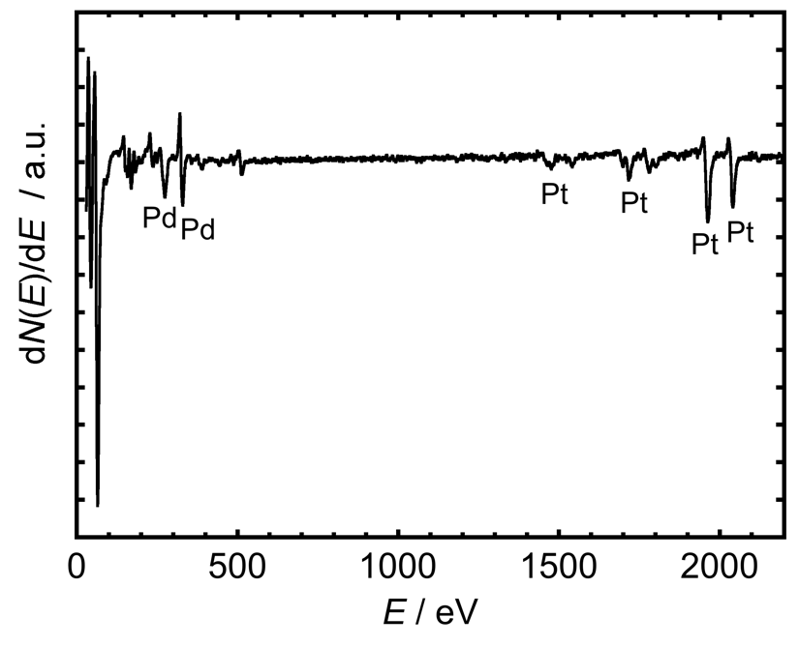
Fig. S1 An Auger electron spectrum of Pd–Pt(100).

Fig. S2 CVs of Sn-modified and unmodified Pt(100), Pd(100) and Pd-Pt(100) single crystalline electrodes recorded at 50 mV s^{–1} in 0.5 H₂SO₄ under Ar. The traces in black and gray indicate CVs of bare and Sn-covered electrodes, respectively.

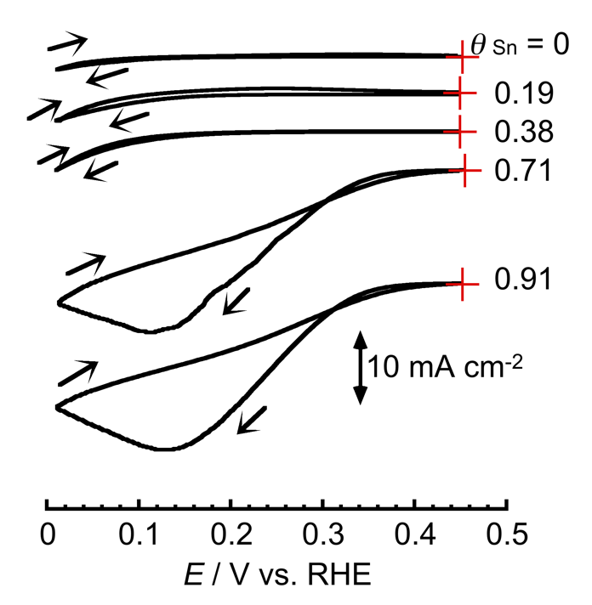
Fig. S3 CVs of Sn/Pd(100) with different θ_{Sn} recorded at 10 mV s^{–1} in an aqueous solution containing 0.1 M HClO₄ and 0.1 M NaNO₃ under Ar. Arrows indicate the sweep direction and plus signs indicate the initial position of the CV.

Quantification of gaseous products using the OLEMS setup.
Although quantitative analysis of OLEMS data remains challenging, we approximately quantified amounts of gaseous products for the NO3RR, and then calculated Faradaic efficiencies of the production of them.
A flow rate of a gas passing through the glass pinhole was approximately determined to be ca. 6.06 µL s^{–1}, which was determined by an injection of the air (100 µL) using a gas-tight syringe. We assumed that the flow rate was a constant and used for the calculation of volumes of gas products. To more accurately determine the gas flow rate, we might need to consider many other factors such as gas diffusion coefficient across the membrane and local concentrations of gas species.
To quantify the gaseous products of NO, N₂O and N₂, calibration lines for them were obtained using standard gas mixtures of these gases with Ar at different flow rates (Fig. S4). Fragmentation of N₂O to NO and N₂ occurred in the quadrupole mass spectrometer [S1] and the fragmentation ratio of N₂O to NO and N₂ was determined to be 1:0.35:0.035. Produced gas volumes (V_{x} / µL, x = NO, N₂O or N₂) were determined using Eq. (1):
$V_{x}= \frac{I_{x}-(f_{x}×I_{N_{2}O})}{a_{x}}×v×t$ (1)
where I_{x} indicates mass currents (A) obtained for a gas of x at the quadrupole mass spectrometer, f_{x} indicates a fragmentation-correction factor for each gas (f_{NO} = 0.35; f_{N2O} = 0; f_{N2} = 0.035), a_{x} indicates the slope obtained for each gas in the calibration line ($a_{NO}$ = 5.74×10^{–8} A; $a_{N_{2}O}$= 4.35×10^{–8} A; $a_{N_{2}}$= 1.66×10^{–7} A), v indicates the flow rate of the gas mixture passing through the pinhole (v = 6.06 µL s^{–1} in this study) and t indicates the integration time to obtain an ionic current using the quadrupole mass spectrometer (t = 4.25 s in this study). Because we used single crystal electrodes with surface areas ranging from 0.063 to 0.070 cm² and observed no drastic impact of surface areas of the working electrode on mass currents (Fig. S5), mass currents obtained were used with no correction of the surface area. Note that no mass current that corresponds to m/z = 2 was observed for the tin-modified electrodes we used in the potential range down to 0 V vs. RHE, indicating that the hydrogen evolution reaction did not occur in our electrochemical condition.
The determination of volumes of gases produced from the electrode using Eq. (1) allowed us to calculate Faradaic efficiencies for each gas production (FE_{x} in %) using Eq. (2):
${FE}_{x}=\frac{N_{x}×F×n_{e_x}}{Q}×100$ (2)
where N_{x} is the number of moles of the produced gas, F is the Faraday constant (F = 96487 C mol^{–1}), n_{e_x} is the number of electrons required for the nitrate reduction to the gas x ($n_{e_NO}$ = 3, $n_{e_N_{2}O}$ = 4, $n_{e_N_{2}}$ = 5) and Q is the total charges required for LSVs for the mass signal acquisition time (4.25 s). N_{x} can be calculated from Eq. 3 as follows:
$N_{x}=\frac{pV_{x}}{RT}$ (3)
where the p is the pressure of the gas (p = 1 atm), R is the gas constant (R = 0.0821 L atm mol^{–1} K^{–1}) and T is the absolute temperature of the gas (298.15 K).

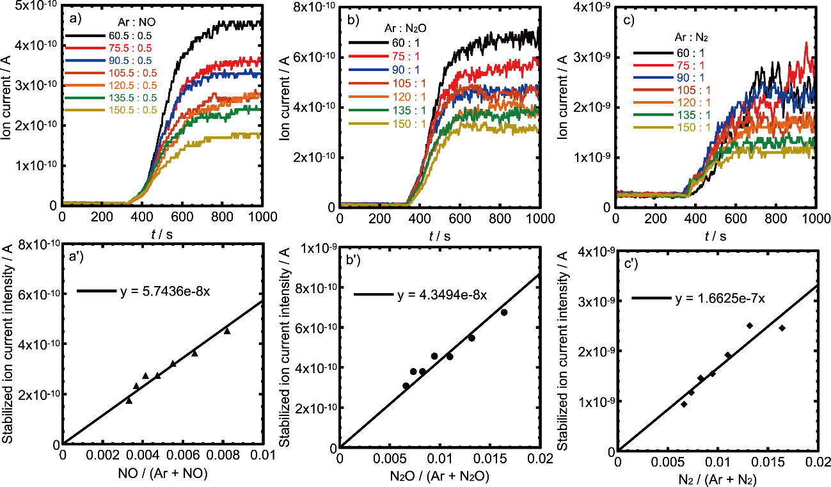
Fig. S4 Mass currents of different gas mixing ratios of standard gases of (a) NO, (b) N₂O and (c) N₂ with Ar at 1 sccm and calibration lines obtained for (a’) NO, (b’) N₂O and (c’) N₂. The slopes obtained from the calibration lines were used to calculate volumes of gases produced from the electrode for the electrocatalytic NO₃RR.

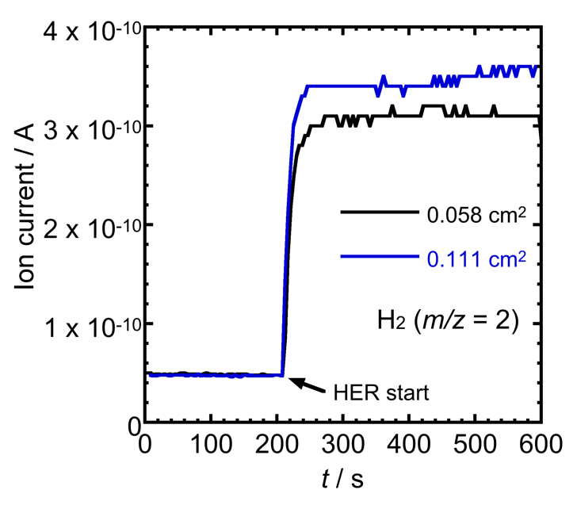
Fig. S5 Time course of mass currents for the hydrogen evolution reaction at 0 V vs. RHE in a 0.1 M HClO₄ aqueous solution using Pt(111) electrodes with different surface areas of 0.058 cm² (the trace in black) and 0.111 cm² (the trace in blue). Mass currents increased by <15% even though the surface area was doubled, indicating that there was no drastic impact of the surface area of the electrode on the mass current in our OLEMS setup. Since single crystalline electrodes with similar surface areas ranging from 0.063 to 0.070 cm² were used in this work, mass currents were not corrected based on the surface area of the electrode.

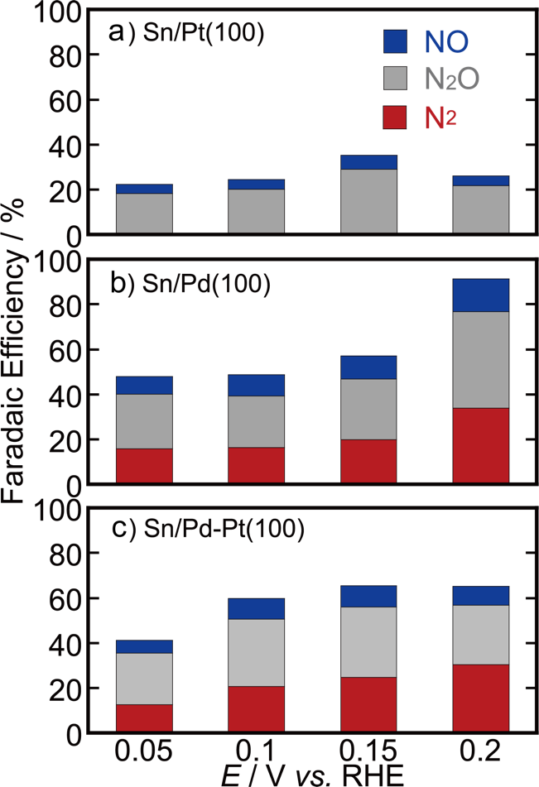
Fig. S6 Bar graphs showing potential dependence of Faradaic efficiencies of NO (in blue), N₂O (in gray) and N₂ (in red) for (a) Sn/Pt(100), (b) Sn/Pd(100) and (c) Sn/Pd–Pt(100). These Faradaic efficiencies were calculated from the ion currents of Fig. 4b–4d in the main text.

Reference
[S1] K. Nishimura, K. Machida, M. Enyo, On-line mass spectroscopy applied to electroreduction of nitrite and nitrate ions at porous Pt electrode in sulfuric acid solutions, Electrochim. Acta, 36 (1991) 877-880.

