**Supporting Information**

X-ray Absorption Fine Structure Studies on Nickel Phosphide Catalysts for the Non-oxidative Coupling of Methane Reaction Using a Theoretical Model

Md Harun Al Rashida , Arnoldus Lambertus Dipub, Yuta Nishikawab, Hitoshi Ogiharac, Yuta Inamib, Shoji Iguchib, Ichiro Yamanakab, Shinchi Nagamatsud, Daiki Kidod, Bing Hud, Kiyotaka Asakura*d

a Graduate School of Engineering, Hokkaido University, Sapporo 060-8628, Hokkaido, Japan

b School of Materials and Chemical Technology, Tokyo Institute of Technology, Tokyo 152-8552, Japan

c Graduate School of Science and Engineering, Saitama University, Saitama 338-8570, Japan

d Institute for Catalysis, Hokkaido University, Hokkaido 001-0021, Japan

* Corresponding author: Institute for Catalysis, Hokkaido University, Kita 21, Nishi 10, Kita-ku, Sapporo, Hokkaido, Japan, 001-0021

Email address: askr@cat.hokudai.ac.jp (Kiyotaka Asakura)

**Contents of the supporting Information**

|  |
| --- |
| **Contents** |
| **Fig. S1(a).** Bulk structures of NiP3, NiP2, NiP, Ni5P4, Ni2P, Ni12P5, and Ni3P. |
| **Fig. S1(b).** Two different Ni sites of bulk Ni2P with different Ni-P and Ni-Ni bond distances. |
| **Fig. S2.** Comparison of Ni K-edge experimental and theoretical XANES spectra: a) Ni2P (black line), b) Ni2P FEFF (cluster size 3Å) (red line), and c) Ni2P FEFF (cluster size 5Å) (blue line). |
| **Fig. S3.** Comparison of Ni K-edge experimental XANES spectra of Ni-P/SiO2: a) Ni:P = 1:1 (black line), b) Ni:P = 2:1 (red line), and c) Ni:P = 3:1 (blue line). |
| **Fig. S4.** Comparison of Ni K-edge theoretical XANES spectra of reference compounds: a) FEFF NiP3 (black line), b) FEFF NiP2 (red line), c) FEFF NiP (blue line), d) FEFF Ni2P (pink line), e) FEFF Ni5P4 (green line), f) FEFF Ni12P5 (navy line), and g) FEFF Ni3P (violet line), |
| **Fig. S5.** Peak Position of Ni K-edge XANES spectra of Ref. Ni2P, experimental samples Ni-P/SiO2: Ni:P = 1:1, Ni:P = 2:1, Ni:P = 3:1, and theoretical Ni K-edge XANES spectra of Ni2P, Ni12P5, Ni3P, NiP3, NiP2, NiP, and Ni5P4 respectively. |
| **Fig. S6.**  Pre-edge comparison of Ni K-edge theoretical XANES spectra of reference compounds: FEFF NiP3 (black line), FEFF NiP2 (red line), FEFF NiP (blue line), FEFF Ni5P4 (pink line), FEFF Ni2P (green line), FEFF Ni12P5 (violet line), and FEFF Ni3P (violet line) respectively. |
| **Fig. S7**. Second derivative of the experimental XANES spectra of Ni-P/SiO2 (Ni:P = 3:1). |
| **Table S1.**  Previous curve fitting results of the Ni K-edge EXAFS spectra for the Ni2P reference and different samples with initial NiP ratios of 1:1, 2:1, and 3:1 |
| **Table S2.** Some components of feff.inp input file for XANES of Ni2P. |
| **Table S3.** Comparison of R-factors between the EXAFS simulation method and CF method. |
| **Table S4.** Peak positions of theoretical and experimental XANES spectra of different nickel phosphide with experimental Sample Ni-P/SiO2 (Ni:P = 1:1). |
| **Table S5.**  Peak positions of theoretical and experimental XANES spectra of different nickel phosphide with experimental Sample Ni-P/SiO2 (Ni:P = 2:1). |
| **Table S6.**  Peak positions of theoretical and experimental XANES spectra of different nickel phosphide with experimental Sample Ni-P/SiO2 (Ni:P = 3:1). |

**1.** Nickel phosphide has different phases, namely NiP3, NiP2, NiP, Ni5P4, Ni2P, Ni12P5, and Ni3P. Those compounds have very complicated structures with different sites and various Ni-Ni and Ni-P distances.

|  |  |  |  |  |  |
| --- | --- | --- | --- | --- | --- |
| Bulk NiP3  a=b=c=7.819  α=β= γ= | | Bulk NiP2  a=6.368; b=5.617; c=5.631  α=β= ${90}^{°}$; γ= ${119.571}^{°}$ | | Bulk NiP  a=4.881;b=6.890; c=6.050  α=β= γ= ${90}^{°}$ | |
| Bulk Ni5P4  a=b=6.789; c=10.989  α=β=; γ= | Bulk Ni2P  a=b=5.865; c=3.387  α=β=; γ= | | Bulk Ni12P5  a=b=8.650; c=5.085  α=β= γ= | | Bulk Ni3P  a=b=8.954; c=4.386  α=β= γ= ${90}^{°}$ |

**Fig. S1(a).** Bulk structures of NiP3, NiP2, NiP, Ni5P4, Ni2P, Ni12P5, and Ni3P.

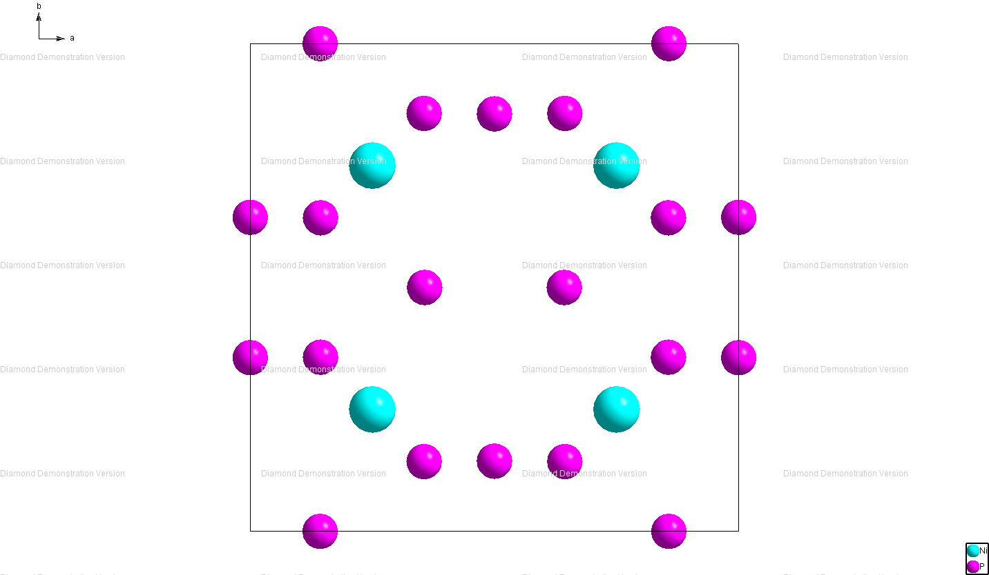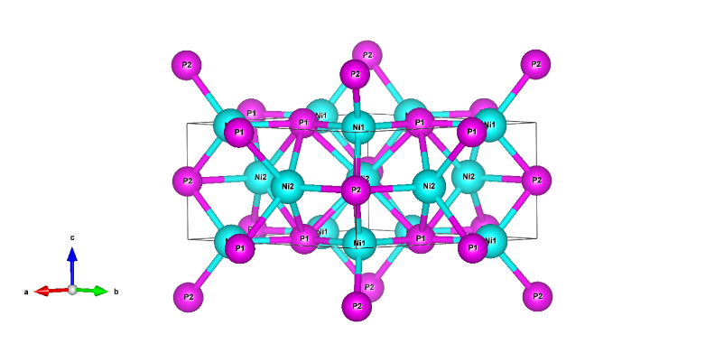

2.67Å

2.61Å

**Fig. S1(b).** Two different Ni sites of bulk Ni2P with different Ni-P and Ni-Ni bond distances.

**2.** Figure S2 shows Ni K-edge XANES spectra of Ni2P reference sample compared with the FEFF8 calculated spectra of Ni2P with different FMS radius. The experimental and theoretical XANES spectra of Ni2P showed the same three peak features A, B, and C.



**Fig. S2.** Comparison of Ni K-edge experimental and theoretical XANES spectra: a) Ni2P (black line), b) Ni2P FEFF (cluster size 3Å) (red line), and c) Ni2P FEFF (cluster size 5Å) (blue line).

**3.** Figure S3 shows the Ni K-edge XANES spectra of the Ni-P/SiO2 catalyst with different initial Ni:P ratios of 1:1, 2:1, and 3:1. Ni-P (1:1) shows the main three features A, B, and C in different eV, where the peak became small and blurred with the increase of initial Ni and P ratios.

**Fig. S3.** Comparison of Ni K-edge experimental XANES spectra of Ni-P/SiO2: a) Ni:P = 1:1 (black line), b) Ni:P = 2:1 (red line), and c) Ni:P = 3:1 (blue line).

**4.** Theoretical XANES spectra of reference compounds: NiP3, NiP2, NiP, Ni5P4, Ni2P, Ni12P5, and Ni3P. The XANES spectra of different nickel phosphide catalysts are characterized by several peaks and shoulder at different eV.



**Fig. S4.** Comparison of Ni K-edge theoretical XANES spectra of reference compounds: a) FEFF NiP3 (black line), b) FEFF NiP2 (red line), c) FEFF NiP (blue line), d) FEFF Ni2P (pink line), e) FEFF Ni5P4 (green line), f) FEFF Ni12P5 (navy line), and g) FEFF Ni3P (violet line),

**5.** The XANES spectra of different nickel phosphide catalysts are characterized by several peaks and shoulder at different eV. Here we indicated the peak positions of experimental XANES spectra of the reference Ni2P, Ni-P/SiO2 catalyst with different initial Ni:P ratios of 1:1, 2:1, 3:1, and theoretical XANES spectra of Ni2P, Ni12P5, Ni3P, NiP3, NiP2, NiP, and Ni5P4, respectively.













**Fig. S5.** Peak Position of Ni K-edge XANES spectra of Ref. Ni2P, experimental samples Ni-P/SiO2: Ni:P = 1:1, Ni:P = 2:1, Ni:P = 3:1, and theoretical Ni K-edge XANES spectra of Ni2P, Ni12P5, Ni3P, NiP3, NiP2, NiP, and Ni5P4 respectively.

**6.** Pre-edge comparison of the theoretical XANES spectra of reference compounds: NiP3, NiP2, NiP, Ni5P4, Ni2P, Ni12P5, and Ni3P. The pre-edge peak intensity gradually changes concerning Ni:P ratios.





**Fig. S6.**  Pre-edge comparison of Ni K-edge theoretical XANES spectra of reference compounds: FEFF NiP3 (black line), FEFF NiP2 (red line), FEFF NiP (blue line), FEFF Ni5P4 (pink line), FEFF Ni2P (green line), FEFF Ni12P5 (violet line), and FEFF Ni3P (violet line) respectively.

**7.** The second derivative peak positions of Ni-P/SiO2 (Ni:P = 3:1) XANES spectra indicated three different peak features in the spectra.



**Fig. S7**. Second derivative of the experimental XANES spectra of Ni-P/SiO2 (Ni:P = 3:1).

**Table S1**

Previous curve fitting results of the Ni K-edge EXAFS spectra for the Ni2P reference and different samples with initial Ni:P ratios of 1:1, 2:1, and 3:1.

|  |  |  |  |  |  |  |  |  |  |  |  |  |  |
| --- | --- | --- | --- | --- | --- | --- | --- | --- | --- | --- | --- | --- | --- |
| **Samples** | |  |  | **Ni-Ni** | | | |  | **Ni-P** | | | | **R(%)a** |
|  |  | **CN** | **R (Å)** |  |  |  | **CN** | **R (Å)** |  |  |
|  | Fresh samples | | | | | | | | | | | | |
| Ni2P ref. | |  |  | 4.0 $±$ 0.3 | 2.62 $±$ 0.02 | 0.0084 | 5.4 |  | 1.0±0.3 | 2.21 $±$ 0.02 | 0.0050 | -5.1 | 0.5 |
| Ni-P(1:1, 0h) | |  |  | 4.6 $±$ 0.6 | 2.62 $±$ 0.02 | 0.0072 | 3.4 |  | 1.3 $±$ 0.3 | 2.19 $±$ 0.02 | 0.0065 | -7.5 | 0.3 |
| Ni-P(2:1, 0h) | |  |  | 4.2 $±$ 0.3 | 2.52 $±$ 0.02 | 0.0086 | -1.1 |  | 0.6 $±$ 0.3 | 2.18 $±$ 0.03 | 0.0012 | -7.3 | 0.1 |
| Ni-P(3:1, 0h) | |  |  | 4.6 $±0.$ 9 | 2.45 $±$ 0.02 | 0.0134 | -7.2 |  | 2.0 $±0.5$ | 2.28 $±$ 0.02 | 0.0193 | -3.6 | 0.5 |
|  | Spent samples | | | | | | | | | | | | |
| Ni-P(1:1, 3h) | |  |  | 4.5 $±$ 0.8 | 2.62 $±$ 0.03 | 0.0067 | 3.5 |  | 1.5 $±$ 0.5 | 2.18 $±$ 0.03 | 0.0070 | -9.8 | 0.5 |
| Ni-P(2:1, 3h) | |  |  | 4.3 $±$ 0.3 | 2.53 $±$ 0.03 | 0.0090 | -0.7 |  | 0.7 $±$ 0.3 | 2.17 $±$ 0.03 | 0.0033 | -8.8 | 0.3 |
| Ni-P(3:1, 3h) | |  |  | 4.6 $±1.0$ | 2.46 $±$ 0.02 | 0.0136 | -6.6 |  | 2.1 $±0.6$ | 2.28 $±$ 0.03 | 0.017 | -2.3 | 0.4 |

Ref.: Al Rashid, M. H. *et al.* Active Phase Structure of the SiO2-supported Nickel Phosphide Catalysts for Non-oxidative Coupling of Methane (NOCM) Reactions. *e-Journal Surf. Sci. Nanotechnol.* **18**, 24–27 (2020).

a

**Table S2**

Some components of feff.inp input file for XANES of Ni2P.

|  |  |
| --- | --- |
| **XANES Calculations** | |
| TITLE | Ni2P |
| EXCHANGE | 0 0 0 |
| SCF | 5.0 0 100 0.2 |
| XANES | 5.0 0.07 0.0 |
| FMS | 5.0 0 |
| POTENTIALS | 0 28 Ni -1 -1 0  1 15 P -1 -1 1  2 28 Ni -1 -1 2 |

**Table S3**

Comparison of R-factors between the EXAFS simulation method and CF method.

|  |  |  |
| --- | --- | --- |
| **Sample** | **R(%) ( EXAFS simulation)** | **R(%) (CF )** |
| Ni2P | 5.8 | 0.5 |
| Ni:P = 1:1 | 4.0 | 0.3 |
| Ni:P = 2:1 | 10.0 | 0.1 |
| Ni:P = 3:1 | 7.2 | 0.5 |

**Table S4**

Peak positions of theoretical and experimental XANES spectra of different nickel phosphide with experimental Sample Ni-P/SiO2 (Ni:P = 1:1).

|  |  |  |
| --- | --- | --- |
| **Exp Ni:P = 1:1 (eV)** | **FEFF8 Ni2P (eV)** | **ΔE (eV)** |
| 8332.7 | 8332.7 | 0.0 |
| 8339.7 | 8340.1 | -0.4 |
| 8354.7 | 8354.7 | 0.0 |
| **Exp Ni:P = 1:1 (eV)** | **FEFF8 NiP2** | **ΔE (eV)** |
| 8332.7 | 8332.5 | 0.2 |
| 8339.7 | 8339.6 | 0.1 |
| 8354.7 | 8344.0 | 10.7 |
| **Exp Ni:P = 1:1 (eV)** | **FEFF8 NiP** | **ΔE (eV)** |
| 8332.7 | 8332.8 | -0.1 |
| 8339.7 | 8342.3 | -2.6 |
| 8354.7 | 8355.8 | -1.1 |
| **Exp Ni:P = 1:1 (eV)** | **FEFF8 Ni5P4** | **ΔE (eV)** |
| 8332.7 | 8332.6 | 0.1 |
| 8339.7 | 8343.5 | -3.8 |
| 8354.7 | 8356.0 | -1.3 |
| **Exp Ni:P = 1:1 (eV)** | **FEFF8 NiP3** | **ΔE (eV)** |
| 8332.7 | 8332.5 | 0.2 |
| 8339.7 | 8343.0 | -3.3 |
| 8354.7 | 8354.2 | 0.5 |
| **Exp Ni:P = 1:1 (eV)** | **FEFF8 Ni12P5** | **ΔE (eV)** |
| 8332.7 | 8332.1 | 0.6 |
| 8339.7 | 8337.8 | 1.9 |
| 8354.7 | 8354.8 | 0.1 |
| **Exp Ni:P = 1:1 (eV)** | **FEFF8 Ni3P** | **ΔE (eV)** |
| 8332.7 | 8332.8 | -0.1 |
| 8339.7 | 8343.7 | -4.0 |
| 8354.7 | 8354.9 | -0.2 |

* Peak position estimated error $±0.4$.

**Table S5**

Peak positions of theoretical and experimental XANES spectra of different nickel phosphide with experimental Sample Ni-P/SiO2 (Ni:P = 2:1).

|  |  |  |
| --- | --- | --- |
| **Exp Ni:P = 2:1 (eV)** | **FEFF8 Ni12P5 (eV)** | **ΔE (eV)** |
| 8331.7 | 8332.1 | -0.4 |
| 8337.7 | 8337.8 | -0.1 |
| 8346.7 | 8346.4 | 0.3 |
| 8354.7 | 8354.6 | 0.1 |
| **Exp Ni:P = 2:1 (eV)** | **FEFF8 Ni5P4 (eV)** | **ΔE (eV)** |
| 8331.7 | 8332.6 | -0.9 |
| 8337.7 | 8343.5 | -5.8 |
| 8346.7 | - | - |
| 8354.7 | 8356.0 | -1.3 |
| **Exp Ni:P = 2:1 (eV)** | **FEFF8 Ni2P (eV)** | **ΔE (eV)** |
| 8331.7 | 8332.7 | -1.0 |
| 8337.7 | 8340.1 | -2.4 |
| 8346.7 | - | - |
| 8354.7 | 8354.7 | 0.0 |
| **Exp Ni:P = 2:1 (eV)** | **FEFF8 Ni3P (eV)** | **ΔE (eV)** |
| 8331.7 | 8332.8 | -1.1 |
| 8337.7 | 8343.7 | -6.0 |
| 8346.7 | - | - |
| 8354.7 | 8354.9 | -0.2 |
| **Exp Ni:P = 2:1 (eV)** | **FEFF8 NiP2 (eV)** | **ΔE (eV)** |
| 8331.7 | 8332.5 | -0.8 |
| 8337.7 | 8339.6 | -1.9 |
| 8346.7 | 8344.0 | 2.7 |
| 8354.7 | 8355.5 | -0.8 |
| **Exp Ni:P = 2:1 (eV)** | **FEFF8 NiP** | **ΔE (eV)** |
| 8331.7 | 8332.8 | -1.1 |
| 8337.7 | 8342.3 | -4.6 |
| 8346.7 | - | - |
| 8354.7 | 8355.8 | -1.1 |
| **Exp Ni:P = 2:1 (eV)** | **FEFF8 NiP3** | **ΔE (eV)** |
| 8331.7 | 8332.5 | -0.8 |
| 8337.7 | 8343.0 | -5.3 |
| 8346.7 | - | - |
| 8354.7 | 8354.2 | 0.5 |

* Peak position estimated error $±0.4$.

**Table S6**

Peak positions of theoretical and experimental XANES spectra of different nickel phosphide with experimental Sample Ni-P/SiO2 (Ni:P = 3:1).

|  |  |  |
| --- | --- | --- |
| **Exp Ni:P = 3:1 (eV)** | **FEFF8 Ni3P (eV)** | **ΔE (eV)** |
| 8332.7 | 8332.8 | -0.1 |
| 8343.7 | 8343.7 | 0.0 |
| 8354.7 | 8354.9 | -0.2 |
| **Exp Ni:P = 3:1 (eV)** | **FEFF8 Ni2P (eV)** | **ΔE (eV)** |
| 8332.7 | 8332.7 | 0.0 |
| 8343.7 | 8340.1 | 3.6 |
| 8354.7 | 8354.7 | 0.0 |
| **Exp Ni:P = 3:1 (eV)** | **FEFF8 Ni12P5 (eV)** | **ΔE (eV)** |
| 8332.7 | 8332.1 | 0.6 |
| 8343.7 | 8337.8 | 5.9 |
| 8354.7 | 8354.6 | 0.1 |
| **Exp Ni:P = 3:1 (eV)** | **FEFF8 NiP2** | **ΔE (eV)** |
| 8332.7 | 8332.5 | 0.2 |
| 8343.7 | 8339.6 | 4.1 |
| 8354.7 | 8344.0 | 10.7 |
| **Exp Ni:P = 3:1 (eV)** | **FEFF8 NiP** | **ΔE (eV)** |
| 8332.7 | 8332.8 | -0.1 |
| 8343.7 | 8342.3 | 1.4 |
| 8354.7 | 8355.8 | -1.1 |
| **Exp Ni:P = 3:1 (eV)** | **FEFF8 Ni5P4** | **ΔE (eV)** |
| 8332.7 | 8332.6 | 0.1 |
| 8343.7 | 8343.5 | 0.2 |
| 8354.7 | 8356.0 | -1.3 |
| **Exp Ni:P = 3:1 (eV)** | **FEFF8 NiP3** | **ΔE (eV)** |
| 8332.7 | 8332.5 | 0.2 |
| 8343.7 | 8343.0 | 0.7 |
| 8354.7 | 8354.2 | 0.5 |

* Peak position estimated error $±0.4$.