Supporting Information
©Wiley-VCH 2021
69451 Weinheim, Germany
Ferroelectric Ionic Molecular Crystals with Significant Plasticity and a Low Melting Point: High Performance in Hot-Pressed Polycrystalline Plates and Melt-Grown Crystalline Sheets
Jun Harada,* Haruka Takahashi, Rin Notsuka, Mika Takehisa, Yukihiro Takahashi, Tomoyasu Usui, and Hiroki Taniguchi

Table of Contents
Experimental Procedures 2
Materials 2
Measurements 2
Results and Discussion 3
Pyroelectricity of crystals of guanidinium tetrafluoroborate (1) 3
Orientations of melt-grown crystalline plates of 1 3
Supporting Figures and Tables 4
References 13

Experimental Procedures
Materials. Guanidinium tetrafluoroborate (1) was prepared by the reaction between guanidinium carbonate and tetrafluoroboric acid in water. After removing the water under reduced pressure, the solid product was purified by recrystallization from ethanol. The colorless powder of 1 was filtered off and dried under reduced pressure. Teflon-coated flasks and beakers were used during the reaction and recrystallization processes. Crystals of 1 are stable up to ~540 K (Figure S9) and do not exhibit significant hygroscopicity under normal indoor environments.
Bulk polycrystalline plates of 1 were prepared by the application of a uniaxial pressure to powder samples of 1 at 100 °C. X-ray diffraction patterns of the polycrystalline plates showed neither structural changes nor loss of crystallinity after pressurization (Figure S10). Melt-grown crystalline plates were fabricated from molten 1 between a pair of Teflon sheets, the temperature of which was slowly decreased from above the melting point of 1 to room temperature. Additionally, the melt-growth of crystalline 1 between a Teflon sheet and a fluorine-doped tin oxide (FTO)-coated glass substrate provided crystalline sheets attached to FTO. The FTO-coated substrates were ultrasonically cleaned sequentially in acetone, ethanol, and deionized water prior to use. A gallium–indium eutectic alloy was applied on the crystalline sheets grown on the FTO-coated substrates to form the electrode.
Measurements. X-ray diffraction patterns of powder samples were measured using a Bruker D8 ADVANCE diffractometer (Ni-filtered Cu radiation) and confirmed the purity and identity of the powders (Figure S10). Differential scanning calorimetry (DSC) measurements were performed under a flow of dry N₂ on a TA Instruments Discovery DSC25 using a heating rate of 10 K min⁻¹. The specific heat capacity was determined using DSC measurements according to the American Society of Testing and Materials (ASTM) standard E1269. TG-DTA measurements were conducted under a flow of dry Ar on a Rigaku Thermo plus EVO TG 8120 using a heating rate of 20 K min⁻¹.
Single-crystal X-ray diffraction analyses were performed on a Bruker APEX II Ultra diffractometer (Mo Kα radiation; λ = 0.71073 Å) using a melt-grown colorless crystalline plate of 1 (0.5 × 0.4 × 0.2 mm). The crystal structure was solved by intrinsic phasing (SHELXT–2018)^{[1]} and refined by full-matrix least-squares on F² using SHELXL–2018.^{[2]} Non-hydrogen atoms were refined anisotropically, while hydrogen atoms were refined isotropically. The crystal and experimental data are summarized in Table S3.
For the electrical measurements using crystalline plates, carbon paste was applied to both sides of the samples to form the electrodes. A homemade cryostat was used to control the temperature of the samples under a helium atmosphere, except in the case of the pyroelectric measurements using the temperature-oscillation method, in which the temperature of the sample was oscillated using a Peltier Cooling Module under the ambient atmosphere. The dielectric constant was measured using an Agilent E4980A precision LCR meter. The dielectric constant of the poled sample (εʹ₃₃ at 1 kHz) was used to calculate the pyroelectric figures of merit (FOMs).
The polarization–electric field (P–E) diagrams were measured with a high-voltage triangular-wave field at 10 Hz on a Sawyer-Tower circuit^{[3]}. Small contributions of the conductivity were eliminated by adjusting a variable resistor to yield compensated hysteresis loops with straight lines in the high-electric-field corners, which enabled a more accurate estimation of the spontaneous polarization of the samples. Having little conductivity at around room temperature, the samples provided essentially identical P–E diagrams both on the Sawyer–Tower circuit and on a virtual ground circuit (Toyo Corp., FCE-3), the latter of which did not compensate the conductive contribution (Figure S11).
The pyroelectric coefficients of the poled samples were evaluated using two methods with different temperature modulations: A constant-temperature-ramp method and a temperature-oscillation method.^{[4]} The polarization of the samples was confirmed by P–E hysteresis measurements prior to the pyroelectric measurements. Both measurements were conducted using unclamped samples, which implies that the sum of the primary and secondary pyroelectric effects were evaluated. In the constant-temperature-ramp method, the temperature of the poled samples was changed at a constant rate (2 K min^{–1}), and the induced current was measured using a Keithley 6487 Picoammeter. The temperature dependence of the spontaneous polarization (P_{s}) was obtained by integrating the current density as a function of time. The pyroelectric coefficient was calculated by differentiating the P_{s} values with respect to temperature. The results were well reproducible in the heating and subsequent cooling runs, which is expected for ferroelectrics without phase transitions.
In the temperature-oscillation method,^{[5]} sinusoidal temperature oscillations with the form T = T₀ + T₁ sin(2πf t) were applied to the poled samples, where T₀ is the base temperature, which was set to several different values, and T₁ and f are the amplitude and the frequency of the temperature oscillation, respectively. The induced current was measured with a Keithley 6517B Electrometer and fitted to i = i₀ + i₁ sin(2πf t + φ), where φ is the phase shift between the temperature and current oscillations.
The piezoelectric d₃₃ coefficients were measured with a d₃₃ meter system (Lead Techno Piezo reader) using a quasi-static method. We verified that the d₃₃ meter system provided accurate d₃₃ values for known piezoelectric samples. The polarization of the samples was confirmed by the P–E hysteresis measurements prior to the piezoelectric measurements.

Results and Discussion
Pyroelectricity of crystals of guanidinium tetrafluoroborate (1). In most ferroelectric crystals, the polarization decreases upon heating and becomes zero at and above the T_{c}, and the pyroelectric coefficient (p) becomes negative below T_{c}. The magnitude of the negative p value of ferroelectric crystals can be evaluated by measuring pyroelectric currents using a variety of methods. In general, the electric current measured using the constant-temperature-ramp method can be affected by thermally stimulated currents (TSCs), which are generated by the release of trapped charges injected into the materials during the poling process. TSCs result in a non-pyroelectric-current contribution, which complicates the precise determination of p values, especially for polycrystalline and polymer samples.^{[4b]} In the temperature-oscillation technique, the contributions of pyroelectric and non-pyroelectric effects can be separated, and the genuine pyroelectric effect can be extracted. The thermally induced current consists of pyroelectric and non-pyroelectric contributions, which have different phase shifts relative to the sinusoidal temperature oscillation. For the pyroelectric contribution, the current is proportional to the first derivative of the temperature with respect to time, and the phase shift φ is equal to |90|°, where the sign corresponds to the sign of p. Non-pyroelectric contributions, such as TSCs, are, in general, either constant or proportional to the temperature, which results in a constant current or a current oscillation in-phase with the temperature wave. If there is a non-pyroelectric contribution, φ will be different from |90|°. A pure pyroelectric contribution therefore yields φ = |90|°, and deviation of φ from |90|° indicates an additional contribution from non-pyroelectric currents. The pyroelectric contribution can be extracted from the out-of-phase component of the measured sinusoidal current, and the pyroelectric coefficient at the temperature T₀ can be calculated as p = i₁ sin(φ)/(2πf A T₁), where A is the sample area. In the present study, the evaluated phase shift φ between the temperature and current oscillations was close to −90°, and the base current i₀ was much smaller than i₁, both of which indicate that the pyroelectric current was the major contributor of the thermally induced current. The nearly identical negative p values obtained for the constant-temperature-ramp (p = −41 μC m^{–2} K^{–1} at 298 K) and the temperature-oscillation technique (p = −44 μC m^{–2} K^{–1} at 296 K) further confirm the validity of the p values of polycrystalline plates of 1. The two techniques also yielded similar negative p values for melt-grown single crystalline plates: p = –35 μC m^{–2} K^{–1} at 298 K by the constant-temperature-ramp method and p = –46 μC m^{–2} K^{–1} at 296 K by the temperature-oscillation technique, each obtained using different samples.
The negative p values for the crystals of 1, which indicate reduced spontaneous polarization (P_{s}) at elevated temperatures, can be reasonably explained in terms of temperature changes of the crystal structure, even though the crystals melt without undergoing the ferroelectric-to-paraelectric phase transition. Based on the reported crystal structures of 1 at 100, 150, 200, 250, 295, 320, 350, 370, 400 K,^{[6]} the P_{s} values at each temperature were calculated. As both the cations and anions of 1 possess non-polar structures, the P_{s} value of the crystal can be evaluated based on the displacement of the cations and anions from the highly symmetric non-polar structure. The P_{s} value was calculated using a simple point-charge model, where the positive and negative charges of the cation and anion are represented by point charges at their gravity centers, i.e., the carbon and boron atoms of the guanidinium cation and the tetrafluoroborate anion, respectively. It should also be noted here that the P_{s} value of a ferroelectric crystal has to be calculated as the change in polarization from the non-polar reference structure to the polar structure.^{[7]} In the case of 1, the cations and anions are arranged in a pseudo-cubic CsCl-type structure (Figure 2); accordingly, the P_{s} value of the crystal should be calculated from the displacement of the ions from the non-polar cubic arrangement, where the carbon atom of the cation resides at the centroid of the eight surrounding boron atoms of the anions (Figure S12). At the same time, the boron atom lies at the centroid of the eight surrounding carbon atoms in that structure. The calculated P_{s} value of 8.62 μC cm⁻² at 295 K (Table S4) agrees well with the reported experimental value of 8.5 μC cm⁻² measured along the polar axis of a single crystal.^{[6]} The calculated P_{s} value decreases with increasing temperature, which indicates that the pyroelectric coefficient p is negative. The p value roughly estimated from the calculated P_{s} values at 250 K (8.79 μC cm⁻²) and 295 K (8.62 μC cm⁻²) is −38 μC m^{–2} K^{–1}, which is close to the experimentally obtained values for bulk polycrystals and melt-grown crystals of 1. These results clearly show that the pyroelectric properties of crystals of 1 and their large negative p values without T_{c} can be explained in terms of temperature changes of the crystal structure. The changes in the crystal structure can be interpreted in terms of a weakening of N—H…F intermolecular H bonds between the cations and anions with increasing temperature.^{[6a]}”

Orientations of melt-grown crystalline plates of 1. Face indexing of melt-grown single crystals using a single-crystal X-ray diffractometer confirmed that the three-fold axis is not perpendicular to the plate (Figure S13). The large faces of each crystalline plate did not correspond to crystal faces with low Miller indices, such as (100), (110), or (111), and the orientation of the lattice varied with each crystal. For most crystals, the direction of the polar axis, i.e., the <111> direction, was oriented close to but not along the in-plane direction of the crystal plates.

Supporting Figures and Tables
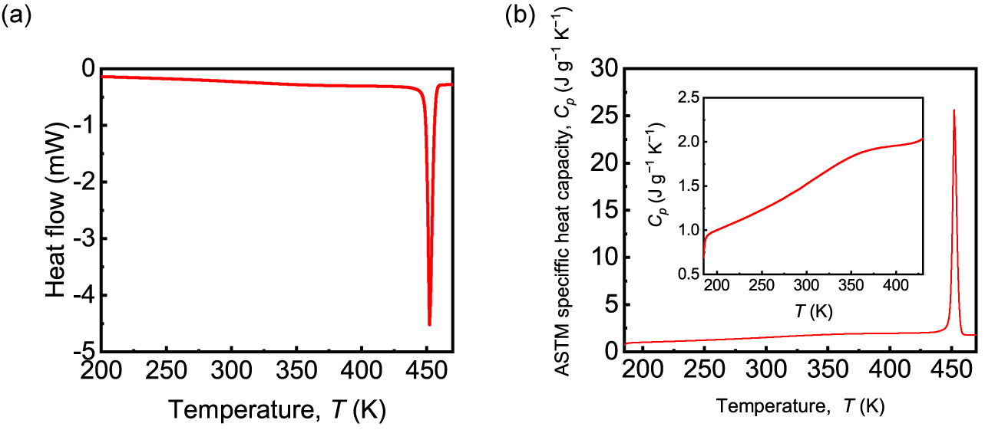
Figure S1. (a) A DSC trace in the heating run and (b) temperature dependence of the specific heat capacity, c_{p}, of a powder sample of guanidinium tetrafluoroborate (1). The specific heat capacity c_{p} = 1.507 J g^{–1} K^{–1} at 298 K was used for the evaluation of F_{v}, along with the density d = 1.673 g cm^{–3} at 300 K obtained from a single-crystal X-ray diffraction analysis.
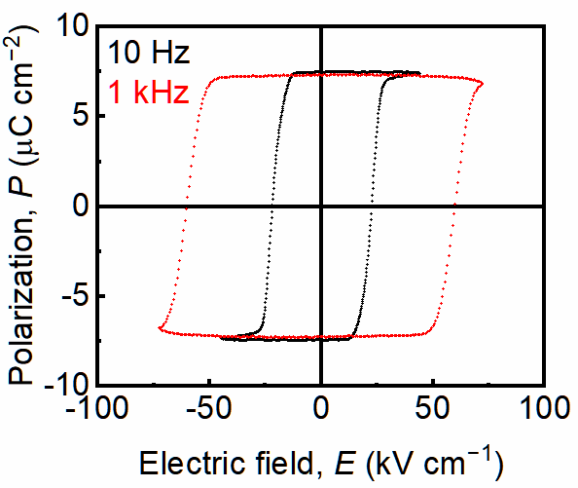
Figure S2. P−E hysteresis loops measured at 300 K using a polycrystalline plate of guanidinium tetrafluoroborate (1) (thickness: 87 μm) with triangular-wave electric field at frequencies of 10 Hz and 1 kHz measured on a virtual ground circuit (Toyo Corp. FCE-3).
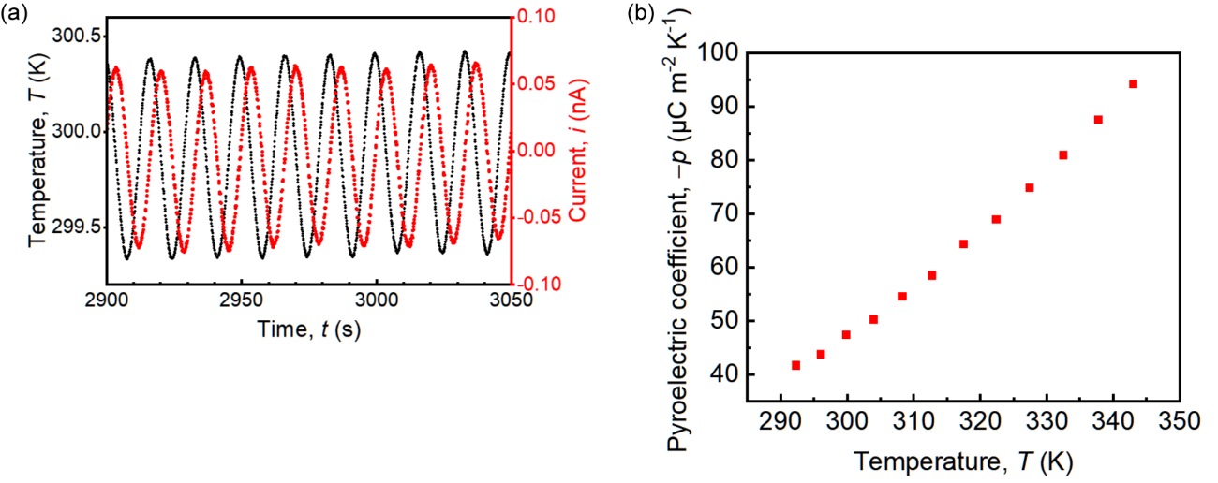
Figure S3. Pyroelectric measurements of a press-formed polycrystalline plate of guanidinium tetrafluoroborate (1) (thickness: 96 μm; area of the electrodes: 7.15 mm²) using a temperature-oscillation technique. (a) An example of sinusoidal temperature oscillations at 0.06 Hz and the resulting current waves. (b) Temperature dependence of the pyroelectric coefficient.
Table S1. Fitted parameters for the temperature and current oscillations (f = 0.06 Hz) at several base temperatures (T₀) and calculated pyroelectric coefficients (p).
T₀ (K) | T₁ (K) | i₀ (nA) | i₁ (nA) | φ (deg) | p (μC m⁻² K⁻¹)
292.29 | 0.494 | −0.00610 | 0.056 | −89.7 | −41.7
296.02 | 0.511 | 0.00618 | 0.060 | −90.3 | −43.8
299.83 | 0.521 | 0.00016 | 0.067 | −90.8 | −47.4
303.95 | 0.535 | −0.00028 | 0.073 | −90.8 | −50.3
308.23 | 0.546 | −0.00461 | 0.080 | −90.9 | −54.6
312.75 | 0.558 | −0.00450 | 0.088 | −91.3 | −58.5
317.46 | 0.566 | 0.00383 | 0.098 | −91.4 | −64.4
322.36 | 0.575 | −0.00047 | 0.107 | −91.4 | −69.0
327.36 | 0.583 | 0.00711 | 0.118 | −91.6 | −74.9
332.42 | 0.589 | 0.00283 | 0.129 | −91.8 | −81.0
337.71 | 0.595 | 0.00117 | 0.141 | −92.4 | −87.6
342.98 | 0.600 | −0.01933 | 0.153 | −92.7 | −94.2
Temperature oscillation: T = T₀ + T₁ sin(2πf t)
Current oscillation: i = i₀ + i₁ sin(2πf t + φ)
Pyroelectric coefficient: p = i₁ sin(φ)/(2πf A T₁)
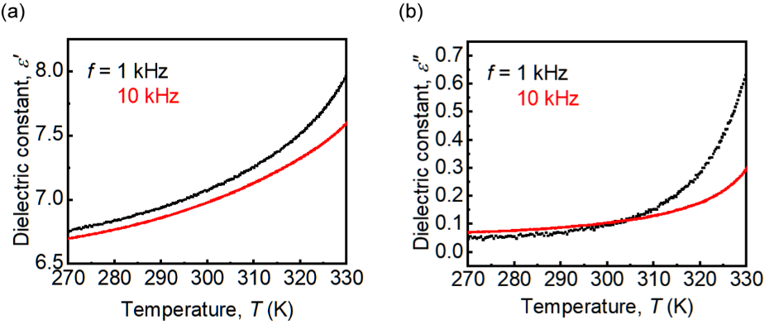
Figure S4. Complex dielectric constants of a press-formed polycrystalline plate of guanidinium tetrafluoroborate (1) (thickness: 82 μm) after poling. (a) The real part (ε′). (b) The imaginary part (ε′′).
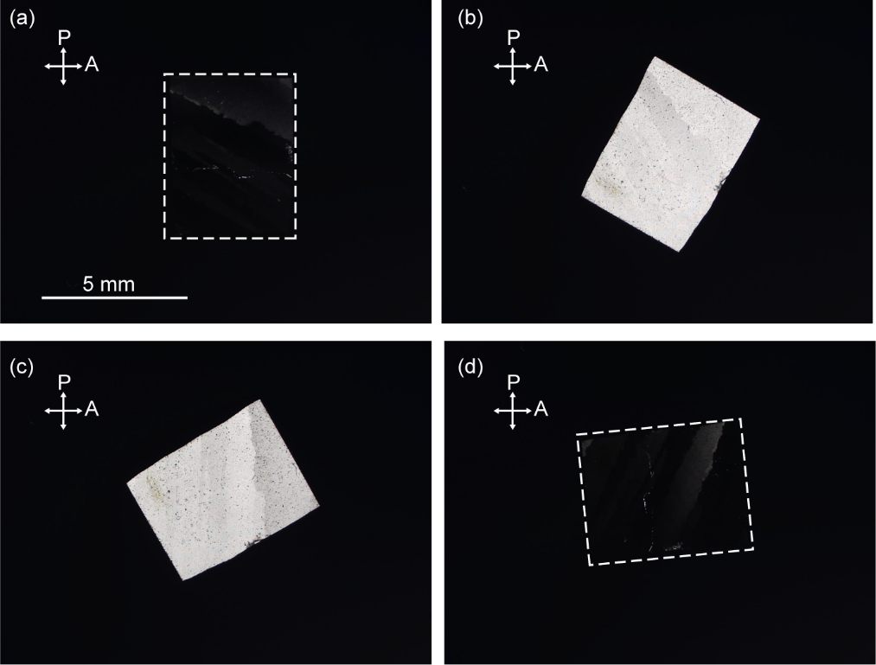
Figure S5. Optical-microscopy images of a multi-domain melt-grown crystalline plate of guanidinium tetrafluoroborate (1) (thickness: 110 μm) viewed through crossed polarizers. The crystals in (b), (c), and (d) are rotated in clockwise directions relative to the crystal in (a) by 30°, 60°, and 85°, respectively. The crystals in (a) and (d) are framed by white dashed rectangles. The double arrows indicate the directions of the polarizer and analyzer.
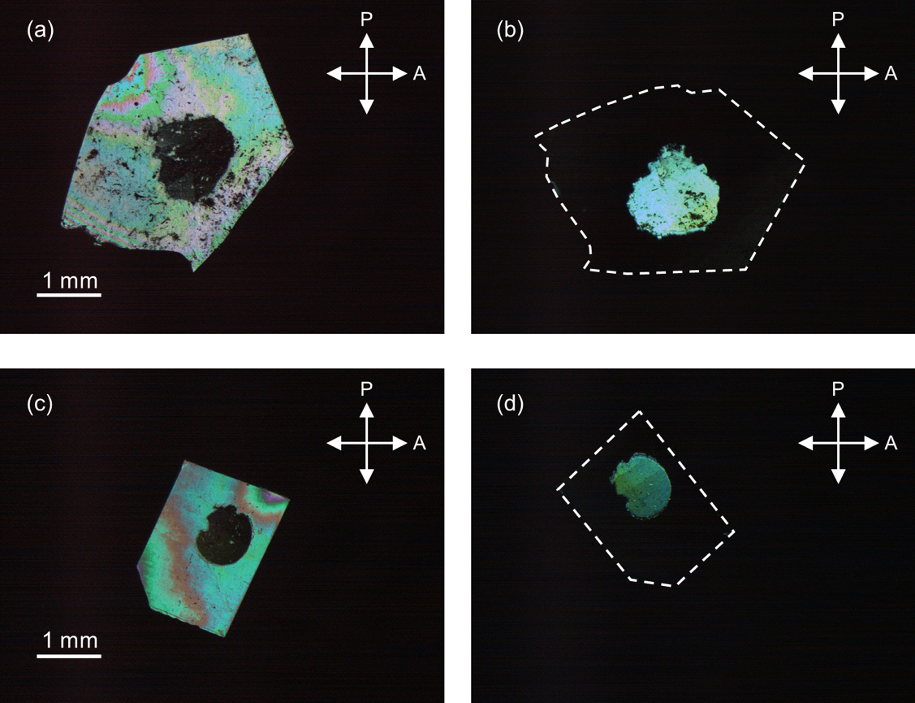
Figure S6. Optical-microscopy images of melt-grown crystalline plates of guanidinium tetrafluoroborate (1) viewed through crossed polarizers. After poling the crystals at room temperature, the gallium-indium eutectic alloy electrodes were removed from the plates. For (a) and (b), the thickness of the crystal is 41 μm; for (c) and (d), the thickness is 24 μm. The crystals in (b) and (d) are framed by white dashed lines. The double arrows indicate the directions of the polarizer and analyzer.
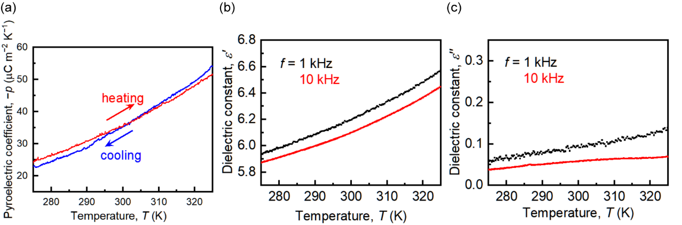
Figure S7. (a) Temperature dependence of the pyroelectric coefficient determined by pyroelectric current measurements using a melt-grown crystalline plate of guanidinium tetrafluoroborate (1) (thickness: 91 μm). The temperature was changed at a constant rate of 2 K min⁻¹. (b) The real part (ε′) and (c) the imaginary part (ε′′) of the complex dielectric constants of the crystalline plate after poling.
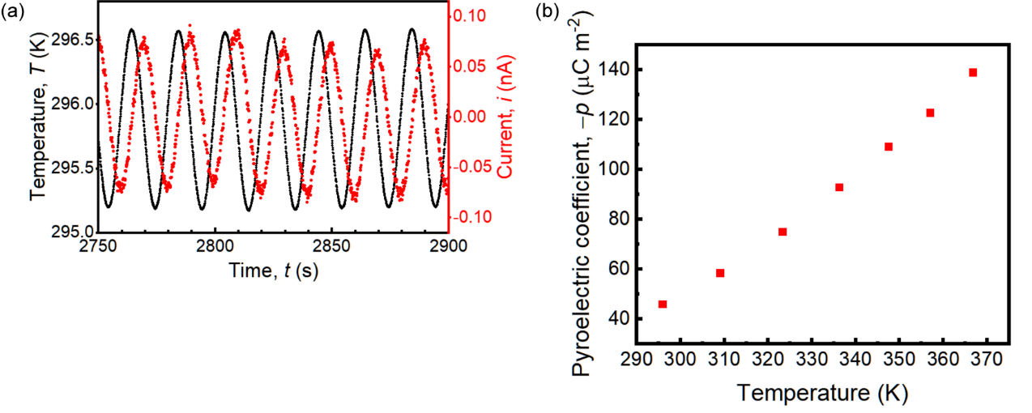
Figure S8. Pyroelectric measurements of a melt-grown single crystalline plate of guanidinium tetrafluoroborate (1) (thickness: 106 μm; area of the electrodes: 7.30 mm²) using a temperature-oscillation technique. (a) An example of sinusoidal temperature oscillations at 0.05 Hz and the resulting current waves. (b) Temperature dependence of the pyroelectric coefficient.
Table S2. Fitted parameters for the temperature and current oscillations (f = 0.05 Hz) at several base temperatures (T₀) and calculated pyroelectric coefficients (p).
T₀ (K) | T₁ (K) | i₀ (nA) | i₁ (nA) | φ (deg) | p (μC m⁻² K⁻¹)
295.88 | 0.690 | 0.000391 | 0.073 | −91.7 | −45.9
309.08 | 0.770 | −0.00178 | 0.103 | −89.2 | −58.4
323.32 | 0.820 | −0.00936 | 0.141 | −88.9 | −75.0
336.25 | 0.852 | 0.00936 | 0.181 | −88.4 | −92.6
347.51 | 0.873 | −0.0345 | 0.218 | −88.8 | −109
357.04 | 0.889 | −0.00830 | 0.250 | −87.7 | −122
366.78 | 0.893 | 0.0421 | 0.285 | −87.4 | −139
Temperature oscillation: T = T₀ + T₁ sin(2πf t)
Current oscillation: i = i₀ + i₁ sin(2πf t + φ)
Pyroelectric coefficient: p = i₁ sin(φ)/(2πf A T₁)
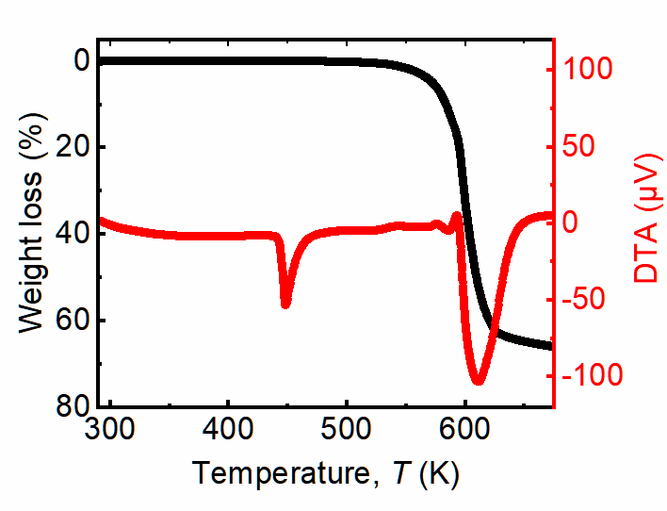
Figure S9. TG-DTA curve of guanidinium tetrafluoroborate (1).

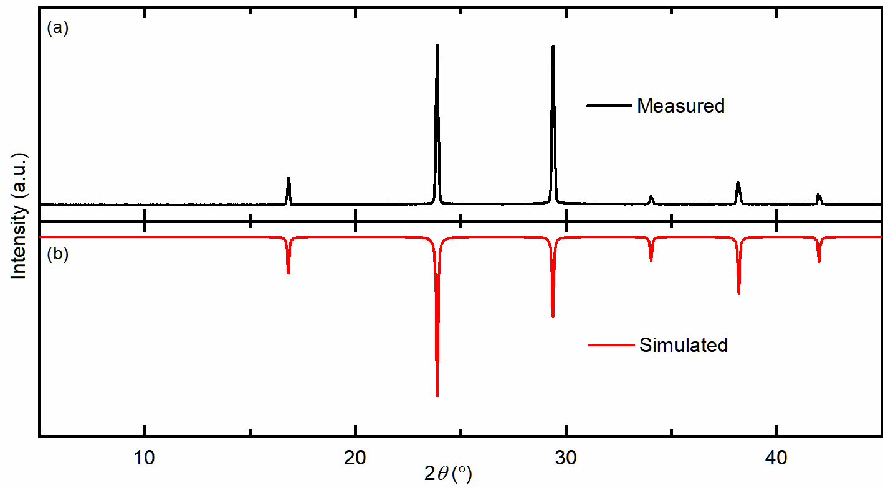
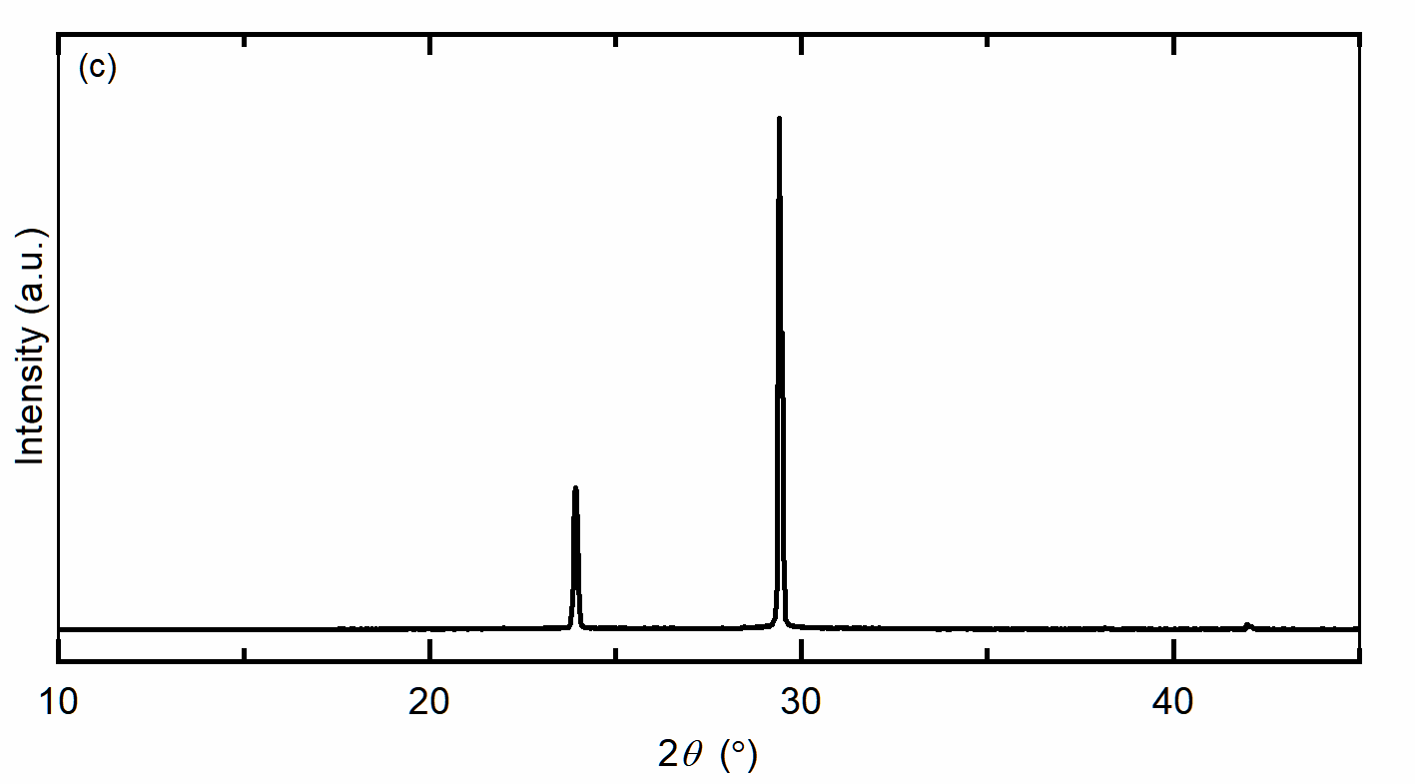
Figure S10. Powder X-ray diffraction patterns of guanidinium tetrafluoroborate (1). (a) Experimental pattern of the ground powder; (b) simulated pattern; (c) pattern of a press-formed polycrystalline plate.
Table S3. Crystal data and structure refinement information for guanidinium tetrafluoroborate (1)
Compound | Guanidinium tetrafluoroborate
Temperature (K) | 300
Empirical formula | CH₆BN₃F₄
Formula weight | 146.90
Crystal system | trigonal
Space group | R3m
a (Å) | 5.2633(11)
α (°) | 90.0312(19)
V (Å³) | 145.81(9)
Z | 1
ρ_{calcd} (g cm⁻³) | 1.673
2θ range for data collection (°) | 7.742 to 59.522
Scan mode | ω and φ scans
Reflections collected | 2540
Independent reflections | 353
R_{int} | 0.0162
Data/restraints/parameters | 353/1/26
Goodness-of-fit on F² | 1.096
R [F² > 2σ(F²)] | 0.0354
wR(F²) (all data) | 0.1098
Largest diff. peak/hole (e Å⁻³) | 0.26/−0.10
Flack parameter | 0.08(17)
CCDC number | 2125004

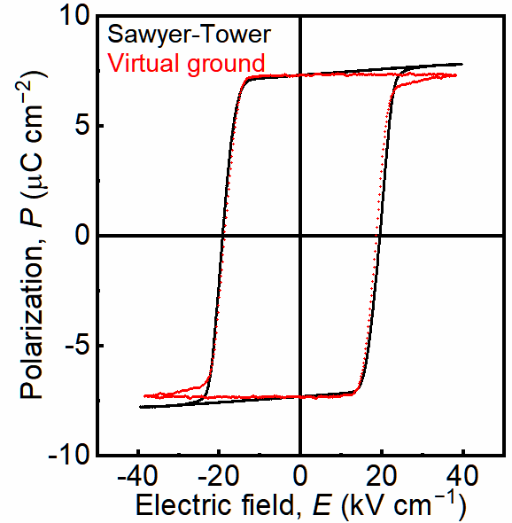
Figure S11. P–E hysteresis loops measured at 300 K using a polycrystalline plate of guanidinium tetrafluoroborate (1) (thickness: 101 μm) with a triangular-wave electric field with a frequency of 10 Hz. The loop drawn in black was obtained by adjusting a variable resistor incorporated into a Sawyer–Tower circuit to eliminate the small contributions from the conductivity. The loop drawn in red was obtained on a virtual ground circuit (Toyo Corp., FCE-3) without compensating for the conductive contribution.
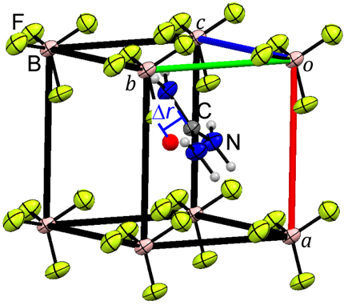
Figure S12. Displacement of the ions (Δr) from the symmetric non-polar structure. The red sphere represents the centroid of the eight B atoms.
Table S4. Calculated Ps values of 1.
T (K) | P_{s} (μC cm⁻²) | REFCODE of crystal structure
100 | 8.95 | FOXNUB07
150 | 8.91 | FOXNUB02
200 | 8.86 | FOXNUB06
250 | 8.79 | FOXNUB03
295 | 8.62 | FOXNUB08
320 | 8.44 | FOXNUB04
350 | 8.10 | FOXNUB05
370 | 7.64 | FOXNUB09
400 | 7.05 | FOXNUB10

The spontaneous polarization (P_{s}) of 1 was calculated using a point-charge model. The P_{s} value was calculated as P_{s} = ΣZe Δr/V, where e is the elementary charge, Z is the formal charge of ions, Δr is the displacement of ions from the non-polar reference structure, and V is the unit cell volume. It should be noted here that the reported structures were represented in the hexagonal lattices (Z = 3) instead of the rhombohedral lattices (Z = 1) used in this study.

For 1 at 100 K, the relevant data of the reported crystal structure (FOXNUB07) are as follows:
a = 7.40437 Å, c = 8.75770 Å, V = 415.812 Å³, Z = 3.
Coordinates:
C: 0.66670, 0.33330, 0.69114
B: 0.00000, 1.00000, 0.76936
The centroid of the eight C atoms surrounding the B atom forming a pseudo cube lies at (0.00000, 1.00000, 0.85781).
Deviation of B from the centroid along the polar axis, i.e., the c-axis in the hexagonal lattice and the [111] direction in the rhombohedral lattice: (0.85781 – 0.76936) × 8.75770 = 0.7746 Å.
Polarization: 1.602 ×10^{–19} × 0.7746 × 10^{–10} × 3 / 415.812 × 10^{–30} = 0.0895 C m^{–2} = 8.95 μC cm^{–2}.

The P_{s} values at the other temperatures were calculated in a similar way.
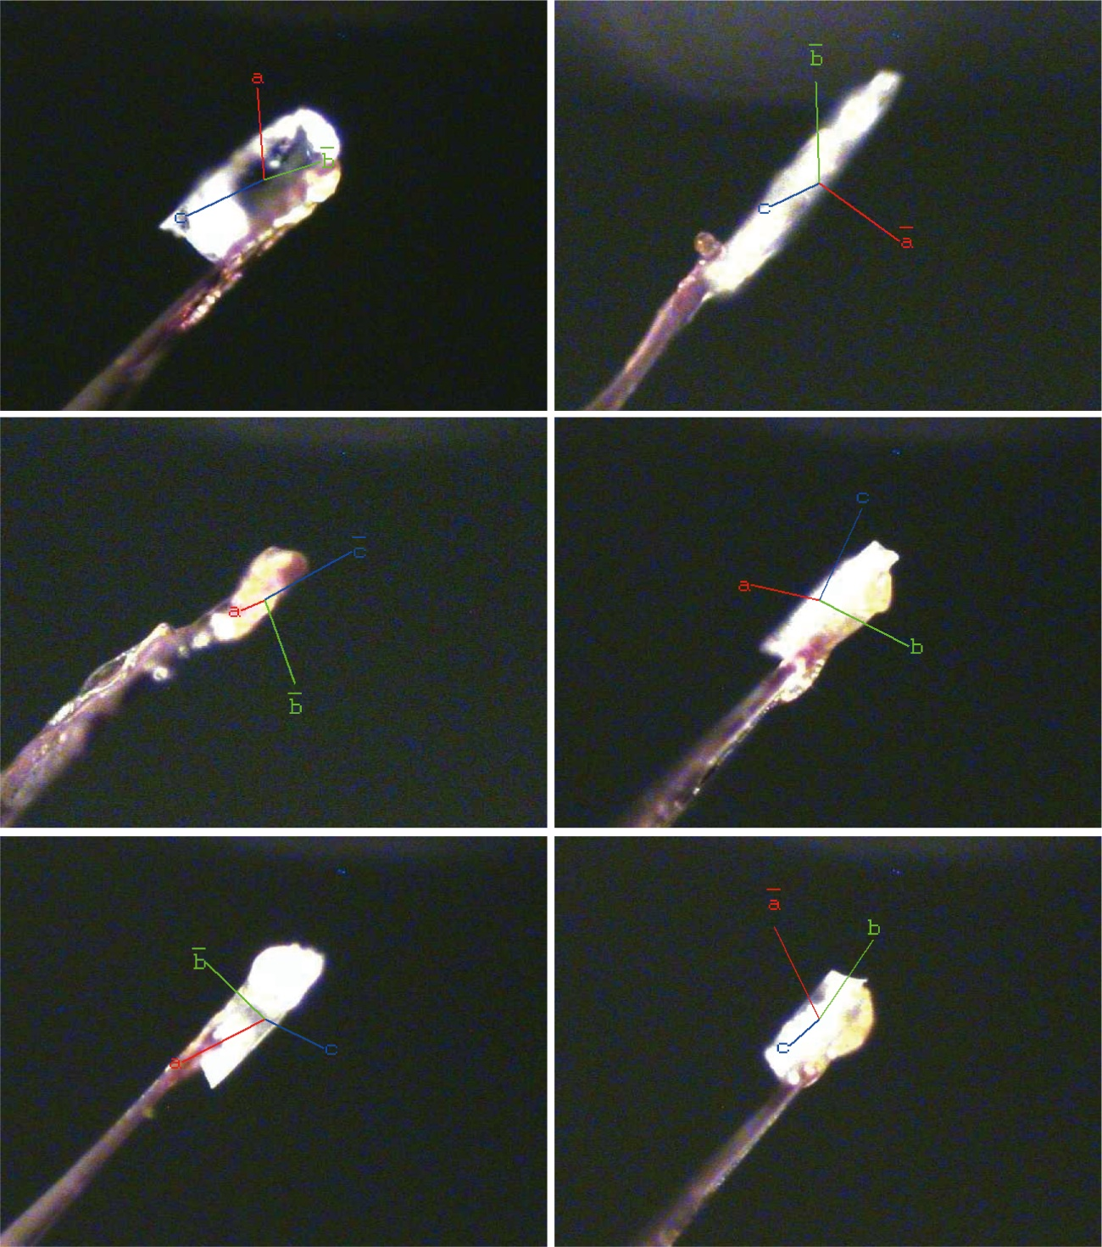
Figure S13. Crystal axes of melt-grown single crystal plates of guanidinium tetrafluoroborate (1). Instead of the rhombohedral lattice setting, the crystal lattice of the trigonal crystal system (space group: R3m) is expressed in the hexagonal setting, where the c-axis represents the three-fold axis and the polar axis of the crystal. The three-fold axis of each crystal was determined by indexing and integrating the diffraction data, which gave reasonably low R_{sym} values, confirming the three-fold symmetry about the axis.

References
[1] G. M. Sheldrick, Acta Crystallogr. A 2015, 71, 3-8.
[2] G. M. Sheldrick, Acta Crystallogr. C 2015, 71, 3-8.
[3] C. B. Sawyer, C. H. Tower, Phys. Rev. 1930, 35, 269-273.
[4] a) I. Lubomirsky, O. Stafsudd, Rev. Sci. Instrum. 2012, 83, 051101; b) S. Jachalke, E. Mehner, H. Stöcker, J. Hanzig, M. Sonntag, T. Weigel, T. Leisegang, D. C. Meyer, Appl. Phys. Rev. 2017, 4, 021303.
[5] a) L. E. Garn, E. J. Sharp, J. Appl. Phys. 1982, 53, 8974-8979; b) E. J. Sharp, L. E. Garn, J. Appl. Phys. 1982, 53, 8980-8987; c) H. Khanbareh, J. B. J. Schelen, S. v. d. Zwaag, W. A. Groen, Rev. Sci. Instrum. 2015, 86, 105111.
[6] M. Szafrański, J. Phys. Chem. B 2011, 115, 8755-8762.
[7] N. A. Spaldin, J. Solid State Chem. 2012, 195, 2-10.

