Figure legends
Figure S1.
ACE2 expression with the duration of smoking cessation with statistical annotations
For the box plot of the expression of ACE2 with the period of smoking cessation (Fig. 1E), additional pairwise comparisons were performed. One-sided Mann–Whitney U-test was conducted on adjacent pairs in the order of the cessation periods (<1 month vs. 1–6 months, 1–6 months vs. 6 months or more, up to 6 months vs. non-smokers) because a significant trend was found with increasing duration of smoking cessation by Jonckheere–Terpstra test (p < 0.0001). A significant difference was found only between 1–6 months and 6 months or more (p=0.04205).

Figure S2.
HEK293/tet-ACE2 expresses ACE2 depended on the concentration of doxycycline.
HEK293/tet-ACE2 cells were transfected with HA-tagged TMPRSS2. After 24h of transfection, TMPRSS2 expressing HEK293/tet-ACE2 cells were treated with various concentrations of doxycycline for 24 h. Then, the cell lysate was blotted with anti-ACE2, anti-HA, and anti-GAPDH antibodies.

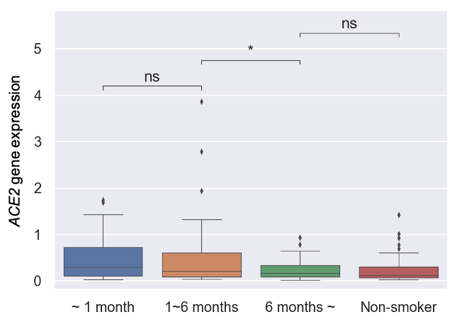

Figure.S1 Suzuki et. al

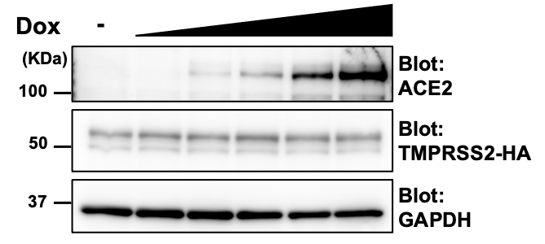

Figure.S2 Suzuki et. al

