Supplemental figure

Different nitrogen acquirement and utilization strategies might determine the ecological competition results between ferns and angiosperms
Running title: Differences in nutrient characteristics between ferns and angiosperms

Chengming Zhang^{1,2}, Chaoqun Zhang², Takayuki Azuma³, Hayato Maruyama², Takuro Shinano², Toshihiro Watanabe^{2*}

¹ College of Chemistry and Life Sciences, Sichuan Provincial Key Laboratory for Development and Utilization of Characteristic Horticultural Biological Resources, Chengdu Normal University, Haike Road-99 East Section, Chengdu, 611130, China
² Research Faculty of Agriculture, Hokkaido University, Kita-9, Nishi-9, Kitaku, Sapporo, 0608589, Japan
³ Field Science Center for Northern Biosphere, Botanic Garden, Hokkaido University, Kita-3, Nishi-8, Chuoku, Sapporo, 0600003, Japan

*For correspondence. Email nabe@agr.hokudai.ac.jp

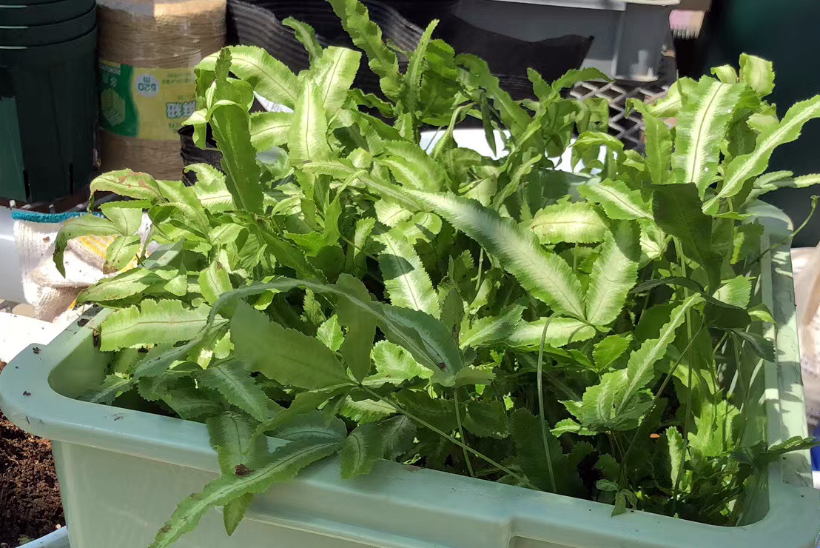

Fig. S1. Pteris cretica pre-cultured in a pot with mixed horticultural soil.

