Ecological value of gravel pit ponds for floodplain wetland fish

Honoka Nakahashi, Taihei Yamada, Nobuo Ishiyama, Futoshi Nakamura

SUPPORTING INFORMATION

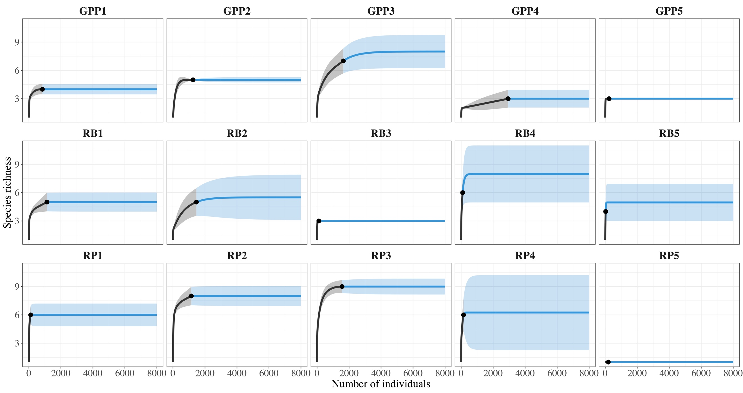
Figure S1 Individual-based rarefaction curves estimating the species richness of each pond (black lines) and the plateau species richness extrapolated from the curves (blue lines). Abbreviation and number represent pond ID: GPP, gravel pit pond; RB, river backwater; RP, remnant pond. The confidence intervals (95%) are shown as shaded areas.
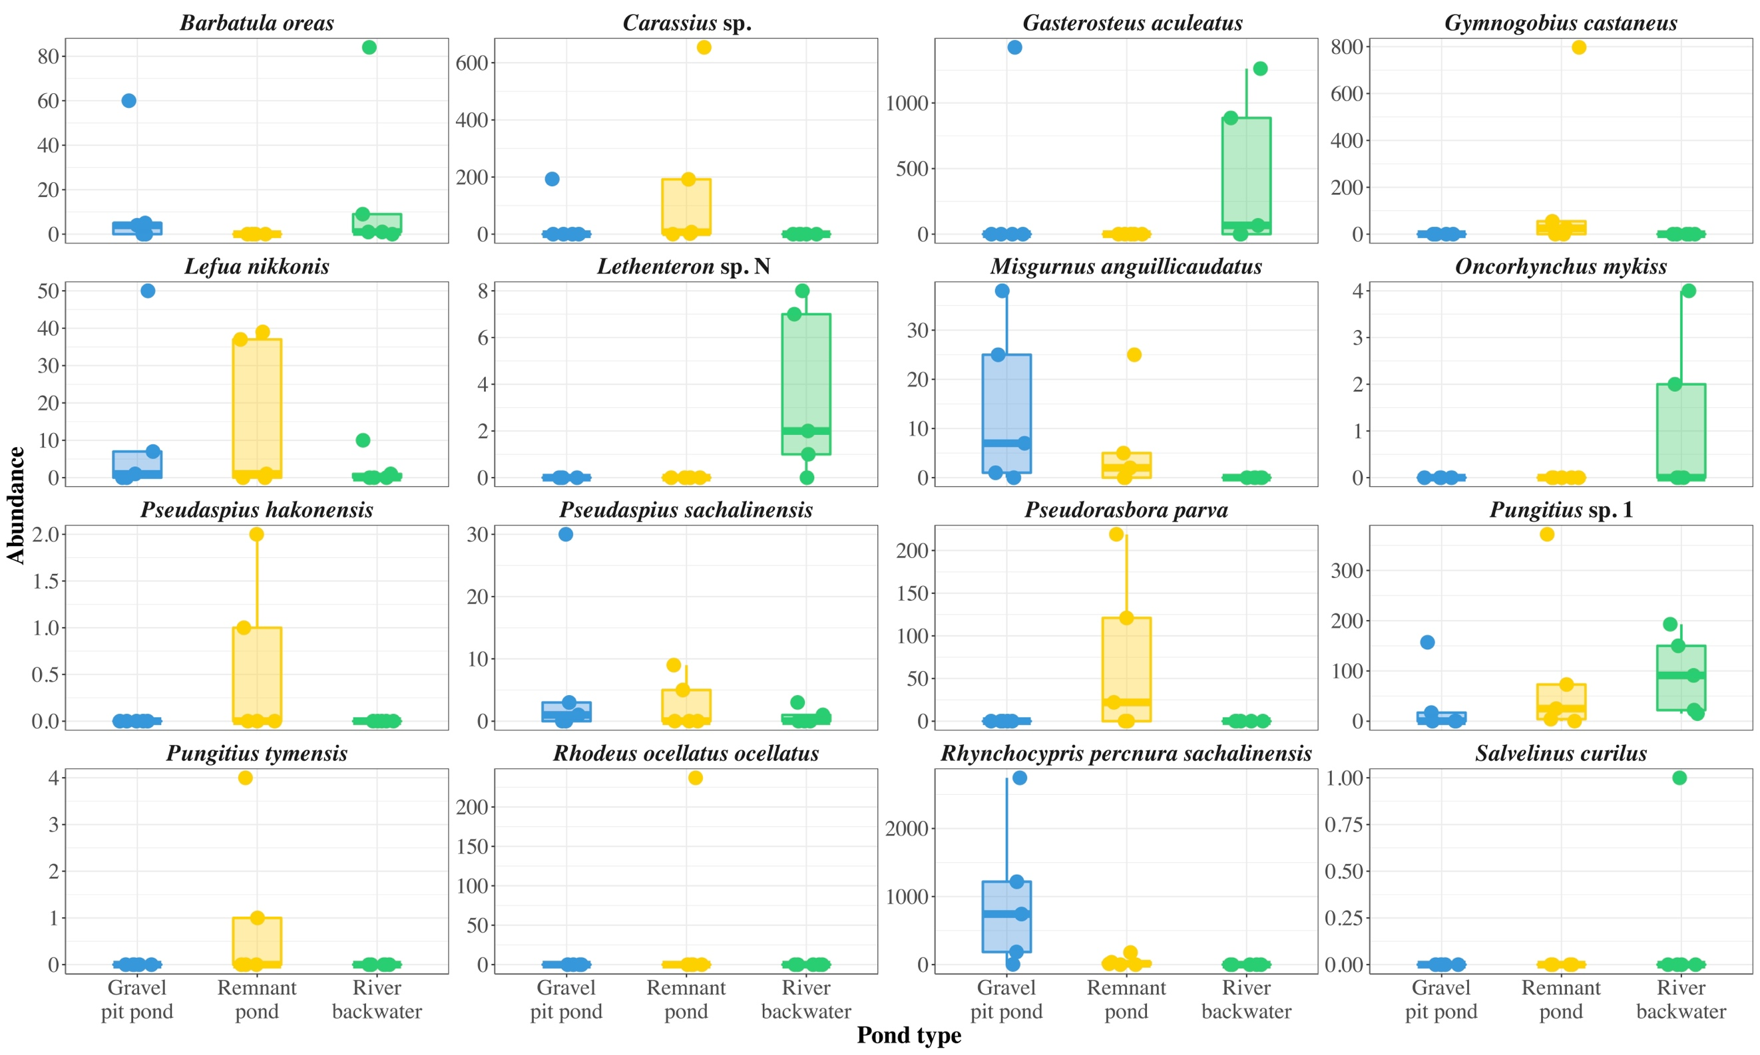
Figure S2 Abundance of each species in each pond type.
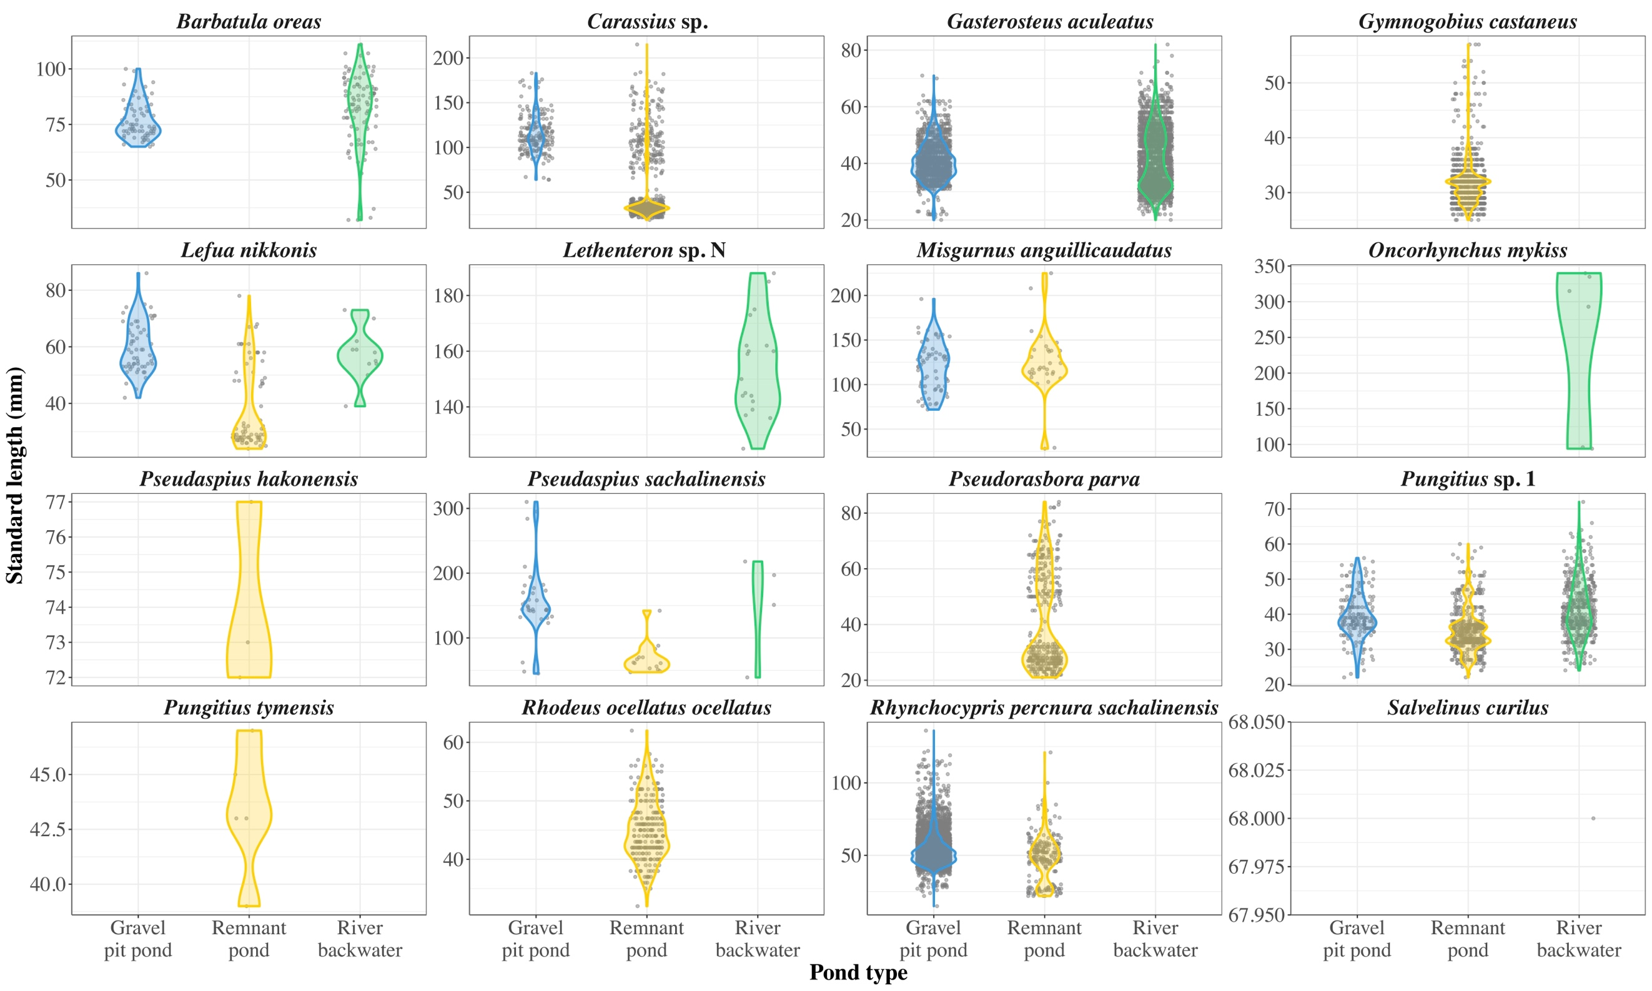
Figure S3 Standard length of each individual of each species in each pond type.
Table S1 Results of GLMMs testing the effects of pond type (gravel pit pond, remnant pond, and river backwater) on each environmental factor.
Response variable | Intercept |  |  |  | Remnant pond |  |  |  | River backwater |  |  | df | AIC
 | Estimate | SE | p |  | Estimate | SE | p |  | Estimate | SE | p
Dissolved oxygen (mg/L) | 2.04 | 0.24 | < 0.001 |  | -0.63 | 0.34 | 0.07 |  | -0.09 | 0.34 | 0.79 | 12 | 82.3
pH | 2.03 | 0.03 | < 0.001 |  | -0.08 | 0.04 | < 0.05 |  | -0.09 | 0.04 | < 0.05 | 12 | 23.8
Electrical conductivity (µs/cm) | 2.73 | 0.22 | < 0.001 |  | 0.23 | 0.31 | 0.46 |  | -0.40 | 0.31 | 0.20 | 12 | 102.1
Turbidity (NTU) | 3.08 | 0.37 | < 0.001 |  | -0.72 | 0.53 | 0.18 |  | -1.21 | 0.53 | < 0.05 | 12 | 108.0
Water temperature (C°) | 3.19 | 0.09 | < 0.001 |  | 0.09 | 0.13 | 0.49 |  | -0.43 | 0.13 | < 0.001 | 12 | 92.8
Distance from the main channel (m) | 5.76 | 0.22 | < 0.001 |  | 0.49 | 0.31 | 0.12 |  | -2.14 | 0.31 | < 0.001 | 12 | 189.0
Depth in the centre (m) | 0.54 | 0.29 | 0.06 |  | -0.06 | 0.41 | 0.88 |  | -0.66 | 0.41 | 0.10 | 12 | 41.5
Depth near shore (m) | -0.64 | 0.19 | < 0.001 |  | 0.10 | 0.26 | 0.71 |  | -0.40 | 0.26 | 0.12 | 12 | -2.6

Table S2 Results of multiple comparisons testing the difference in environmental factors among the pond types.
Contrast |  | Estimate | SE | t-ratio | p
Dissolved oxygen (mg/L)
 | GPP vs. Remnant pond | 0.63 | 0.34 | 1.84 | 0.27
 | GPP vs. River backwater | 0.09 | 0.34 | 0.27 | 0.80
 | Remnant pond vs. River backwater | -0.54 | 0.34 | -1.57 | 0.28
pH
 | GPP vs. Remnant pond | 0.08 | 0.04 | 2.09 | 0.15
 | GPP vs. River backwater | 0.09 | 0.04 | 2.18 | 0.15
 | Remnant pond vs. River backwater | 0.00 | 0.04 | 0.09 | 0.93
Electrical conductivity (µs/cm)
 | GPP vs. Remnant pond | -0.23 | 0.31 | -0.74 | 0.47
 | GPP vs. River backwater | 0.40 | 0.31 | 1.27 | 0.45
 | Remnant pond vs. River backwater | 0.63 | 0.31 | 2.01 | 0.20
Turbidity (NTU)
 | GPP vs. Remnant pond | 0.72 | 0.53 | 1.36 | 0.40
 | GPP vs. River backwater | 1.21 | 0.53 | 2.29 | 0.12
 | Remnant pond vs. River backwater | 0.49 | 0.53 | 0.93 | 0.40
Water temperature (C°)
 | GPP vs. Remnant pond | -0.09 | 0.13 | -0.70 | 0.50
 | GPP vs. River backwater | 0.43 | 0.13 | 3.36 | < 0.05
 | Remnant pond vs. River backwater | 0.52 | 0.13 | 4.05 | < 0.01
Distance from the main channel (m)
 | GPP vs. Remnant pond | -0.49 | 0.31 | -1.57 | 0.14
 | GPP vs. River backwater | 2.14 | 0.31 | 6.81 | < 0.001
 | Remnant pond vs. River backwater | 2.63 | 0.31 | 8.38 | < 0.001
Depth in the centre (m)
 | GPP vs. Remnant pond | 0.06 | 0.41 | 0.15 | 0.88
 | GPP vs. River backwater | 0.66 | 0.41 | 1.63 | 0.39
 | Remnant pond vs. River backwater | 0.60 | 0.41 | 1.48 | 0.39
Depth near shore (m)
 | GPP vs. Remnant pond | -0.10 | 0.26 | -0.38 | 0.71
 | GPP vs. River backwater | 0.40 | 0.26 | 1.54 | 0.30
 | Remnant pond vs. River backwater | 0.50 | 0.26 | 1.92 | 0.24

Table S3 Species list and mean and standard deviation of abundance for each species
Species |  | Red list status |  | Gravel pit pond |  |  | Remnant pond |  |  | River backwater
 |  |  |  | Mean | SD |  | Mean | SD |  | Mean | SD
Native species
 | Barbatula oreas |  |  | 13.8 | 25.9 |  | 0.0 | 0.0 |  | 19.0 | 36.5
 | Carassius sp. |  |  | 38.6 | 86.3 |  | 171.0 | 282.1 |  | 0.0 | 0.0
 | Gasterosteus aculeatus |  |  | 284.8 | 636.8 |  | 0.0 | 0.0 |  | 443.0 | 591.8
 | Gymnogobius castaneus | NT |  | 0.0 | 0.0 |  | 175.4 | 348.2 |  | 0.0 | 0.0
 | Lefua nikkonis | EN |  | 11.6 | 21.7 |  | 15.4 | 20.6 |  | 2.2 | 4.4
 | Lethenteron sp. N | VU |  | 0.0 | 0.0 |  | 0.0 | 0.0 |  | 3.6 | 3.6
 | Pseudaspius hakonensis |  |  | 0.0 | 0.0 |  | 0.6 | 0.9 |  | 0.0 | 0.0
 | Pseudaspius sachalinensis |  |  | 6.8 | 13.0 |  | 2.8 | 4.1 |  | 0.8 | 1.3
 | Pungitius sp. 1 |  |  | 34.8 | 68.7 |  | 94.8 | 157.7 |  | 94.2 | 78.1
 | Pungitius tymensis | VU |  | 0.0 | 0.0 |  | 1.0 | 1.7 |  | 0.0 | 0.0
 | Rhynchocypris percnura sachalinensis | NT |  | 979.0 | 1096.3 |  | 45.2 | 75.6 |  | 0.0 | 0.0
 | Salvelinus curilus | VU |  | 0.0 | 0.0 |  | 0.0 | 0.0 |  | 0.2 | 0.4
Nonnative species
 | Misgurnus anguillicaudatus | NT |  | 14.2 | 16.7 |  | 6.4 | 10.6 |  | 0.0 | 0.0
 | Oncorhynchus mykiss |  |  | 0.0 | 0.0 |  | 0.0 | 0.0 |  | 1.2 | 1.8
 | Pseudorasbora parva |  |  | 0.0 | 0.0 |  | 72.4 | 96.0 |  | 0.0 | 0.0
 | Rhodeus ocellatus ocellatus |  |  | 0.0 | 0.0 |  | 47.4 | 106.0 |  | 0.0 | 0.0
Table S4 Results of GLMMs testing the effects of pond type (gravel pit pond, remnant pond, and river backwater) on the species richness and abundance of native and nonnative species.
Response variable | Intercept |  |  |  | Remnant pond |  |  |  | River backwater |  |  | df | AIC
 | Estimate | SE | p |  | Estimate | SE | p |  | Estimate | SE | p
Richness of native fishes | 1.28 | 0.24 | < 0.001 |  | 0.25 | 0.31 | 0.44 |  | 0.15 | 0.32 | 0.63 | 12 | 63.1
Abundance of native fishes | 7.22 | 0.46 | < 0.001 |  | -1.00 | 0.65 | 0.12 |  | -0.89 | 0.65 | 0.17 | 12 | 235.8
Richness of nonnative fishes | -0.22 | 0.50 | 0.66 |  | 0.56 | 0.63 | 0.37 |  | -0.69 | 0.87 | 0.42 | 12 | 36.9
Abundance of nonnative fishes | 2.65 | 0.75 | < 0.001 |  | 2.18 | 1.06 | < 0.05 |  | -2.47 | 1.13 | < 0.05 | 12 | 110.9

Table S5 Results of multiple comparisons testing the difference in fish species richness and abundance among the pond types.
Contrast |  | Estimate | SE | z-ratio | p
Richness of native fishes
 | GPP vs. Remnant pond | -0.25 | 0.31 | -0.78 | 1.00
 | GPP vs. River backwater | -0.15 | 0.32 | -0.48 | 1.00
 | Remnant pond vs. River backwater | 0.09 | 0.30 | 0.30 | 1.00
Abundance of native fishes
 | GPP vs. Remnant pond | 1.00 | 0.65 | 1.54 | 0.37
 | GPP vs. River backwater | 0.89 | 0.65 | 1.37 | 0.37
 | Remnant pond vs. River backwater | -0.11 | 0.65 | -0.16 | 0.87
Richness of nonnative fishes
 | GPP vs. Remnant pond | -0.56 | 0.63 | -0.89 | 0.74
 | GPP vs. River backwater | 0.69 | 0.87 | 0.80 | 0.74
 | Remnant pond vs. River backwater | 1.25 | 0.80 | 1.56 | 0.35
Abundance of nonnative fishes
 | GPP vs. Remnant pond | -2.18 | 1.06 | -2.06 | 0.06
 | GPP vs. River backwater | 2.47 | 1.13 | 2.18 | 0.06
 | Remnant pond vs. River backwater | 4.66 | 1.13 | 4.13 | < 0.001

Table S6 Results of permutation tests used to determine the significance of correlation of the variables with nonmetric multidimensional scaling (NMDS) axes.
Metrics | NMDS1 | NMDS2 | R² | p
pH | -0.32 | -0.95 | 0.25 | 0.18
Dissolved oxygen (mg/L) | 0.43 | -0.90 | 0.14 | 0.39
Electrical conductivity (μs/cm) | -0.96 | -0.28 | 0.17 | 0.31
Turbidity (NTU) | -0.39 | -0.92 | 0.52 | < 0.05
Water temperature (C°) | -0.99 | 0.10 | 0.67 | < 0.01
Depth near shore (m) | -0.96 | -0.27 | 0.49 | < 0.05
Distance from the main channel (m) | -1.00 | 0.09 | 0.57 | < 0.01

