Additional File 3: Supplementary Figures (S1-11)

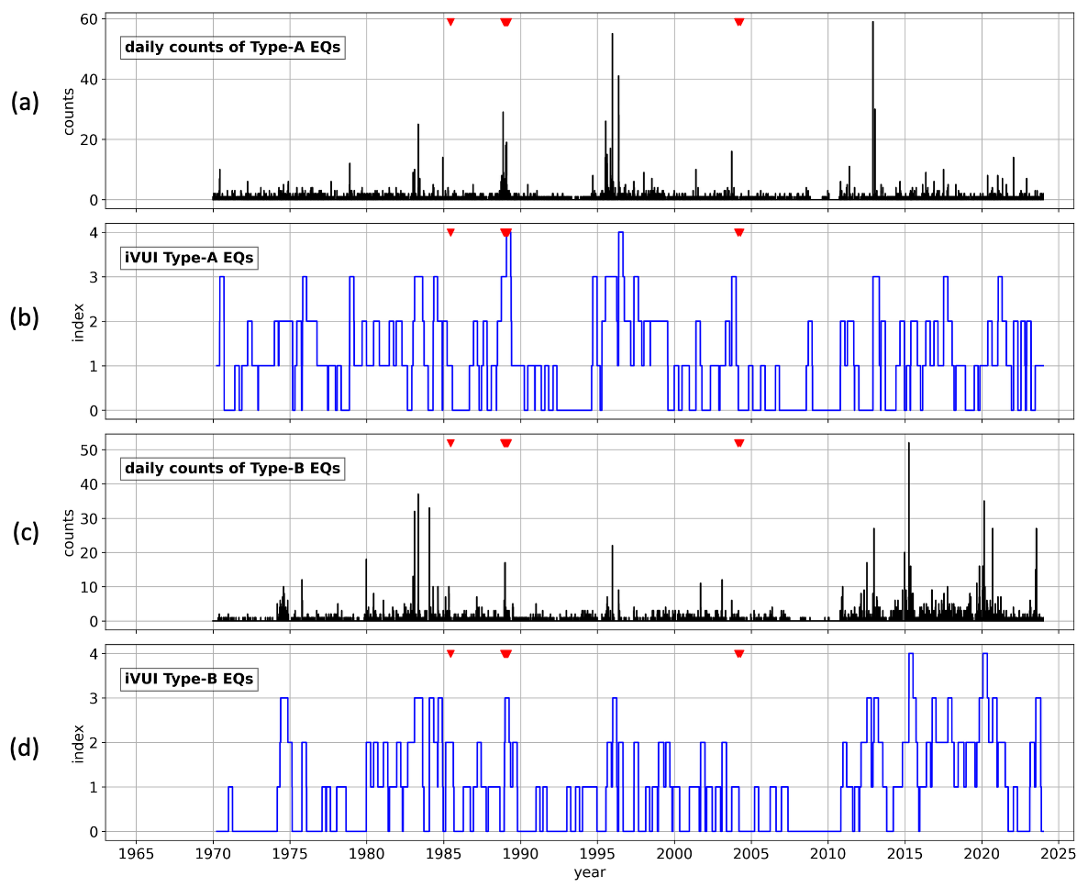

Fig. S1 Time series plots of seismicity and unrest indices (iVUI) for Mount Tokachidake. Inverted red triangles indicate eruption timings. (a) Daily number of A-type earthquakes; (b) The iVUI for A-type earthquakes; (c) Daily number of B-type earthquakes; (d) The iVUI for B-type earthquakes.

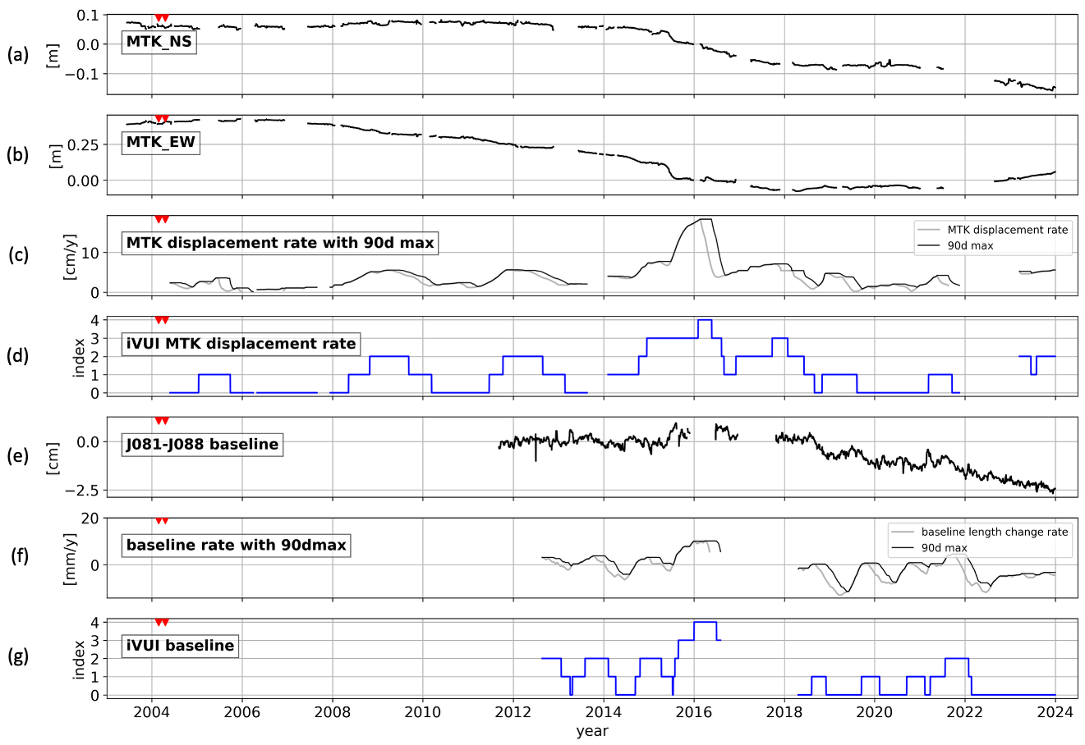

Fig. S2 Time series plots of ground deformations and unrest indices for Mount Tokachidake. Inverted red triangles indicate eruption timings. (a, b) Northward and eastward displacements of the GNSS station MTK, respectively; a moving median with a preceding 15-day window was applied; (c) Horizontal displacement rate (gray line) and its maxima during the preceding 90 days (black line); (d) The iVUI derived from the MTK displacement rate; (e) Baseline length changes between J081 (Bougakudai) and J088 (Yunotaki) GNSS stations; a moving median with a preceding 15-day window was applied; (f) A 365-day-based rate of change in the baseline (gray line) and its maxima over the preceding 90-days (black line); (g) The iVUI derived from the baseline change rate.

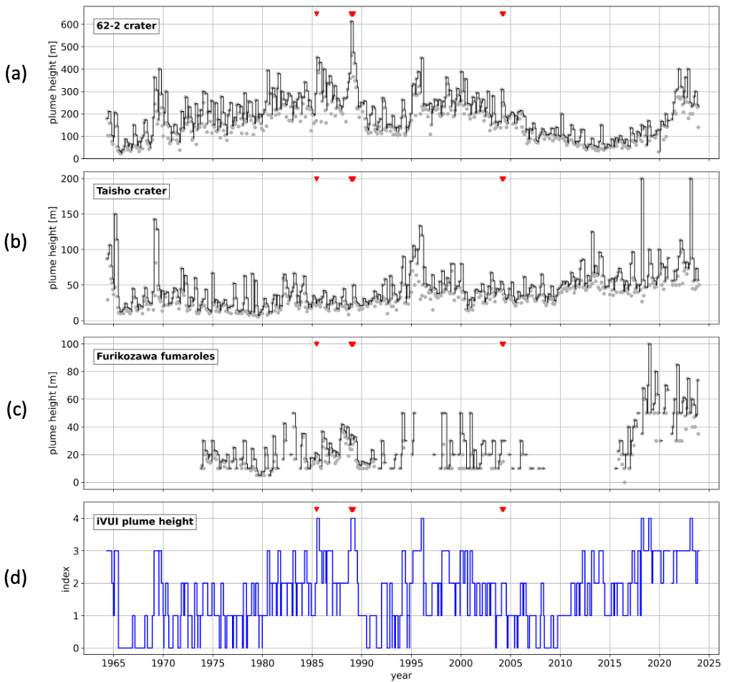

Fig. S3 Time series plots of plume heights and the unrest index for Mount Tokachidake. Inverted red triangles at the top of each panel indicate eruption timings. (a-c) Plume heights from the 62-2 crater, Taisho crater, and Furikozawa fumaroles, respectively. Gray dots: Monthly average of the daily maxima; Black lines: Maximum values over the preceding 90 days; (d) The iVUI derived from these three plume height records.

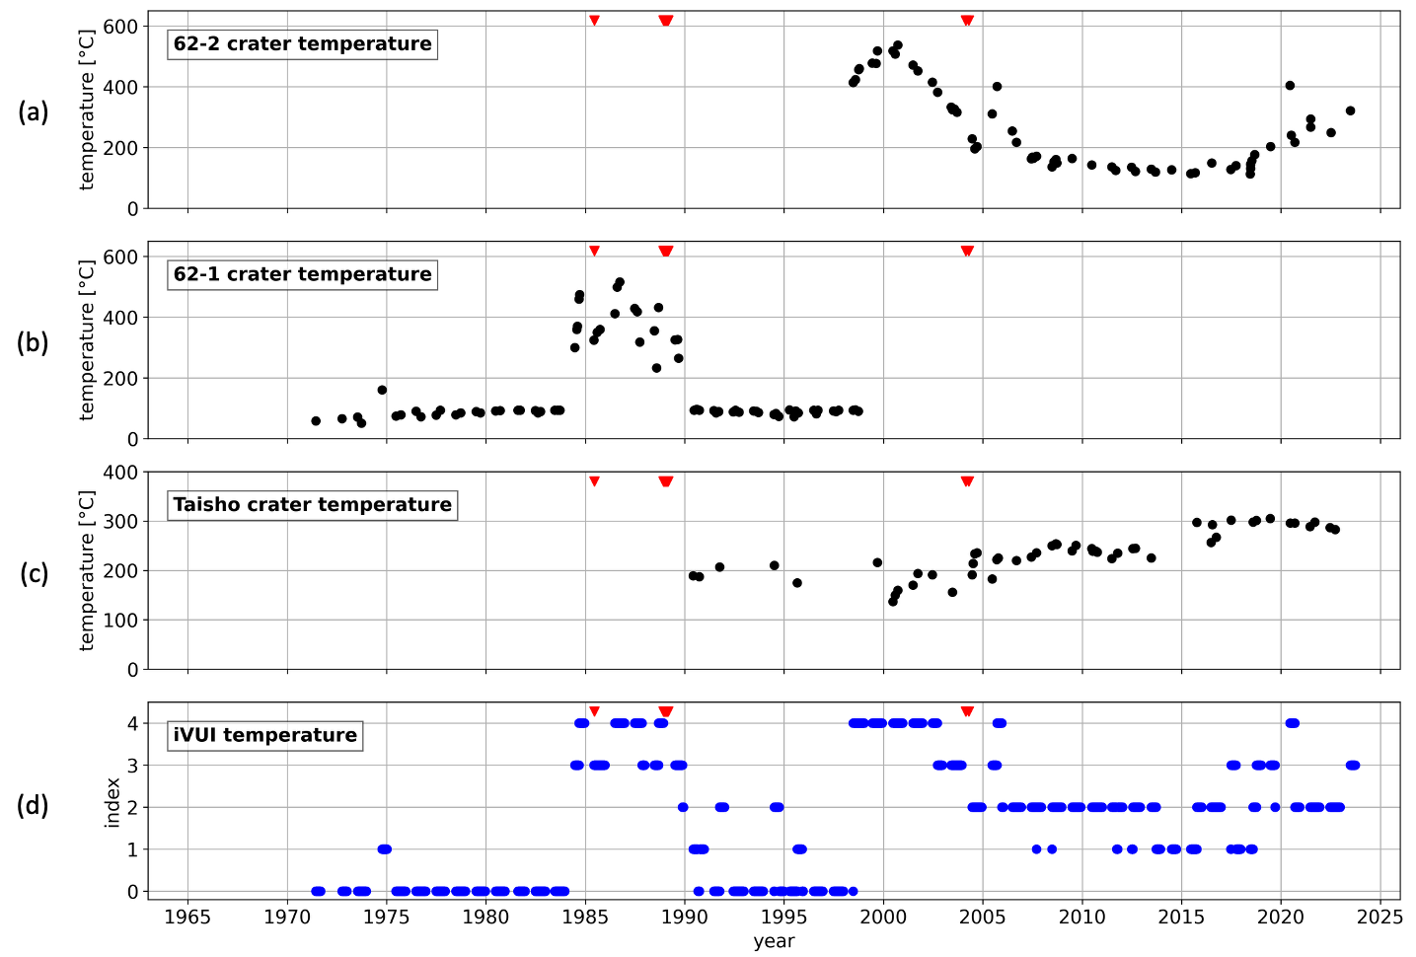

Fig. S4 Time series plots of crater temperatures and the unrest index for Mount Tokachidake. Inverted red triangles at the top of each panel indicate eruption timings. (a-c) Temperatures measured at the 62-2, 62-1, and Taisho craters, respectively; (d) The iVUI derived from these three temperature records.

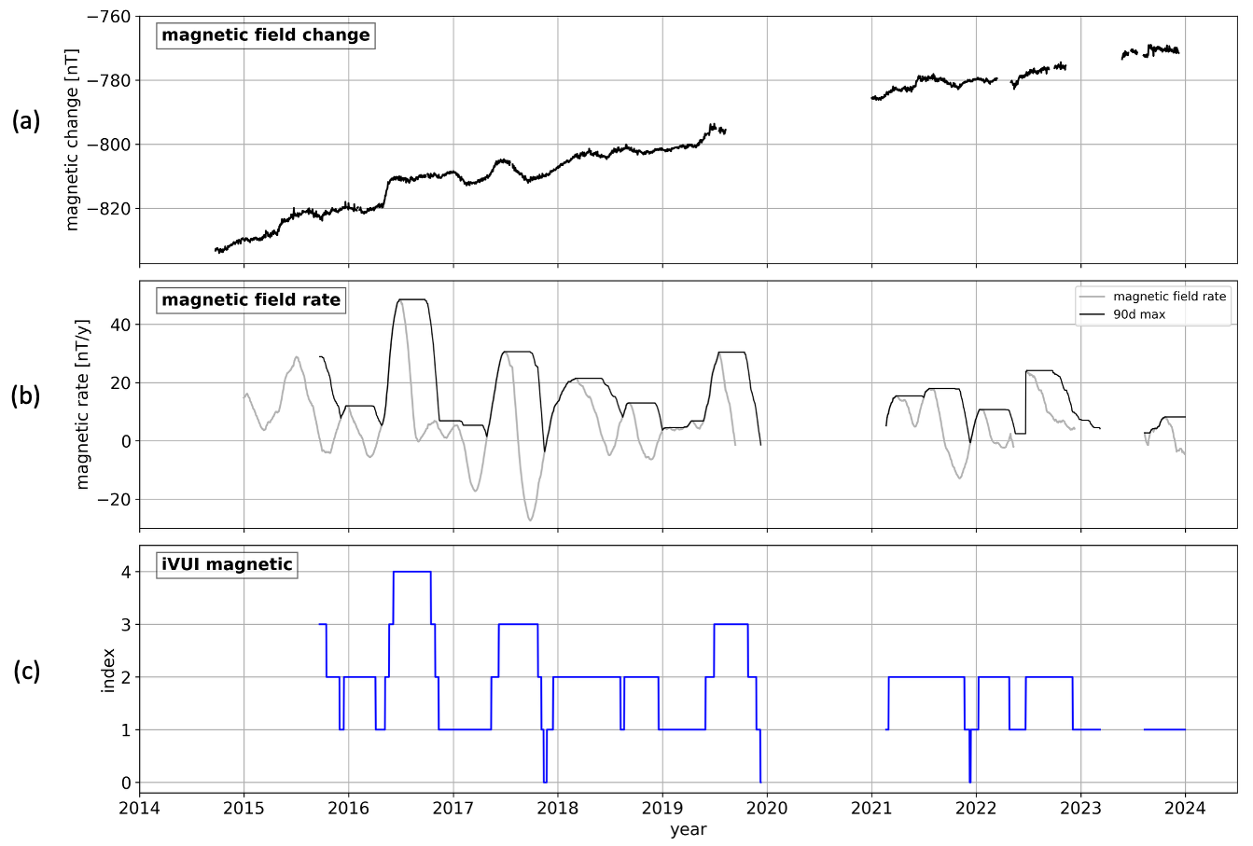

Fig. S5 Time series plots of geomagnetic field and the unrest index for Mount Tokachidake. (a) Differential geomagnetic total field at station TKNM, referenced to MTY; (b) Rate of the magnetic field changes over the preceding 100-day window (gray line) and its 90-day maxima (black line) (units: nT/year); (c) The iVUI derived from the rate of the magnetic field change.

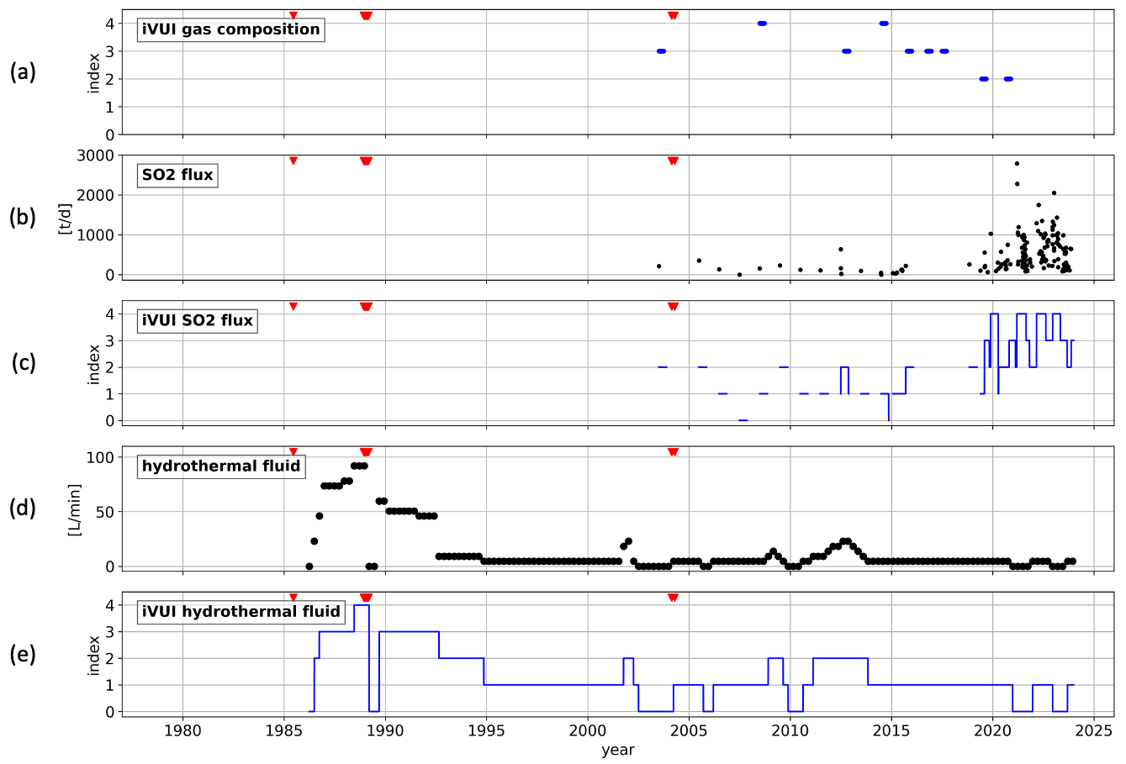

Fig. S6 Time series plots of geochemical records and unrest indices for Mount Tokachidake. Inverted red triangles at the top of each panel indicate eruption timings. (a) The iVUI derived from fumarolic gas composition; (b) Discharge rate of sulfur dioxide (units: ton/day); a moving median with a preceding 50-day window was applied; (c) The iVUI derived from the SO₂ flux records. (d) Supply rate of the NaCl-type hydrothermal water calculated using the model of Takahashi et al. (2015; 2019) (units: L/min); (e) The iVUI derived from the supply rate of the hydrothermal water.

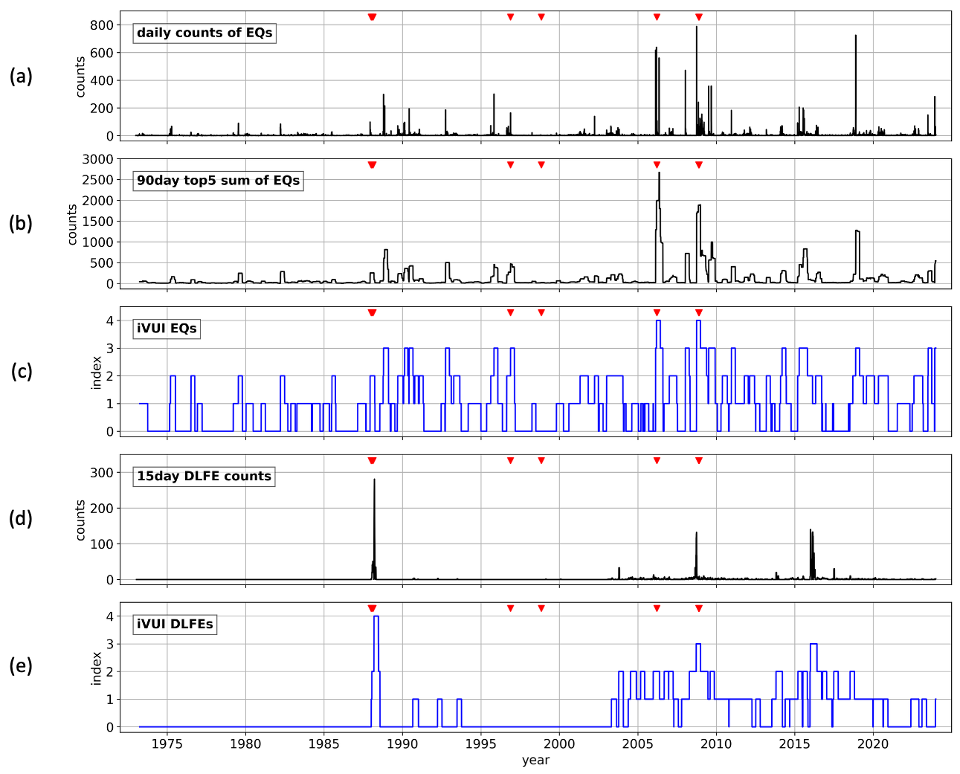

Fig. S7 Time series plots of seismicity and unrest indices for Mount Meakandake. Inverted red triangles indicate eruption timings. (a) Daily counts of earthquakes; (b) Sum of the top 5 daily earthquake counts over the preceding 90 days; (c) The iVUI derived from the earthquake records; (d) 15-day counts of DLFEs; (e) The iVUI derived from the DLFE records.

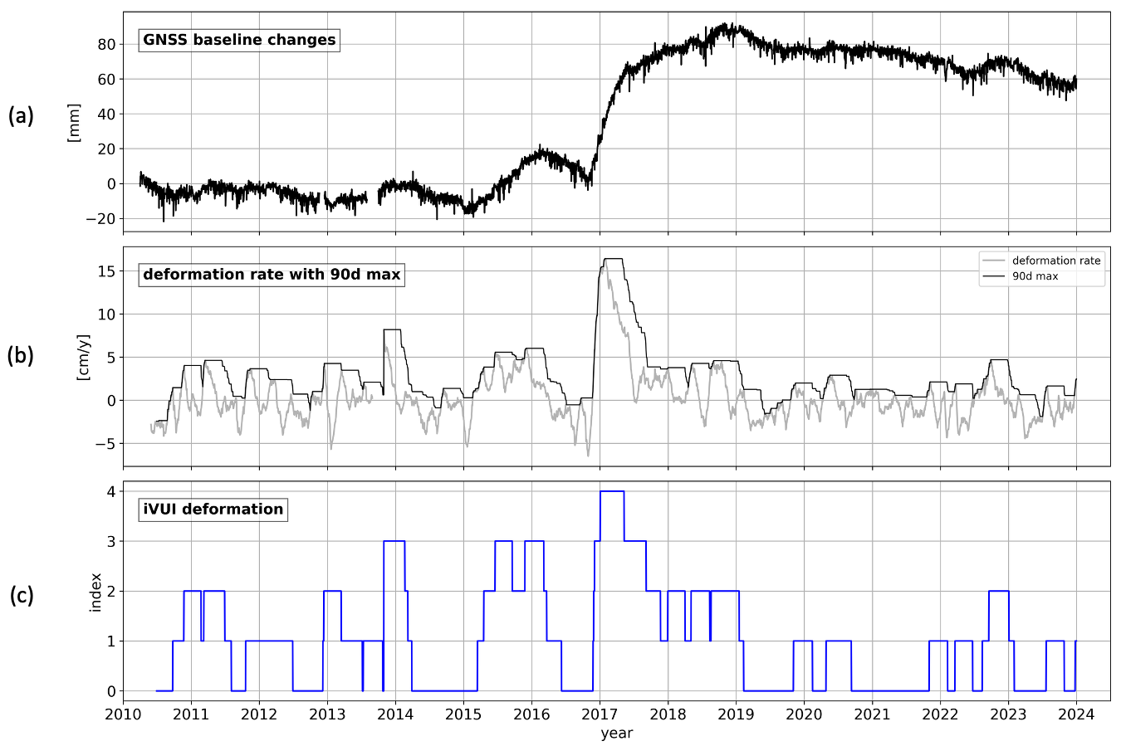

Fig. S8 Time series plots of ground deformation and the unrest index for Mount Meakandake. (a) Changes in baseline length between stations J055 and 960513 based on GNSS records; (b) Deformation rate calculated as the slope over the preceding 60 days (gray line) and its 90-day maxima (black line); (c) The iVUI derived from the deformation rate.

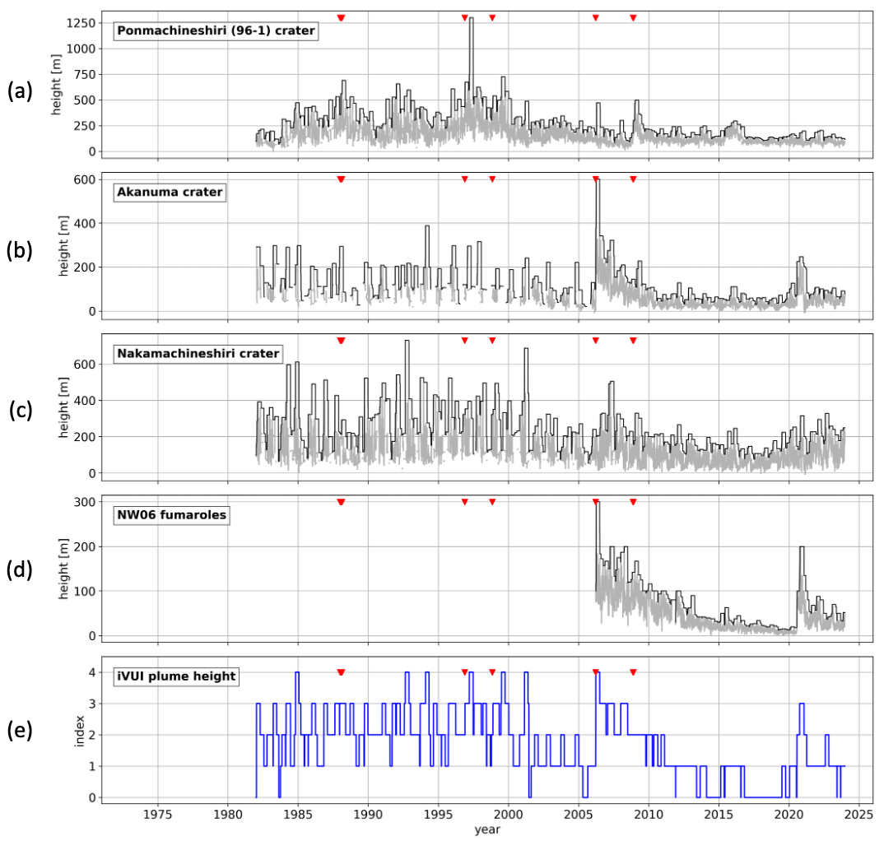

Fig. S9 Time series plots of plume heights and the unrest index for Mount Meakandake. Inverted red triangles at the top of each panel indicate eruption timings. (a-d) Plume heights from the Ponmachineshiri (96-1) crater, Akanuma crater, Nakamachineshiri crater, and NW06 fumaroles, respectively. Gray lines: Daily records after applying a 7-day average with atmospheric temperature correction; Black lines: Maxima over the preceding 90 days; (d) The iVUI derived from the four plume height records.

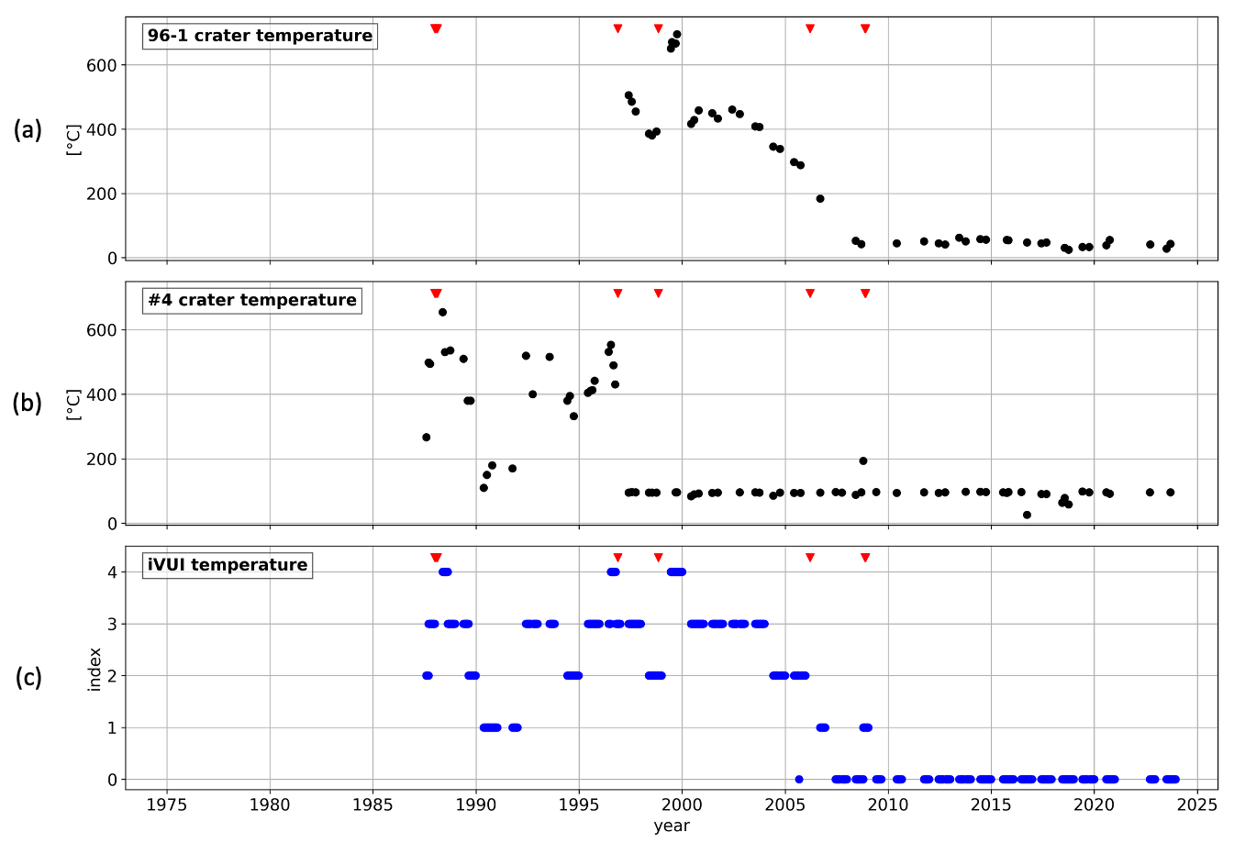

Fig. S10 Time series plots of crater temperatures and the unrest index for Mount Meakandake. Inverted red triangles at the top of each panel indicate eruption timings. (a, b) Temperatures measured at the 96-1 and #4 craters, respectively; (c) The iVUI derived from these two temperature records.

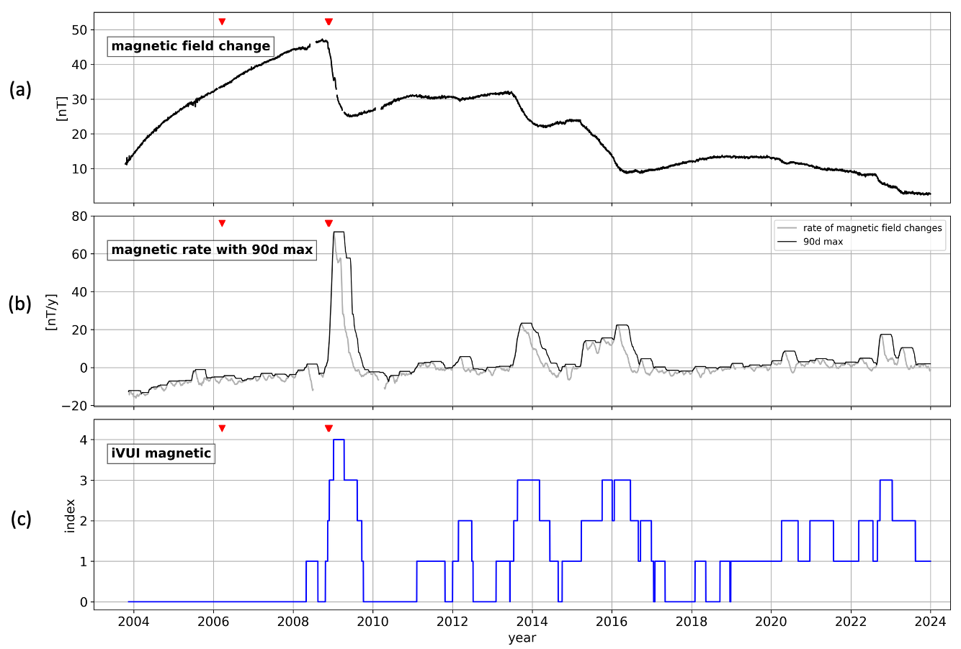

Fig. S11 Time series plots of geomagnetic field and the unrest index for Mount Meakandake. (a) Differential geomagnetic total field at station MEA, referenced to MMB; (b) Rate of the magnetic field changes calculated as the slope over the preceding 60-day window (gray line) and its 90-day maxima (black line) (units: nT/year); (c) The iVUI derived from the rate of the magnetic field change.

