Supplementary materials
Table S1. Appendix along with rating values of each sentence and constituent words.
(Using following materials, we created two counterbalanced lists. Each list contained 20 metaphors and 20 similes on which each pair of topic and vehicle was presented only once in each list.)
Sentence condition comprehensibility similarity aptness familiarity word familiarity word frequency word length
topic vehicle topic vehicle topic vehicle
Metaphor
The earth is a mother. 8.57 6.49 5.04 4.28 6.13 6.47 3.24 4.28 2 2
The child is an angel. 8.29 6.33 3.76 5.30 6.69 6.28 4.72 2.86 3 2
Charm is a magnet. 8.00 5.38 5.30 5.76 6.22 6.09 4.05 2.81 2 2
Impact is electricity. 8.00 6.27 5.00 4.51 5.81 6.41 3.81 4.05 2 2
A smile is a flower. 7.71 6.91 5.54 4.09 6.28 6.56 3.84 4.24 2 1
A riot is stormy. 7.29 6.53 4.49 4.80 5.34 6.03 3.49 2.76 2 1
Judgment is a scale balance. 7.14 5.72 4.30 4.22 5.75 5.16 3.77 1.54 2 2
Strain is a bowstring. 7.00 6.21 5.49 4.49 5.94 4.59 4.14 2.74 2 1
A butterfly is a dancer. 6.86 5.35 5.09 4.97 5.89 5.56 2.88 2.31 3 4
Uneasiness is a dense fog. 6.71 6.37 5.70 5.18 6.44 5.09 4.48 2.45 2 2
Hatred is a toxic substance. 6.57 4.49 4.45 4.84 5.41 5.41 2.84 3.05 2 2
Conversation is a gear. 6.43 5.35 5.38 4.93 6.22 5.69 3.73 2.88 2 2
A crowd is a big river. 6.29 4.61 4.72 4.61 5.44 5.44 3.13 2.44 2 2
An education is a flight of stairs. 6.14 5.01 5.10 4.96 6.34 6.13 4.67 3.57 2 2
Temptation is honey. 5.86 6.21 5.20 4.58 5.88 5.47 2.84 2.44 2 1
Freedom is the sea. 5.57 6.55 5.52 4.46 6.69 6.63 4.43 4.18 2 1
Love is ice cream. 5.14 3.64 5.04 5.36 6.56 6.69 3.50 2.81 1 7
Breathing is a pump. 4.86 6.03 4.24 4.61 6.03 6.03 3.64 3.22 2 3
Happiness is alcohol. 4.71 4.74 5.67 5.36 6.59 6.59 3.18 4.07 2 1
Average 6.70 5.77 5.02 4.80 6.06 5.88 3.65 3.05 2.00 2.15
SD 1.11 0.91 0.53 0.43 0.42 0.61 0.63 0.77 0.46 1.39

Simile
Rage is like an eruption. 8.43 7.53 4.93 4.31 5.88 5.78 2.63 3.67 2 2
Difficulty is like a wall. 8.29 7.92 5.15 3.81 5.97 6.13 3.96 4.17 2 1
Men are like wolves. 8.00 6.27 5.43 6.85 6.47 6.06 4.47 2.49 1 1
Life is like a voyage. 7.86 7.15 5.35 4.16 6.50 5.53 4.17 3.30 2 2
Memory is like a warehouse. 7.71 5.73 4.73 5.46 6.06 5.91 4.02 3.61 2 2
Powdery snow is like feathers. 7.14 5.32 5.47 4.60 5.53 6.00 1.80 2.45 2 2
An age (or epoch) is like a tide. 7.00 5.54 4.27 4.34 6.22 4.47 4.95 2.15 2 2
Hope is like a lamplight. 7.00 6.39 5.11 4.56 6.47 4.56 4.38 2.05 2 2
Research is like a climb. 6.86 4.86 4.84 5.06 6.22 6.06 4.86 3.63 2 2
Zeal is like lava. 6.86 5.56 5.11 5.10 6.16 5.47 3.38 2.83 2 2
Discussion is like war. 6.86 5.51 4.84 4.42 5.53 6.34 4.51 4.61 2 2
Therapy is like repair. 6.71 7.08 4.24 3.89 6.19 6.16 4.34 3.77 2 2
The truth is like a labyrinth. 6.43 4.86 4.58 4.86 5.69 5.47 2.91 2.13 2 2
A horse is like a track. 6.29 3.35 4.58 3.91 6.50 6.56 3.66 3.98 1 4
Loneliness is like a desert. 6.14 6.19 5.12 5.29 5.88 5.94 3.20 3.54 2 2
Love is like a febrile disease. 6.14 6.04 5.42 5.09 6.34 5.34 3.32 1.89 2 2
The heart is like a clock. 5.71 5.67 4.92 4.69 6.25 6.44 3.85 3.47 2 2
Sleep is like death. 5.43 6.41 4.21 4.18 6.19 6.38 2.88 4.25 2 1
Power is like a drug. 5.14 4.03 4.88 5.03 5.91 5.91 3.95 3.72 2 2
A job is like a jail. 4.71 4.00 3.93 4.88 6.56 4.97 4.76 1.89 2 2
Average 6.74 5.77 4.86 4.72 6.13 5.77 3.80 3.18 1.90 1.95
SD 1.02 1.19 0.44 0.69 0.32 0.59 0.83 0.86 0.31 0.60
Comprehensibility, aptness, familiarity (of each sentence), and similarity (between constituent terms) were rated on a 9-point scale.
Word frequency and word familiarity were checked using the NTT database: “Lexical Properties of Japanese” (Amano & Kondo, 2000), and word frequency data were transformed into log word frequency. Word length indicates number of characters of each Japanese word (Kanji, Kana and Katakana). There were no significant differences between metaphor and simile sentences
(comprehensibility: F (1, 38) = 0.01, p = .92, similarity: F (1, 38) = 0.00, p = .99, aptness: F (1, 38) = 1.12, p = .30, familiarity: F (1, 38) = 0.17, p = .68, word familiarity: F (1, 78) = 0.04, p = .85, word frequency: F (1, 78) = 0.55, p = .46, word length: F (1, 78) = 0.71, p = .40).

Figure S1

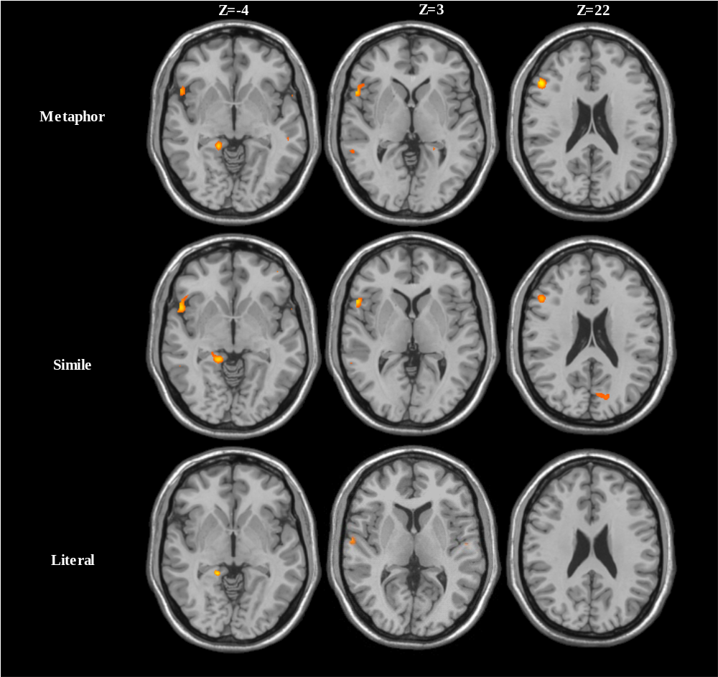
Summary of imaging results. Top row: The main effect of metaphor condition. Middle row: The main effect of simile condition. Bottom row: The main effect of literal sentence condition (p < 0.05, FDR).

Figure S2
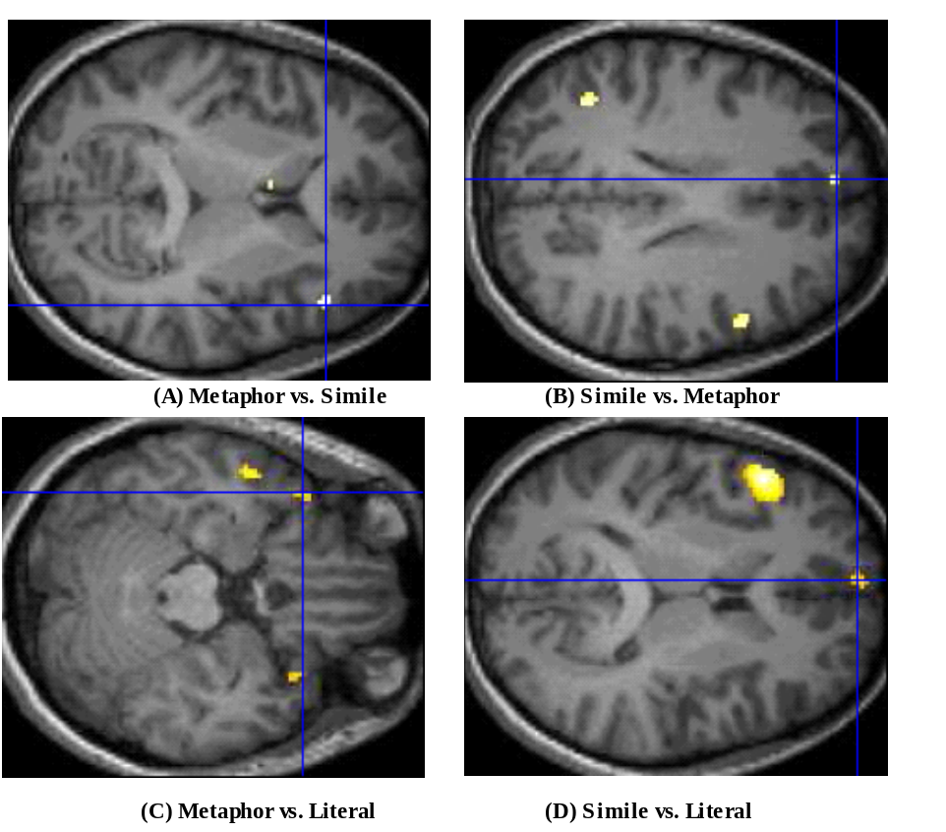
(A) Metaphor versus simile sentence condition (Z = 8).
(B) Simile versus metaphor sentence condition (Z = 25).
(C) Metaphor versus literal sentence condition (Z = -20).
(D) Simile versus literal sentence condition (Z = 14).
(p < .001, uncorrected)

