Supporting Information
Cyclization mechanism of phomopsene synthase: Mass spectrometry based analysis
of various site-specifically labeled terpenes
Sandip S. Shinde,^{1†} Atsushi Minami,¹ Zhi Chen,¹ Tetsuo Tokiwano,¹ Toyonobu Toyomasu,²
Nobuo Kato,³ Takeshi Sassa,² and Hideaki Oikawa¹*

¹Division of Chemistry, Graduate School of Science, Hokkaido University, Sapporo 060-0810, Japan.
²Department of Bioresource Engineering, Yamagata University, Yamagata 997-8555, Japan.
³Institute of Scientific and Industrial Research, Osaka University, Osaka 567-0047, Japan.
†Current address: Organic Chemistry Division, CSIR-National Chemical Laboratory, Pune 411008, India.

Table of Contents

Experimental section Page S2

Figures
Figure S1 : Structures of di-/sesterterpenes. Page S6
Figure S2 : MS/MS spectra of nonlabeled-1. Page S7
Figure S3 : MS spectra of site-specifically deuterium labeled-1. Page S8

Schemes
Scheme S1 : Enzymatic synthesis of deuterium labeled-GGPP. Page S11
Scheme S2 : Proposed cyclization mechanism of 1 and the core structure of mangicol A.
Page S12

General.
All reagents commercially supplied were used as received. ¹H-NMR spectra were recorded on JEOL ECP-300. NMR spectra were recorded in CDCl₃ (99.8 atom % enriched, Merck). ¹H chemical shifts were reported in δ value based on solvent residual signal (7.26 ppm) as reference. Data are reported as follows: chemical shift, multiplicity (s = singlet, d = doublet, t = triplet, q = quartet, m = multiplet), coupling constant (Hz), and integration. Column chromatography was carried out with Merck Kieselgel 60 Art. Nr. 7734. Mass spectra were measured on a JEOL JMS-T100CS (ESI mode). GC-MS analyses were conducted with MS-2010 (Shimadzu), using a DB-1 MS capillary column (0.32 mm x 30 m, 0.25 μm film thickness; J&W Scientific).

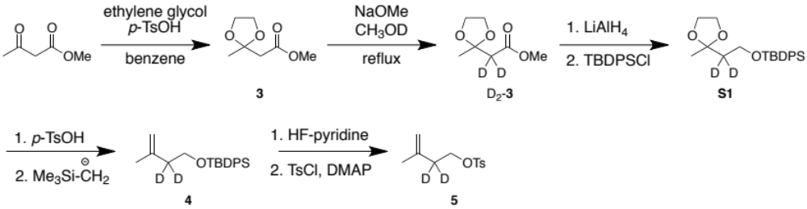

D₂-3
To a solution of 3 (500 mg, 3.12 mmol) in MeOD (15 mL, 99 atom% ²H, Kanto Chemical) was added NaOMe (33 mg, 0.62 mmol) at 0°C. After refluxed for 10 h, aqueous saturated NaHCO₃ was added to the reaction mixture. The mixture was extracted with diethyl ether and the combined organic layers were washed with brine, dried over Na₂SO₄, filtered and concentrated under reduced pressure. The crude products were purified by flash silica gel column chromatography to give D₂-3 (409 mg, 95%); ¹H NMR (300 MHz, CDCl₃) δ 1.49 (s, 3H), 3.70 (s, 3H), 3.97 (s, 4H).

S1
To a stirred suspension of LiAlH₄ (11.8 mg, 0.31 mmol) in dry THF (500 μL) was added solution of D₂-3 (50 mg, 0.31 mmol) in THF (250 μL) at 0°C. After 2 h, reaction mixture diluted with saturated Na₂SO₄ and stirred for 40 min at room temperatures. Then reaction mixture was filtered through a 1:1 mixture of Celite/Na₂SO₄ pad and the filtrate was dried over Na₂SO₄ and concentrated under reduced pressure to give the alcohol.
To a solution of the crude alcohol in DMF (500 μL) was added imidazole (53 mg, 0.78 mmol) and TBDPSCl (95 μL, 0.37 mmol) at 0°C. After 30min, the reaction mixture allowed to warm to room temperature and was stirred for 12 h. The reaction mixture was diluted with H₂O (1.0 mL) and extracted with Et₂O (12 mL). The combined organic layers were washed with brine, dried over Na₂SO₄, filtered, and concentrated under reduced pressure. The crude product was purified by silica gel column chromatography to give S1 (170 mg, 97%) as colorless liquid; ¹H NMR (300 MHz, CDCl₃) δ 1.04 (s, 9H), 1.31 (s, 3H), 3.78-3.90 (m, 6H), 7.37-7.40 (m, 5H), 7.66-7.69 (m, 5H). HR-ESIMS analysis (positive); calcd. for C₂₂H₂₈²H₂O₃NaSi [M+Na]⁺: 395.5586, found: 395.5571.

4
To a solution of S1 (800 mg, 2,16 mmol) in acetone/H₂O (2/2 mL) at room temperature was added p-toluenesulfonic acid (205 mg, 1.08 mmol) in one portion and stirred for 24 h. The reaction mixture was diluted saturated NaHCO₃ and extracted with Et₂O (15 mL). The combined organic layers were washed with brine, dried over Na₂SO₄, filtered and concentrated under reduced pressure to give a crude deprotected ketone (592.8 mg).
To a solution of the ketone in Et₂O was added LiCH₂Si(CH₃)₃ (3.2 mL, 3.2 mmol, 1 M in pentane solution) at -78°C. After 3 h, the reaction mixture was quenched with aqueous saturated NH₄Cl and NaHCO₃ (1/1 mL), and extracted with Et₂O (50 mL). The combined organic layers were washed with brine, dried over Na₂SO₄, filtered and concentrated under reduced pressure. The crude product was purified by silica gel column chromatography to give 4 (241 mg, 34%) as colorless oil; ¹H NMR (300 MHz, CDCl₃) δ 1.05 (s, 9H), 1.69 (s, 3H), 3.75 (s, 2H), 4.69 (m, 1H), 4.75 (m, 1H), 7.35-7.43 (m, 5H), 7.67-7.70 (m, 5H). HR-ESIMS analysis (positive); calcd. for C₂₁H₂₆²H₂ONaSi [M+Na]⁺: 349.5333, found: 349.5369.

5
To a solution of 4 (100 mg, 0.31 mmol) in THF (5 mL) was added hydrogen fluoride pyridine (55 μL, 0.46 mmol) at room temperature. After stirring for 24 h, the reaction mixture was quenched with aqueous saturated NaHCO₃ and extracted with CH₂Cl₂ (10 mL). The combined organic layers were washed with brine, dried over Na₂SO₄, and filtered. To the solution of the crude alcohol were added DMAP (123 mg, 1.01 mmol) and p-toluenesulfonyl chloride (400 mg, 0.81 mmol) at 0°C. After stirring for 3 h, the reaction mixture was diluted with aq. saturated NH₄Cl and extracted with Et₂O (10 mL × 3). The combined organic layers were washed with brine, dried over Na₂SO₄ and concentrated under reduced pressure. The crude product was purified by silica gel column chromatography to give 5 (145.3 mg 89%); ¹H NMR (300 MHz, CDCl₃) δ 1.64 (s, 3H), 2.45 (s, 3H), 4.09 (s, 2H), 4.65 (s, 1H), 4.80 (s, 1H), 7.39 (d, J = 6.2 Hz, 1H), 7.75 (d, J = 6.2 Hz, 1H). HR-ESIMS analysis (positive); calcd. for C₁₂H₁₄ ²H₂O₃NaS [M+Na]⁺: 265.0843, found: 265.0845.

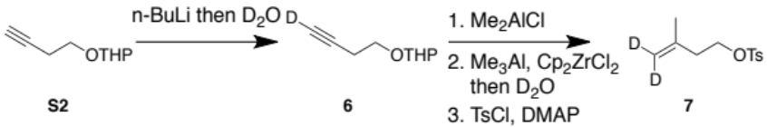

6
To a solution of S2 (2.0 g, 12.9 mmol) in THF (20 mL) was added n-BuLi (9.5 mL, 15.5 mmol, 1.63 mol/L in THF) at -78°C. After stirring for 1 h, to the reaction mixture was added D₂O (387 μL, 19.4 mmol, 99.8 atom% ²H, Kanto Chemical) in THF (20 mL), and the reaction mixture was quenched with saturated NH₄Cl (5 mL) at 0°C. The mixture was extracted with diethyl ether (60 mL) and the combined organic layers were washed with brine, dried over Na₂SO₄, filtered and concentrated under reduced pressure. The crude product was purified by column chromatography to give 6 (1.6 g, 80%) as a colorless liquid; ¹H NMR (300 MHz, CDCl₃) δ 1.55-1.83 (m, 6H), 2.49 (t, J = 7.0 Hz, 2H), 3.53-3.58 (m, 2H), 3.82-3.88 (m, 2H), 4.65 (m, 1H). HR-ESIMS analysis (positive); calcd. for C₉H₁₃²HO₂Na [M+Na]⁺: 178.0948, found: 178.0910.

7
A suspension of Me₂AlCl (11 mL, 12.8 mmol, 1.0 mol/L) in CH₂Cl₂ (7 mL) was treated with 6 (1.0 g, 6.4 mmol) at -25°C for 1 h. The reaction mixture allowed to warm room temperature and stirred for 5 h. The reaction was quenched with saturated NaHCO₃ and extracted with CH₂Cl₂ (30 mL), washed with brine, dried over Na₂SO₄, filtered, and concentrated under reduced pressure to give the alcohol.
To a suspension of Cp₂ZrCl₂ (208 mg, 0.71 mmol) in (CH₂)₂Cl₂ (10 mL) was subsequently treated with AlMe₃ (4.0 mL, 8.52 mmol) and the crude alcohol (200 mg, 0.21 mmol) in CH₂Cl₂ (5 mL) at room temperature. After refluxing for 2 days, to the reaction mixture was added a solution of D₂O (341 μL) in THF (7 mL) at -45°C. After 1 h, the reaction mixture was quenched by saturated K₂CO₃ and extracted with CH₂Cl₂ (90 mL), washed with brine, dried over Na₂SO₄, filtered, and concentrated under reduced pressure.
To the crude products in CH₂Cl₂ were added p-toluenesulfonyl chloride (541 mg, 2.84 mmol) and DMAP (427 mg, 3.5 mmol) at room temperature. After 2 h, the reaction mixture was diluted with saturated NH₄Cl and extracted with CH₂Cl₂ (60 mL). The combined organic layers were washed with brine, dried over Na₂SO₄, filtered, and concentrated under reduced pressure. The crude product was purified by silica gel column chromatography to give 7 (170 mg, 25%); ¹H NMR (300 MHz, CDCl₃) δ 1.66 (s, 3H), 2.35 (t, J = 5.1, 2H), 2.46 (s, 3H), 4.13 (t, J = 5.1 Hz, 2H), 7.35 (d, J = 6.2 Hz, 2H), 7.80 (d, J = 6.2 Hz, 2H). HR-ESIMS analysis (positive); calcd. for 265.0838; found 265.0821.

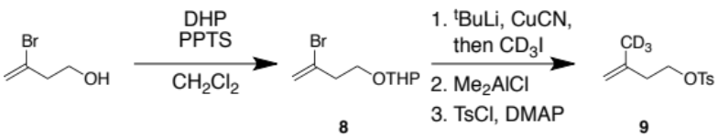

8
To a solution of 3-bromo-3-buten-1-ol (1.0 g, 14.2 mmol) in CH₂Cl₂ (19 mL) were added dihydropyran (1.0 mL, 10.5 mmol) and p-toluenesulfonic acid (356 mg, 1.42 mmol) at room temperature. After 13 h, to the reaction mixture was added a portion of dihydropyran (1.0 mL, 10.5 mmol). After 3 h, the reaction mixture was extracted with CH₂Cl₂ (50 mL) and the organic layers were washed with brine, dried over Na₂SO₄, filtered and concentrated under reduced pressure. The crude product was purified by silica gel column chromatography to give 8 (2.0 g, 90%) as colorless oil; ¹H NMR (300 MHz, CDCl₃) δ 1.52-1.63 (m, 6H), 2.71 (m, 2H), 3.24-3.61 (m, 2H), 3.78-3.98 (m, 2H), 4.61 (t, J = 3.0 Hz, 1H), 5.47 (d, J = 1.6 Hz, 1H), 5.67 (d, J = 1.6 Hz, 1H). HR-ESIMS analysis (positive); calcd. for C₉H₁₅BrO₂Na [M+Na]⁺: 258.1074, found: 258.1102.

9
To a solution of 8 (500 mg, 2.13 mmol) in dry THF (7.5 mL) was added t-BuLi (2.7 mL, 4.27 mmol, 1.59 mol/L THF) at -78°C. After stirring for 15 min, solution of CuCN (95 mg, 1.06 mmol) in dry THF (500 μL) was added and the reaction mixture allowed to warm to -50°C. After 3 min, the flask was recooled to -78°C and solution of CD₃I (265 μL, 4.27 mmol, 99.5 atom% ²H, Cambridge Isotope Laboratories) in dry THF (1.0 mL) was added. The reaction mixture was allowed to warm to -50°C and stirred for 1 h. The reaction was quenched with saturated NH₄Cl and extract with Et₂O (90 mL). The combined organic layers were washed with brine, dried over Na₂SO₄, filtered and concentrated under reduced pressure.
To a solution of the crude product in CH₂Cl₂ (10 mL) was added in Me₂AlCl (3.0 mL, 3.0 mmol). After 1 h stirring at room temperature, the reaction mixture was quenched with H₂O and extracted with diethyl ether (90 mL). The combined organic layers were washed with brine, dried over Na₂SO₄, filtered, and concentrated under reduce pressure. The crude products were purified by silica gel column chromatography to give the alcohol as colorless liquid. The NMR data are in good agreement with the reported data.¹
To a solution of the alcohol in CH₂Cl₂ was added p-toluenesulfonyl chloride and DMAP, and the reaction mixture was stirred for 3 h. The reaction was quenched with sat. NH₄Cl and extracted with Et₂O. The organic layer was washed with brine, dried over MgSO₄, and concentrated in vacuo. The crude products were purified by silica gel column chromatography to give 9. ¹H NMR, (300 MHz, CDCl₃) δ 2.35 (t, J = 5.2 Hz, 2H), 2.46 (s, 3H), 4.13 (t, J = 5.2 Hz, 2H), 4.68 (s, 1H) 4.79 (s, 1H), 7.35 (d, J = 6.2 Hz, 1H), 7.80 (d, J = 6.2 Hz, 1H). HR-ESIMS analysis (positive); calcd. for C₁₂H₁₃ ²H₃O₃NaS [M+Na]⁺: 266.0906, found: 266.0903.

General phosphorylation procedure.
The synthetic procedure is according to the literature procedure.² To a solution of the tosylate (1 eq) in benzene was added tris(tetra-n-butylammonium) hydrogen pyrophosphate (2 eq) in acetonitorile. After stirring for 5 h at room temperature, the reaction mixture was diluted with hexane and the acetonitrile layer was concentrated in vacuo. The residues were then dissolved in the mixture of isopropyl alcohol and ammonium bicarbonate buffer. The solution was passed through a column containing DOWEX AG 50W-X8 cation-exchange resin (ammonium form) and the eluent was lyophilized to dryness. The residues were then dissolved in the mixture of acetonitrile and isopropyl alcohol and the suspension was cleared by centrifugation. The supernatant was concentrated in vacuo and the residues were loaded onto a cellulose column to afford phosphorylated product (yield; ~ 20%). The amount of deuterium in each compound is as follows; 2b (97%), 2c (> 99%), and 2d (> 99%).

References
- Winter, R. E. D. & Jian, Z. A convenient preparation of 3-[²H₃]Methyl-3-buten-1-ol. J. Labelled Comp. 31, 787-791 (1991).
- Davisson V. J. et al. Phosphorylation of isoprenoid alcohols. J. Org. Chem. 51, 4768-4779 (1986).

Figure S1. Structures of di-/sesterterpenes.

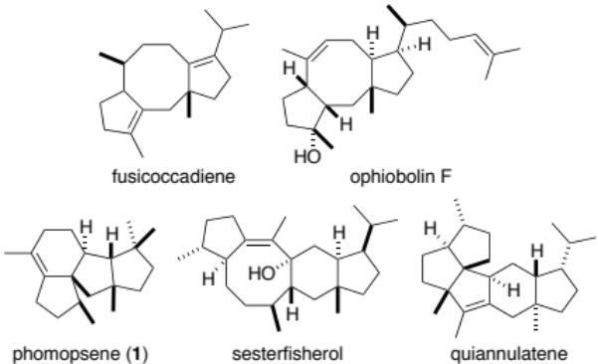
Figure S2. (A) MS spectrum of non-labeled 1. MS/MS spectra of (B) F₂₀₂, (C) F₁₆₀, and (D) F₂₅₇.

(A)
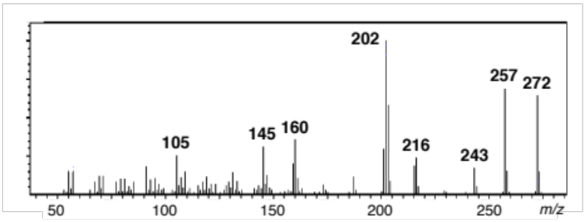
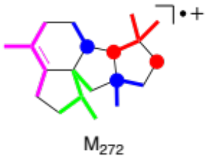

(B)
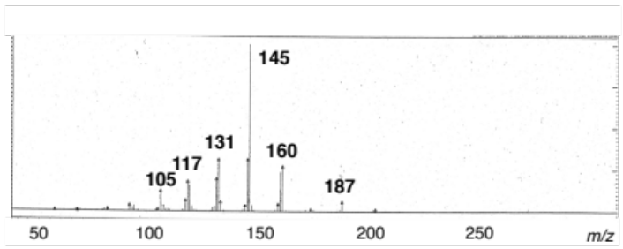
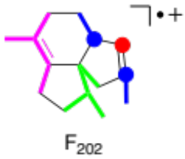

(C)
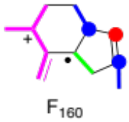
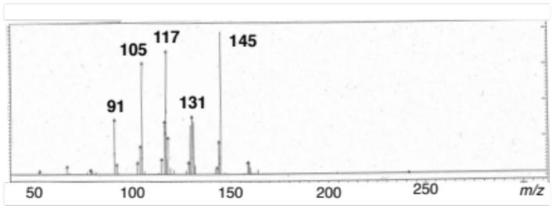

(D)

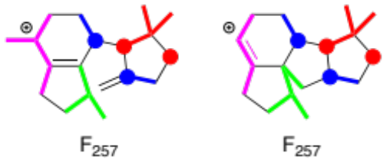
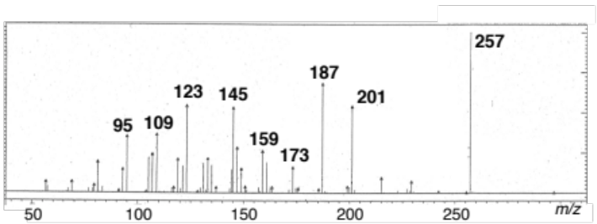

Figure S3. MS spectra of site-specifically deuterium labeled 1. Proposed fragmentation reactions are shown in the frame with a broken line. The observed mass shifts are shown in the parenthesis.
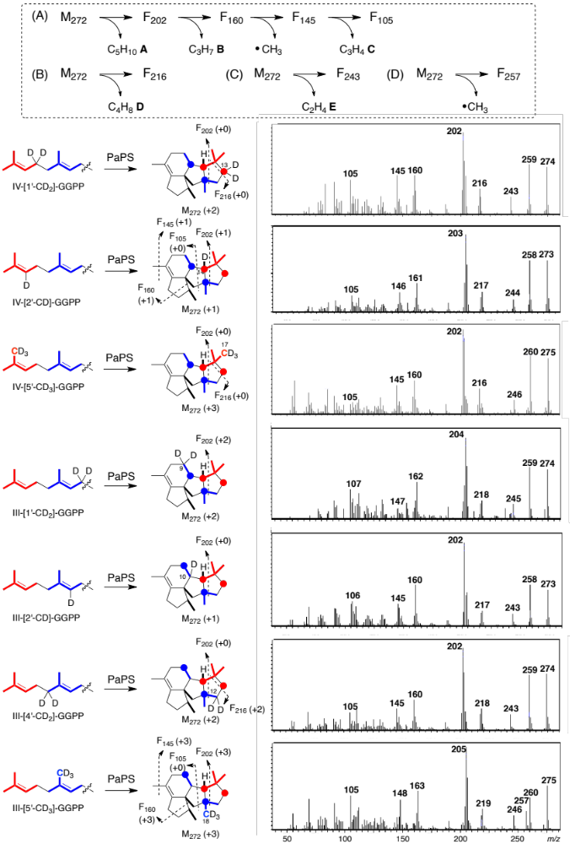

Figure S3. Continued.
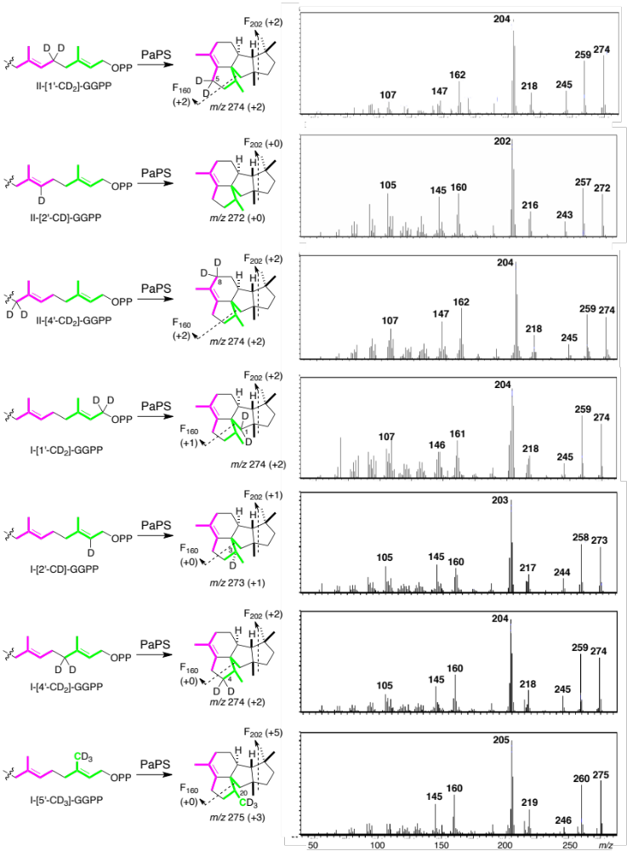

Figure S3. Continued.

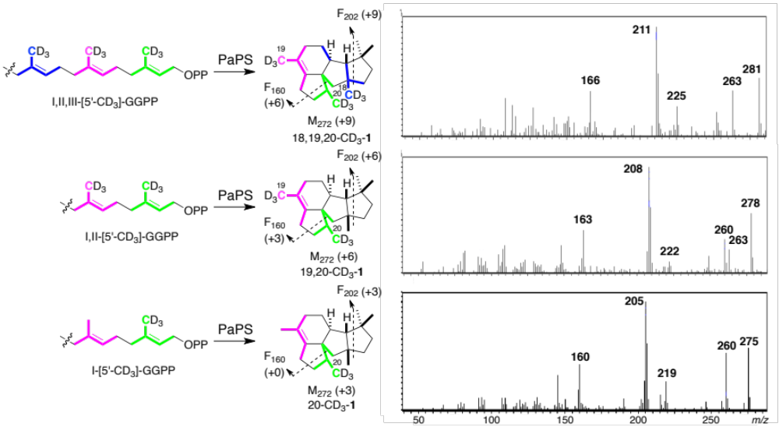
Scheme S1. Enzymatic synthesis of (A) IV-[1’-CD₂]-GGPP, (B) III-[1’-CD₂]-GGPP, (C) II-[1’-CD₂]-GGPP, and (D) I-[1’-CD₂]-GGPP by utilizing 1-CD₂-IPP 2a. The same procedure can be applied to synthesize other deuterium labeled-GGPP from 2-CD₂-IPP 2b, 4-CD₂-IPP 2c, and 5-CD₃-IPP 2d. The labeled-GGPP is directly used for the substrate of the cyclization because PaPS is a bifunctional terpene synthase, which has a N-terminal terpene cyclase domain (TC domain) and a C-terminal prenyltransferase domain (PT domain).

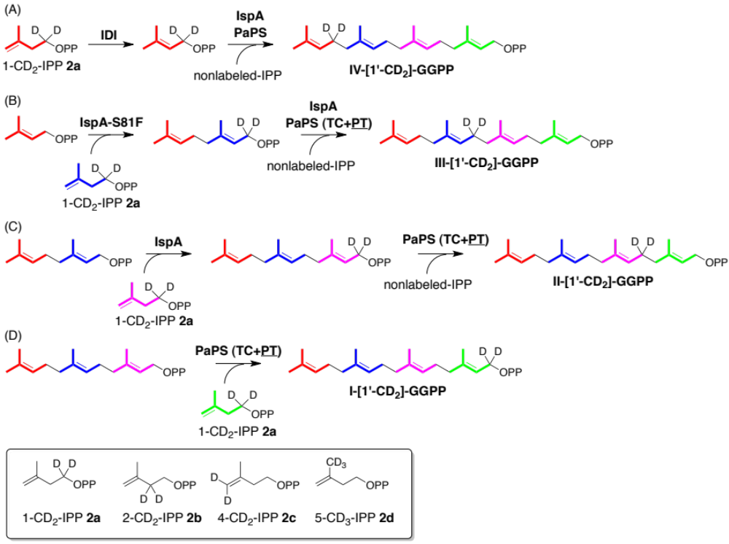
Scheme S2. Proposed cyclization mechanism of 1 and the core structure of mangicol A.

