Supplementary Material
Conditioned medium from human amnion-derived
mesenchymal stem cells regulates activation of primary hepatic stellate cells

Qingjie Fu, Shunsuke Ohnishi and Naoya Sakamoto

Correspondence: Dr. Shunsuke Ohnishi sonishi@pop.med.hokudai.ac.jp

Figure and Figure Legends
Supplementary Figure 1. Expressions of MSC-specific gene IGTA11 and fibroblast-specific gene CD26 were examined in hAMSCs and skin fibroblasts by quantitative reverse-transcription polymerase chain reaction. Gene expression was normalized to 18s rRNA. Data are shown as mean ± SD (n = 3). **P < 0.01 versus hAMSC.
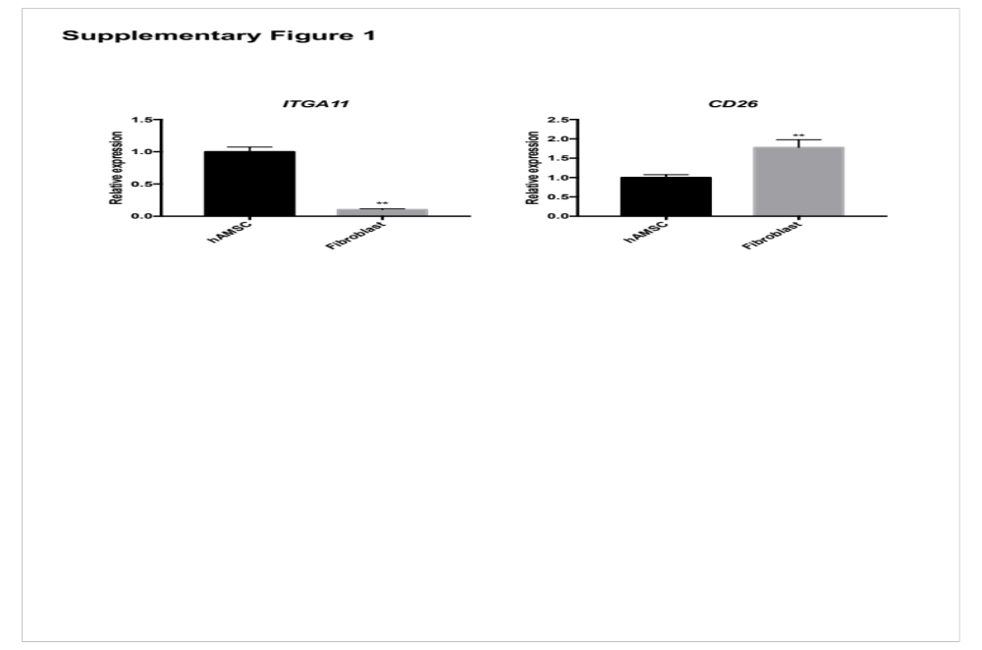

Supplementary Figure 2. Morphology of sorted HSCs in vitro. (A) Most of the seeded HSCs present an asteroid phenotype with remaining a great quantity of lipid droplets after 1 day of culture. Arrows indicate lipid droplets and the inset at the upper right corner shows the lipid droplets close-up. Scale bar = 100 μm. (B) Sorted HSCs proliferated during culture and presented a fibroblast-like phenotype. Scale bar = 100 μm
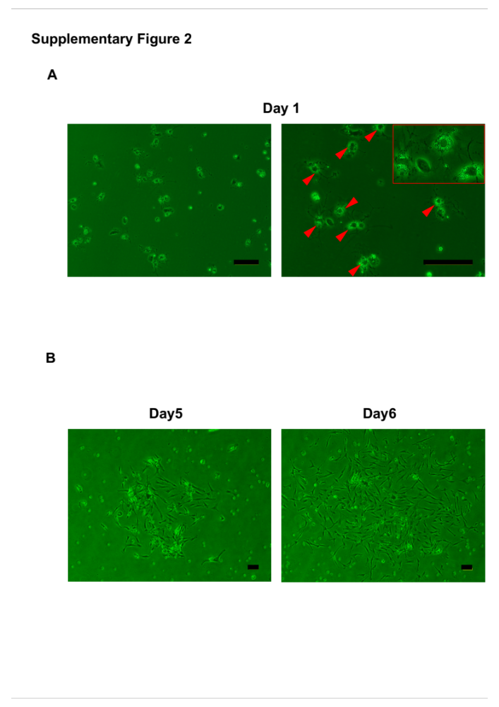

Supplementary Figure 3 Characterization of sorted HSCs. (A) Cell type-specific gene expression analysis of sorted HSCs and remaining cells. Beta-type platelet-derived growth factor receptor (Pdgfb) is a marker of HSCs, C-type lectin domain family 4f (Clec4f) is a marker for Kupffer cells, and albumin is a marker for hepatocytes. Data are expressed as mean ± SD (n = 3). *P < 0.05; **P < 0.01 versus sorted HSCs. (B) Desmin (HSC marker), CD31 (endothelial cell marker), CD163 (Kupffer cell marker) expression of sorted HSCs were analyzed by flow cytometry.
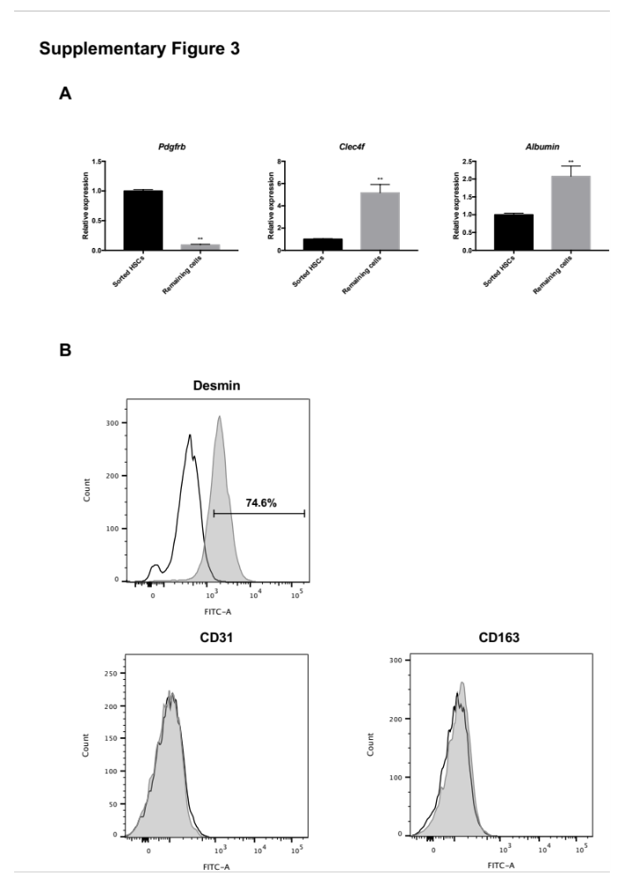

Supplementary Figure 4 Gene expressions of primary HSCs cultured in SM or skin fibroblast-CM. Data are expressed as mean ± SD (n = 3). *P < 0.05; **P < 0.01 versus SM.
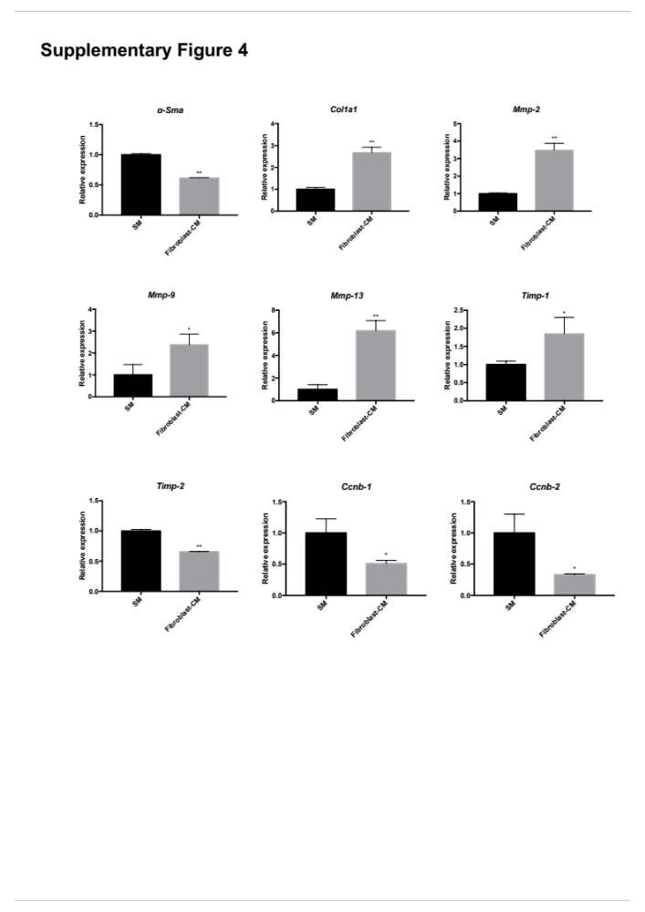
Table
Supplementary Table 1 Sequences of primers
Gene | Forward primers (5’–3’) | Reverse primers (5’–3’)
IGTA11  CD26  18s rRNA  Clec4f  Albumin | TCACGGACACCTTCAACATGG  AGTGGCGTGTTCAAGTGTGG  GATATGCTCATGTGGTGTTG  ACGGAGAGCGTGAAGACTGT  TGTCCCCAAAGAGTTTAAAGCTG | CCAGCCACTTATTGCCACTGA  CAAGGTTGTCTTCTGGAGTTGG  AATCTTCTTCAGTCGCTCCA  CTTGCACACCCAGTTGTAGG  TCTTTATCTGCTTCTCCTTGTCTGG

