Supplenemtal data of “Leaf defense capacity of Japanese elm (Ulmus davidiana var. japonica) seedlings subjected to a nitrogen loading and insect herbivore dynamics in a free air ozone-enriched environment”, in Environmental Science and Pollution Research

Fig. 1S. Photos of leaf beetle (Pyrrhalta maculicollis, A), elm sawfly (Arge captiva, B) grazing on Japanese elm seedlings and elm sawfly eggs oviposited on elm plants (C) in free air ozone enrichment system (O₃-FACE) plots.

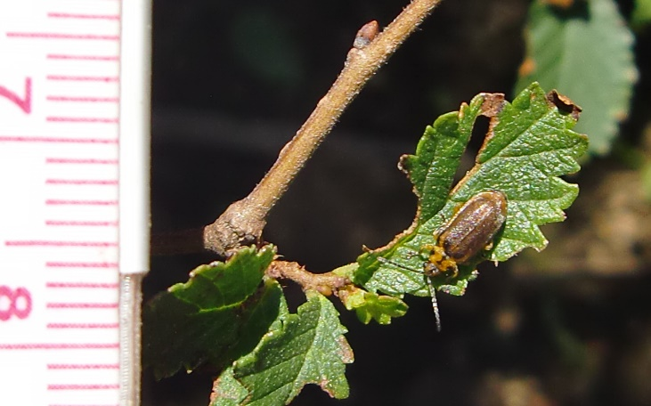
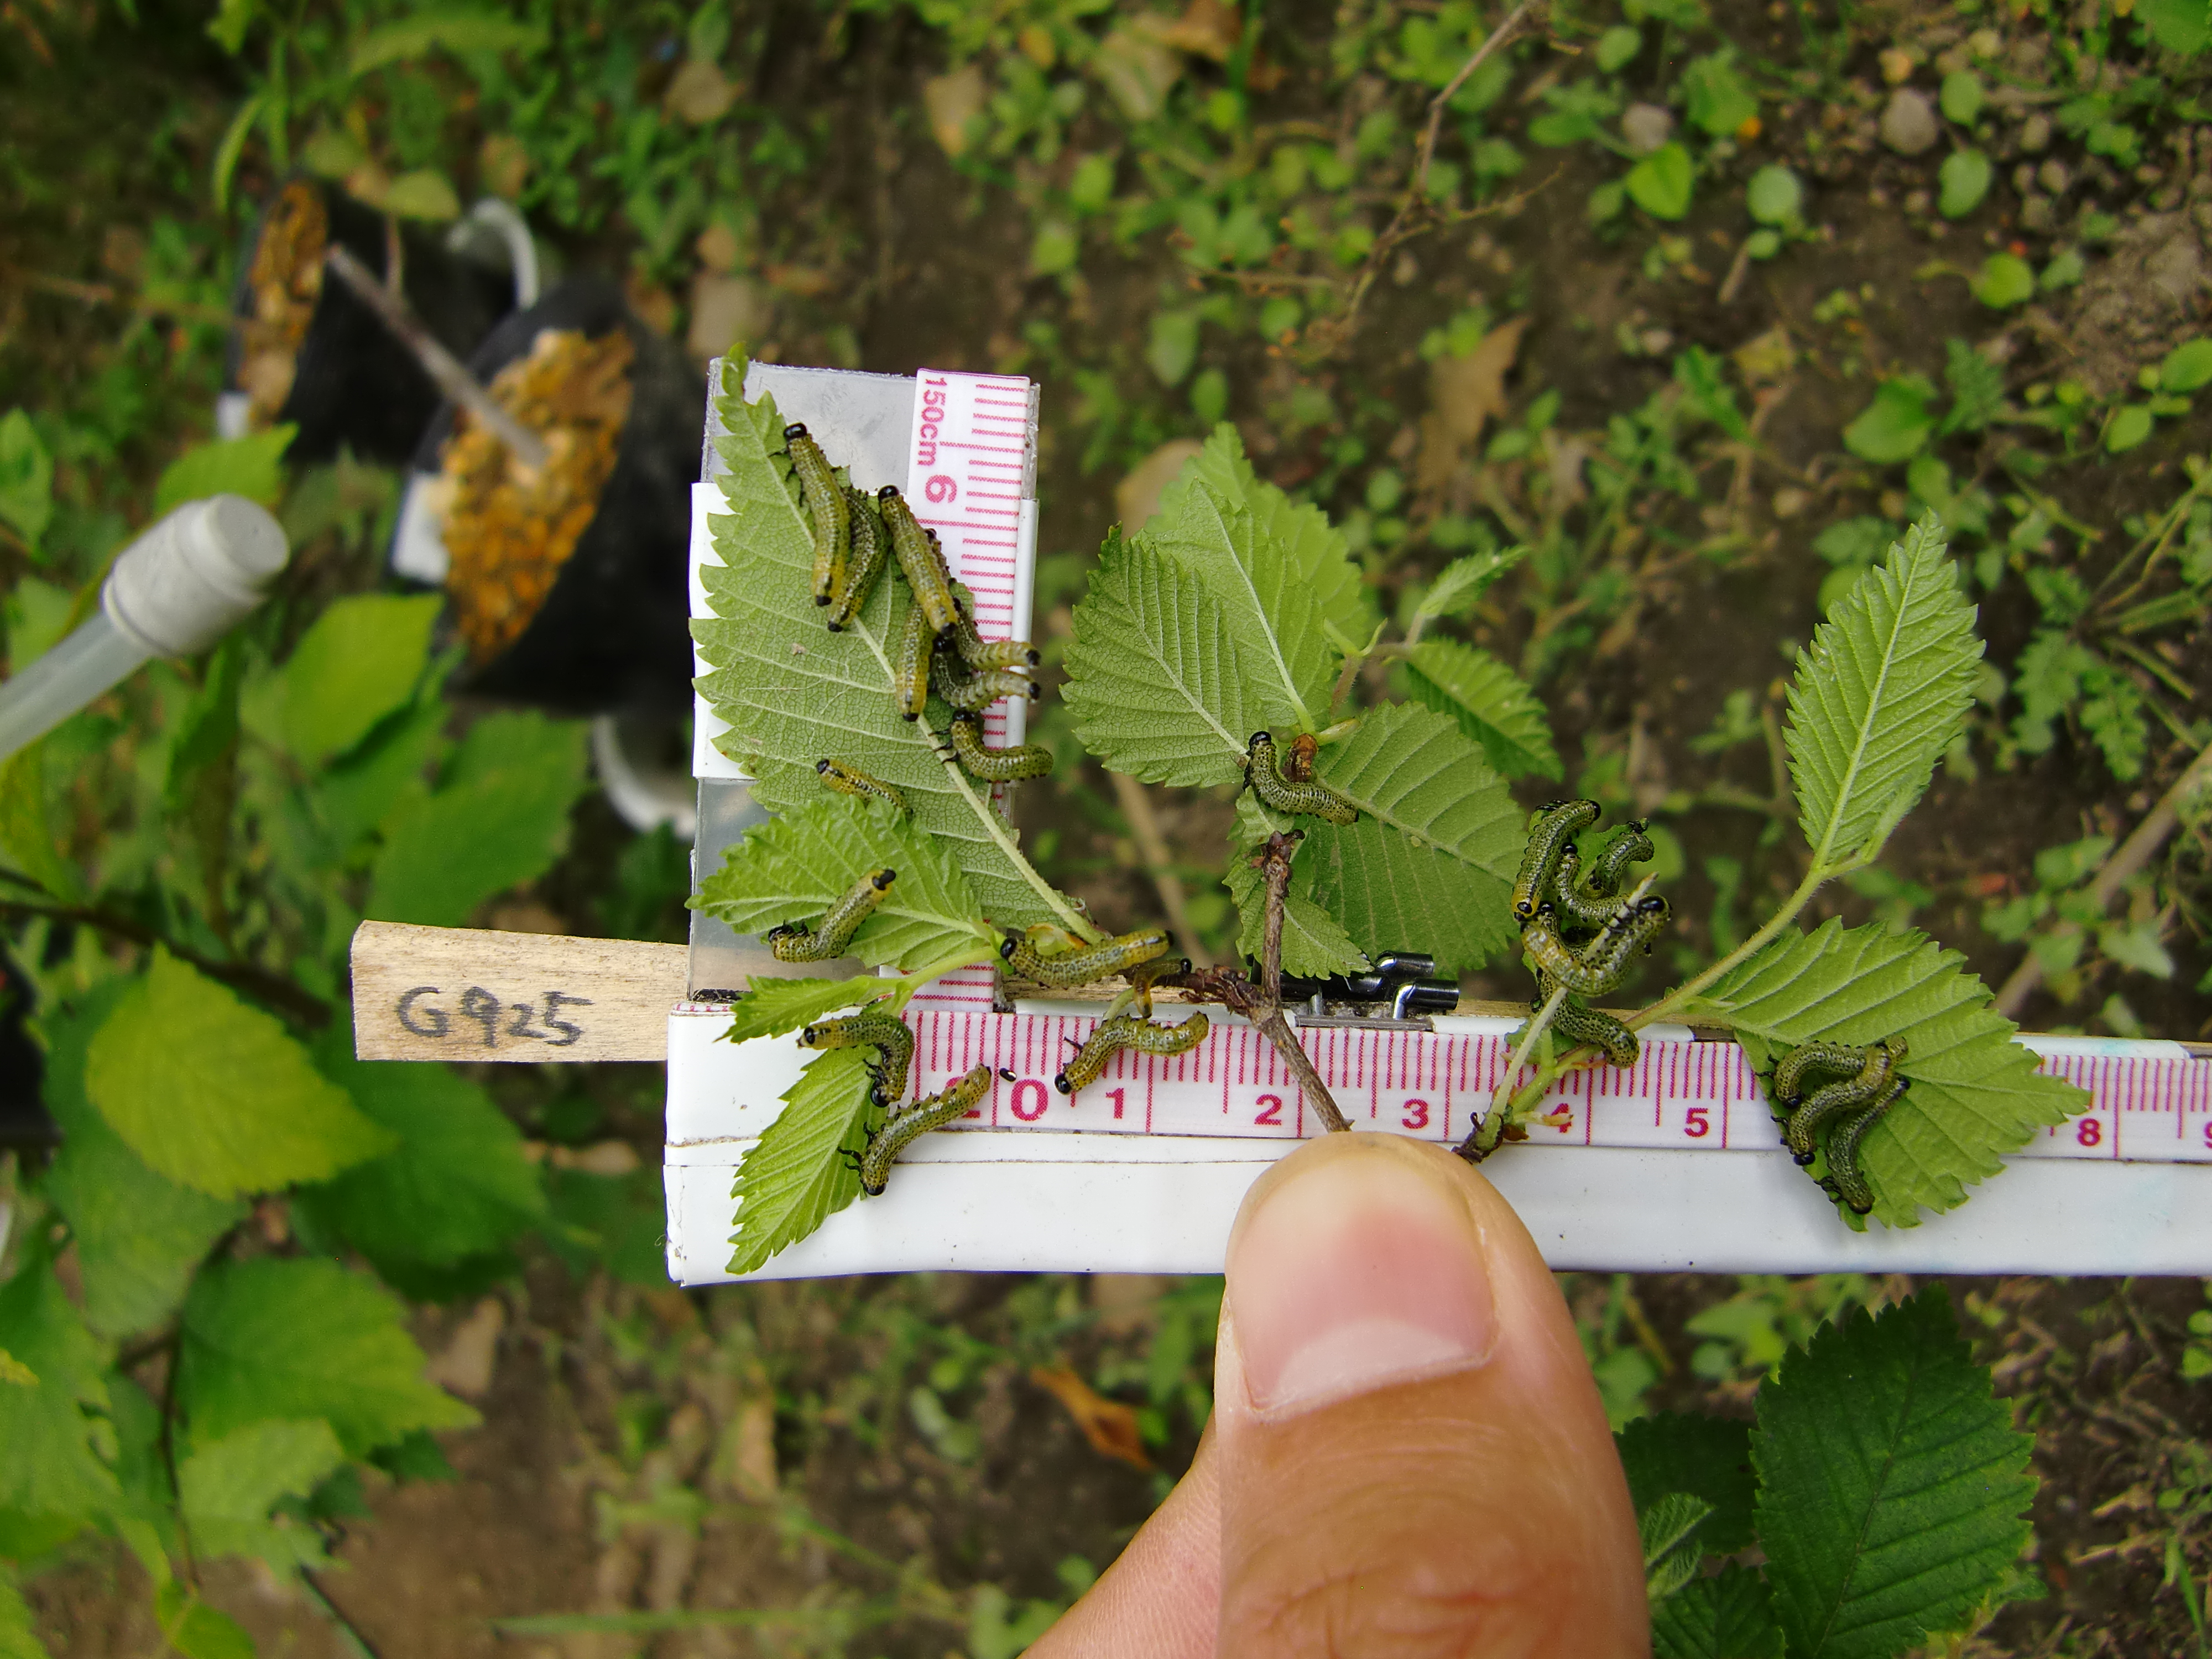
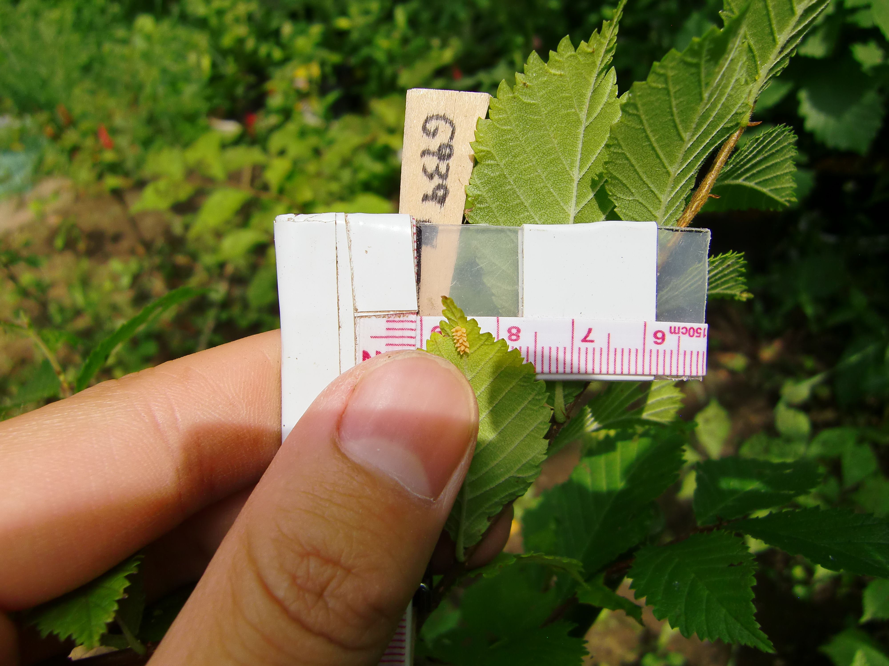
A

B

C

Fig. 2S.
Means (±SE) of the total leaf number where elm sawfly eggs oviposited on elm plants were observed treated with 0 (N0) or 50 (N50) kg N ha⁻¹ yr⁻¹ (given as (NH₄)₂SO₄) and ambient (AOZ) or elevated (EOZ) ozone. The data were analyzed by General Linear Model (GLM) at a level of significance α=0.05.

