
Global Biogeochemical Cycles
Supporting Information for
Physical forcing controls the basin-scale occurrence of nitrogen-fixing organisms in the North Pacific Ocean
Shunyan Cheung^{1,2}, Risa Nitanai³, Chihiro Tsurumoto³, Hisashi Endo^{4,5}, Shin-ichiro Nakaoka⁶, Wee Cheah⁷, Jaime Färber Lorda⁸, Xiaomin Xia⁹, Hongbin Liu^{1,2}*, Koji Suzuki^{3,4}*
¹ Department of Ocean Science, The Hong Kong University of Science and Technology, Hong Kong, China
² Hong Kong Branch of Southern Marine Science & Engineering Guangdong Laboratory, The Hong Kong University of Science and Technology, Hong Kong, China
³ Graduate School of Environmental Science, Hokkaido University, Sapporo 060-0810, Japan
⁴ Faculty of Environmental Earth Science, Hokkaido University, Sapporo 060-0810, Japan
⁵ Bioinformatics Center, Institute for Chemical Research, Kyoto University, Kyoto 611-0011, Japan
⁶ Center for Global Environmental Research, National Institute for Environmental Studies, Tsukuba, Japan
⁷ Institute of Ocean and Earth Sciences, University of Malaya, Federal Territory of Kuala Lumpur, Malaysia
⁸ Departmento de Ecología, CICESE, Carr. Tijuana, Ensenada 3918, Zona Playitas, 22890, Ensenada, B. C., Mexico
⁹ Key Laboratory of Tropical Marine Bio-resources and Ecology, South China Sea Institute of Oceanology, Chinese Academy of Sciences, Guangzhou, P.R. China
*Corresponding authors:
Koji Suzuki, +81-117062370, kojis@ees.hokudai.ac.jp, ORCID: 0000-0001-5354-1044
Hongbin Liu, +852-23587341, liuhb@ust.hk, ORCID: 0000-0002-3184-2898

Contents of this file

Figures S1 to S7
Tables S1

Introduction
In this file, the geographical patterns of selected environmental parameters, including sea surface temperature (SST), sea surface temperature anomaly (SSTA), sea surface height anomaly (SSHA), eddy kinetic energy (EKE), dissolved organic nitrogen, phosphate, silicate, chlorophyll-a and NP ratio are displayed in Figure S1-S3. SST and SSTA at 0.25° resolution were obtained from NOAA’s Optimum Interpolation SST (https://www.ncdc.noaa.gov/oisst). SSHA, zonal (u) and meridian (v) geostrophic currents components at 0.25° resolution were obtained from the Copernicus Marine Environment Monitoring Service (http://marine.copernicus.eu/). EKE was calculated using the following equation: ½ * (u²+v²). The SSTA, SSHA and EKE were then matched with the ship’s coordinates and the time of in situ sampling (Table S1) to extract the collocated data (Figure S1 and S3). The NP ratio was the ratio between in-situ data of total dissolved inorganic nitrogen and phosphate.
In the subtropical North Pacific, shifts of surface salinity from 33.8 to 33.0 and 35.2-34.8 indicated subarctic frontal zone and subtropical frontal zone (Roden, 1991), which were used to estimate the regions of subarctic gyre, North Pacific transition zone and North Pacific subtropical gyre in different seasons during the sampling period (Figure S4). The sea surface salinity in the North Pacific was obtained from the Copernicus Marine Environment Monitoring Service (http://marine.copernicus.eu/).
Besides, latitudinal profiles of abundance and fraction of detectable data points of diazotrophs in different seasons were displayed with boxplots and bar charts, respectively (Figure S5 and S6). Moreover, seasonal relationships between the abundance of diazotrophs and eddy kinetic energy in western and eastern subtropical North Pacific were showed in Figure S7, which highlights the strong relationship between mesoscale eddies and diazotrophs in the western subtropical North Pacific. In addition, detailed information of the sampling stations and all the data presented in this study were listed in Table S1.

Figure S1. Average sea surface temperature in 4 seasons during the sampling period (2014-2016).
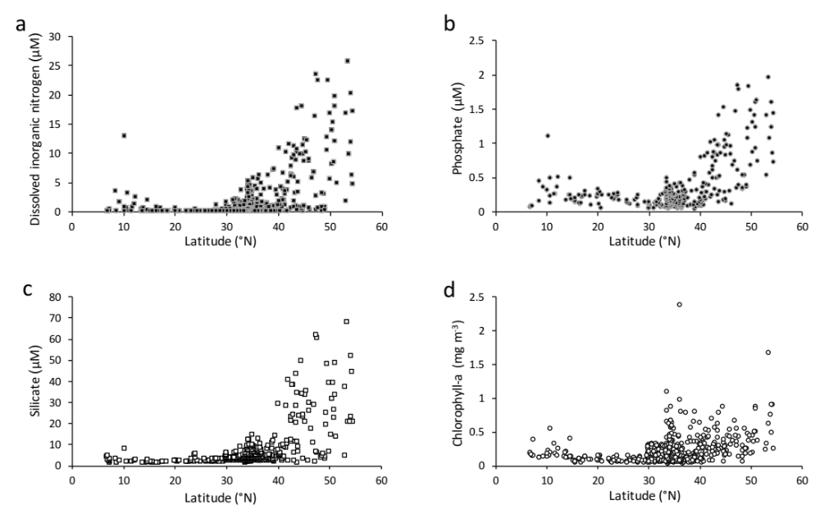
Figure S2. Latitudinal patterns of dissolved inorganic nitrogen (a), phosphate (b), silicate(c), and chlorophyll-a (d) in the sampling stations.
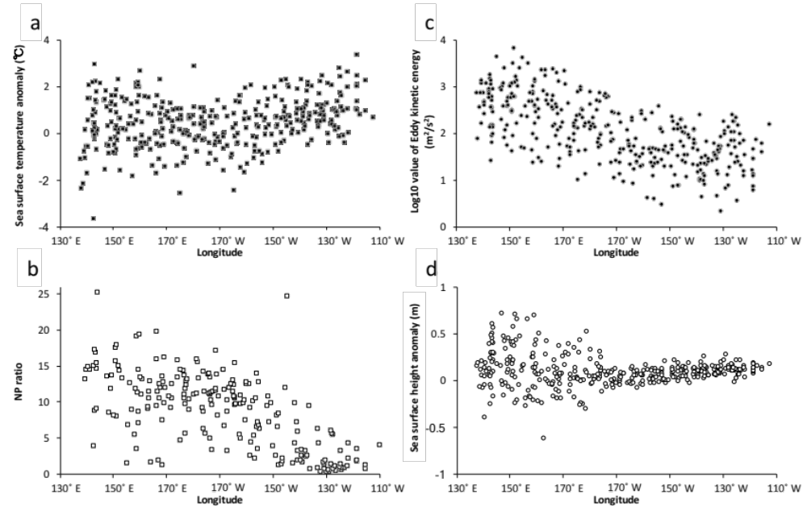

Figure S3. Longitudinal patterns of sea surface temperature anomaly (a), NP ratio (b), eddy kinetic energy (c), and sea surface height anomaly (d) in the sampling stations.

Figure S4. Average sea surface salinity in 4 seasons during the sampling period (2014-2016). The salinity contour lines of 33.8 (black) and 34.8 (white) in the subtropical North Pacific indicate the southern boundary of subarctic frontal zone and northern boundary of subtropical frontal zone. The regions of subarctic gyre (SG), North Pacific transition zone (NPTZ) and North Pacific subtropical gyre (NPSG) were labeled with their abbreviations. The sampling stations are indicated by black crosses. Detailed information of the sampling stations is listed in Table S1.

Figure S5. Boxplots showing latitudinal patterns of diazotroph abundance in different seasons. The latitudinal ranges which were not sampled in particular season were labeled with gray color.

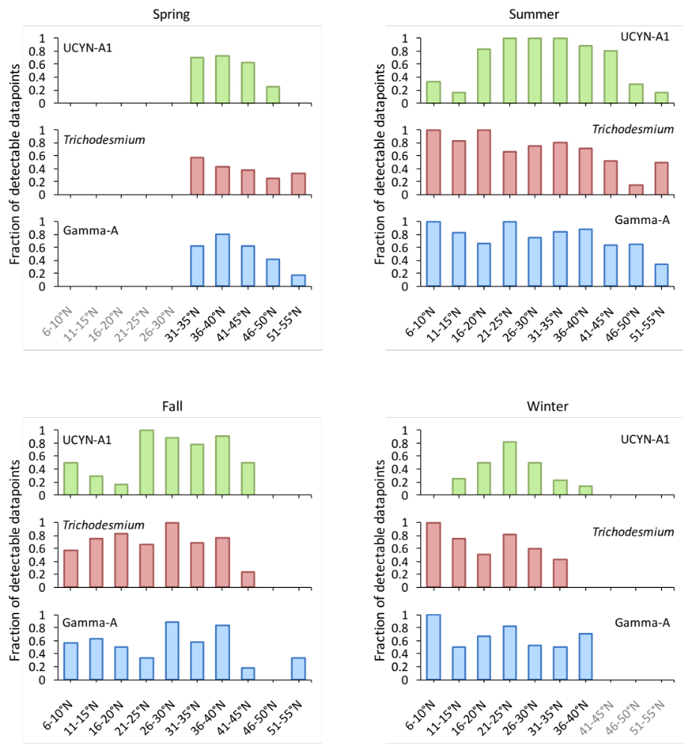

Figure S6. Bar charts showing fraction of detectable data points of diazotroph abundance in different seasons. The latitudinal ranges which were not sampled in particular season were labeled with gray color.

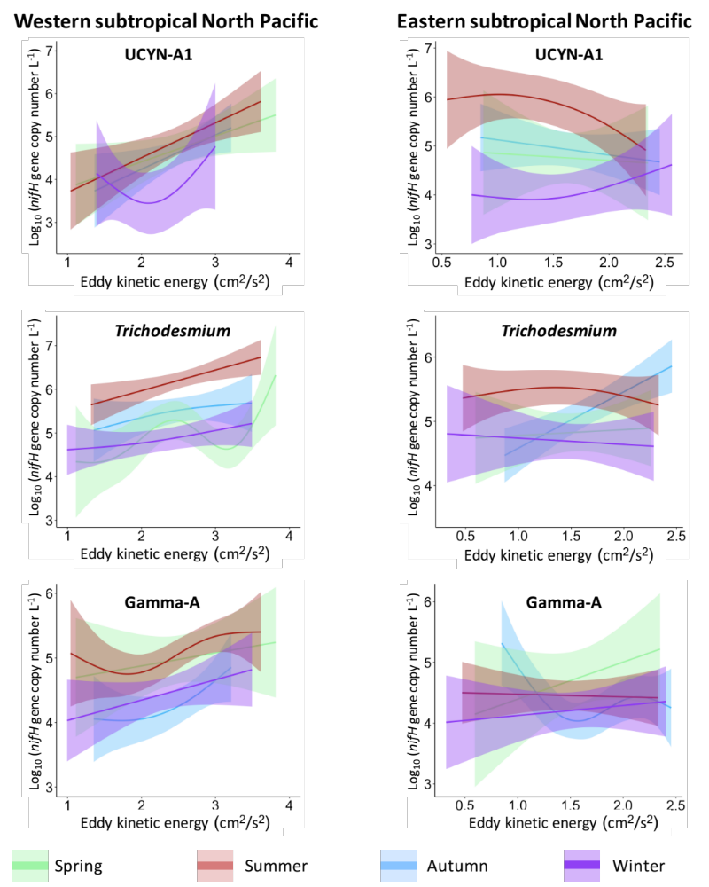

Figure S7. Result of general additive models showing the seasonal relationship between diazotroph abundance and eddy kinetic energy in western subtropical North Pacific and eastern subtropical North Pacific.

Table S1. Detailed information of the sampling stations, including dates, locations, diazotroph abundances and environmental parameters.

Reference

Roden, G. I. (1991). Subarctic-subtropical transition zone of the North Pacific: large-scale aspects and mesoscale structure. NOAA Technical Report NMFS, 105, 1-38.

