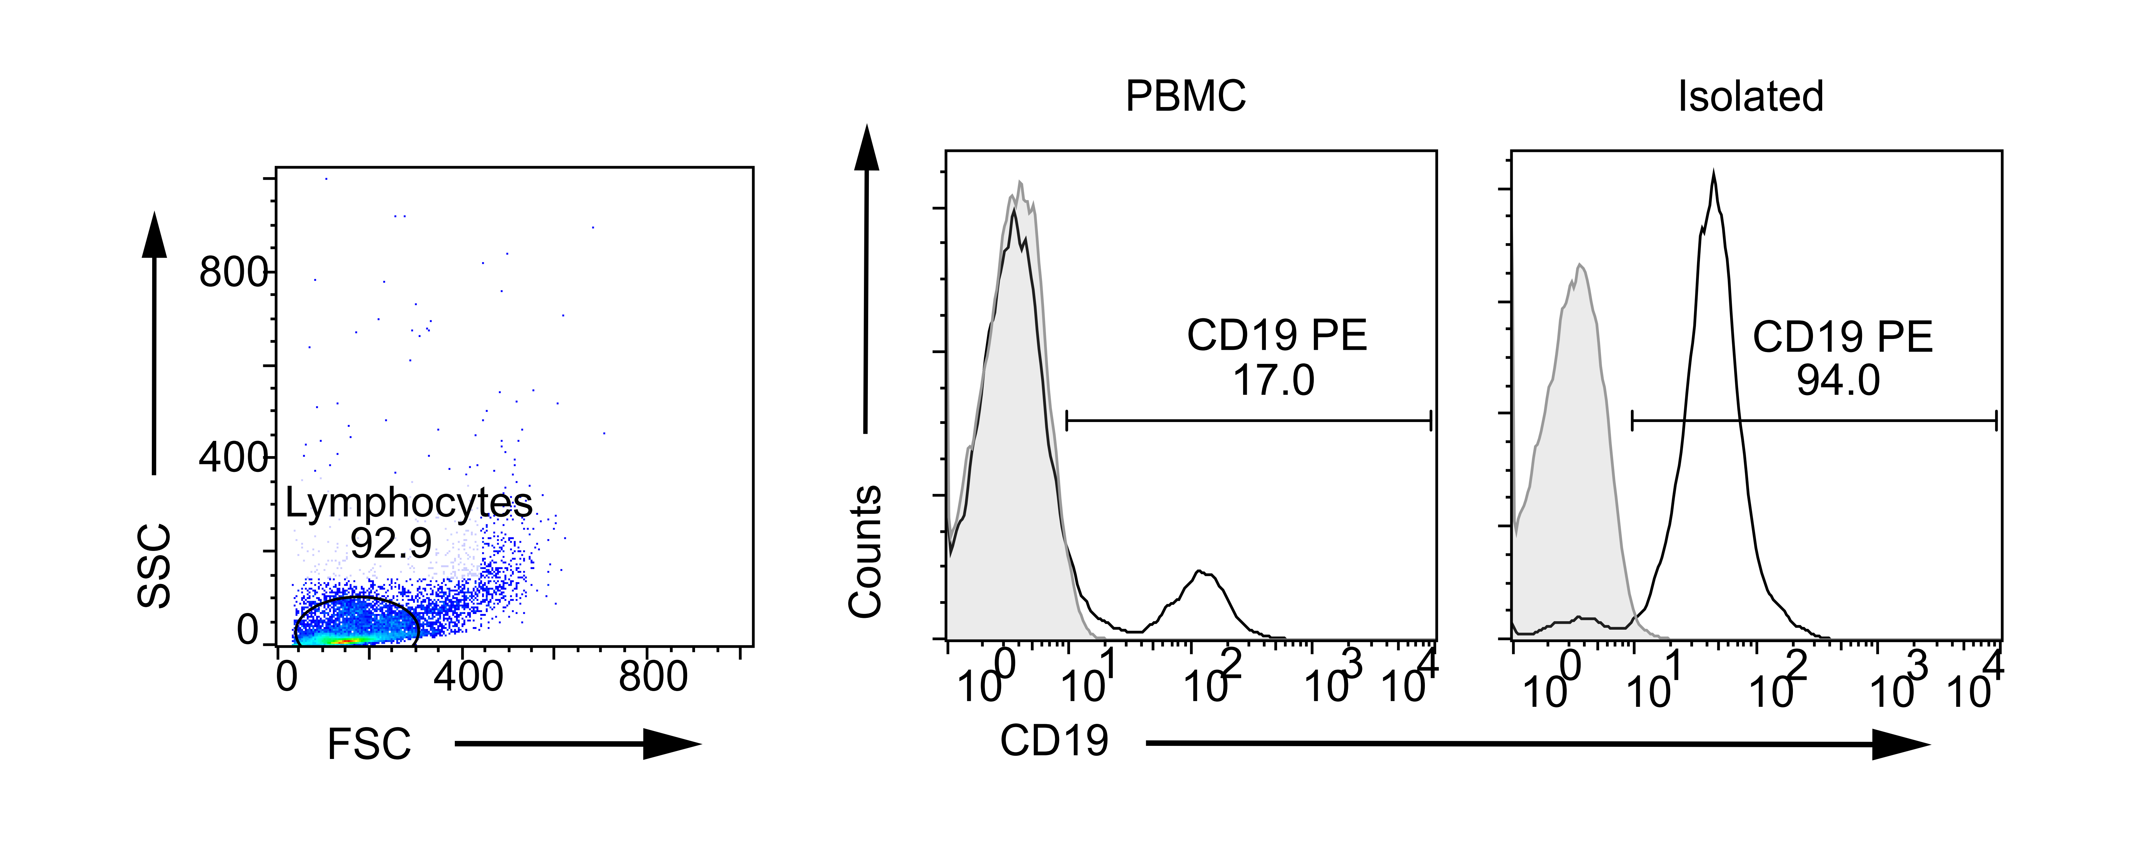
Figure S1. B cells were isolated from patient’s peripheral blood. Purity of isolated cells were above 90%. PBMC: peripheral blood mononuclear cells

Figure S2. Effects of autophagy induction by proteasome inhibition on citrullination of intracellular VIM in synovial fibroblasts (SFs). Rheumatoid arthritis (RA) and osteoarthritis (OA) SFs were left untreated or treated with the proteasome inhibitor MG132 with the indicated concentrations and their lysates were immunoblotted using anti -citrullinated VIM (cVIM) or -LC3 antibody as a primary antibody. Blots are representative of 4 experiments, respectively (A and C)). Densitometric analysis of A and C. Autophagy activity and cVIM were evaluated by LC3-II:ACTB/β-actin and cVIM:ACTB ratio, respectively (B and D). RASFs and OASFs were left untreated or treated with 10 μM MG132 in the presence or absence of 5 mM 3-methyladenine (3-MA), an autophagy inhibitor, and their lysates were immunoblotted. Blots are representative of 4 independent experiments (E and G). Densitometric analysis of E and G (F and H). Values are presented as mean ± S.D. *= P <0.05.
Figure S3. Immunocytochemical analysis of the co-expression of human leukocyte antigen (HLA)-DR-citrullinated VIM (cVIM) in synovial fibroblasts (SFs). cVIM (green), HLA-DR (red) were visualized and nuclei were stained with DAPI (blue). RASFs and OASFs were left untreated (control) or treated with 100 ng/mL IFNG for 72 h followed by proteasome inhibition with 10 μM of proteasome inhibitor MG132 in the last 24 h (MG132+ IFNG). Scale bar: 50 μm

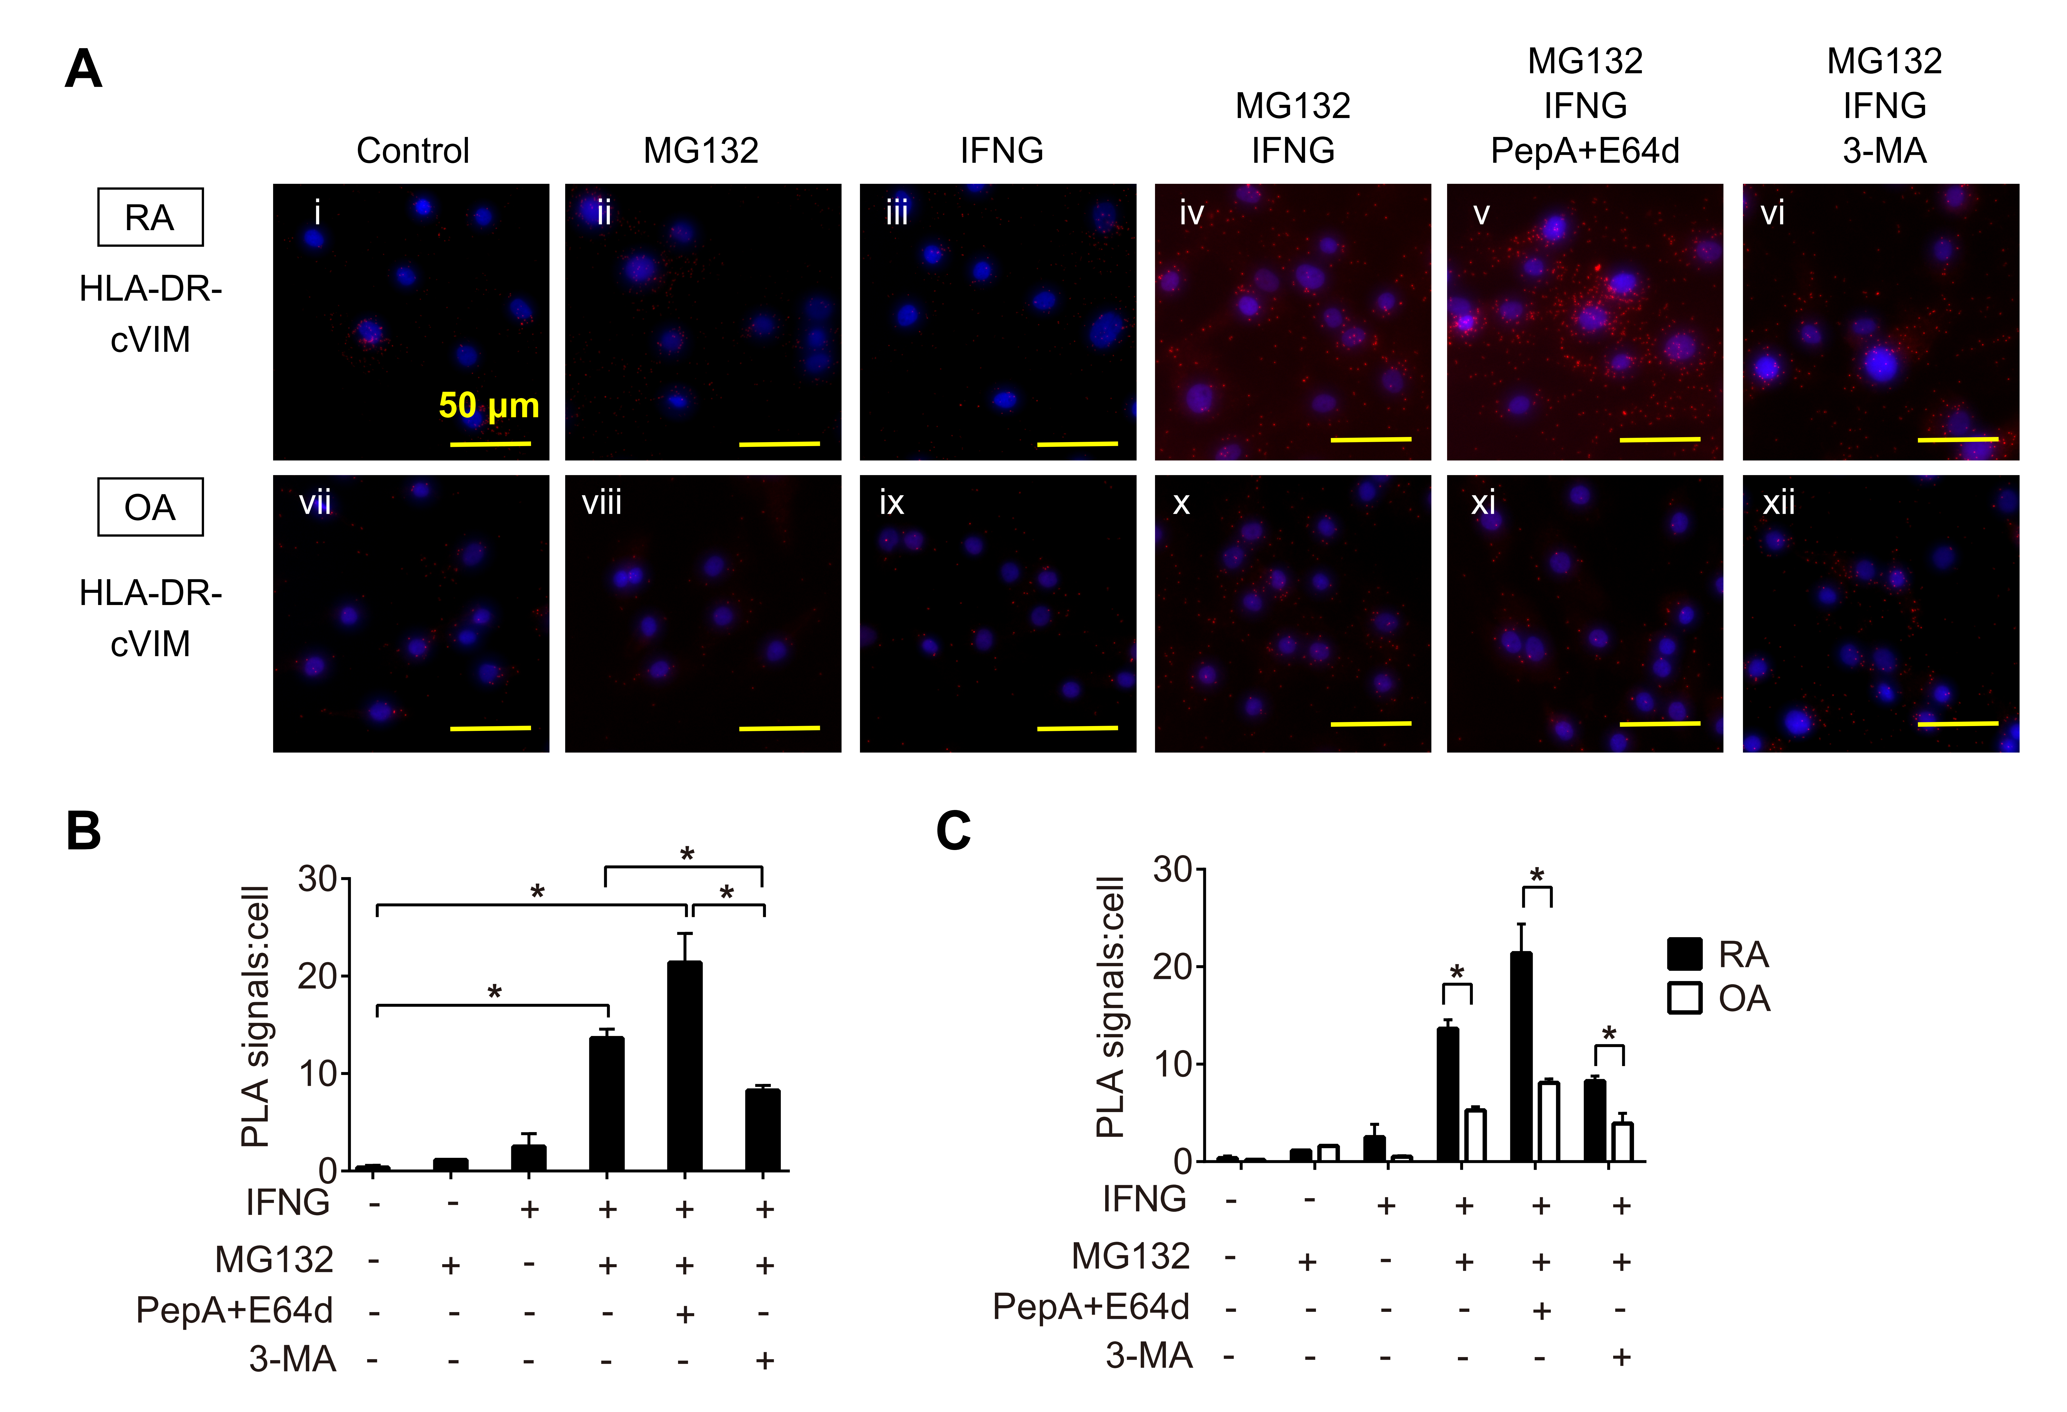
Figure S4. Proximity ligation assay to demonstrate the formation of human leukocyte antigen (HLA)-DR-c-VIM complexes. RA and OA synovial fibroblasts (SFs) were left untreated (control), treated with 10 μM of proteasome inhibitor MG132, or treated with combination of 100 ng/mL IFNG (interferon-gamma) in the presence or absence 3-methyladenine (3-MA) or combination of 10 μM of lysosomal protease inhibitors pepstatin A (PepA) and 10 μM of E64d Figures are representative images of 3 independent experiments using cells from 3 different patients (A). Quantification of HLA-DR-cVIM PLA complexes in RASFs (B). Values are presented as mean PLA signal per cell ± S.D *= P <0.05. Comparison the quantification of HLA-DR-cVIM PLA complexes in RASFs and OASFs (C). Values are presented as mean PLA signal per cell ± S.D *= P <0.05. Scale bar: 50 μm

Figure S5. Effectiveness of siRNA mediated knockdown of endogenous BECN1, ATG5 and ATG7 in RASFs. Control siRNA and targeted siRNAs were introduced into RASFs. After 24 h, transcripts levels of BECN1 (left), ATG5 (middle) and ATG7 (right) were measured by qRT-PCR (A) Relative expression of mRNAs were presented as mean ± S.D *= P <0.05. After 48 h, lysates of SFs were immunoblotted (B).

