Supporting Information

Molecular motion of halogenated ethylammonium / [18]crown-6 supramolecular ions in nickel dithiolate magnetic crystals

Naohiro Hasuo, Kiyonori Takahashi, Kenta Kokado, Ichiro Hisaki, and Takayoshi Nakamura

Table of Contents
§1. Crystal data, data collection and reduction parameter.
§2. Crystallographically independent molecules with atom numbering
§3. Packing structures of crystals 2-4.
§4. Detailed analysis of structures of crystals 1-4.
§5. Temperature- and frequency-dependent dielectric constants for crystals 1-4
§6. Transfer integrals between [Ni(dmit)₂]– molecules in crystals 1-4.

§1. Crystal data, crystal data, data collection, and reduction parameter.
Table S1. Crystal data, data collection, and reduction parameter for crystals 1, 2, 3 and 4 at the lowest temperatures.
 | 1@113K | 2@93K | 3@93K | 4@106K
Temperature / K | 113 | 93 | 93 | 106
Crystal Dimensions / mm³ | 0.724×0.378×0.207 | 0.507×0.211×0.090 | 0.69×0.60×0.18 | 0.40×0.11×0.07
Chemical formula | C₂₀H₃₂NNiO₆S₁₀ | C₂₀H₃₁FNNiO₆S₁₀ | C₂₀H₃₁ClNNiO₆S₁₀ | C₂₀H₃₁BrNNiO₆S₁₀
Formula weight | 761.77 | 779.77 | 796.22 | 840.73
Crystal System | Triclinic | Triclinic | Triclinic | Triclinic
Space group | P-1 | P-1 | P-1 | P-1
a / Å | 11.1765(4) | 10.3645(3) | 11.2107(3) | 10.9869(3)
b / Å | 12.2812(3) | 12.6254(5) | 12.3150(2) | 12.0485(4)
c / Å | 12.6527(4) | 12.9123(4) | 12.7451(3) | 13.7559(5)
α / deg | 87.364(2) | 69.835(3) | 92.2792(18) | 115.833(4)
β / deg | 68.465(3) | 79.972(3) | 112.126(2) | 91.587(3)
γ / deg | 80.094(2) | 79.948(3) | 96.0601(18) | 100.906(3)
V / Å³ | 1591.12(9) | 1549.82(10) | 1614.83(7) | 1596.83(10)
Z | 2 | 2 | 2 | 2
D_{calc} / g∙cm⁻³ | 1.590 | 1.671 | 1.638 | 1.748
μ(Mo Kα) / cm⁻¹ | 1.302 | 1.343 | 1.366 | 2.549
2θ_{max} / deg | 61.784 | 61.986 | 61.838 | 61.140
Reflections measured | 22773 | 18605 | 45358 | 19669
Independent reflections | 7934 | 7679 | 8651 | 7891
Reflections used | 7934 | 7679 | 8651 | 7891
R₁ ª | 0.0357 | 0.0324 | 0.0495 | 0.0356
R_{w} (F²) ^{b} | 0.0980 | 0.0792 | 0.1395 | 0.0703
GOF | 1.051 | 1.070 | 1.098 | 0.995
CCDC number | 2053279 | 2053282 | 2053390 | 2053298
ª R₁ = ∑||F_{o}| - |F_{c}|| / ∑|F_{o}| and ^{b} R_{w} = (∑ω(|F_{o}| - |F_{c}|)² / ∑ωF_{o}²)^{1/2}.

Table S2. Crystal data, data collection, and reduction parameter for crystal 1.
Temperature / K | 293
Crystal Dimensions / mm³ | 0.724×0.378×0.207
Chemical formula | C₂₀H₃₂NNiO₆S₁₀
Formula weight | 761.77
Crystal System | Triclinic
Space group | P-1
a / Å | 11.2486(6)
b / Å | 12.3540(8)
c / Å | 12.7375(8)
α / deg | 87.498(5)
β / deg | 69.343(6)
γ / deg | 80.758(5)
V / Å³ | 1634.62(18)
Z | 2
D_{calc} / g∙cm⁻³ | 1.548
μ(Mo Kα) / cm⁻¹ | 1.267
2θ_{max} / deg | 62.114
Reflections measured | 20189
Independent reflections | 8034
Reflections used | 8034
R₁ ª | 0.0365
R_{w} (F²) ^{b} | 0.0945
GOF | 1.051
CCDC number | 2053280
ª R₁ = ∑||F_{o}| - |F_{c}|| / ∑|F_{o}| and ^{b} R_{w} = (∑ω(|F_{o}| - |F_{c}|)² / ∑ωF_{o}²)^{1/2}.

Table S3. Crystal data, data collection, and reduction parameter for crystal 2 at different temperatures.
 | 2
Temperature / K | 113 | 133 | 153 | 173
Crystal Dimensions / mm³ | 0.507×0.211×0.090 | 0.507×0.211×0.090 | 0.507×0.211×0.090 | 0.507×0.211×0.090
Chemical formula | C₂₀H₃₁FNNiO₆S₁₀ | C₂₀H₃₁FNNiO₆S₁₀ | C₂₀H₃₁FNNiO₆S₁₀ | C₂₀H₃₁FNNiO₆S₁₀
Formula weight | 779.77 | 779.77 | 779.77 | 779.77
Crystal System | Triclinic | Triclinic | Triclinic | Triclinic
Space group | P-1 | P-1 | P-1 | P-1
a / Å | 10.3864(2) | 10.3884(3) | 10.3994(3) | 10.4067(3)
b / Å | 12.6343(5) | 12.6271(4) | 12.6286(5) | 12.6314(5)
c / Å | 12.9338(5) | 12.9344(4) | 12.9431(4) | 12.9479(4)
α / deg | 69.944(3) | 70.113(3) | 70.317(3) | 70.517(3)
β / deg | 79.973(3) | 79.966(2) | 79.956(2) | 79.892(2)
γ / deg | 79.970(3) | 80.068(2) | 80.078(3) | 80.138(3)
V / Å³ | 1557.90(10) | 1559.30(9) | 1564.10(9) | 1567.96(9)
Z | 2 | 2 | 2 | 2
D_{calc} / g∙cm⁻³ | 1.662 | 1.661 | 1.656 | 1.650
μ(Mo Kα) / cm⁻¹ | 1.336 | 1.335 | 1.331 | 1.327
2θ_{max} / deg | 62.114 | 61.916 | 61.652 | 61.248
Reflections measured | 19702 | 19502 | 19288 | 19026
Independent reflections | 7645 | 7689 | 7694 | 7718
Reflections used | 7645 | 7689 | 7694 | 7718
R₁ ª | 0.0329 | 0.0386 | 0.0340 | 0.0366
R_{w} (F²) ^{b} | 0.0806 | 0.0941 | 0.0865 | 0.0925
GOF | 1.054 | 0.990 | 1.075 | 1.075
CCDC number | 2053283 | 2053284 | 2053285 | 2053286
ª R₁ = ∑||F_{o}| - |F_{c}|| / ∑|F_{o}| and ^{b} R_{w} = (∑ω(|F_{o}| - |F_{c}|)² / ∑ωF_{o}²)^{1/2}.

 | 2
Temperature / K | 193 | 213 | 233 | 253
Crystal Dimensions / mm³ | 0.507×0.211×0.090 | 0.507×0.211×0.090 | 0.507×0.211×0.090 | 0.507×0.211×0.090
Chemical formula | C₂₀H₃₁FNNiO₆S₁₀ | C₂₀H₃₁FNNiO₆S₁₀ | C₂₀H₃₁FNNiO₆S₁₀ | C₂₀H₃₁FNNiO₆S₁₀
Formula weight | 779.77 | 779.77 | 779.77 | 779.77
Crystal System | Triclinic | Triclinic | Triclinic | Triclinic
Space group | P-1 | P-1 | P-1 | P-1
a / Å | 10.4204(3) | 10.4363(3) | 10.4520(3) | 10.4754(3)
b / Å | 12.6319(4) | 12.6370(4) | 12.6374(4) | 12.6503(4)
c / Å | 12.9511(4) | 12.9511(4) | 12.9527(4) | 12.9637(4)
α / deg | 70.735(3) | 70.974(3) | 71.178(3) | 71.385(3)
β / deg | 79.898(2) | 79.852(2) | 79.806(2) | 79.802(2)
γ / deg | 80.250(2) | 80.316(2) | 80.408(2) | 80.550(2)
V / Å³ | 1572.90(9) | 1578.17(8) | 1582.77(9) | 1591.61(9)
Z | 2 | 2 | 2 | 2
D_{calc} / g∙cm⁻³ | 1.646 | 1.641 | 1.636 | 1.627
μ(Mo Kα) / cm⁻¹ | 1.323 | 1.319 | 1.315 | 1.308
2θ_{max} / deg | 61.70 | 61.50 | 62.07 | 61.34
Reflections measured | 19734 | 19305 | 19876 | 19688
Independent reflections | 7797 | 7814 | 7847 | 7844
Reflections used | 7797 | 7814 | 7847 | 7844
R₁ ª | 0.0414 | 0.0336 | 0.0335 | 0.0343
R_{w} (F²) ^{b} | 0.1011 | 0.0838 | 0.0864 | 0.0810
GOF | 1.016 | 1.050 | 1.044 | 1.047
CCDC number | 2053287 | 2053288 | 2053289 | 2053290
ª R₁ = ∑||F_{o}| - |F_{c}|| / ∑|F_{o}| and ^{b} R_{w} = (∑ω(|F_{o}| - |F_{c}|)² / ∑ωF_{o}²)^{1/2}.

 | 2
Temperature / K | 273 | 293 | 313 | 333
Crystal Dimensions / mm³ | 0.507×0.211×0.090 | 0.507×0.211×0.090 | 0.507×0.211×0.090 | 0.507×0.211×0.090
Chemical formula | C₂₀H₃₁FNNiO₆S₁₀ | C₂₀H₃₁FNNiO₆S₁₀ | C₂₀H₃₁FNNiO₆S₁₀ | C₂₀H₃₁FNNiO₆S₁₀
Formula weight | 779.77 | 779.77 | 779.77 | 779.77
Crystal System | Triclinic | Triclinic | Triclinic | Triclinic
Space group | P-1 | P-1 | P-1 | P-1
a / Å | 10.4883(2) | 10.5115(3) | 10.5377(3) | 10.5475(3)
b / Å | 12.6467(3) | 12.6531(4) | 12.6697(3) | 12.6632(3)
c / Å | 12.9675(3) | 12.9821(3) | 13.0079(4) | 13.0124(4)
α / deg | 71.543(2) | 71.701(2) | 71.903(2) | 72.091(3)
β / deg | 79.792(2) | 79.787(2) | 79.822(2) | 79.842(3)
γ / deg | 80.656(2) | 80.782(2) | 80.956(2) | 81.154(2)
V / Å³ | 1595.30(6) | 1603.24(8) | 1615.05(8) | 1618.65(8)
Z | 2 | 2 | 2 | 2
D_{calc} / g∙cm⁻³ | 1.623 | 1.615 | 1.603 | 1.600
μ(Mo Kα) / cm⁻¹ | 1.305 | 1.298 | 1.289 | 1.286
2θ_{max} / deg | 61.89 | 61.438 | 58.006 | 57.812
Reflections measured | 39570 | 20112 | 17913 | 19117
Independent reflections | 8451 | 7909 | 7336 | 7320
Reflections used | 8451 | 7909 | 7336 | 7320
R₁ ª | 0.0357 | 0.0336 | 0.0354 | 0.0383
R_{w} (F²) ^{b} | 0.1327 | 0.0801 | 0.0855 | 0.0986
GOF | 0.870 | 1.055 | 1.042 | 1.077
CCDC number | 2053291 | 2053292 | 2053293 | 2053294
ª R₁ = ∑||F_{o}| - |F_{c}|| / ∑|F_{o}| and ^{b} R_{w} = (∑ω(|F_{o}| - |F_{c}|)² / ∑ωF_{o}²)^{1/2}.

 | 2
Temperature / K | 353 | 373
Crystal Dimensions / mm³ | 0.507×0.211×0.090 | 0.507×0.211×0.090
Chemical formula | C₂₀H₃₁FNNiO₆S₁₀ | C₂₀H₃₁FNNiO₆S₁₀
Formula weight | 779.77 | 779.77
Crystal System | Triclinic | Triclinic
Space group | P-1 | P-1
a / Å | 10.5673(4) | 10.5742(7)
b / Å | 12.6724(4) | 12.6426(7)
c / Å | 13.0358(6) | 13.0305(11)
α / deg | 72.219(4) | 72.446(6)
β / deg | 79.801(4) | 79.808(6)
γ / deg | 81.293(3) | 81.420(5)
V / Å³ | 1627.17(12) | 1626.1(2)
Z | 2 | 2
D_{calc} / g∙cm⁻³ | 1.592 | 1.593
μ(Mo Kα) / cm⁻¹ | 1.279 | 1.280
2θ_{max} / deg | 58.162 | 58.054
Reflections measured | 18534 | 18911
Independent reflections | 7331 | 7413
Reflections used | 7331 | 7413
R₁ ª | 0.0459 | 0.0514
R_{w} (F²) ^{b} | 0.1373 | 0.1505
GOF | 0.911 | 0.911
CCDC number | 2053295 | 2053296
ª R₁ = ∑||F_{o}| - |F_{c}|| / ∑|F_{o}| and ^{b} R_{w} = (∑ω(|F_{o}| - |F_{c}|)² / ∑ωF_{o}²)^{1/2}.

Table S4. Crystal data, data collection, and reduction parameter for crystal 3 at different temperatures.

 | 3
Temperature / K | 113 | 133 | 153 | 173
Crystal Dimensions / mm³ | 0.69×0.60×0.18 | 0.69×0.60×0.18 | 0.69×0.60×0.18 | 0.290×0.249×0.157
Chemical formula | C₂₀H₃₁ClNNiO₆S₁₀ | C₂₀H₃₁ClNNiO₆S₁₀ | C₂₀H₃₁ClNNiO₆S₁₀ | C₂₀H₃₁ClNNiO₆S₁₀
Formula weight | 796.22 | 796.22 | 796.22 | 796.22
Crystal System | Triclinic | Triclinic | Triclinic | Triclinic
Space group | P-1 | P-1 | P-1 | P-1
a / Å | 11.2193(3) | 11.2216(3) | 11.2185(3) | 11.2452(2)
b / Å | 12.3191(2) | 12.3162(3) | 12.3084(3) | 12.3442(2)
c / Å | 12.7473(3) | 12.7541(3) | 12.7536(3) | 12.8113(2)
α / deg | 92.239(2) | 92.155(2) | 92.083(2) | 91.8320(10)
β / deg | 111.956(2) | 111.864(2) | 111.733(2) | 111.4310(10)
γ / deg | 96.066(2) | 96.100(2) | 96.128(2) | 96.2430(10)
V / Å³ | 1618.98(7) | 1620.96(7) | 1621.02(7) | 1640.65(5)
Z | 2 | 2 | 2 | 2
D_{calc} / g∙cm⁻³ | 1.633 | 1.631 | 1.631 | 1.612
μ(Mo Kα) / cm⁻¹ | 1.363 | 1.361 | 1.361 | 7.865
2θ_{max} / deg | 52.742 | 52.744 | 61.84 | 144.97
Reflections measured | 37298 | 35045 | 41879 | 39675
Independent reflections | 6613 | 6623 | 8598 | 6266
Reflections used | 6613 | 6623 | 8598 | 6266
R₁ ª | 0.0446 | 0.0419 | 0.0438 | 0.0385
R_{w} (F²) ^{b} | 0.1268 | 0.1168 | 0.1217 | 0.1156
GOF | 1.077 | 1.056 | 1.068 | 1.020
CCDC number | 2053392 | 2053393 | 2053394 | 2053395
ª R₁ = ∑||F_{o}| - |F_{c}|| / ∑|F_{o}| and ^{b} R_{w} = (∑ω(|F_{o}| - |F_{c}|)² / ∑ωF_{o}²)^{1/2}.

 | 3
Temperature / K | 193 | 213 | 233 | 253
Crystal Dimensions / mm³ | 0.371×0.624×0.961 | 0.290×0.249×0.157 | 0.290×0.249×0.157 | 0.290×0.249×0.157
Chemical formula | C₂₀H₃₁ClNNiO₆S₁₀ | C₂₀H₃₁ClNNiO₆S₁₀ | C₂₀H₃₁ClNNiO₆S₁₀ | C₂₀H₃₁ClNNiO₆S₁₀
Formula weight | 796.22 | 796.22 | 796.22 | 796.22
Crystal System | Triclinic | Triclinic | Triclinic | Triclinic
Space group | P-1 | P-1 | P-1 | P-1
a / Å | 11.25474(18) | 11.2637(2) | 11.27140(10) | 11.27840(10)
b / Å | 12.34881(18) | 12.34200(10) | 12.34060(10) | 12.34600(10)
c / Å | 12.82304(17) | 12.8337(2) | 12.84520(10) | 12.86190(10)
α / deg | 91.7415(11) | 91.3720(10) | 91.2410(10) | 91.1450(10)
β / deg | 111.2915(14) | 110.9960(10) | 110.8230(10) | 110.6780(10)
γ / deg | 96.3016(12) | 96.4500(10) | 96.4520(10) | 96.4220(10)
V / Å³ | 1645.75(4) | 1651.13(4) | 1655.78(3) | 1661.63(3)
Z | 2 | 2 | 2 | 2
D_{calc} / g∙cm⁻³ | 1.607 | 1.602 | 1.597 | 1.591
μ(Mo Kα) / cm⁻¹ | 1.341 | 7.815 | 7.793 | 7.765
2θ_{max} / deg | 58.252 | 145.476 | 146.17 | 144.498
Reflections measured | 33190 | 42270 | 41408 | 41385
Independent reflections | 7803 | 6349 | 6351 | 6340
Reflections used | 7803 | 6349 | 6351 | 6340
R₁ ª | 0.0347 | 0.0310 | 0.0321 | 0.0271
R_{w} (F²) ^{b} | 0.0910 | 0.0815 | 0.0845 | 0.0763
GOF | 1.084 | 1.034 | 1.052 | 1.053
CCDC number | 2053396 | 2053397 | 2053398 | 2053399
ª R₁ = ∑||F_{o}| - |F_{c}|| / ∑|F_{o}| and ^{b} R_{w} = (∑ω(|F_{o}| - |F_{c}|)² / ∑ωF_{o}²)^{1/2}.

 | 3
Temperature / K | 273 | 293 | 313 | 333
Crystal Dimensions / mm³ | 0.69×0.60×0.18 | 0.371×0.624×0.961 | 0.371×0.624×0.961 | 0.69×0.60×0.18
Chemical formula | C₂₀H₃₁ClNNiO₆S₁₀ | C₂₀H₃₁ClNNiO₆S₁₀ | C₂₀H₃₁ClNNiO₆S₁₀ | C₂₀H₃₁ClNNiO₆S₁₀
Formula weight | 796.22 | 796.22 | 796.22 | 796.22
Crystal System | Triclinic | Triclinic | Triclinic | Triclinic
Space group | P-1 | P-1 | P-1 | P-1
a / Å | 11.2803(3) | 11.2892(3) | 11.3149(3) | 11.3046(5)
b / Å | 12.3375(2) | 12.3438(3) | 12.3589(3) | 12.3319(4)
c / Å | 12.8611(3) | 12.8805(3) | 12.9090(3) | 12.9008(6)
α / deg | 91.103(2) | 91.047(2) | 90.9686(19) | 90.991(3)
β / deg | 110.634(2) | 110.467(2) | 110.340(2) | 110.208(4)
γ / deg | 96.375(2) | 96.326(2) | 96.269(2) | 96.173(3)
V / Å³ | 1661.43(7) | 1668.26(7) | 1679.59(8) | 1675.11(13)
Z | 2 | 2 | 2 | 2
D_{calc} / g∙cm⁻³ | 1.592 | 1.583 | 1.574 | 1.579
μ(Mo Kα) / cm⁻¹ | 1.328 | 1.322 | 1.314 | 1.317
2θ_{max} / deg | 62.142 | 58.016 | 58.032 | 52.744
Reflections measured | 49247 | 32304 | 32926 | 27105
Independent reflections | 8848 | 7906 | 7989 | 6845
Reflections used | 8848 | 7906 | 7989 | 6845
R₁ ª | 0.0389 | 0.0366 | 0.0389 | 0.0516
R_{w} (F²) ^{b} | 0.1292 | 0.1064 | 0.1150 | 0.1420
GOF | 1.015 | 1.015 | 0.996 | 0.986
CCDC number | 2053391 | 2053400 | 2053401 | 2053402
ª R₁ = ∑||F_{o}| - |F_{c}|| / ∑|F_{o}| and ^{b} R_{w} = (∑ω(|F_{o}| - |F_{c}|)² / ∑ωF_{o}²)^{1/2}.

 | 3
Temperature / K | 353 | 373
Crystal Dimensions / mm³ | 0.69×0.60×0.18 | 0.371×0.624×0.961
Chemical formula | C₂₀H₃₁ClNNiO₆S₁₀ | C₂₀H₃₁ClNNiO₆S₁₀
Formula weight | 796.22 | 796.22
Crystal System | Triclinic | Triclinic
Space group | P-1 | P-1
a / Å | 11.3244(5) | 11.3571(2)
b / Å | 12.3495(4) | 12.3603(2)
c / Å | 12.9385(6) | 12.9511(3)
α / deg | 90.918(3) | 90.864(2)
β / deg | 110.128(4) | 109.988(2)
γ / deg | 96.018(3) | 95.958(2)
V / Å³ | 1686.95(13) | 1696.81(6)
Z | 2 | 2
D_{calc} / g∙cm⁻³ | 1.568 | 1.558
μ(Mo Kα) / cm⁻¹ | 1.308 | 1.300
2θ_{max} / deg | 58.424 | 58.26
Reflections measured | 30129 | 33505
Independent reflections | 8054 | 8059
Reflections used | 8054 | 8059
R₁ ª | 0.0559 | 0.0396
R_{w} (F²) ^{b} | 0.1553 | 0.1222
GOF | 0.916 | 0.968
CCDC number | 2053403 | 2053404
ª R₁ = ∑||F_{o}| - |F_{c}|| / ∑|F_{o}| and ^{b} R_{w} = (∑ω(|F_{o}| - |F_{c}|)² / ∑ωF_{o}²)^{1/2}.

Table S5. Crystal data, data collection, and reduction parameter for crystal 4 at different temperatures.
 | 4
Temperature / K | 113 | 133 | 153 | 173
Crystal Dimensions / mm³ | 0.40×0.11×0.07 | 0.40×0.11×0.07 | 0.40×0.11×0.07 | 0.40×0.11×0.07
Chemical formula | C₂₀H₃₁BrNNiO₆S₁₀ | C₂₀H₃₁BrNNiO₆S₁₀ | C₂₀H₃₁BrNNiO₆S₁₀ | C₂₀H₃₁BrNNiO₆S₁₀
Formula weight | 840.68 | 840.68 | 840.68 | 840.68
Crystal System | Triclinic | Triclinic | Triclinic | Triclinic
Space group | P-1 | P-1 | P-1 | P-1
a / Å | 10.9810(3) | 11.0117(3) | 11.0165(3) | 11.0374(3)
b / Å | 12.0448(3) | 12.0652(3) | 12.0569(4) | 12.0627(3)
c / Å | 13.7409(4) | 13.7791(4) | 13.7786(4) | 13.7656(4)
α / deg | 115.825(3) | 115.895(3) | 64.116(3) | 64.349(3)
β / deg | 91.535(2) | 91.351(2) | 79.239(3) | 79.574(2)
γ / deg | 100.927(2) | 101.004(2) | 78.965(2) | 78.920(2)
V / Å³ | 1593.91(8) | 1604.68(8) | 1605.03(9) | 1611.42(9)
Z | 2 | 2 | 2 | 2
D_{calc} / g∙cm⁻³ | 1.747 | 1.740 | 1.739 | 1.733
μ(Mo Kα) / cm⁻¹ | 2.554 | 2.537 | 2.536 | 2.526
2θ_{max} / deg | 62.086 | 61.834 | 62.064 | 62.062
Reflections measured | 38281 | 38326 | 39974 | 40700
Independent reflections | 8378 | 8423 | 8484 | 8560
Reflections used | 8378 | 8423 | 8484 | 8560
R₁ ª | 0.0315 | 0.0325 | 0.0337 | 0.0333
R_{w} (F²) ^{b} | 0.0677 | 0.0677 | 0.0706 | 0.0690
GOF | 1.016 | 1.026 | 1.032 | 1.039
CCDC number | 2053299 | 2053300 | 2053301 | 2053302
ª R₁ = ∑||F_{o}| - |F_{c}|| / ∑|F_{o}| and ^{b} R_{w} = (∑ω(|F_{o}| - |F_{c}|)² / ∑ωF_{o}²)^{1/2}.

 | 4
Temperature / K | 193 | 213 | 233 | 253
Crystal Dimensions / mm³ | 0.40×0.11×0.07 | 0.40×0.11×0.07 | 0.40×0.11×0.07 | 0.40×0.11×0.07
Chemical formula | C₂₀H₃₁BrNNiO₆S₁₀ | C₂₀H₃₁BrNNiO₆S₁₀ | C₂₀H₃₁BrNNiO₆S₁₀ | C₂₀H₃₁BrNNiO₆S₁₀
Formula weight | 840.68 | 840.68 | 840.68 | 840.68
Crystal System | Triclinic | Triclinic | Triclinic | Triclinic
Space group | P-1 | P-1 | P-1 | P-1
a / Å | 11.0467(3) | 11.0537(3) | 11.0760(3) | 11.0864(3)
b / Å | 12.0603(3) | 12.0557(3) | 12.0662(3) | 12.0734(3)
c / Å | 13.7505(4) | 13.7262(4) | 13.7164(5) | 13.7103(4)
α / deg | 64.635(3) | 64.890(3) | 65.106(3) | 65.253(3)
β / deg | 79.967(2) | 80.331(2) | 80.573(3) | 80.773(3)
γ / deg | 78.865(2) | 78.815(2) | 78.719(2) | 78.660(2)
V / Å³ | 1615.49(8) | 1617.26(9) | 1623.84(9) | 1627.77(9)
Z | 2 | 2 | 2 | 2
D_{calc} / g∙cm⁻³ | 1.728 | 1.726 | 1.719 | 1.715
μ(Mo Kα) / cm⁻¹ | 2.520 | 2.517 | 2.507 | 2.501
2θ_{max} / deg | 62.048 | 62.122 | 62.116 | 62.16
Reflections measured | 40000 | 40716 | 40270 | 42066
Independent reflections | 8603 | 8593 | 8614 | 8660
Reflections used | 8603 | 8593 | 8614 | 8660
R₁ ª | 0.0375 | 0.0391 | 0.0405 | 0.0377
R_{w} (F²) ^{b} | 0.0851 | 0.0818 | 0.0923 | 0.0875
GOF | 1.073 | 1.039 | 1.019 | 1.039
CCDC number | 2053303 | 2053304 | 2053305 | 2053306
ª R₁ = ∑||F_{o}| - |F_{c}|| / ∑|F_{o}| and ^{b} R_{w} = (∑ω(|F_{o}| - |F_{c}|)² / ∑ωF_{o}²)^{1/2}.

 | 4
Temperature / K | 273 | 293 | 313 | 333
Crystal Dimensions / mm³ | 0.40×0.11×0.07 | 0.40×0.11×0.07 | 0.40×0.11×0.07 | 0.40×0.11×0.07
Chemical formula | C₂₀H₃₁BrNNiO₆S₁₀ | C₂₀H₃₁BrNNiO₆S₁₀ | C₂₀H₃₁BrNNiO₆S₁₀ | C₂₀H₃₁BrNNiO₆S₁₀
Formula weight | 840.68 | 840.68 | 840.68 | 840.68
Crystal System | Triclinic | Triclinic | Triclinic | Triclinic
Space group | P-1 | P-1 | P-1 | P-1
a / Å | 11.1022(4) | 11.1201(5) | 11.1694(4) | 11.1865(5)
b / Å | 12.0838(4) | 12.1021(5) | 12.1413(4) | 12.1459(5)
c / Å | 13.7055(5) | 13.7058(7) | 13.7408(6) | 13.7395(6)
α / deg | 65.348(3) | 65.393(5) | 65.543(4) | 65.630(4)
β / deg | 80.897(3) | 80.958(4) | 81.123(3) | 81.204(4)
γ / deg | 78.557(3) | 78.454(4) | 78.362(3) | 78.269(4)
V / Å³ | 1632.00(11) | 1637.40(15) | 1656.09(12) | 1659.95(14)
Z | 2 | 2 | 2 | 2
D_{calc} / g∙cm⁻³ | 1.709 | 1.705 | 1.686 | 1.682
μ(Mo Kα) / cm⁻¹ | 2.494 | 2.486 | 2.458 | 2.452
2θ_{max} / deg | 62.156 | 62.106 | 58.064 | 58.072
Reflections measured | 41574 | 42141 | 33146 | 34340
Independent reflections | 8724 | 8744 | 7890 | 7868
Reflections used | 8724 | 8744 | 7890 | 7868
R₁ ª | 0.0413 | 0.0431 | 0.0416 | 0.0879
R_{w} (F²) ^{b} | 0.0922 | 0.0958 | 0.0958 | 0.1086
GOF | 1.020 | 1.031 | 1.049 | 1.027
CCDC number | 2053307 | 2053308 | 2053309 | 2053310
ª R₁ = ∑||F_{o}| - |F_{c}|| / ∑|F_{o}| and ^{b} R_{w} = (∑ω(|F_{o}| - |F_{c}|)² / ∑ωF_{o}²)^{1/2}.
.

 | 4
Temperature / K | 353 | 373
Crystal Dimensions / mm³ | 0.40×0.11×0.07 | 0.40×0.11×0.07
Chemical formula | C₂₀H₃₁BrNNiO₆S₁₀ | C₂₀H₃₁BrNNiO₆S₁₀
Formula weight | 840.68 | 840.68
Crystal System | Triclinic | Triclinic
Space group | P-1 | P-1
a / Å | 11.2110(4) | 11.2167(4)
b / Å | 12.1703(4) | 12.1808(4)
c / Å | 13.7456(5) | 13.7373(5)
α / deg | 65.635(3) | 65.696(3)
β / deg | 81.252(3) | 81.308(3)
γ / deg | 78.145(3) | 78.012(3)
V / Å³ | 1667.21(10) | 1668.72(11)
Z | 2 | 2
D_{calc} / g∙cm⁻³ | 1.675 | 1.673
μ(Mo Kα) / cm⁻¹ | 2.442 | 2.439
2θ_{max} / deg | 58.086 | 58.11
Reflections measured | 34600 | 35265
Independent reflections | 7944 | 7932
Reflections used | 7944 | 7932
R₁ ª | 0.0522 | 0.0470
R_{w} (F²) ^{b} | 0.1284 | 0.1118
GOF | 1.016 | 1.008
CCDC number | 2053311 | 2053312
ª R₁ = ∑||F_{o}| - |F_{c}|| / ∑|F_{o}| and ^{b} R_{w} = (∑ω(|F_{o}| - |F_{c}|)² / ∑ωF_{o}²)^{1/2}.

§2. Crystallographically independent molecules with atom numbering
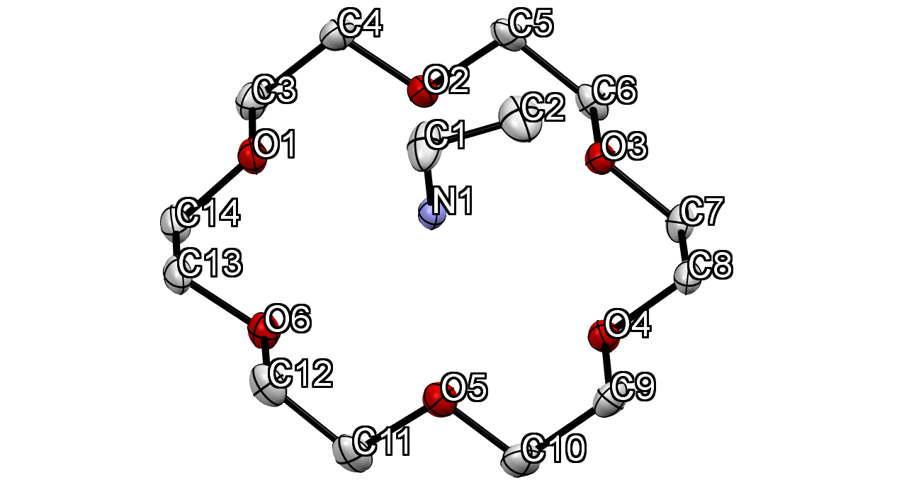
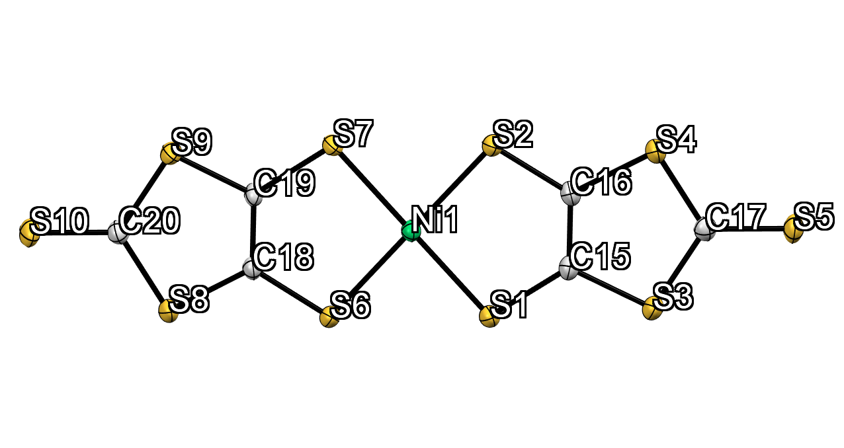
Figure S1. Crystallographically independent molecules in the crystal 1 at 113 K with atomic numbers. Crystallographically independent molecular structure is depicted as ORTEP with 50% thermal ellipsoids probability level. Hydrogen atoms are omitted for clarity.

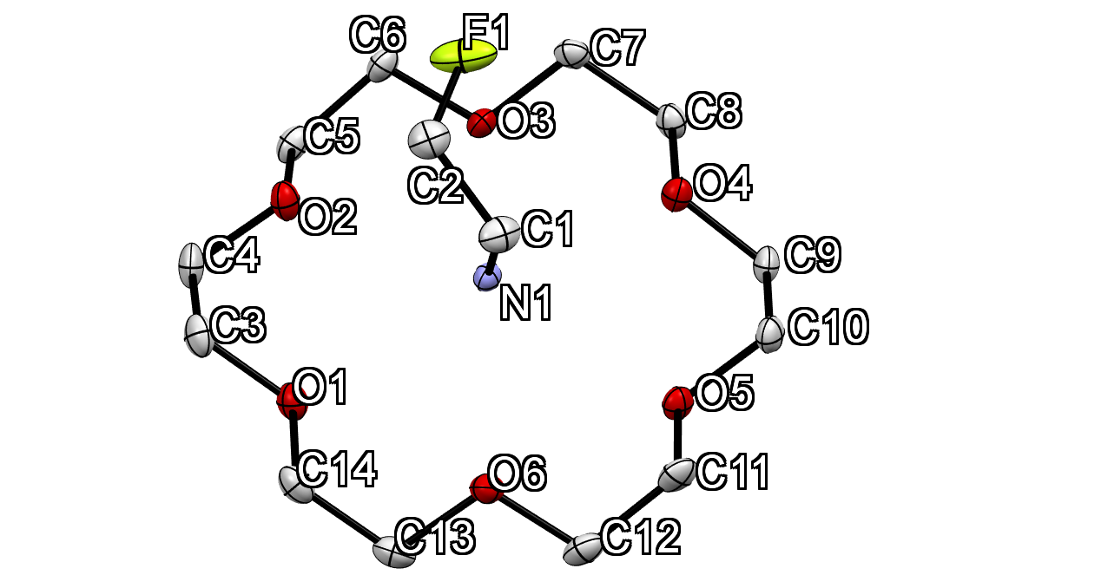
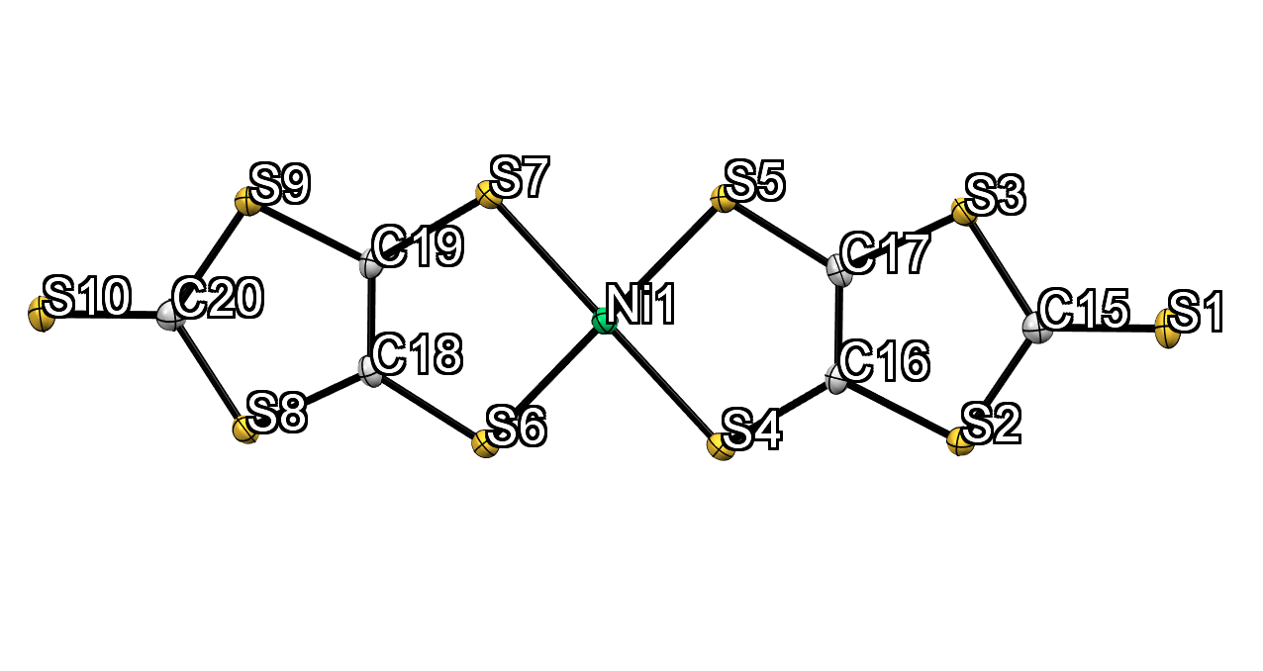
Figure S2. Crystallographically independent molecules in the crystal 2 at 93 K with atomic numbers. The structure is depicted as ORTEP with 50% probability. Hydrogen atoms are omitted for clarity.

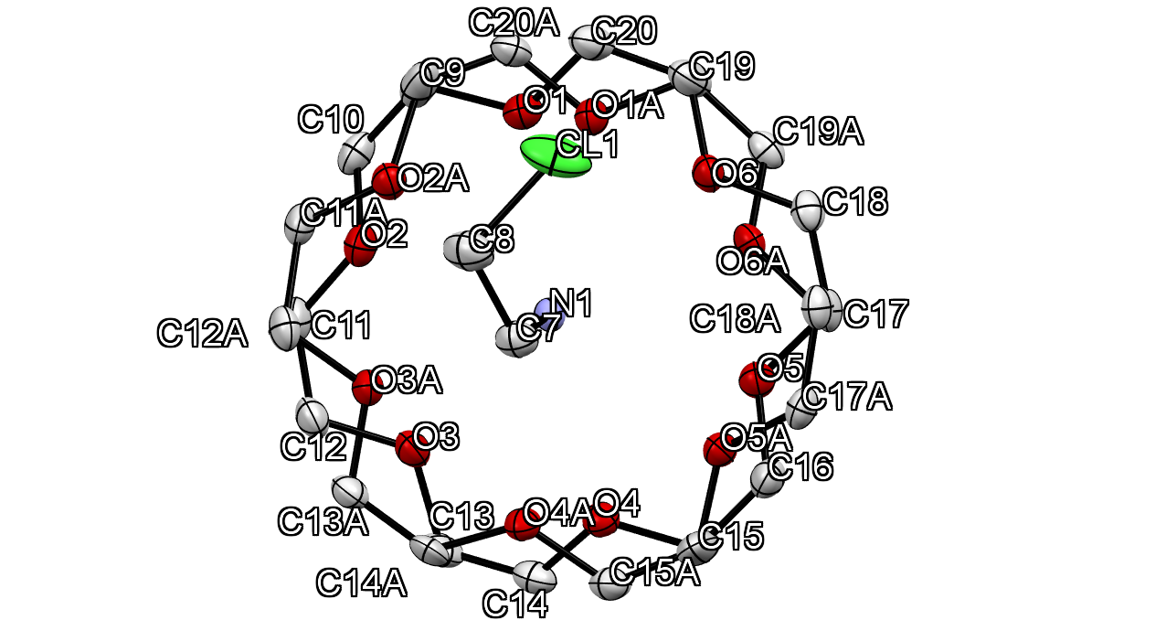
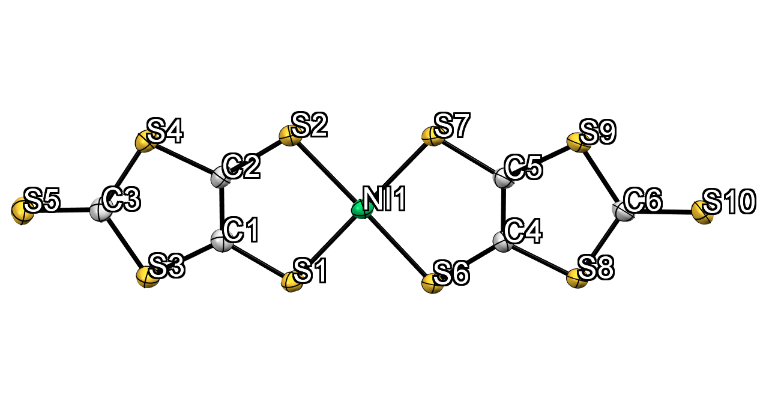
Figure S3. Crystallographically independent molecules in the crystal 3 at 93 K with atomic numbers. The structure is depicted as ORTEP with 50% probability. Hydrogen atoms are omitted for clarity.

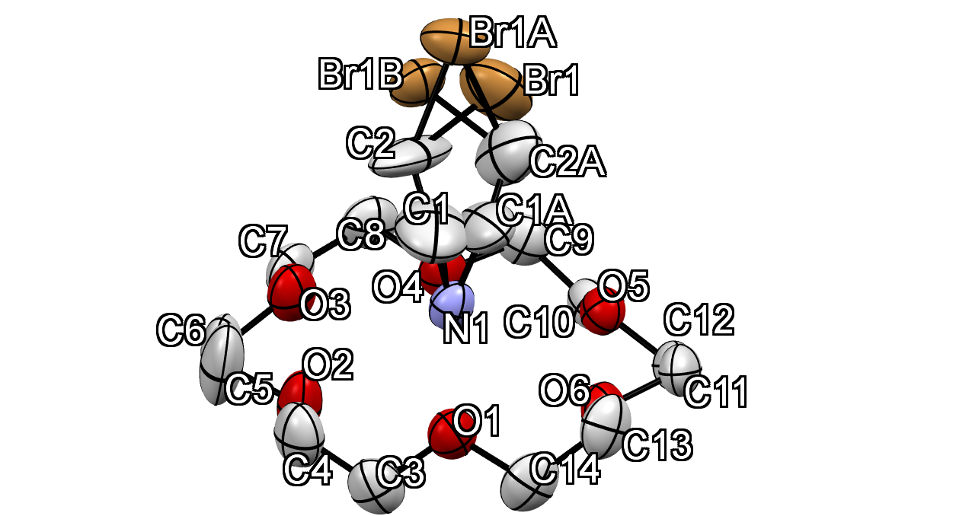
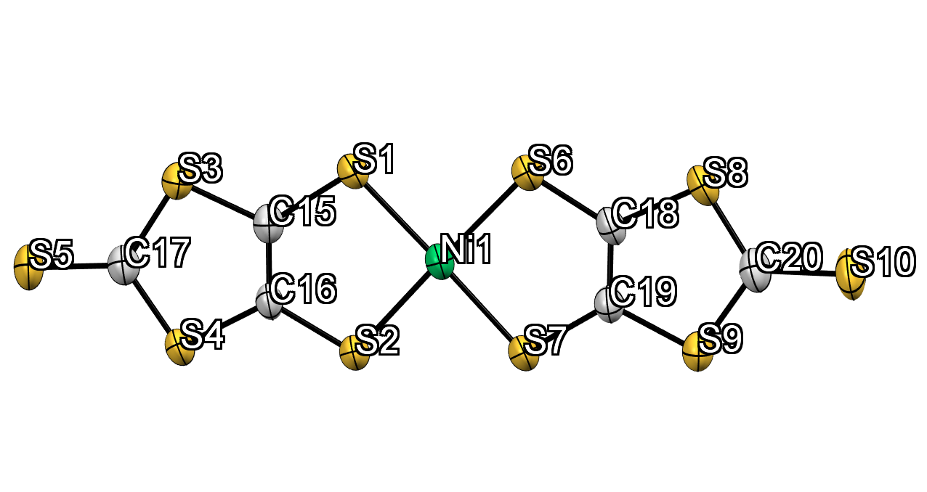
Figure S4. Crystallographically independent molecules in the crystal 4 at 293 K with atomic numbers. The structure is depicted as ORTEP with 50% probability. Hydrogen atoms are omitted for clarity.

§3. Packing structures of crystals 2-4.
Figure S5. Packing structures of crystals 2, 3 and 4 viewed along the (a) c, (c) c and (e) b axis, respectively. 2D arrangement of supramolecular cations for crystals 2, 3 and 4 viewed along the (b) b, (d) b and (f) c axis, respectively. Dotted square encircles the 1D arrangement of supramolecular cations. Hydrogen atoms are omitted for clarity except the atoms connected to nitrogen atom. Sulfur, carbon, and nickel atoms in [Ni(dmit)₂] colored as yellow, grey, and green, respectively. Yellow X-C₂-NH₃ and blue [18]crown-6, and red X-C₂-NH₃ and green [18]crown-6 is supramolecular cation unit and the two unit form supramolecular cation pair.

§4. Detailed analysis of structures of crystal 1-4.
Table S6. Intermolecular interaction between supramolecular cations and density of the crystals at the lowest temperatures.
Crystals | ªInteraction | Å | ^{b}d_{c•••c} / Å | D_{calc} / g cm³
1 | C-H•••O | 3.595(2) | 3.726 | 1.590
2 | C-H•••O | 3.633(2) | 3.745 | 1.671
3 |  |  | 3.782 | 1.638
4 | C-H•••O | 3.468(3), 3.477(4) | 3.635 | 1.748
ª Intermolecular interaction between the neighboring supramolecular cations. Instead of H•••O distance, distance of C•••O was used for C-H•••O interaction. Distance of weak hydrogen bonding is in the range of 3.2-4.0 Å between hydrogen-bonded donor•••acceptor atoms.
^{b} Distance between two plane of neighboring [18]crown-6. The plane of [18]crown-6 used by six oxygen atom in [18]crown-6.

§5. Temperature- and frequency-dependent dielectric constants for crystals 1-4

Figure S6. Temperature- and frequency-dependent real part of dielectric constant (ε₁) and tangent delta for crystal 1.

Figure S7. Temperature- and frequency-dependent real part of dielectric constant (ε₁) and tangent delta for crystal 2.

Figure S8. Temperature- and frequency-dependent real part of dielectric constant (ε₁) and tangent delta for crystal 3.

§6. Transfer integrals between [Ni(dmit)₂]– molecules in crystals 1-4.
Figure S9. Transfer integral between [Ni(dmit)₂]– anions in crystals (a) 1, (b) 2, (c) 3, and (d) 4. t₁ corresponds to the transfer integrals between the intradimer [Ni(dmit)₂]– anions, whereas t₂ and t₃ are transfer integrals between interdimer [Ni(dmit)₂] anions.

