Supporting Information

The role of cobalt oxide or magnesium oxide in ozonation of ammonia nitrogen in water

Philip Anggo Krisbiantoroª, Tomokazu Togawaª, Lina Mahardiani^{b}, Haruka Aiharaª, Ryoichi Otomo^{c}, Yuichi Kamiya^{c,}*

ª Graduate School of Environmental Science, Hokkaido University, Nishi 5, Kita 10, Kita-ku Sapporo 060-0810, Japan
^{b} Department of Chemistry Education, Faculty of Teacher Training and Education, Sebelas Maret University, Jl. Ir. Sutami 36A Surakarta, Central Java 57126, Indonesia
^{c} Faculty of Environmental Earth Science, Hokkaido University, Nishi 5, Kita 10, Kita-ku Sapporo 060-0810, Japan

*Corresponding author: Prof. Yuichi Kamiya
Email: kamiya@ees.hokudai.ac.jp
TEL: +81 11 706 2217

Fig. S1. Time course in the concentrations of (□) NH₄⁺ and (●) Cl– in the reaction solution for ozonation of ammonia nitrogen in Sol(Cl) over Co₃O₄. Reaction conditions: Co₃O₄, 0.1 g; 10 mmol L^{–1} NH₄Cl, 100 mL; O₃/O₂ flow rate, 100 mL min^{–1}; concentration of O₃, 0.7 vol%; reaction temperature, 333 K.

Fig. S2. Changes in the concentration of ClO– in the reaction solution for the reaction of Cl– with O₃ (○) in the presence and (●) absence of Co₃O₄. Reaction conditions: Co₃O₄, 0.1 g; 10 mmol L^{–1} NaCl, 100 mL; O₃/O₂ flow rate, 100 mL min^{–1}; concentration of O₃, 0.7 vol%; reaction temperature, 333 K.

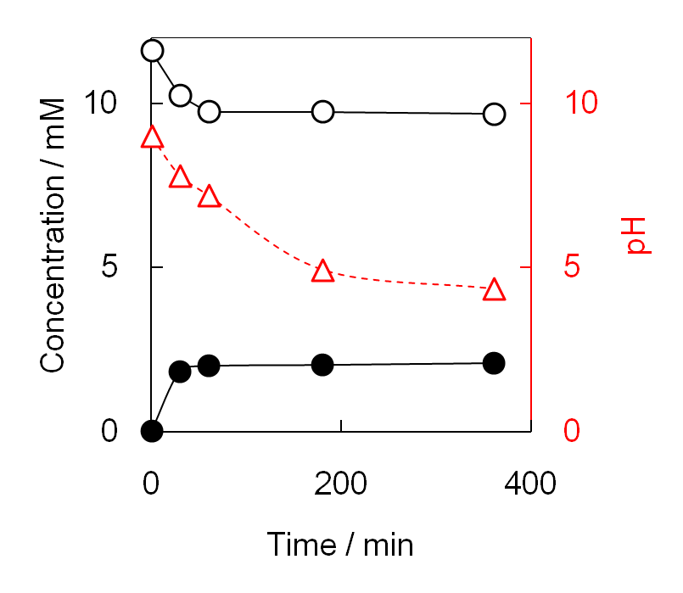
Fig. S3. Ozonation of ammonia nitrogen in Sol(SO₄) in the absence of MgO without pH restoration during the reaction. Concentrations of (○) ammonia nitrogen and (●) NO₃–, and (△) pH of the reaction solution. Reaction conditions: 10 mmol L^{–1} NH₄⁺, 100 mL; initial pH of the reaction solution, 9.0; O₃/O₂ flow rate, 100 mL min^{–1}; concentration of O₃, 0.7 vol%; reaction temperature, 333 K.

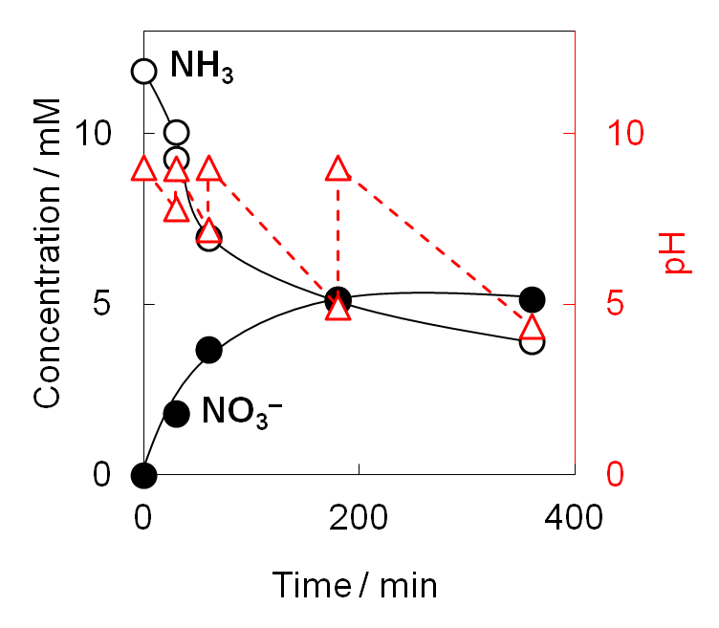
Fig. S4. Ozonation of ammonia nitrogen in Sol(SO₄) in the absence of MgO with pH restoration during the reaction. The pH of the reaction solution was repeatedly restored to 9.0 by the addition of aqueous KOH solution at each sampling time. Concentrations of (○) ammonia nitrogen and (●) NO₃–, and (△) pH of the reaction solution. Reaction conditions: 10 mmol L^{–1} NH₄⁺, 100 mL; initial pH of the reaction solution, 9.0; O₃/O₂ flow rate, 100 mL min^{–1}; concentration of O₃, 0.7 vol%; reaction temperature, 333 K.

