Fig. 1 Analytical procedures of environmental monitoring in emergency (Fukushima prefecture 2017a).

Fig. 2 Map of present municipalities of Fukushima prefecture with former Oguni village. Different colours on the map indicate 3 types of inspection in 2011 (see Table 3).
Red: Category a; Yellow: Category b; and Blue: Category c in Table 3.
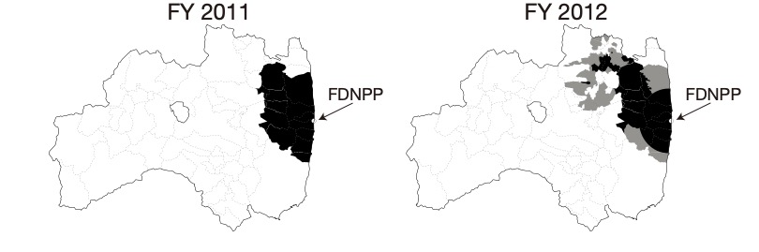

Fig. 3 Restricted area of brown rice production in Fukushima prefecture in fiscal years 2011 and 2012.
: Prohibited area, : Controlled management and monitoring area.

Fig. 4 Monitoring flow of the environmental radioactivity of agricultural, forestry and fishery products in emergency.

Fig. 5 Inspection flow of food from home garden products: a) destructive way; and b) non-destructive way.

Fig. 6 Map of divided 7 areas of Fukushima prefecture.

Fig. 7 Flow of inspection of the radioactivity of persimmon with processing (Fukushima prefecture 2017d)

