For submission to Chemosphere as a Research paper

Simple Assay for Colorimetric Quantification of Unamplified Bacterial 16S rRNA in Activated Sludge using Gold Nanoprobes

Meri Nakajimaª, Reiko Hirano^{b}, Satoshi Okabeª, Hisashi Satoh^{a,}*
ª Division of Environmental Engineering, Faculty of Engineering, Hokkaido University, North-13, West-8, Sapporo 060-8628, Japan.
^{b} Cellspect Co., Ltd., 1-10-82 Kitaiioka, Morioka, Iwate 020-0857, Japan.

Email addresses:
Meri Nakajima – meri1210@eis.hokudai.ac.jp
Reiko Hirano – hirano0317@gmail.com
Satoshi Okabe – sokabe@eng.hokudai.ac.jp
Hisashi Satoh – qsatoh@eng.hokudai.ac.jp

Corresponding Author
*Hisashi Satoh, Division of Environmental Engineering, Faculty of Engineering, Hokkaido University, North-13, West-8, Sapporo 060-8628, Japan.
Tel: +81-(0)11-706-6277; Fax: +81-(0)11-706-6277; Email: qsatoh@eng.hokudai.ac.jp

Highlights

- A simple 16S rRNA quantification method with gold nanoprobes was developed.
- Reverse transcription and amplification of 16S rRNA were not necessary.
- The operational parameters affecting the assay were optimized.
- The detection limit was approximately 1% of 16S rRNA of total bacteria.
- 16S rRNA in anammox could be determined from activated sludge analysis.

Abstract
Domestic and industrial wastewater treatment systems are vital in the protection of natural ecosystems and human health. Identification of microbial communities in the systems is essential to stable treatment performance. However, the current tools of microbial community analysis are labor intensive and time consuming, and require expensive equipment. Therefore, we developed a simple assay for colorimetric quantification of bacterial 16S rRNA extracted from environmental samples. The assay is based on RNA extraction with commercial kits, mixing the unamplified RNA sample with Au-nanoprobes and NaCl, and analyzing the absorbance spectra. Our experimental results confirmed that the assay format was valid. By analyzing the synthesized DNA, we optimized the operational parameters affecting the assay. We achieved adequate capture DNA density by setting the capture DNA probe concentration at 10 μM during the functionalization step. The required incubation time after NaCl addition was 30 min. The binding site of the target had negligible effect on DNA detection. Under the optimized condition, a calibration curve was created using 16S rRNA extracted from activated sludge. The curve was linear above 5.0×10⁷ copies/μL of bacterial 16S rRNA concentration, and the limit of detection was 1.17×10⁸ copies/μL. Using the calibration curve, the bacterial 16S rRNA concentration in activated sludge samples could be quantified with deviations between 48% and 208% against those determined by RT-qPCR. The findings of our study introduce an innovative tool for the quantification of 16S rRNA concentration as the activity of key bacteria in wastewater treatment processes, achieving stable treatment performance.

Keywords
Simple colorimetric assay; Gold-nanoprobes; Bacterial 16S rRNA; Bacterial activity; Non-amplification

1. Introduction
Domestic and industrial wastewater treatment is crucial to protecting natural ecosystems and human health. Wastewater treatment is performed in several steps, including the separation of solids from liquids by sedimentation, biological degradation of pollutants (e.g., organic compounds, inorganic compounds, and nutrients), and disinfection. Biological degradation is vital to neutralizing pollutants. The activated sludge (AS) process is the most commonly applied biological wastewater treatment technology, in which aerobic and anaerobic microorganisms such as bacteria, archaea, fungi, and protists play a critical role in neutralizing pollutants (Shchegolkova et al., 2016). Therefore, investigation of microbial communities in AS is essential to stable treatment performance and recovery from process failure (Hatamoto et al., 2017; Miura et al., 2007).
The investigation of microbial communities is not easy because AS is a quite complex system with complex, interconnected trophic relationships between microorganisms. Lately, the microbial communities of AS has generally being determined by analyzing the 16S rRNA gene (16S rDNA) using polymerase chain reaction (PCR) (Su et al., 2019; Wu et al., 2019). Although 16S rDNA analysis can be used in the classification and quantification of microorganisms, it does not allow determining their activity owing to the presence of extracellular DNA and DNA in dead cells (Maza-Márquez et al., 2016). Accordingly, to reveal microbial activity, 16S rRNA in addition to 16S rDNA (a 16S ratio) have been determined (Maza-Márquez et al., 2016; Shu et al., 2019). The quantification of bacterial 16S rRNA in AS is generally conducted by quantitative fluorescence in situ hybridization (qFISH), quantitative RNA membrane hybridization, and real-time reverse-transcription polymerase chain reaction (RT-qPCR) (Kapoor et al., 2016; Maza-Márquez et al., 2016). Analysis by qFISH comprises sample fixation, hybridization, and microscope observation steps (Miura et al., 2007). The abundance of the targeted microorganisms can be determined in qFISH analysis; however, it is not possible to determine their activity. Although the latter two methods (RNA membrane hybridization and RT-qPCR) require a laborious RNA extraction step, they can quantify the 16S rRNA abundance of the target. Unfortunately, these methods have major disadvantages, namely being labor intensive and time consuming after RNA extraction, and requiring expensive equipment and adequately equipped laboratories. For example, blotting to membranes, hybridization, and washing are necessary before a quantification step in a quantitative RNA membrane hybridization technique (Oerther et al., 2001). Furthermore, the RT-qPCR method is subsequently subjected to purification, reverse transcription, and quantitative amplification (Maza-Márquez et al., 2016), which pose significant limitations to the routine monitoring of the 16S rRNA of AS samples. Therefore, alternative approaches to 16S rRNA quantification are needed quite urgently.
In recent years, numerous nucleic acid assays based on gold nanoparticles (AuNPs) have been developed in the fields of clinical diagnosis (Shi et al., 2014; Xia et al., 2010) and food safety (Manzano et al., 2016), because of their unique properties (Xia et al., 2010). These properties include cost-effectiveness, high molar extinction coefficient, highly specific spectral absorption properties, easy surface modification, large surface to volume ratios, and strong photostability. For example, in clinical samples without amplification, Shawky and coworkers developed a novel assay platform based on inducing aggregation of citrate AuNPs decorated with a specific nanoparticle by quantifying total RNA extracted from the hepatitis C virus (Shawky et al., 2017). Jung and coworkers developed the AuNP-mediated colorimetric method for real-time detection of Chlamydia trachomatis plasmid. Despite its sensitivity, with 10² copies of the detection limit, the method requires isothermal chain amplification. However, as a clinical sample has not been analyzed, the applicability of the technology to real samples remains unknown (Jung et al., 2011). Recently, a target DNA sequence identical to one of Acinetobacter baumannii was detected with target-specific capture DNA probes conjugated to AuNPs (Au-nanoprobes), in which a real sample was not analyzed (Bahavarnia et al., 2020). These previous studies clearly demonstrate that quantifying 16S rRNA in AS samples remains a challenge. Indeed, to our knowledge, although drugs (Shi et al., 2019), heavy metals (Zong et al., 2011), and toxic organic compounds (Ma et al., 2019) have been detected with nanoparticles, no study has achieved the quantification of 16S rRNA extracted from wastewater with Au-nanoprobes.
In this study, we developed a simple assay for direct colorimetric quantification of 16S rRNA extracted from environmental samples. We first confirmed the assay format and subsequently attempted to detect a synthetic DNA strand that contained identical sequences to bacterial 16S rRNA. Thereafter, we optimized the assay conditions. Furthermore, we determined the abundances of bacterial 16S rRNA extracted from activated sludge and anaerobic ammonium oxidation (anammox) samples by the assay. Based on the experimental results we obtained, we discuss the putative sensing mechanism of the assay, chemistry determining the optimal operational conditions, and the importance of the assay in terms of environmental engineering. We achieved quantification of bacterial 16S rRNA extracted from activated sludge and anammox samples. To the best of our knowledge, this study is the first attempt to quantify bacterial 16S rRNA of biomass in wastewater treatment processes. Our results have shown the feasibility of a simple, on-site, colorimetric ‘spot and read’ test in contrast to amplification-based detection methods.

2. Materials and Methods
2.1 Chemicals and materials
Single-strand oligonucleotides were synthesized by Eurofins Genomics K.K. (Tokyo, Japan). The sequences of these oligonucleotides are provided in Table 1. As we targeted the 16S rRNA of total bacteria, we designed Au-nanoprobes, which are target-specific capture DNA probes conjugated to AuNPs, specific to total bacteria. Two types of Au-nanoprobes for total bacteria were synthesized (see below). One capture DNA probe was complementary to a PCR primer for the detection of total bacteria (341F), named c341F, and the other was a PCR primer for the detection of total bacteria (805R), named 805R (Herlemann et al., 2011). TGT, representing a target, contains sequences of universal primer (i.e., 341F and 805R) binding site on bacterial 16S rRNA, which are underlined in TGT in Table 1. T10 represents 10 thymine bases. Gold nanoparticles, 5 nm in diameter (5 nm AuNPs), in citrate buffer solution (catalogue number 741949) were purchased from Merck KGaA (Darmstadt, Germany). Tris(2-carboxyethyl)phosphine (TCEP) was purchased from Nacalai Tesque Inc. (Kyoto, Japan). Sodium acetate (192-01075), acetic acid (017-00256), and sodium chloride (NaCl, 191-01665) were purchased from Fujifilm Wako Pure Chemical Corporation (Osaka, Japan). All solutions were prepared with Milli-QWater (Merck Millipore, Tokyo, Japan).

Table 1. Sequences of oligonucleotides used in this study.
Oligonucleotide | Sequence
c341F | 5'HS−(CH₂)₆−CTGCWGCCNCCCGTAGG−3'
805R | 5'HS−(CH₂)₆−GACTACHVGGGTATCTAATCC−3'
TGT | 5'−CCTACGGGNGGCWGCAG-T10-GGATTAGATACCCVHGTAGTC−3'

2.2 RNA Extraction and cDNA synthesis
To quantify bacterial 16S rRNA by RT-qPCR, we carried out RNA extraction from approximately 500 mg wet weight of AS and anammox samples using the RNeasy Mini Kit (Qiagen, Hilden, Germany) according to the manufacturer's instructions. This sample was named an unamplified RNA pool. The AS samples used in this study were collected from a municipal wastewater treatment plant A (WWTP-A) in Sapporo city (Satoh et al., 2020). Anammox samples were collected from a laboratory-scale up-flow column reactor (Rathnayake et al., 2018). We determined the concentration of the extracted RNA fluorometrically using the Quant-iT™ RiboGreen™ RNA Assay Kit (Thermo Fisher Scientific, Waltham, MA USA). Residual DNA in the sample was digested using an amplification grade deoxyribonuclease (DNase) I (Thermo Fisher Scientific, Waltham, MA USA). We did not find DNA contamination in the samples treated with DNase.
We performed synthesis of cDNA from the extracted RNA using a PrimeScriptTM RT reagent Kit (Perfect Real Time) (Takara Bio Inc., Shiga, Japan) according to the manufacturer's instructions, as well as information from a previous study (Amarasiri et al., 2018). Briefly, 4 μL of 5×Prime script buffer, 1 μL of RT enzyme mix, 1 μL Oligo dT primer, 4 μL of random 6 mers, and 6 μL of Nuclease-Free Water (Thermo Fisher Scientific, Waltham, MA USA) were mixed with 4 μL of the extracted RNA. The mixture was incubated at 37 °C for 15 min and 85 °C for 5 sec. The prepared cDNA was stored at -20 °C until further processing.

2.3 RT-qPCR
The cDNA was amplified with the primers Bakt_341F (CCTACGGGNGGCWGCAG) and Bakt_805R (GACTACHVGGGTATCTAATCC). We prepared 25 μL of the reaction mixture in a 96-well PCR plate by mixing 10 μL of TB Green Premix Ex Taq II, 4 pmol each of primers (341F and 805R), 0.4 μL of ROX reference dye II (Takara Bio Inc., Japan), 7.8 μL of Nuclease-Free Water, and 1 μL of cDNA. For standard DNA, the nucleotide sequence corresponding to the PCR-amplified region of 16S rDNA was synthesized artificially and inserted into the pTAKN-2 vector by Eurofins Genomics K.K. (Tokyo, Japan). The plasmid DNA was purified, and the concentration of the purified plasmid DNA was determined fluorometrically using the Quant-iT PicoGreen dsDNA Assay Kit (Thermo Fisher Scientific, Waltham, MA USA). It was subsequently serially diluted from 1.0×10¹⁰ copies/μL to 1.0×10³ copies/μL using Nuclease-Free Water for the preparation of standard curves for the RT-qPCR assay. All the reactions were performed in triplicate. Incubation was performed using an Applied Biosystems 7500 Fast Real-Time PCR System (Thermo Fisher Scientific Inc., USA). The reaction conditions were set as follows: initial denaturation at 95 °C for 30 sec, followed by 40 cycles of amplification with denaturation at 95 °C for 5 sec, annealing at 56 °C for 30 sec, and extension at 72 °C for 30 sec. The amplification data were collected and analyzed with Applied Biosystems 7500 FAST Real-Time PCR System Sequence Detection Software (version 2.0.6) (Thermo Fisher Scientific Inc., California, USA). We calculated the PCR efficiency (E) using the formula E=10^{-1/slope}-1.

2.4 Functionalization of AuNPs with capture DNA probes
AuNPs were individually functionalized with capture probes according to the method of Liu and Lu (2006). In brief, 3 μL of 10 μM thiol-modified capture DNA solution and 2.7 μL of 10 mM TCEP were added to 24.3 μL of 100 mM acetate buffer (pH 5.2) to activate the thiol-modified DNA. The sample was incubated at room temperature for 1 h. The sample, including the TCEP-treated thiol DNA and 3 μL of 0.1 M HCl, was added to 300 μL of the original AuNP solution. The sample was incubated at room temperature for 20 min. The solution, named Au-nanoprobe solution, was vortexed vigorously for 5 sec before use.

2.5 Assay format and procedure
Au-nanoprobes have been used in a general format to detect single-strand DNA and RNA. Scheme S1 shows the sensing mechanism of the method. The format comprises using each of (or both) the Au-nanoprobes, which are designed to recognize single-strand DNA (TGT sequence) and bacterial 16S rRNA as targets, hybridization of targets with the Au-nanoprobes, and aggregation of these. The Au-nanoprobe solutions exhibit red color that derives from the localized SPR of the AuNPs and an absorbance peak of approximately 520 nm in the ultraviolet (UV)–visible spectrum. In the presence of the target DNA or RNA, it hybridizes with c341F and 805R on the Au-nanoprobes. The Au-nanoprobes that are covered with a negatively charged DNA are protected against salt-induced aggregation and remain dispersed in the solution even at a high NaCl concentration. The color of the dispersed Au-nanoprobes remains red because of the enhancement of the negative charge on a surface of AuNPs by negatively charged phosphate groups on the DNA backbone. On the other hand, in the absence of a target, Au-nanoprobes are no longer covered with a negatively charged target and protected from aggregation and, therefore, are subjected to NaCl-induced aggregation. The aggregation of AuNPs leads to a color change of AuNPs from red to blue. This process can be analyzed by ultraviolet–visible (UV–vis) spectroscopy. Therefore, quantitative analysis of the target DNA concentration is possible by measuring the ratio of the absorbance that corresponds to the red (approximately 520 nm) and blue (approximately 620 nm) colors (i.e., A620/A520) based on the UV–vis spectra analysis before and after the addition of NaCl. This process can be visualized in solution even with the naked eye as the red to blue color change.
One micro-liter of sample solution and 30 μL of 5 M NaCl solution were mixed in the same order to 20 μL of the Au-nanoprobe solution. TGT, described above, or an unamplified RNA pool served as the target in the assay. We set three different measurement conditions with regard to the Au-nanoprobe solutions, namely individual use of Au-nanoprobes with c341F and 805R, and the dual-use of these two types of Au-nanoprobes. After incubation of this solution for 30 min at room temperature, the absorbance spectrum of 50 μL of the solution was measured in an ultraviolet (UV)– transmission-type disposable cuvette (UVC−Z8.5, VIOLAMO, AS ONE corporation, Osaka, Japan). Unless otherwise mentioned, this measurement condition was used. In a previous study, because 3 M NaCl solution aggregated neither the Au-nanoprobes nor the Au-nanoprobes hybridized with TGT (data not shown), 5 M NaCl solution was used in this study.

3. Results
3.1 DNA detection with Au-nanoprobes
The typical absorbance spectra of the test solutions of Au-nanoprobes designated as Probe, Au-nanoprobe solution in the presence of TGT (a positive sample), and the positive sample (abbreviated as POS sample) and Au-nanoprobe solution in the absence of Art Back (a negative sample) at 1 min after the addition of 5 M of NaCl solution were analyzed (Figure 1). The maximum peak of the absorbance spectrum of an Au-nanoprobe solution provides the status of the Au-nanoprobes. The absorbance spectrum of the Probe sample shown in Figure 1 was almost identical to that of the bare AuNPs (data not shown), indicating that conjugation of c341F to AuNPs did not affect the absorbance spectrum. A typical absorbance spectrum of the Probe sample showed a maximum peak at 522 nm. The presence of TGT (the POS sample) resulted in a slight decrease in the absorbance peak but no absorbance peak shift. The addition of NaCl solution to the POS and negative (abbreviated as NEG) samples caused a decrease in the absorbance peak intensity, mainly because of dilution and the salt-induced aggregation in both samples at 1 min. However, a decrease in the absorbance peak intensity with concomitant peak shift to 534 nm and the broadness of the absorbance spectrum were more significant in the NEG sample than they were in the POS sample, where the peak shifted to 527 nm.
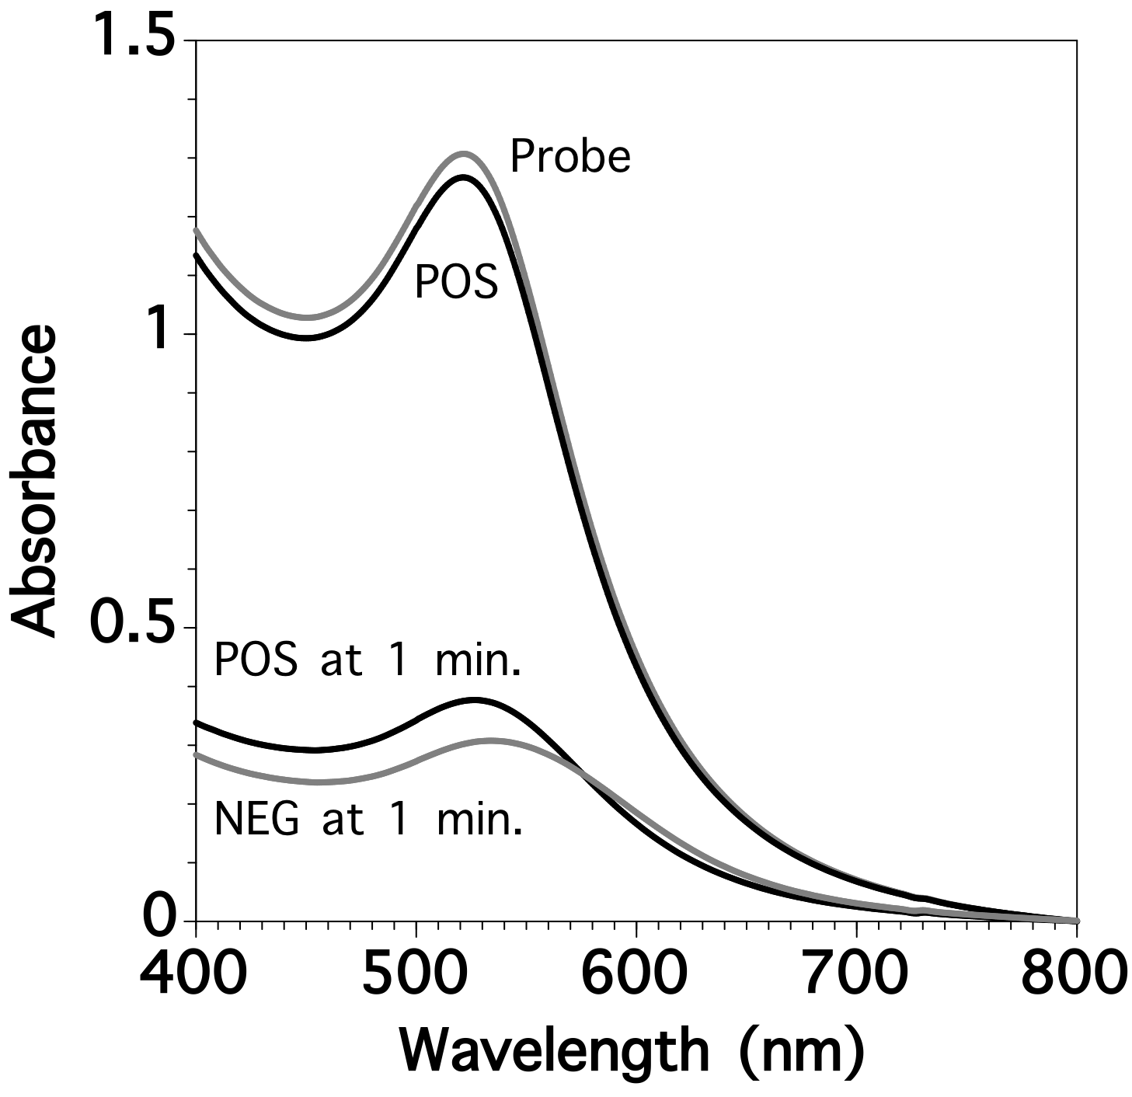
Figure 1. Typical absorbance spectra of the test solutions of Au-nanoprobes with c341F (Probe), an Au-nanoprobe solution in the presence of TGT (a POS sample), and the POS sample and an Au-nanoprobe solution in the absence of Art Back (a NEG sample) at 1 min after addition of 5 M of NaCl solution.

Subsequent observation of the absorbance spectra of the POS and NEG samples showed that the absorbance peak intensity of both samples at 522 nm decreased with time and these values became stable after approximately 25 min (Figure S1).
Based on the time course analysis of the absorbance spectra, we calculated the ratio between the absorbance at 522 nm and 620 nm (A620/A522). Figure 2 shows the time course of the A620/A522 of the POS and NEG samples after NaCl addition. The A620/A522 of the Probe and POS samples shown in Figure 1 was 0.23. The A620/A522 of the NEG sample increased immediately and sharply to 0.42 at 1 min after NaCl addition, whereas the increase in the A620/A522 of the POS sample was slight (0.31). Thereafter, the A620/A522 of both samples increased slightly with time and stabilized at approximately 25 min.

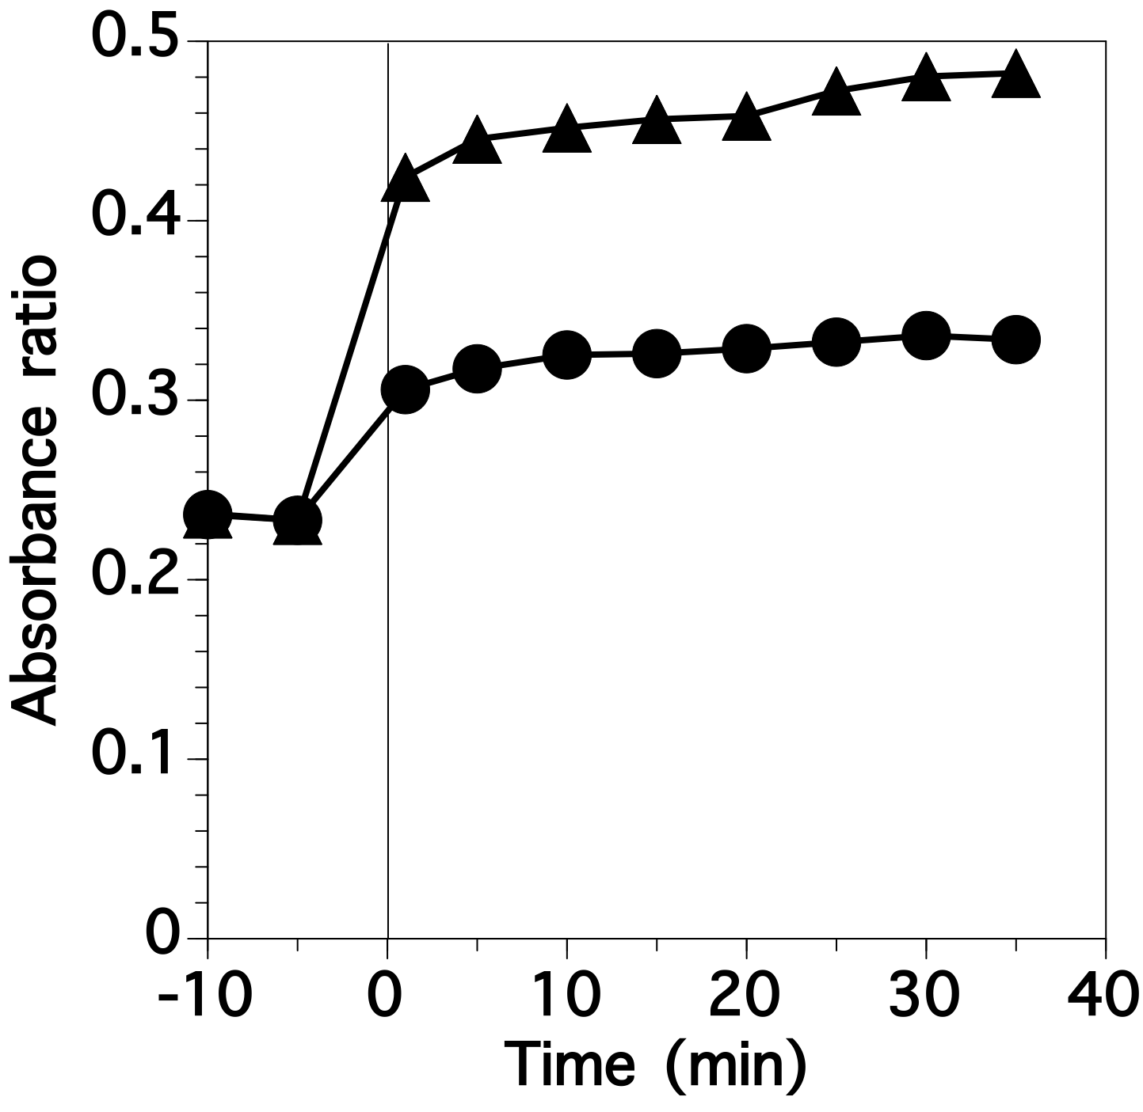
Figure 2. Time course of the A620/A522 of the POS (circles) and NEG (triangles) samples after NaCl addition. The plots at -10 min and -5 min indicate the A620/A522 of the Probe and POS samples, respectively, shown in Figure 1.

In the nucleic acid detection systems using Au-nanoprobes, the hybridization of a target with a capture probe on an Au-nanoprobe and the stability of the Au-nanoprobes against NaCl-induced aggregation depend strongly on the performance of the assay (Jin et al., 2003). Therefore, we investigated the effect of the capture probe density on the assay. The average surface density of the capture DNA was controlled by altering the relative concentration of DNA added from 1 μM to 100 μM during the DNA functionalization process. The functionalization of DNA at 1 μM of capture DNA concentration resulted in 0.42 of the absorbance peak intensity and 0.35 of A620/A522 (Figure 3). The addition of NaCl increased A620/A522 to 0.41 and 0.49 in the POS and NEG samples, respectively. The difference between A620/A522 of the POS and NEG samples was 0.08. When the capture DNA was functionalized in the solution at 10 μM, A620/A522 was 0.35 before NaCl addition, 0.42 for the POS sample, and 0.58 for the NEG sample. Therefore, the difference between the POS and NEG samples was 0.16, which was higher than was that of the Au-nanoprobes functionalized at 1 μM of DNA concentration. In contrast, a further increase in the capture DNA concentration during functionalization to 50 μM and 100 μM resulted in a decrease in the difference to 0.08 and 0.005, respectively. The absorbance peak at approximately 520 nm of the NEG samples increased with an increase in the capture DNA concentration during functionalization.

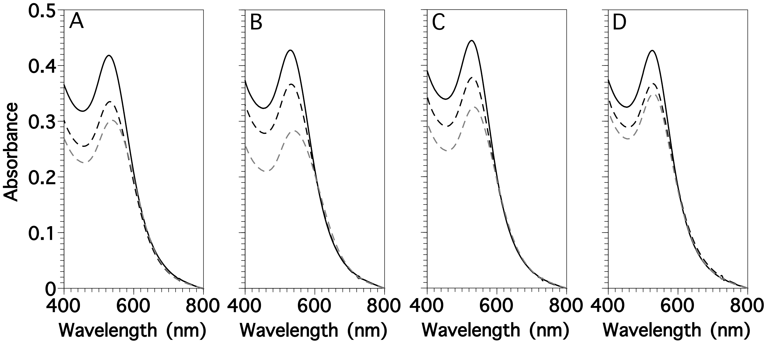
Figure 3. Absorbance spectra of the POS samples (solid lines) using 5 nm Au-nanoprobes with c341F just after NaCl addition (solid lines), and the POS (black dashed lines) and NEG (gray dashed lines) samples at 30 min after NaCl addition. The DNA concentrations during the DNA functionalization process were altered at 1 μM (A), 10 μM (B), 50 μM (C), and 100 μM (D).

The size of the AuNPs used for the Au-nanoprobes affected the assay because larger AuNPs could hinder the hybridization of target nucleic acids with capture DNA and/or could be aggregated more easily compared with smaller ones (data not shown). The absorbance spectra of the POS and NEG samples using 5 nm Au-nanoprobes with c341F were taken just after NaCl addition and 30 min later (Figure 4A). The absorbance spectra of the POS and NEG samples showed maximum peaks at 528 nm and 537 nm, respectively, just after NaCl addition. After 30 min of NaCl addition, the absorbance peaks decreased in both samples, but more significant red-shift and peak drop were found in the NEG sample. The A620/A522 of the samples just after NaCl addition and 30 min later were calculated as 0.34 and 0.35 for the POS sample and 0.49 and 0.56 for the NEG sample, respectively (see Table 2). The red-shift, which occurred in the NEG sample but not in the POS sample, was visualized with the naked eye as a red to dark-purple color change only in the NEG sample (Figure 4B).

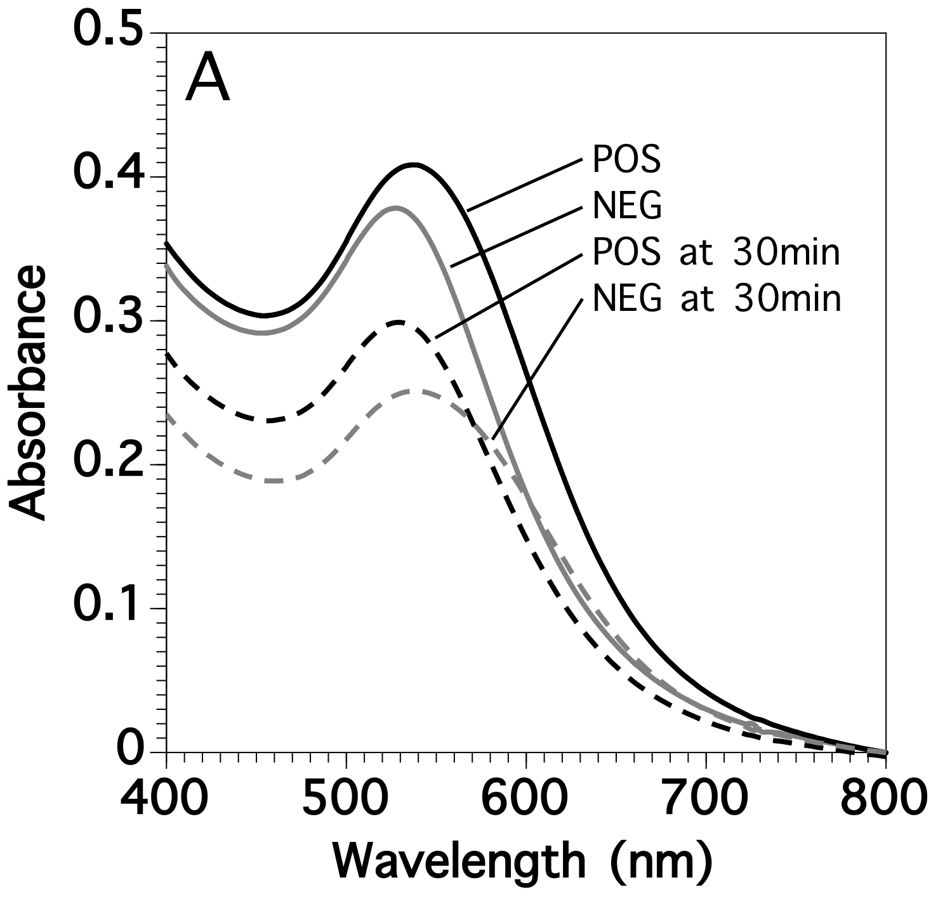
B
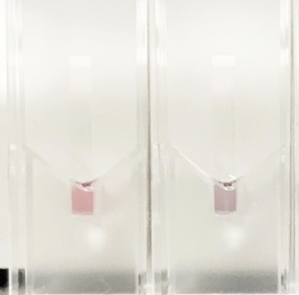
Figure 4. (A) Absorbance spectra of the POS (black lines) and NEG (gray lines) samples using 5 nm Au-nanoprobes with c341F just after NaCl addition (solid lines) and 30 min later (dashed lines). (B) Photograph of the POS (left) and NEG (right) samples at 30 min after NaCl addition shown in Figure 4A.

Similarly, we calculated the A620/A522 of 5 nm and 30 nm Au-nanoprobes with c341F and 805R applied to the three types of samples (POS, NEG, and T48) just after NaCl addition and 30 min later, as well as the differences after incubation of 30 min (Table 2). When 5 nm Au-nanoprobes were used, the A620/A522 at 0 h were almost the same (between 0.34 and 0.36), regardless of the assay conditions (i.e., choice of the Au-nanoprobes). When individually using 5 nm Au-nanoprobes with c341F and 805R in the POS samples, the differences for 30 min were extremely low (0.01 and 0.02, respectively), whereas they were substantial (0.06) in the dual-use of Au-nanoprobes. In the NEG samples, the difference after incubation of 30 min was greater than was that of the POS sample under each of the three assay conditions. In the assay of T48, the differences after incubation of 30 min were similar to those of the NEG samples under the three assay conditions. In contrast, the difference after incubation of 30 min using 30 nm Au-nanoprobes in the POS sample was similar to those in the NEG and T48 samples.

Table 2 Summary of the A620/A522 of the samples just after NaCl addition (0 min), 30 min later, and the differences. POS, NEG, and T48 represent the samples with TGT, without TGT, and with T48 as target. We set three different measurement conditions with respect to the Au-nanoprobe solutions, which are the individual use of Au-nanoprobes with c341F and 805R, and the dual-use of these two types of Au-nanoprobes.
 |  | Size of Au-nanoprobes and measurement conditions
Samples |  | 5 nm  c341F | 5 nm  805R | 5 nm  Dual | 30 nm  c341F | 30 nm  805R | 30 nm  Dual
POS
0 min |  | 0.34 | 0.36 | 0.35 | 0.19 | 0.18 | 0.43
30 min |  | 0.35 | 0.38 | 0.42 | 0.24 | 0.24 | 0.73
Difference |  | 0.01 | 0.02 | 0.06 | 0.06 | 0.06 | 0.31
NEG
0 min |  | 0.49 | 0.49 | 0.44 | 0.20 | 0.20 | 0.43
30 min |  | 0.56 | 0.55 | 0.58 | 0.26 | 0.26 | 0.70
Difference |  | 0.07 | 0.07 | 0.14 | 0.06 | 0.05 | 0.27
T48
0 min |  | 0.49 | 0.50 | 0.41 | 0.20 | 0.20 | 0.44
30 min |  | 0.56 | 0.57 | 0.58 | 0.25 | 0.25 | 0.64
Difference |  | 0.07 | 0.08 | 0.17 | 0.05 | 0.05 | 0.21

3.2 Calibration curve for the target DNA
After the operational parameters were optimized as described above, a calibration curve was created under the optimized assay conditions. The absorbance spectra of the Au-nanoprobes with serial dilutions of TGT as target were analyzed at 30 min after NaCl addition (Figure 5). The absorbance spectra of the sample with 10 μM of TGT showed a peak at 531 nm. As the TGT concentrations decreased, the absorbance peak at approximately 520 nm decreased and red-shifted, and the absorbance band at >570 nm increased.

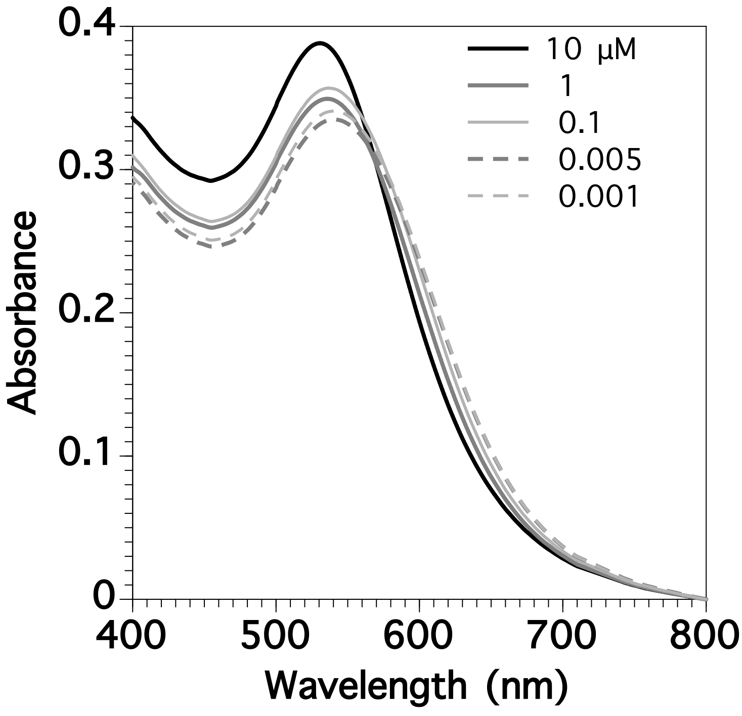
Figure 5. Absorbance spectra of the samples with serial dilutions of TGT as target at 30 min after NaCl addition.

The A620/A522 were calculated from the absorption spectra and plotted against TGT concentrations (Figure 6). When the TGT concentrations were below 0.005 μM, A620/A522 were relatively high and constant at approximately 0.45. As the TGT concentrations increased from 0.005 μM to 10 mM, A620/A522 decreased gradually.

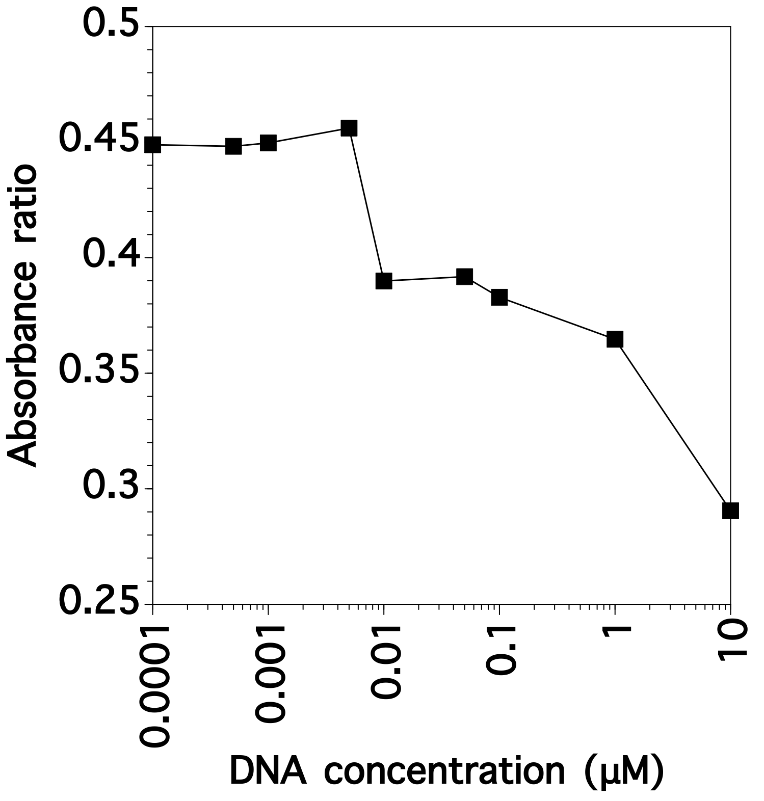
Figure 6. Typical calibration curve for TGT in our method.

3.3 Analysis of 16S rRNA of bacteria extracted from activated sludge samples
To validate the reliability and practicality of our method, we determined the abundance of bacterial 16S rRNA with our method and compared our results with those determined by the gold standard RT-qPCR method. We extracted RNA samples from three activated sludge (AS) samples and purified them with the RNeasy Mini kit®. The absorbance spectra of the Au-nanoprobes with serial dilutions of the RNA sample were analyzed at 30 min after NaCl addition, as was done in the assay of TGT (Figure 5). The sample at 50 μg/mL of the bacterial 16S rRNA showed a peak at 532 nm. At concentrations of the bacterial 16S rRNA above 5 μg/mL, a decrease in the bacterial 16S rRNA concentration caused an increase in the absorbance band between the 500 and 750 nm wavelengths and red-shift in the absorbance spectrum. In contrast, with a further decrease in the bacterial 16S rRNA concentrations from 5 μg/mL, the absorbance peak intensity decreased and further red-shifted to 544 nm, whereas the absorption band in the >600 nm wavelength region remained unchanged.

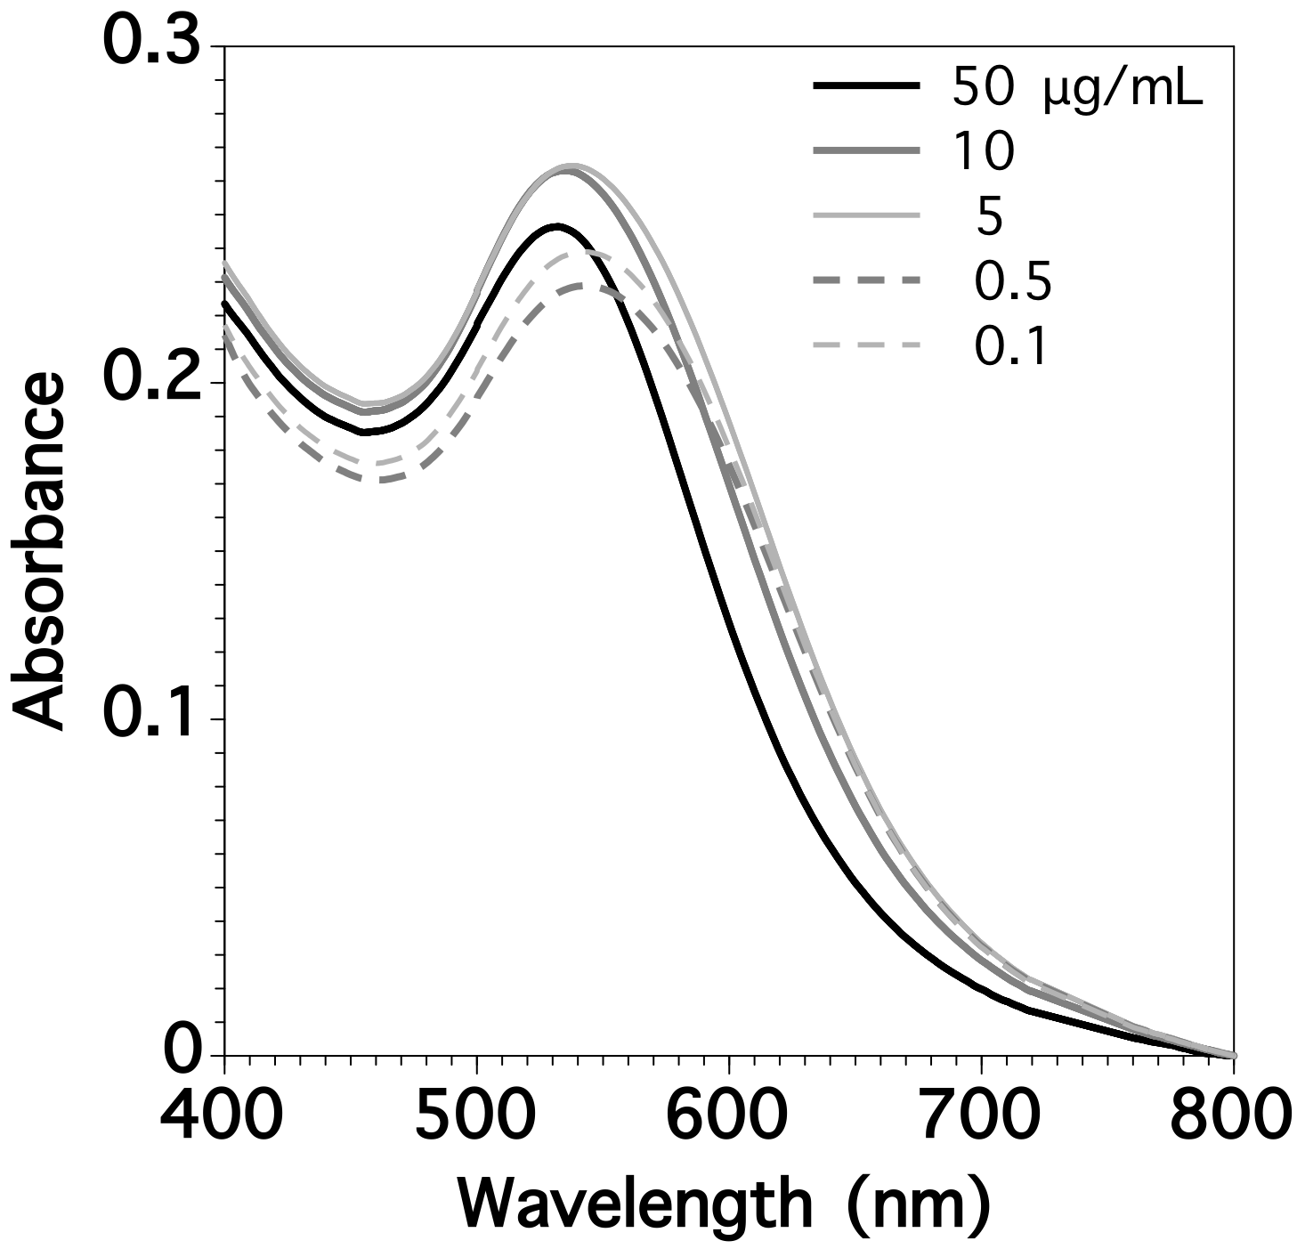
Figure 7. Absorbance spectra of the samples with serial dilutions of the RNA extracted from an activated sludge sample at 30 min after NaCl addition.

We analyzed the relationship between the abundance of bacterial 16S rRNA and A620/A522 for three AS samples (Figure 8). When the bacterial 16S rRNA concentration was below 5.0×10⁷ copies/μL, A620/A522 were ca. 0.5. In contrast, A620/A522 decreased from ca. 0.5 to 0.3 above 5.0×10⁷ copies/μL of bacterial 16S rRNA concentration. We determined a correlation equation of three AS samples in this range as y = -0.125 x + 1.49, with a determination coefficient of 0.84. The equation served as a calibration curve for the determination of the bacterial 16S rRNA concentration. The limit of detection (LOD) was estimated at 1.17×10⁸ copies/μL. As the bacterial 16S rRNA concentration in AS ranged from 6.5×10⁸ copies/μL to 1.2×10¹⁰ copies/μL (Figure 9), this value corresponded to 1% to 18%.

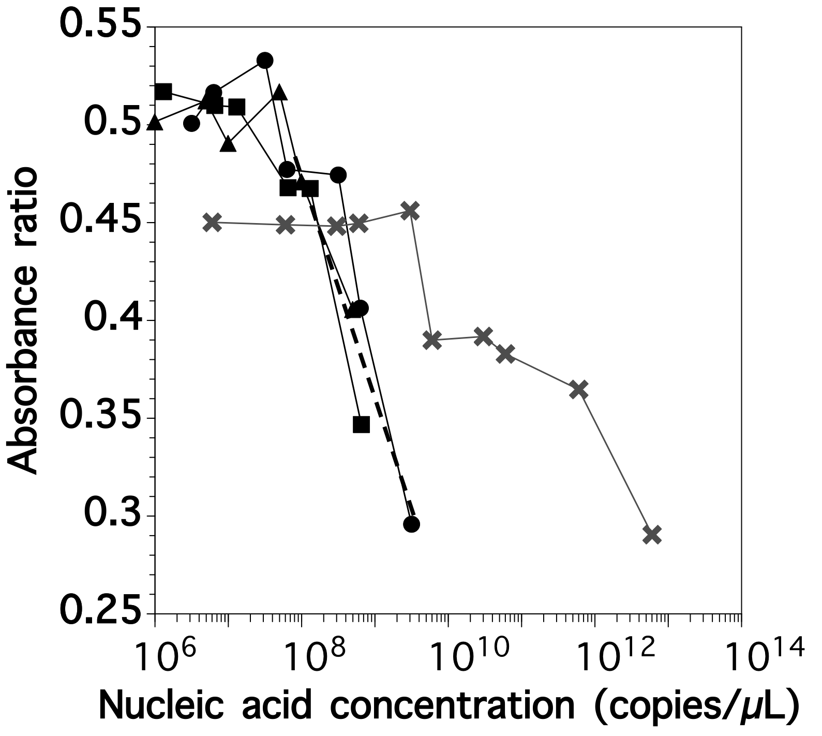
Figure 8. Relationship between the abundance of the bacterial 16S rRNA for three AS samples and TGT (gray crosses) and A620/A522. A correlation equation is shown as a dashed line.

To validate the assay, we determined the abundance of total bacterial 16S rRNA extracted from other AS and anammox samples using the calibration curve we determined, as shown in Figure 8, and we compared our results with results determined by using the RT-qPCR method. The value of the blank sample was 1.2×10⁸ copies/μL (Figure 9), which was below the LOD. The total bacterial 16S rRNA concentration of AS samples was estimated with deviations between 48% and 208% against those determined by RT-qPCR. The deviation might be attributed to the interference of impurity ions and organic materials. The abundance of total bacterial 16S rRNA of an anammox sample could be determined with high accuracy (73%) using the correlation equation derived from the AS samples.

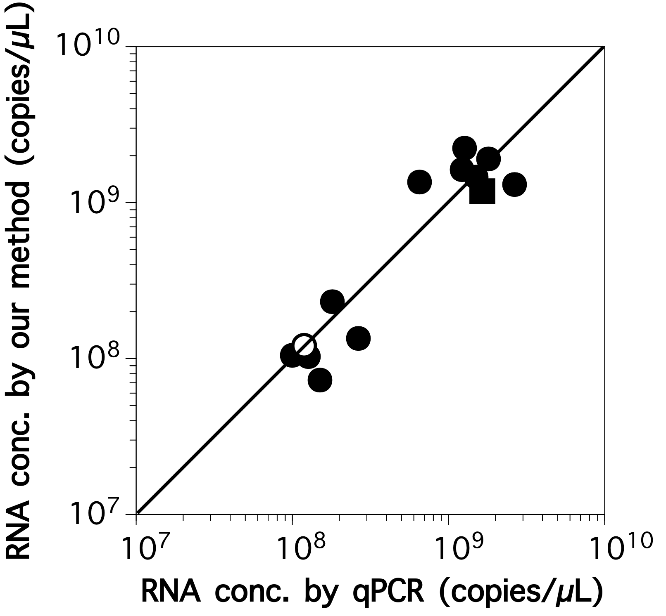
Figure 9. Relationship between the abundance of total bacterial 16S rRNA in AS (circles) and anammox (a square) samples determined by our method and RT-qPCR. A white circle represents the blank sample.

4. Discussion
4.1 Confirmation of the sensing mechanism
To confirm the sensing mechanism, we performed detection primarily of DNA instead of 16S rRNA with the experimental setup shown in Scheme S1. The method comprises adding the sample to the Au-nanoprobe solution, followed by NaCl addition, and spectrophotometric comparison of the solutions before and after NaCl-induced Au-nanoprobes aggregation. It is well known that collective oscillation of electrons on the surface of AuNPs causes a phenomenon called surface plasmon resonance, which results in the strong extinction of light, with the aggregation of the AuNPs causing red-shift of the absorbance spectrum. Therefore, analyzing the absorbance spectrum of the POS and NEG samples after NaCl addition could provide information on the aggregation state of the Au-nanoprobes. Figure 1 shows a more significant red-shift of the absorbance spectrum in the NEG sample compared with that of the POS sample. In the presence of TGT, the capture DNA functionalized to the Au-nanoprobes could hybridize with TGT, and TGT protected the Au-nanoprobes against salt-induced aggregation. Such protection could probably be ascribed to enhanced electrostatic repulsion by coverage of the negatively charged phosphate groups of TGT. In contrast, the absence of TGT did not protect Au-nanoprobes from aggregation (Scheme S1). Accordingly, our study results verified the detection mechanism of the method, i.e., compared with free Au-nanoprobes, the target DNA molecules hybridized with the Au-nanoprobes hampered salt-induced aggregation of the DNA probes. The aggregation of Au-nanoprobes could be visualized in the NEG sample with the naked eye (red to dark-purple color change) (Figure 4B), i.e., the presence of a target DNA in a sample could be easily detected with the naked eye.

4.2 Optimization of the operational conditions
We optimized the operational conditions by investigating the key operational parameters, such as the capture DNA density on the Au-nanoprobes, incubation time after NaCl addition, binding site on the target nucleotide sequence, and AuNP size. A high capture probe density is advantageous in terms of a potential increase in hybridization efficiency (Jin et al., 2003). On the other hand, capture probe density that is too high is detrimental and will lead to a decline in hybridization efficiency and the slowing down of kinetics (Peterson et al., 2001), as well as an increase in the stability of free Au-nanoprobes against aggregation. The differences between A620/A522 of the POS and NEG after NaCl addition were 0.08 at 1 μM, 0.16 at 10 μM, 0.08 at 50 μM, and 0.005 at 100 μM, respectively, of capture DNA concentration during the DNA functionalization process (Figure 3). As the absorbance peak intensity of the POS sample increased (i.e., less aggregation) with the changing concentrations from 1 μM to 10 μM (Figure 3A and B), the density of the capture DNA appeared to increase and, therefore, the Au-nanoprobes were protected further by the higher abundance of hybridized TGT. The absorbance peak intensities of the POS samples did not increase over 10 μM of capture DNA concentrations, probably because of a reduction in the abundance of the effective DNA on the surface of the Au-nanoprobes rather than saturation of the capture DNA density on it (see below). In contrast, a further increase in the capture DNA concentration during functionalization increased the absorbance peak of the NEG samples (Figure 3B to D). This could be ascribed to less aggregation of the Au-nanoprobes in the NEG samples by the higher capture DNA density on the Au-nanoprobes. A small gap between the peaks of the POS and NEG samples implied that the capture DNA density was almost saturated when the capture DNA was functionalized at 100 μM. Under the functionalized condition, the ratio of the number of capture DNA molecules (copies) to AuNPs (particles) was 7.3. Based on the surface area of 5 nm AuNPs (79 nm²) and the ratio determined above, the capture DNA density was calculated at 9.3×10¹¹ copies/cm² if all the DNA molecules used for functionalization could be attached. This value is comparable to density (9.5×10¹¹ copies/cm²) of 32-mer DNA functionalized to a 20 nm AuNP (Shawky et al., 2017), or lower than that (3.4×10¹³ copies/cm²) of 25-mer DNA functionalized to a 13 nm AuNP (Zu et al., 2011). Considering that the AuNPs used in this study were smaller (5 nm), the amount of DNA functionalized to the AuNPs in our study was likely saturated. As shown in Figure 3, the assay sensitivity was highest under the condition of maximal difference at 10 μM. Consequently, the optimal concentration of the capture DNA during functionalization was determined at 10 μM, with the ratio of the capture DNA copy numbers to AuNP particles being 0.73.
The red-shift of the absorbance spectrum occurred mainly within 1 min in both NEG and POS samples and it became stabilized at 25 min (Figure 2). Therefore, the optimal incubation time after NaCl addition was determined as 30 min. However, such incubation time is still long. PCR-amplified genomic DNA concentrations were determined at <10 min by an assay consisting of label-free DNA and unmodified AuNPs (Li and Rothberg, 2004). A sensing strategy employing a single-strand probe DNA, unmodified gold nanoparticles, and a positively charged, water-soluble conjugated polyelectrolyte achieved <10 min of incubation time (Xia et al., 2010). Heating of the test sample is beneficial to reducing the incubation time (Shawky et al., 2017). Accordingly, in future study, the incubation time could be reduced, for example, by heating the test sample.
Similarly, the single use of each Au-nanoprobe with c341F and 805R prevented aggregation (Table 2), implying that the TGT binding site had little effect on DNA detection by the assay. The latest result was the opposite of the result obtained in the previous study (Chan et al., 2014). However, the dual-use of the two Au-nanoprobes led to aggregation in the POS sample, making it impossible for the assay. This could be ascribed probably to an Au-nanoprobe with c341F being closely adjacent to an Au-nanoprobe with 805R on single TGT (see Scheme 1). Assuming that the average distance between two stacked nucleotides is 0.34 nm, the lengths of c341F, 805R, and TGT were 5.8 nm, 7.1 nm, and 16.3 nm, respectively. Therefore, the distance between the centers of two Au-nanoprobes on single TGT was less than 10.5 nm. The formation of AuNP dimers causes color change in the sample (Li et al., 2017).
As the 30 nm Au-nanoprobes also aggregated in the POS samples, there was little difference between the A620/A522 of the POS and NEG samples under all three assay conditions (Table 2). Using 30 nm Au-nanoprobes was inapplicable to the assay for TGT for a number of reasons. These are, first, larger AuNPs could interfere with the hybridization of the capture DNA probes functionalized to AuNPs with TGT (Scheme S1). As already mentioned, the lengths of c341F and 805R were 5.8 nm and 7.1 nm, respectively, i.e., much smaller than the 30 nm AuNPs however not small compared with 5 nm AuNPs. Second, NaCl-induced aggregation of the Au-nanoprobes occurred even in the POS sample because the large size of the AuNPs generally aggregated easily by NaCl addition in comparison with small AuNPs (data not shown). Third, as the nanoparticle size increases, the number of linkers increases (Jin et al., 2003), which accelerates DNA-linked aggregation of Au-nanoprobes in the case of the dual-use of Au-nanoprobes. In contrast to the findings of this study, Jin and coworkers found that 50 nm Au-nanoprobes with 15 bp capture DNA and 20 bp DNA spacers could hybridize with a 30 bp target DNA (Jin et al., 2003).
The differences in the A620/A522 for the measurement of T48 were similar to those of the NEG samples, demonstrating the high specificity of the Au-nanoprobes (Table 2). To summarize, the assay could discriminate the presence and absence of a target DNA molecule using single type 5 nm Au-nanoprobes for 30 min incubation time after the addition of NaCl solution. Note that it is difficult to validate the optimization of the key operational parameters described above because these depend, among others, on the buffer solution, properties of AuNPs, length of capture probes, and, especially, a target nucleotide that is not identical from experiment to experiment. Such factors point to the necessity of further improvement to the assay conditions.

4.3 Detection of nucleic acid concentrations using Au-nanoprobes
Based on the optimized operational parameters described above, we were able to create a TGT calibration curve (Figure 6). The absorbance spectra of the samples with serial dilutions of TGT showed red-shift of the absorbance spectra (Figure 5) and a corresponding gradual increase in A620/A522 (Figure 6). This demonstrated clearly that the Au-nanoprobes completely aggregated below 0.005 μM of the TGT concentrations; however, they were protected more strongly from aggregation by hybridization of more TGT with an increase in the DNA concentrations. Moreover, the abundance of 16S rRNA of bacteria extracted from activated sludge samples was determined by our method and was compared with those determined by RT-qPCR (Figures 7 and 8). Compared with the results of TGT measurement (Figure 5), the aspect of change in the absorbance spectra differed. The absorbance peak at approximately 520 nm decreased gradually and the absorbance spectra red-shifted in the DNA assay, whereas the absorbance peak drop was not significant but a clear red-shift was found (Figure 7). This finding implied that the aggregation mechanisms of the Au-nanoprobes on hybridization of the bacterial 16S rRNA differed from those of TGT. The observed difference in the aggregation aspect is not fully understood yet; however, it is likely caused by a combination of effects, including differences in the length (ca. 1600 bp for the bacterial 16S rRNA versus 48 bp for TGT), conformation, flexibility (Liu et al., 2019), and electrostatic properties between RNA and DNA.
The relationship between the nucleic acid concentration and A620/A522 of RNA samples differed markedly from TGT (Figure 8). Figure 8 showed that the hybridization efficiency of the bacterial 16S rRNA was quite higher than that of TGT, indicating that a smaller nucleotide (i.e., TGT) required a higher number of molecules to prevent aggregation of the Au-nanoprobes owing to a lower negative charge per nucleotide. Nevertheless, the trend of the relationship between nucleic acid concentration and A620/A522 was valid and showed that A620/A522 decreased with an increasing nucleic acid concentration.
Finally, the abundance of total bacterial 16S rRNA in activated sludge and anammox samples was determined by our method and compared with that determined by RT-qPCR (Figure 9). Our method could detect samples with 6.5×10⁸ to 1.2×10¹⁰ copies/μL of the total bacterial 16S rRNA with deviations between 48% and 208% against those determined by RT-qPCR. Interestingly, the abundance of total bacterial 16S rRNA of an anammox sample could be determined with high accuracy (73%) using the correlation equation derived from AS samples, suggesting the versatility of our method. In future study, the accuracy, sensitivity and the limit of detection of the assay should be improved, particularly in the assay at low target concentrations. This could be done, for example, by inserting a spacer molecule between the AuNPs and a capture DNA (Jin et al., 2003), unfolding the RNA tertiary structure (Shawky et al., 2017), changing the binding site of a target (Chan et al., 2014), and optimizing the NaCl concentration (Jin et al., 2003) and the composition of a buffer solution (e.g., pH and ionic strength) (Chan et al., 2014). In addition, we intend investigating whether the assay can differentiate perfectly complementary targets from those with single-base mismatches.

4. Conclusions
We developed a simple assay to quantify bacterial 16S rRNA in biomass taken from wastewater treatment processes. After RNA extraction with commercial kits, bacterial 16S rRNA could be quantified by only adding Au-nanoprobes and NaCl to a sample and analyzing UV–visible absorbance spectra for 30 min without reverse transcription and qPCR. Our assay has potential for the monitoring of dominant bacteria (>1% total bacteria) that contribute to major processes (e.g., nitrification, denitrification, and phosphorous removal) or process failure (e.g., filamentous bulking and foaming). Furthermore, our assay could be applicable even for unculturable bacteria (Kindaichi et al., 2016) in wastewater treatment processes by developing Au-nanoprobes specific to the target bacterial species. As colorimetric analysis using Au-nanoprobes and a UV–visible spectrophotometer is inexpensive compared with FISH analysis and RT-qPCR assay, it can become a powerful alternative tool for bacterial community analysis. The data obtained from the novel assay helped us to formulate a strategy for stable performance and recovery from process failure in biological wastewater treatment processes. However, to emphasize the advantages of the assay, further studies are recommended to improve the reliability and sensitivity, and apply the assay to specific bacterial species.

Acknowledgements
This research was supported financially by JSPS KAKENHI [grant number 19K21979 and 26630243].

REFERENCES

Amarasiri, M., Kitajima, M., Miyamura, A., Santos, R., Monteiro, S., Miura, T., Kazama, S., Okabe, S., Sano, D., 2018. Reverse transcription-quantitative PCR assays for genotype-specific detection of human noroviruses in clinical and environmental samples. International Journal of Hygiene and Environmental Health 221, 578–585. doi:10.1016/j.ijheh.2018.02.008
Bahavarnia, F., Mobed, A., Hasanzadeh, M., Saadati, A., Hassanpour, S., Mokhtarzadeh, A., 2020. Bio-assay of Acintobacter baumannii using DNA conjugated with gold nano-star: A new platform for microorganism analysis. Enzyme and Microbial Technology 133, 109466. doi:10.1016/j.enzmictec.2019.109466
Chan, W.S., Tang, B.S.F., Boost, M.V., Chow, C., Leung, P.H.M., 2014. Detection of methicillin-resistant Staphylococcus aureus using a gold nanoparticle-based colourimetric polymerase chain reaction assay. Biosensors and Bioelectronics 53, 105–111. doi:10.1016/j.bios.2013.09.027
Hatamoto, M., Kaneko, T., Takimoto, Y., Ito, T., Miyazato, N., Maki, S., Yamaguchi, T., Aoi, T., 2017. Microbial community structure and enumeration of Bacillus species in activated sludge. Journal of Water and Environment Technology 15, 233–240. doi:10.2965/jwet.17-037
Herlemann, D.P.R., Labrenz, M., Jürgens, K., Bertilsson, S., Waniek, J.J., Andersson, A.F., 2011. Transitions in bacterial communities along the 2000 km salinity gradient of the Baltic Sea. ISME Journal 5, 1571–1579. doi:10.1038/ismej.2011.41
Jin, R., Wu, G., Li, Z., Mirkin, C.A., Schatz, G.C., 2003. What controls the melting properties of DNA-linked gold nanoparticle assemblies? Journal of the American Chemical Society 125, 1643–1654. doi:10.1021/ja021096v
Jung, C., Chung, J.W., Kim, U.O., Kim, M.H., Park, H.G., 2011. Real-time colorimetric detection of target DNA using isothermal target and signaling probe amplification and gold nanoparticle cross-linking assay. Biosensors and Bioelectronics 26, 1953–1958. doi:10.1016/j.bios.2010.07.088
Kapoor, V., Elk, M., Li, X., Impellitteri, C.A., Santo Domingo, J.W., 2016. Effects of Cr(III) and Cr(VI) on nitrification inhibition as determined by SOUR, function-specific gene expression and 16S rRNA sequence analysis of wastewater nitrifying enrichments. Chemosphere 147, 361–367. doi:10.1016/j.chemosphere.2015.12.119
Kindaichi, T., Yamaoka, S., Uehara, R., Ozaki, N., Ohashi, A., Albertsen, M., Nielsen, P.H., Nielsen, J.L., 2016. Phylogenetic diversity and ecophysiology of Candidate phylum Saccharibacteria in activated sludge. FEMS Microbiology Ecology 92, fiw078. doi:10.1093/femsec/fiw078
Li, H., Rothberg, L.J., 2004. Label-free colorimetric detection of specific sequences in genomic DNA amplified by the polymerase chain reaction. Journal of the American Chemical Society 126, 10958–10961. doi:10.1021/ja048749n
Li, J., Liu, Q., Xi, H., Wei, X., Chen, Z., 2017. Y-Shaped DNA Duplex Structure-Triggered Gold Nanoparticle Dimers for Ultrasensitive Colorimetric Detection of Nucleic Acid with the Dark-Field Microscope. Analytical Chemistry 89, 12850–12856. doi:10.1021/acs.analchem.7b03391
Liu, J., Lu, Y., 2006. Preparation of aptamer-linked gold nanoparticle purple aggregates for colorimetric sensing of analytes. Nature Protocols 1, 246–252. doi:10.1038/nprot.2006.38
Liu, J.H., Xi, K., Zhang, Xi, Bao, L., Zhang, Xinghua, Tan, Z.J., 2019. Structural Flexibility of DNA-RNA Hybrid Duplex: Stretching and Twist-Stretch Coupling. Biophysical Journal 117, 74–86. doi:10.1016/j.bpj.2019.05.018
Ma, Y., Yu, Y., Lin, B., Zhang, L., Cao, Y., Guo, M., 2019. A novel signal amplification strategy based on the use of copper nanoclusters for ratiometric fluorimetric determination of o-phenylenediamine. Microchimica Acta 186, 206. doi:10.1007/s00604-019-3327-7
Manzano, M., Vizzini, P., Jia, K., Adam, P.M., Ionescu, R.E., 2016. Development of localized surface plasmon resonance biosensors for the detection of Brettanomyces bruxellensis in wine. Sensors and Actuators, B: Chemical 223, 295–300. doi:10.1016/j.snb.2015.09.099
Maza-Márquez, P., Vílchez-Vargas, R., Boon, N., González-López, J., Martínez-Toledo, M. V., Rodelas, B., 2016. The ratio of metabolically active versus total Mycolata populations triggers foaming in a membrane bioreactor. Water Research 92, 208–217. doi:10.1016/j.watres.2015.12.057
Miura, Y., Hiraiwa, M.N., Ito, T., Itonaga, T., Watanabe, Y., Okabe, S., 2007. Bacterial community structures in MBRs treating municipal wastewater: Relationship between community stability and reactor performance. Water Research 41, 627–637. doi:10.1016/j.watres.2006.11.005
Oerther, D.B., De Los Reyes, F.L., De Los Reyes, M.F., Raskin, L., 2001. Quantifying filamentous microorganisms in activated sludge before, during, and after an incident of foaming by oligonucleotide probe hybridizations and antibody staining. Water Research 35, 3325–3336. doi:10.1016/S0043-1354(01)00057-4
Peterson, A.W., Heaton, R.J., Georgiadis, R.M., 2001. The effect of surface probe density on DNA hybridization. Nucleic Acids Research 29, 5163–5168. doi:10.1093/nar/29.24.5163
Rathnayake, R.M.L.D., Oshiki, M., Ishii, S., Segawa, T., Satoh, H., Okabe, S., 2018. Experimental evidence for in situ nitric oxide production in anaerobic ammonia-oxidizing bacterial granules, Environmental Science and Technology. doi:10.1021/acs.est.8b00876
Satoh, H., Kikuchi, K., Katayose, Y., Tsuda, S., Hirano, R., Hirakata, Y., Kitajima, M., Ishii, S., Oshiki, M., Hatamoto, M., Takahashi, M., Okabe, S., 2020. Simple and reliable enumeration of Escherichia coli concentrations in wastewater samples by measuring β-D-glucuronidase (GUS) activities via a microplate reader. Science of the Total Environment 715, 136928. doi:10.1016/j.scitotenv.2020.136928
Shawky, S.M., Awad, A.M., Allam, W., Alkordi, M.H., EL-Khamisy, S.F., 2017. Gold aggregating gold: A novel nanoparticle biosensor approach for the direct quantification of hepatitis C virus RNA in clinical samples. Biosensors and Bioelectronics 92, 349–356. doi:10.1016/j.bios.2016.11.001
Shchegolkova, N.M., Krasnov, G.S., Belova, A.A., Dmitriev, A.A., Kharitonov, S.L., Klimina, K.M., Melnikova, N. V., Kudryavtseva, A. V., 2016. Microbial community structure of activated sludge in treatment plants with different wastewater compositions. Frontiers in Microbiology 7, 1–15. doi:10.3389/fmicb.2016.00090
Shi, D., Huang, J., Chuai, Z., Chen, D., Zhu, X., Wang, H., Peng, J., Wu, H., Huang, Q., Fu, W., 2014. Isothermal and rapid detection of pathogenic microorganisms using a nano-rolling circle amplification-surface plasmon resonance biosensor. Biosensors and Bioelectronics 62, 280–287. doi:10.1016/j.bios.2014.06.066
Shi, T., Fu, H., Tan, L., Wang, J., 2019. CdTe quantum dots coated with a molecularly imprinted polymer for fluorometric determination of norfloxacin in seawater. Microchimica Acta 186, 362. doi:10.1007/s00604-019-3440-7
Shu, D., Guo, J., Zhang, B., He, Y., Wei, G., 2019. rDNA- and rRNA-derived communities present divergent assemblage patterns and functional traits throughout full-scale landfill leachate treatment process trains. Science of the Total Environment 646, 1069–1079. doi:10.1016/j.scitotenv.2018.07.388
Su, T., Satoh, H., Suda, W., Hattori, M., Mino, T., 2019. Pyrosequencing analysis of bacterial species affected by ethanol-extract from activated sludge. Journal of Water and Environment Technology 17, 9–17. doi:10.2965/JWET.18-030
Wu, H., Wang, M., Zhu, S., Xie, J., Preis, S., Li, F., Wei, C., 2019. Structure and function of microbial community associated with phenol co-substrate in degradation of benzo[a]pyrene in coking wastewater. Chemosphere 228, 128–138. doi:10.1016/j.chemosphere.2019.04.117
Xia, F., Zuo, X., Yang, R., Xiao, Y., Kang, D., Vallée-Bélisle, A., Gong, X., Yuen, J.D., Hsu, B.B.Y., Heeger, A.J., Plaxco, K.W., 2010. Colorimetric detection of DNA, small molecules, proteins, and ions using unmodified gold nanoparticles and conjugated polyelectrolytes. Proceedings of the National Academy of Sciences of the United States of America 107, 10837–10841. doi:10.1073/pnas.1005632107
Zong, C., Ai, K., Zhang, G., Li, H., Lu, L., 2011. Dual-emission fluorescent silica nanoparticle-based probe for ultrasensitive detection of Cu²⁺. Analytical Chemistry 83, 3126–3132. doi:10.1021/ac2001324
Zu, Y., Ting, A.L., Yi, G., Gao, Z., 2011. Sequence-selective recognition of nucleic acids under extremely low salt conditions using nanoparticle probes. Analytical Chemistry 83, 4090–4094. doi:10.1021/ac2001516

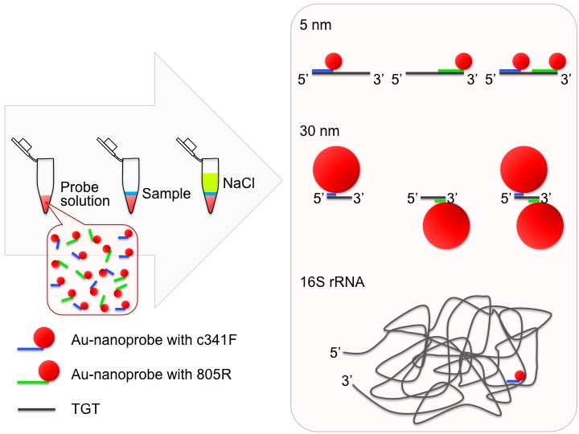
Scheme S1. Schematic representation of the sensing mechanism of the method.

Figure S1. Time course of the absorbance spectra of the POS (solid lines) and NEG (dashed lines) samples after NaCl addition for 60 min. The absorbance spectra were analyzed every 5 min.

