Oecologia

Electronic Supplementary Material (ESM)

Article title: Size-dependent growth tactics of a partially migratory fish before migration

Authors: Ryo Futamura, Kentaro Morita, Yoichiro Kanno, Shoji Kumikawa, Yuichi Matsuoka, Atsushi Okuda, Hiroshi Sugiyama, Hiroyuki Takahashi, Jiro Uchida, Osamu Kishida*

* Corresponding author: kishida@fsc.hokudai.ac.jp

The following Supporting Information is available for this article

Online Resource 1
Detailed information of the statistical analyses for the first prediction (i.e., smaller eventual migrants accelerated pre-migration periods)

Online Resource 2
Detailed information of the statistical analyses for the second prediction (i.e., smaller eventual migrants descend the river later than larger ones)

Online Resource 3
Statistical analysis of the complementary relationship between the effects of growth rate and period

Online Resource 1
Detailed information of the statistical analyses for the first prediction (i.e., smaller eventual migrants accelerated pre-migration periods)

Table S1 Formulae of eight models used to test the first prediction
Model | Response variable | Fixed factor | Random factor
A | Ln (FL in ES) | Ln (FL in PA), life history, year, habitat section and their interactions
B | Ln (BM in ES) | Ln (BM in PA), life history, year, habitat section and their interactions
C | Ln (FL in ES) | Ln (FL in PA), life history, year and their interactions | Habitat section
D | Ln (BM in ES) | Ln (BM in PA), life history, year and their interactions | Habitat section
E | Ln (FL in MS) | Ln (FL in ES), life history, habitat section, their interactions and length of spring period
F | Ln (BM in MS) | Ln (BM in ES), life history, habitat section, their interactions and length of spring period
G | Ln (FL in MS) | Ln (FL in ES), life history, their interactions and length of spring period | Habitat section
H | Ln (BM in MS) | Ln (BM in ES), life history, their interactions and length of spring period | Habitat section
In each model, abbreviations PA, ES, MS, FL and BM stands for previous autumn, early spring, migration season, fork length and body mass. Continuous variables and categorical variables are shown in roman and italic, respectively.

Table S2 Results of the eight models used to test first prediction
Model A | Fixed factor | Coefficient | Mean squares | F value | P value
 | Ln (FL in PA) | 0.43 | 2.56 | 1500.00 | <0.0001
 | Life history | -1.73 | 0.35 | 203.70 | <0.0001
 | Habitat section | -7.2×10⁻⁵ | 1.3 × 10⁻³ | 0.81 | 0.3689
 | Year | -1.00 | 0.3 | 176.51 | <0.0001
 | Ln (FL in PA) × Life history | 0.36 | 0.1 | 59.17 | <0.0001
 | Ln (FL in PA) × Habitat section | 1.3×10⁻⁵ | 3.0 × 10⁻⁴ | 0.18 | 0.6748
 | Life history × Habitat section | 1.8×10⁻⁵ | 6.9 × 10⁻⁴ | 0.41 | 0.5251
 | Ln (FL in PA) × Year | 0.20 | 0.03 | 18.40 | <0.0001
 | Life history × Year | -0.16 | 0.01 | 3.63 | 0.0581
 | Habitat section × Year | -1.0×10⁻⁴ | 0.01 | 6.01 | 0.0149
 | Ln (FL in PA) × Life history × Habitat section | -3.6×10^{-６} | 9.7 × 10⁻⁴ | 0.57 | 0.4511
 | Ln (FL in PA) × Life history × Year | 0.04 | 3.3 × 10⁻³ | 1.93 | 0.1660
 | Ln (FL in PA) × Habitat section × Year | 2.4×10⁻⁵ | 2.0 × 10⁻⁴ | 0.13 | 0.7235
 | Life history × Habitat section × Year | 2.7×10⁻⁴ | 4.3 × 10⁻⁴ | 0.25 | 0.6160
 | Ln (FL in PA) × Life history × Habitat section × Year | -5.8×10⁻⁵ | 1.6 × 10⁻³ | 0.95 | 0.3296
 | Intercept | 2.81
Model B | Fixed factor | Coefficient | Mean squares | F value | p value
 | Ln (BM in PA) | 0.31 | 23.36 | 1164.92 | <0.0001
 | Life history | -1.06 | 3.11 | 155.17 | <0.0001
 | Habitat section | -1.6×10⁻⁴ | 0.21 | 10.69 | 0.0012
 | Year | -0.91 | 2.41 | 120.02 | <0.0001
 | Ln (BM in PA) × Life history | 0.36 | 0.58 | 28.93 | <0.0001
 | Ln (BM in PA) × Habitat section | 5.6×10⁻⁵ | 2.7 × 10⁻³ | 0.13 | 0.7163
 | Life history × Habitat section | 1.0×10⁻⁴ | 0.05 | 2.72 | 0.1005
 | Ln (BM in PA) × Year | 0.31 | 0.25 | 12.70 | 0.0004
 | Life history × Year | 0.22 | 0.05 | 2.32 | 0.1289
 | Habitat section × Year | 7.5×10⁻⁵ | 0 | 0.00 | 0.9990
 | Ln (BM in PA) × Life history × Habitat section | -4.1×10⁻⁵ | 0.05 | 2.29 | 0.1315
 | Ln (BM in PA) × Life history × Year | -0.08 | 0.05 | 2.72 | 0.1003
 | Ln (BM in PA) × Habitat section × Year | -3.8×10⁻⁵ | 0.05 | 2.70 | 0.1020
 | Life history × Habitat section × Year | 4.1×10⁻⁵ | 0.01 | 0.28 | 0.5963
 | Ln (BM in PA) × Life history × Habitat section × Year | -1.2×10⁻⁵ | 7.0 × 10⁻⁴ | 0.03 | 0.8519
 | Intercept | 2.09
Model C | Fixed factor | Coefficient | Mean squares | F value | p value
 | Ln (FL in PA) | 0.50 | 1.77 | 1163.94 | <0.0001
 | Life history | -1.43 | 0.06 | 41.31 | <0.0001
 | Year | -1.06 | 0.03 | 21.16 | <0.0001
 | Ln (FL in PA) × Life history | 0.30 | 0.06 | 37.08 | <0.0001
 | Ln (FL in PA) × Year | 0.22 | 0.03 | 18.14 | <0.0001
 | Life history × Year | 0.30 | 9.0 × 10⁻⁴ | 0.59 | 0.4423
 | Ln (FL in PA) × Life history × Year | -0.06 | 8.0 × 10⁻⁴ | 0.50 | 0.4809
 | Intercept | 2.44
Model D | Fixed factor | Coefficient | Mean squares | F value | p value
 | Ln (BM in PA) | 0.48 | 12.29 | 847.93 | <0.0001
 | Life history | -0.73 | 0.46 | 31.99 | <0.0001
 | Year | -0.66 | 0.37 | 25.48 | <0.0001
 | Ln (BM in PA) × Life history | 0.22 | 0.2 | 13.78 | 0.0003
 | Ln (BM in PA) × Year | 0.20 | 0.16 | 11.02 | 0.0010
 | Life history × Year | 0.30 | 0.03 | 2.13 | 0.1460
 | Ln (BM in PA) × Life history × Year | -0.10 | 0.02 | 1.18 | 0.2794
 | Intercept | 1.61
Model E | Fixed factor | Coefficient | Mean squares | F value | p value
 | Ln (FL in ES) | 0.70 | 1.31 | 647.42 | <0.0001
 | Life history | -0.64 | 0.01 | 6.77 | 0.001
 | Habitat | 6.9×10⁻⁵ | 6.3 × 10⁻³ | 3.11 | 0.0793
 | Days of spring period | 3.2×10⁻³ | 0.15 | 74.36 | <0.0001
 | Ln (FL in ES) × Life history | 0.11 | 0.02 | 7.78 | 0.0058
 | Habitat × ln (FL in ES) | -1.6×10⁻⁵ | 6.2 × 10⁻⁴ | 0.30 | 0.5821
 | Habitat × Life history | -1.0×10⁻⁴ | 4.5 × 10⁻³ | 2.24 | 0.1363
 | Ln (FL in ES) × Life history × Habitat | 2.4 × 10⁻⁵ | 5.0 × 10⁻⁴ | 0.23 | 0.6292
 | Intercept | 1.42
Model F | Fixed factor | Coefficient | Mean squares | F value | p value
 | Ln (BM in ES) | 0.54 | 5.54 | 285.28 | <0.0001
 | Life history | -0.89 | 1.34 | 69.25 | <0.0001
 | Habitat | 6.4 × 10⁻⁵ | 8.0 × 10⁻⁴ | 0.04 | 0.8386
 | Days of spring period | 0.01 | 1.45 | 74.70 | <0.0001
 | Ln (BM in ES) × Life history | 0.29 | 0.25 | 13.08 | 0.0004
 | Habitat × ln (BM in ES) | 2.3 × 10⁻⁵ | 0.01 | 0.55 | 0.4605
 | Habitat × Life history | 9.3 × 10⁻⁵ | 0.1 | 5.37 | 0.0216
 | Ln (BM in ES) × Life history × Habitat | -2.2 × 10⁻⁵ | 3.4 × 10⁻³ | 0.18 | 0.6740
 | Intercept | 1.10
Model G | Fixed factor | Coefficient | Mean squares | F value | p value
 | Ln (FL in ES) | 0.65 | 1.07 | 528.06 | <0.0001
 | Life history | -0.90 | 0.02 | 9.36 | 0.0025
 | Days of spring period | 3.1 × 10⁻³ | 0.12 | 59.14 | <0.0001
 | Ln (FL in ES) × Life history | 0.17 | 0.01 | 7.04 | 0.0087
 | Intercept | 1.61
Model H | Fixed factor | Coefficient | Mean squares | F value | p value
 | Ln (BM in ES) | 0.58 | 8.28 | 419.59 | <0.0001
 | Life history | -0.66 | 0.34 | 17.44 | <0.0001
 | Days of spring period | 0.01 | 1.06 | 53.47 | <0.0001
 | Ln (BM in ES) × Life history | 0.25 | 0.26 | 12.96 | 0.0004
 | Intercept | 1.00

Abbreviations: PA (previous autumn), ES (early spring), FL (fork length), BM (body mass). Before the analyses, the categorical variables were transformed into dummy variables (i.e., converted to either 0 or 1). Specifically, we transformed life history (i.e., eventual migrant [0] and resident [1]) and year (i.e., autumn 2018–early spring 2019 [0] and autumn 2019–early spring 2020 [1]).

Fig. S1 Relationship between initial size (body mass) and the subsequent size of eventual migrants (black) and residents (grey) of masu salmon juveniles during the pre-migration period. Regression lines are estimated after natural logarithmic transformation (i.e., ln (Y) = a × ln (X) + b ↔ Y = Xª × e^{b}). a Size relationship between previous autumn and early spring (winter period, 2018–2019); b size relationship between previous autumn and early spring (winter period, 2019–2020); c size relationship between early spring and migration season (spring period, 2020). Regression lines; a Y = X^{0.48} × e^{1.62}, p < 0.001, adjusted R² = 0.60, for eventual migrants (N=60); Y = X^{0.71} × e^{0.84}, p < 0.001, adjusted R²= 0.80, for residents (N = 41); b Y = X^{0.68} × e^{0.95}, p < 0.001, adjusted R² = 0.78, for eventual migrants (N = 72); Y = X^{0.81} × e^{0.49}, p <0.001, adjusted R² = 0.86, for residents (N = 74); c Y = X^{0.45} × e^{1.91}, p < 0.001, adjusted R² = 0.49, for eventual migrants (N = 117); Y = X^{0.83} × e^{1.18}, p < 0.001, adjusted R² = 0.76, for residents (N = 74)
As we predicted, compared to lighter residents, lighter eventual migrants at the beginning of pre-migration periods gained more weight at the end of pre-migration periods, but such a final mass difference between the life history types diminished with an increase in initial mass of individuals (a, b). However, although panel (c) showed a similar pattern in that the regression slope was less steep for the eventual migrants than for the residents, the eventual migrants gained less weight than the residents. This means that the eventual migrants increased comparatively more in length than in weight, i.e., the eventual migrants became slenderer just before the migration. However, we cannot exclude the possibility that the patterns were caused by the difference in the timing of measuring final mass between life history types. Final mass of the eventual migrants was measured when the migrants were caught at the migrant trap in the river-descending season (April to mid-June 2020), while that of the residents was measured at the capture survey held in summer (June 25 or 26, 2020). Other factors such as resource availability might have caused the different growth patterns between the life history types.
Online Resource 2
Detailed information of the statistical analyses for the second prediction (i.e., smaller eventual migrants descend the river later than larger ones)

Table S3 Results of the two models predicting migration timing
 | Fixed factor | Coefficient | Sum of squares | F value | P value
Fork length model | FL in ES | -0.65 | 5073.60 | 24.85 | <0.0001
 | Habitat section | 0.00 | 1959.30 | 9.60 | 0.0026
 | Year | 13.76 | 4606.80 | 22.56 | <0.0001
 | Intercept | 115.98
Body mass model | BM in ES | -1.58 | 5545.20 | 26.91 | <0.0001
 | Habitat section | 0.00 | 1336.90 | 6.49 | 0.0124
 | Year | 13.71 | 4571.60 | 22.18 | <0.0001
 | Intercept | 66.86

Abbreviations: ES (early spring), FL (fork length), BM (body mass). Before analysis, the “year” as a categorical variable was transformed to the dummy variables (i.e., 2019 [0] and 2020 [1])

Fig. S2 Relationship between the river-descending timing (date) and body mass (g) at the early spring of the eventual migrants in a 2019 and b 2020. Regression lines: a Y = -1.75X + 75.93, p < 0.001, adjusted R² = 0.18 (N = 60); b Y = -2.18X + 95.99, p < 0.003, adjusted R² = 0.18 (N = 41)
Online Resource 3
Statistical analysis of the complementary relationship between the effects of growth rate and period

Eventual migrants may not delay the start of migration to minimize the cost of delayed migration, if they grow well in winter. This hypothesis was tested in the analysis using the following model:
$${River descending timing}_{i}\sim Normal(u_{i})$$
$$u_{i}=Intercept+{Daily growth during the winter period}_{i}$$
$$+{Fork length in previous autumn}_{i}+{Year}_{i}$$

Here, daily growth during the winter period was calculated as instantaneous growth rate (Lugert et al. 2016) (i.e. (ln [fork length in early spring] - ln [fork length in previous autumn]) / days between two surveys ×100).

Table S4 Result of the analysis on the complementary relationship.
Fixed factor | Coefficient | Sum of squares | F value | P value
Fork length in autumn | -0.89 | 244.2 | 1.089 | 0.2992
Daily growth in winter period | -214.95 | 6153.4 | 27.449 | <0.0001
Year | 13.61 | 3301 | 14.725 | 0.0002
Intercept | 154.11

Before analysis, the “year” as a categorical variable was transformed to the dummy variables (i.e., autumn 2018–spring 2019 [0] and autumn 2019– spring 2020 [1])
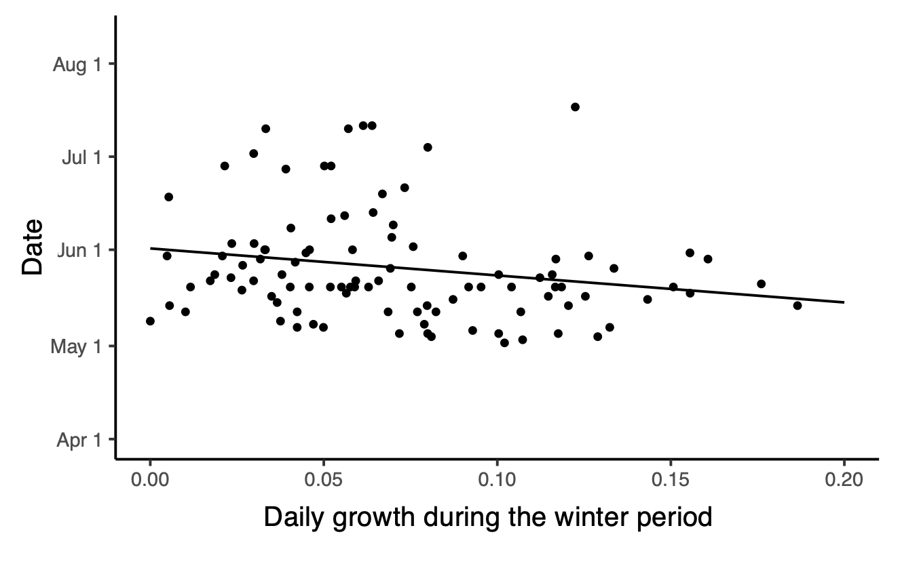
Fig. S3 Relationship between the daily growth during the winter period and migration timing. Eventual migrants that grew faster in the winter period descended the river earlier. Regression line: Y = -86.94 X + 61.43, p < 0.04, adjusted R² = 0.03 (N = 101)

