Photocatalytic Activity of Radial Rutile Titanium(IV) Oxide Microspheres for Aerobic Oxidation of Organics

Ryota Kojima,^{[a]} Bunsho Ohtani,* ^{[b]} Hiroaki Tada*^{[a]}
^{[a]} Graduate School of Science and Engineering, Kindai University, 3-4-1, Kowakae, Higashi-Osaka, Osaka 577-8502, Japan.
^{[b]} Graduate School of Environmental Science, Hokkaido University, Sapporo, Hokkaido 060-0810, Japan, and Institute for Catalysis, Hokkaido University, Sapporo, Hokkaido 001-0021, Japan.

* To whom correspondence should be addressed: TEL: +81-6-6721-2332, FAX: +81-6-6727-2024,
E-mail: h-tada@apch.kindai.ac.jp.

Figure S1. Absorption spectra of TiO₂ particles recovered from aqueous and acetonitrile solutions of 2-naphthol with different concentrations (10 μM and 5 mM).

A)
B)
Figure S2. The energy difference between the surface electron traps (SETs) and the CBB in the TiO₂-NR HOMC system in the ERDT/CBB pattern (ΔE) and the compensated value (ΔE_{c}) in the . TiO₂-NR HOMC (A) and FeO_{x}/TiO₂-NR HOMC (B) systems. The energy of the SETs observed in the ERDT/CBB pattern occurs from the levels 0.1~0.2 eV below the CBB since the DOSs of the VBT and the SETs are small. Then, the energy difference is compensated by ΔE_{c} ≈ ΔE – 0.15 eV in the TiO₂-NR HOMC system. Also, the energy difference can be compensated by ΔE_{c} ≈ ΔE – 0.55 eV in the FeO_{x}/TiO₂-NR HOMC system.

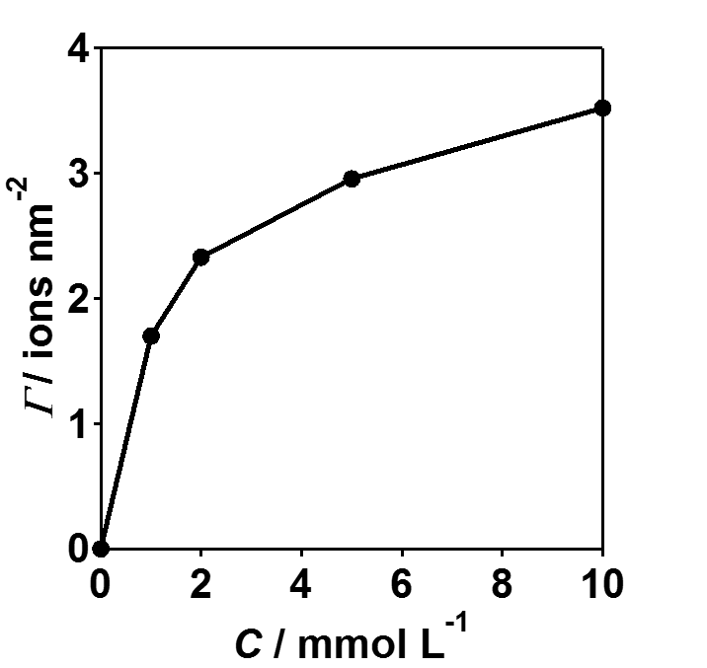
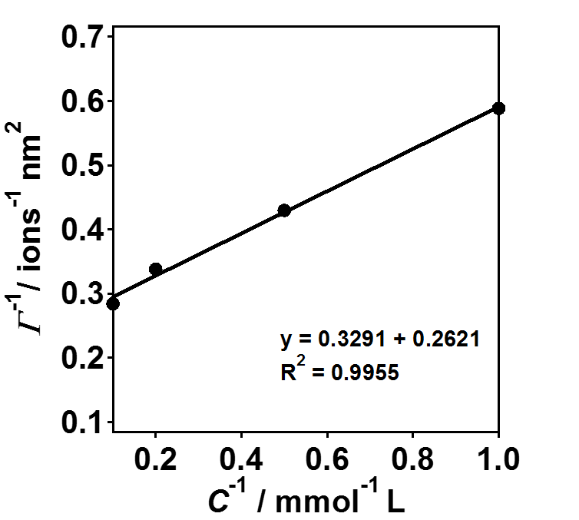
A)
B)
Figure S3. Plots of Fe-loading amount (Γ) vs. Fe(acac)₃ concentration in the chemisorption-calcination ptocess (C) (A) and Γ⁻¹vs. C⁻¹ in the FeO_{x}/TiO₂-NR HOMC system.
Figure S4. Time courses for FeO_{x}(Γ)/TiO₂-NR HOMC-photocatalyzed 2-naphthol degradation under irradiation of visible light (I _{420~485 nm} = 10 mW cm⁻²).

