Table S1. PERMANOVA table of the fish assemblage in the seasonal survey.

Table S2. PERMANOVA table of the whole biota (including all faunal groups) in the spatial survey.

Table S3: Results of SIMPER (similarity percentage analysis) per connectivity.

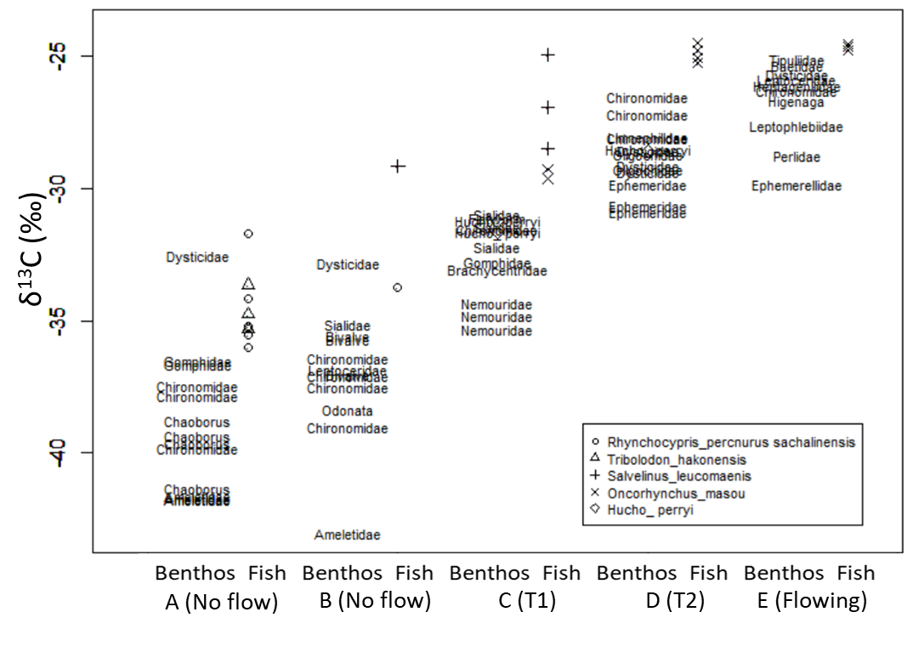
Figure S1: Carbon stable isotope ratio of benthos and fishes in the five focal sites captured at the end of the flooding season.

Figure S2: NMDS plot of the whole biota (four faunal groups included after standardization).

