Fig.1 (Hasegawa and Nakaoka)
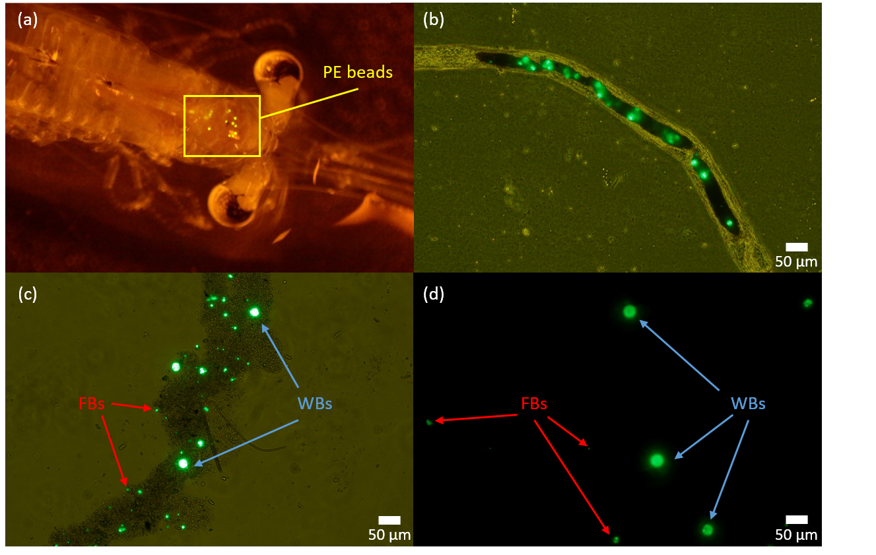

Fig.2 (Hasegawa and Nakaoka)
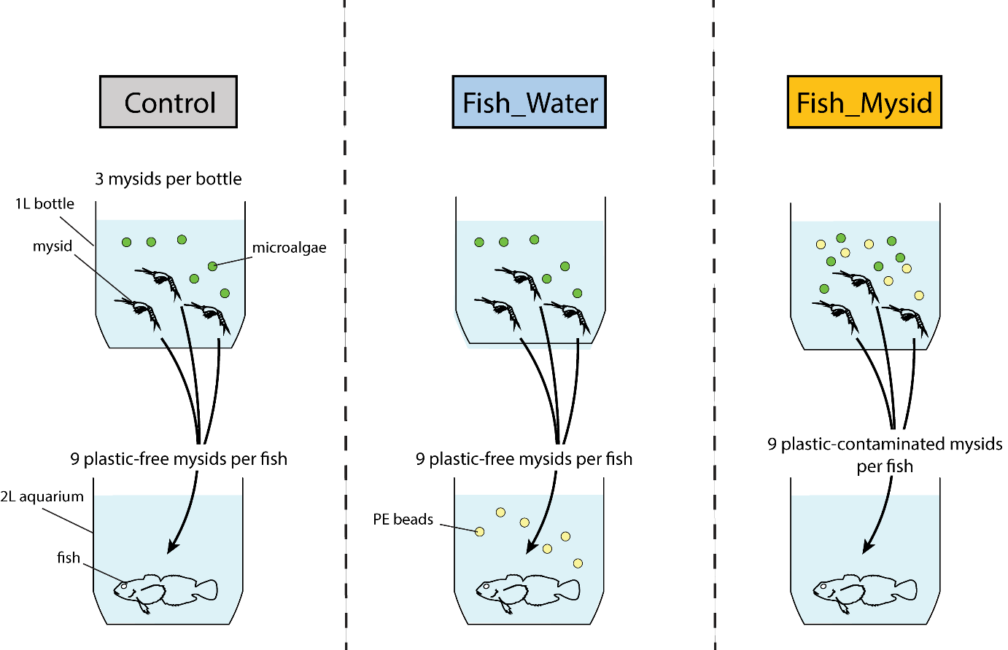
Fig. 3 (Hasegawa and Nakaoka)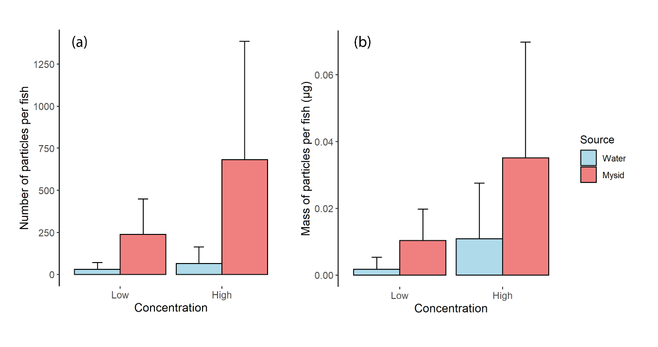
Fig. 4 (Hasegawa and Nakaoka)

