Supplemental Material

Assessment of LeadCare® II analysis for testing of a wide range of blood lead levels in comparison with ICP–MS analysis

Hokuto Nakata, Shouta M.M. Nakayama, John Yabe, Kaampwe Muzandu, Haruya Toyomaki, Yared Beyene Yohannes, Andrew Kataba, Golden Zyambo, Yoshinori Ikenaka, Kennedy Choongo, Mayumi Ishizuka

Table of Contents

Supplementary Table S1. Heating program of sample digestion using Microwave equipment.

Supplementary Table S2. Operating conditions for ICP-MS analysis.

Supplementary Table S3. Characteristics of the studied population.

Supplementary Figure S1. Map of sampling points widely distributed across the whole Kabwe town (Yabe et al., 2020).

Supplementary Figure S2. Passing–Bablok regression analysis between BLL_{LC} and BLL_{IM} in the BLLLC ranges of 3.3 to 4.9 µg/dL (A), 5.0 to 9.9 µg/dL (B), 10.0 to 19.9 µg/dL (C), 20.0 to 44.9 µg/dL (D), 45.0 to 64.9 µg/dL (E), and >65.0 µg/dL (F). Parts of BLL_{LC} (Yabe et al., 2020) and BLL_{IM} (Nakata et al., 2020) data were reported in earlier papers and cited.

Supplementary Figure S3. Deming regression analysis between log BLL_{LC} and log BLL_{IM} in the BLL_{LC} ranges of 3.3 to 4.9 µg/dL (A), 5.0 to 9.9 µg/dL (B), 10.0 to 19.9 µg/dL (C), 20.0 to 44.9 µg/dL (D), 45.0 to 64.9 µg/dL (E), and >65.0 µg/dL (F). Parts of BLL_{LC} (Yabe et al., 2020) and BLL_{IM} (Nakata et al., 2020) data were reported in earlier papers and cited.

Supplementary Table S1. Heating program of sample digestion using Microwave equipment.
Step | 1 | 2 | 3
Ramp (min) | 5 | 1 | 0
Time (min) | 5 | 10 | 10
Temperature (℃) | 160 | 190 | 75

Supplementary Table S2. Operating conditions for ICP-MS analysis.
Parameter | Value
Radiation frequency power | 1500 W
Argon gas pressure | 600 kPa
Cell gas (Helium) | 100 kPa
Peak pattern | 3
Replicates | 10
Sweeps/replicate | 1000
Integration time/mass | 9.00 sec
Stabilization time | 30 sec

Supplementary Table S3. Characteristics of the studied population.
 |  | Sample size | Age
 |  | Sample size | Mean | SD | Median | min | max
All area |  | 1208 | 24.0 | 20.8 | 21 | 0 | 96
 | Female | 660 | 26.3 | 19.6 | 26 | 0 | 90
 | Male | 548 | 21.3 | 21.7 | 9 | 0 | 96
Bwacha |  | 109 | 26.6 | 21.5 | 24 | 1 | 72
 | Female | 55 | 30.2 | 21.8 | 36 | 1 | 71
 | Male | 54 | 22.9 | 20.6 | 10 | 1 | 72
Chowa |  | 103 | 18.1 | 17.4 | 10 | 0 | 80
 | Female | 50 | 22.8 | 15.6 | 23.5 | 2 | 57
 | Male | 53 | 13.7 | 18.0 | 6 | 0 | 80
Hamududu |  | 101 | 25.1 | 20.2 | 25 | 0 | 82
 | Female | 54 | 24.7 | 19.1 | 24 | 0 | 71
 | Male | 47 | 25.5 | 21.6 | 27.5 | 1 | 82
Kang'omba |  | 99 | 25.1 | 19.1 | 24 | 0 | 67
 | Female | 52 | 26.5 | 18.0 | 26 | 0 | 67
 | Male | 47 | 23.5 | 20.3 | 21 | 0 | 63
Kasanda |  | 203 | 24.7 | 21.2 | 11 | 1 | 86
 | Female | 120 | 24.0 | 18.6 | 24.5 | 1 | 68
 | Male | 83 | 25.9 | 24.7 | 10 | 1 | 86
Katondo |  | 40 | 32.9 | 24.7 | 27 | 3 | 77
 | Female | 25 | 29.9 | 22.5 | 23 | 3 | 72
 | Male | 15 | 37.9 | 28.1 | 38 | 5 | 77
Mahatma Ghandi |  | 24 | 25.6 | 21.1 | 21.5 | 1 | 69
 | Female | 13 | 30.8 | 22.5 | 35 | 3 | 69
 | Male | 11 | 19.5 | 18.6 | 9 | 1 | 51
Makululu |  | 373 | 25.2 | 21.9 | 23 | 0 | 96
 | Female | 213 | 27.5 | 21.3 | 27 | 0 | 90
 | Male | 160 | 22.0 | 22.2 | 9 | 0 | 96
Mpima prison |  | 46 | 19.7 | 17.8 | 9 | 0 | 72
 | Female | 23 | 27.1 | 18.4 | 25 | 4 | 72
 | Male | 23 | 12.3 | 13.9 | 7 | 0 | 47
Natuseko |  | 45 | 15.8 | 14.7 | 8 | 0 | 49
 | Female | 21 | 22.3 | 12.9 | 25 | 0 | 49
 | Male | 24 | 10.2 | 14.1 | 4 | 0 | 49
Ngungu |  | 38 | 18.0 | 19.4 | 9 | 1 | 70
 | Female | 16 | 27.0 | 18.1 | 26 | 2 | 67
 | Male | 22 | 11.4 | 18.0 | 7 | 1 | 70
Pollen |  | 16 | 24.4 | 19.9 | 29 | 0 | 62
 | Female | 13 | 26.2 | 20.6 | 31 | 0 | 62
 | Male | 3 | 16.7 | 17.8 | 9 | 4 | 37
Railway |  | 11 | 23.1 | 17.0 | 27 | 1 | 52
 | Female | 5 | 25.6 | 15.1 | 28 | 6 | 47
 | Male | 6 | 21.0 | 19.6 | 18.5 | 1 | 52

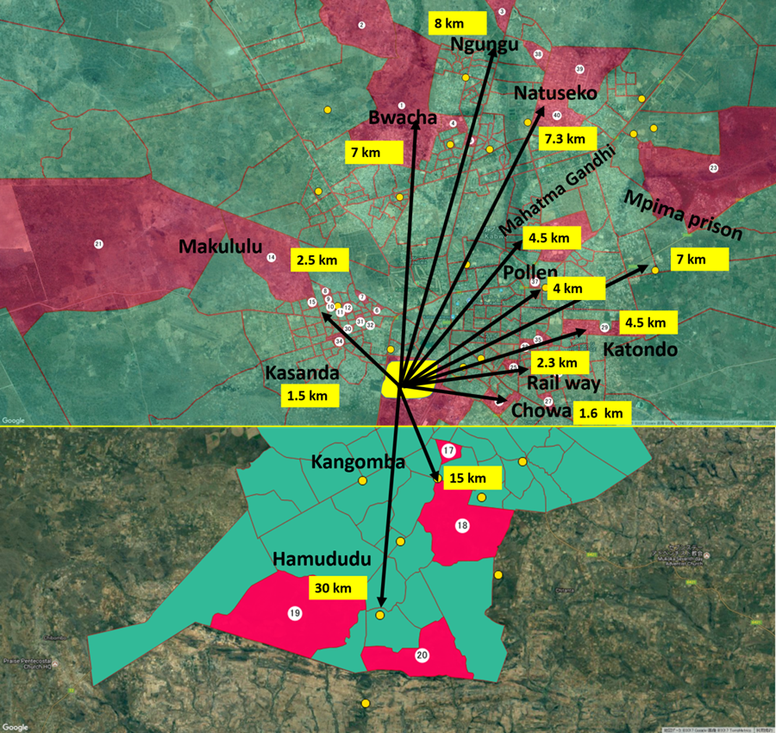
Supplementary Figure S1. Map of sampling points widely distributed across the whole Kabwe town (Yabe et al., 2020).

Supplementary Figure S2. Passing–Bablok regression analysis between BLL_{LC} and BLL_{IM} in the BLL_{LC} ranges of 3.3 to 4.9 µg/dL (A), 5.0 to 9.9 µg/dL (B), 10.0 to 19.9 µg/dL (C), 20.0 to 44.9 µg/dL (D), 45.0 to 64.9 µg/dL (E), and >65.0 µg/dL (F). Parts of BLL_{LC} (Yabe et al., 2020) and BLL_{IM} (Nakata et al., 2020) data were reported in earlier papers and cited.

Supplementary Figure S3. Deming regression analysis between log BLLLC and log BLLIM in the BLLLC ranges of 3.3 to 4.9 µg/dL (A), 5.0 to 9.9 µg/dL (B), 10.0 to 19.9 µg/dL (C), 20.0 to 44.9 µg/dL (D), 45.0 to 64.9 µg/dL (E), and >65.0 µg/dL (F). Parts of BLL_{LC} (Yabe et al., 2020) and BLL_{IM} (Nakata et al., 2020) data were reported in earlier papers and cited.

