Supporting Information to:

Unexpected Structural Defects Formed in a Main-chain Conjugated Polymer Synthesized through Suzuki-Miyaura Coupling Polymerization

Yuehui Yuan,ª Zhiyi Song,ª Masayoshi Bando,ª and Tamaki Nakano^{*ab}

ªInstitute for Catalysis (ICAT) and, Graduate School of Chemical Sciences and Engineering, Hokkaido University, N 21, W 10, Kita-ku, Sapporo 001-0021, Japan. E-mail: tamaki.nakano@cat.hokudai.ac.jp; Fax: +81-11-7069156; Tel: +81-11-7069155.
^{b}Integrated Research Consortium on Chemical Sciences (IRCCS), Institute for Catalysis, Hokkaido University, N21W10, Kita-ku, Sapporo 001-0021, Japan

*Corresponding author, e-mail: tamaki.nakano@cat.hokudai.ac.jp

Experimental details S2
NMR spectra from attempted reactions of PhenBr₂ to induce defective structures S5
NMR spectra from attempted reactions of DOF[B(OH)₂]₂ to induce defective structures S6
NMR spectra from attempted reactions of poly(DOF-alt-Phen) to induce defective structures S7
NMR spectra from attempted polymerization between DOF[B(OH)₂]₂ and PhenBr₂ S8
¹H NMR spectra of monomers and poly(DOF-alt-Phen)s S9
¹³C NMR spectra of monomers and poly(DOF-alt-Phen)s S10
IR spectra of monomers and poly(DOF-alt-Phen)s S11
IR spectra of the model triad compound (DOF-Phen-DOF) S12
Mass spectra of the model triad compound (DOF-Phen-DOF) S13
DTA profiles of poly(DOF-alt-Phen)s S14
Synthesis and properties of poly(DOF-alt-Bz) S15
References S19

Experimental details

Materials.

1,4-Phenyldiboronic acid (TCI), 2,7-dibromo-9,9-dioctylfluorene (Aldrich), 1,10-phenanthroline monohydrate (TCI), tetrakis(triphenylphosphine)palladium(0) (TCI), 1.6 M n-butylithium in hexane (TCI), triisopropyl borate (Aldrich), potassium carbonate (Wako), magnesium sulfate (Kanto chemical), hydrochloric acid (Kanto chemical), disulfur dichloride (TCI), n-butyl chloride (TCI), bromine (TCI) were used as purchased. p-Xylene (TCI), dimethoxyethane (TCI), ethanol (Kanto Chemical), toluene (Kanto Chemical), pyridine (Kanto Chemical), D₂O (99.8% d) (Kanto Chemical), and H₂¹⁸O (>98% ¹⁸O) (Taiyo Nippon Sanso) were used as obtained. Tetrahydrofuran (Kanto Chemical) was dried with sodium benzophenone ketyl and distilled immediately before use under N₂.

General instrumentation.
¹H NMR spectra were recorded on a JEOL JNM-ECX400 spectrometer (400 MHz for ¹H measurement) and a JEOL JNM-ECA600 spectrometer (600 MHz for ¹H measurement). SEC measurements were carried out using a chromatographic system consisting of a Hitachi L-7100 chromatographic pump, a Hitachi L-7420 UV detector (254 nm), and a Hitachi L-7490 RI detector equipped with TOSOH TSK gel G6000H_{HR} and G3000H_{HR} columns (30 x 0.72(i.d.) cm) connected in series (eluent THF, flow rate 1.0 mL/min). UV-vis absorption spectra were measured at room temperature with a JASCO V-550 and V-570 spectrophotometers. Steady-state emission spectra were taken on a JASCO FP-8500 fluorescence spectrophotometer. IR spectra were recorded on a JASCO FT/IR-6100 spectrometer using KBr pellet and KBr plate. Differential scanning calorimetry (DSC) and thermal gravity analysis (TGA) were taken on Rigaku Thermo Plus DSC8230 and TG8120 analyzer at a heating rate of 10 K/min in nitrogen atmosphere.

Synthesis and Structural Analysis of Compounds
3,8-Dibromo-1,10-phenanthroline (PhenBr₂).¹
A 50-mL two-necked flask was charged with 1,10-phenanthroline monohydrate (0.90 g, 5 mmol), n-butyl chloride (20 mL), pyridine (2 mL), and disulfur dichloride (2 mL). Bromine was dissolved in 5 mL of n-butyl chloride and added to the solution dropwise. The mixture was heated to 130 ºC and stirred for 24 h. The reacted mixture was filtered and the solid was dissolved in chloroform and get brown solution after filtration. The solution was washed with excess KOH and water, dried over MgSO₄. The crude product was concentrated on vacuum evaporator and was purified by silica gel column chromatography (eluent: chloroform) to obtain the product (0.29 g, 18 %) as a light yellow solid.¹ ¹H NMR (400 MHz, CDCl₃, r.t.): 9.19 ppm (d, J = 2.3 Hz, 2H), 8.41 ppm (d, J = 2.23 Hz, 2H), 7.76 ppm (s, 2H). FTIR (KBr, cm⁻¹): 1616, 1582, 1481, 1413, 1372, 1339, 1289, 1249, 1204, 1150, 1104, 1034, 908, 892, 808, 784, 723, 709, 508.

9,9-Dioctylfluorene-2,7-diboronic acid (DOF[B(OH)₂]₂).
2,7-Dibromo-9,9-dioctylfluorene (2.74 g, 5 mmol) were dissolved in dry THF (30 mL) in an oven dried 100 mL flask, and cooled to -78°C. 1.6 M n-BuLi (6.25 mL, 10 mmol) was added to the solution dropwise, and stirred for 2 hours. Triisopropyl borate (2.3 mL, 10 mmol) was then added and the reaction was stirred overnight at room temperature. The reaction was quenched with 2 M HCl (20 mL) and stirred for 3 hours. The reacted mixture was extracted with diethyl ether. The organic layers were collected, dried over anhydrous MgSO₄, concentrated at room temperature under reduced pressure. The crude product was recrystallized by hexane to obtain a white solid (1.70 g, 71%, m.p. = 140 ºC).² ¹H NMR (400 MHz, acetone-d₆, r.t.): 7.96 ppm (s, 2H), 7.87 ppm (d, J = 8.0 Hz, 2H), 7.77 ppm (d, J = 8.0 Hz, 2H), 7.14 ppm (1H, s), 1.27-0.97 ppm (m, 28H), 0.82-0.74 ppm (m, 6H). FTIR (KBr, cm⁻¹): 3411, 2924, 2845, 1608, 1469, 1416, 1346, 1251, 1146, 1090, 1015, 829, 737, 693, 633.

9,9-Dioctylfluorene-2-boronic acid (DOF-B(OH)₂).
2,7-Dibromo-9,9-dioctylfluorene (0.22 mL, 0.5 mmol) were dissolved in dry THF (2 mL) in an oven dried 25 mL ampul, and cooled to -78°C. 1.6 M n-BuLi (0.32 mL, 0.5mmol) was added to the solution dropwise, and stirred for 2 hours. Triisopropyl borate (0.12 mL, 0.5 mmol) was then added and the reaction was stirred overnight at room temperature. The reaction was quenched with 2 M HCl (2 mL) and stirred for 3 hours. The reacted mixture was extracted with diethyl ether. The organic layers were collected, dried over anhydrous MgSO₄, concentrated at room temperature under reduced pressure. The crude product was purified through flash chromatography (silica gel, eluent: EtOAc) to obtain an oily product (213 mg, 98%). ¹H NMR (400 MHz, acetone-d₆, r.t.): 8.33 ppm (s, 1H), 7.96 ppm (s, 1H), 7.87 ppm (d, J = 8.0 Hz, 1H), 7.77 ppm (d, J = 8.0 Hz, 1H), 7.42-7.30 ppm (m, 3H), 7.14 ppm (1H, s), 1.27-0.97 ppm (m, 28H), 0.82-0.74 ppm (m, 6H).

​3,​8-Bis(9,​9-​dioctyl​fluorene-​2-​yl)​-1,10-phenathroline (PhenDOF₂).
3,8-Dibromo-1,10-pheanthroline (33.8 mg, 0.1 mmol) and 9,9-dioctylfluorene-2,7-diboronic acid (86,71 mg, 0.2 mmol) were dissovled in DME (3 mL) in a 10-mL flask. After adding Pd(PPh₃)₄, air was removed by liquified nitrogen and vacuum. 2 M aqueous K₂CO₃ (1 mL)was bubbled with N₂ and injected in the solution. The reaction mixture was stirred at 80 ºC under nitrogen atmosphere for 24 h. The solvent was removed under vacuum and the product was washed by water. The water-insoluble and -soluble parts were separated with a centrifuge. water-insoluble part: yield (75.39 mg g, 90%); ¹H NMR (400 MHz, CDCl₃, r.t.) d (ppm): 9.55 ppm (s, 2H), 8.56 ppm (s, 2H), 8.07-7.64 ppm (m, 10H), 7.37 ppm (m, 4H), 2.17 ppm (m, 8H), 1.35-0.93 ppm (m, 40H),0.90-0.71 ppm (m,20H); FTIR (KBr, cm⁻¹): 2921, 2853, 1610, 1464, 1423, 1435, 1374, 1262, 912, 888, 830, 740, 723.
The same reaction was conducted also at 100 ºC. Yield (63.38 mg, 76%). ¹H NMR (400 MHz, CDCl₃, r.t.) 9.55 ppm (s, 2H), 8.56 ppm (s, 2H), 8.07-7.64 ppm (m, 10H), 7.37 ppm (m, 4H), 2.17 ppm (m, 8H), 1.35-0.93 ppm (m, 40H),0.90-0.71 ppm (m,20H); FTIR (KBr, cm⁻¹): 2921, 2853, 1610, 1464, 1423, 1435, 1374, 1262, 912, 888, 830, 740, 723.

Poly(9,9-dioctylfluorene-2,7-diyl-alt-phenylene-1,4-diyl) (poly(DOF-alt-Bz)) (Entry 5 in Table S1).
2,7-Dibromo-9,9-dioctylfluorene (0.11 g, 0.2 mmol) and 1,4-phenyldiboronic acid (0.03 g, 0.2 mmol) were dissovled in DME (3 mL) in a 10-mL flask. After adding Pd(PPh₃)₄, air was removed by liquified nitrogen and vacuum. 2 M aqueous K₂CO₃ (1 mL) was bubbled with N₂ and injected in the solution.³ The reaction mixture was stirred at 80 ºC under nitrogen atmosphere for 24 h, quenched with methanol and the methanol-insoluble part was dissolved in THF. The THF-insoluble and -soluble parts were separated with a centrifuge. THF-soluble part: yield (0.077 g, 68%); ¹H NMR (400 MHz, CDCl₃, r.t.) d (ppm): 7.9-7.3 ppm (m, 10H), 2.1-1.9 ppm (m, 4H), 1.3-1.0 ppm (m, 24H), 0.82 ppm (m, 6H); M_{n} 3700, M_{w}/M_{n} 3.30 (estimated by SEC based on PS standards).

Figure S1. ¹H NMR spectra of crude mixture from an attempted reaction of PhenBr₂ with Pd(PPh₃)₄ and K₂CO₃ in DME/H₂O (3/1 (v/v)) at 100 ºC for 24 h (a), that from an attempted reaction of PhenBr₂ with K₂CO₃ in DME/ at 100 ºC for 24 h (b), and pristine PhenBr₂ (c). [400MHz, r.t, CDCl₃] The samples in a and b were washed with water to remove DME.
Reaction conditions: [PhenBr₂] = 0.05 M, [Pd(PPh₃)₄] = 0.005 M, [K₂CO₃] = 0.5 M in a; [PhenBr₂] = 0.05 M, [K₂CO₃] = 0.5 M in b.

Figure S2. ¹H NMR spectra of crude mixture from an attempted reaction of DOF[B(OH)₂]₂ with Pd(PPh₃)₄ and K₂CO₃ in DME/H₂O (3/1 (v/v)) at 100 ºC for 24 h (a), that from an attempted reaction DOF[B(OH)₂]₂ with K₂CO₃ in DME/H₂O (3/1 (v/v)) at 100 ºC for 24 h (b), and pristine DOF[B(OH)₂]₂ (c). [400MHz, r.t, (CD₃)₂CO] Solvents were removed from the samples in a and b under vacuum.
Reaction conditions: [DOF[B(OH)₂]₂] = 0.05 M, [Pd(PPh₃)₄] = 0.005 M, [K₂CO₃] = 0.5 M in a; [DOF[B(OH)₂]₂] = 0.05 M, [K₂CO₃] = 0.5 M in b.

Figure S3. ¹H NMR spectra of crude mixtures from a mimicked polymerization between DOF[B(OH)₂]₂ and PhenBr₂ with Pd(PPh₃)₄ in DME/H₂O (3/1 (v/v)) at 100 ºC for 24 h (a) and from an attempted polymerization between the two monomers with no catalyst in DME/H₂O (3/1 (v/v)) at 100 ºC for 24 h. (b). [400MHz, r.t, (CD₃)₂CO]
The samples were recovered by removing the solvents under vacuum.
Reaction conditions: [DOF[B(OH)₂]₂] = 0.05 M (per residue), [PhenBr₂] = 0.05 M, [Pd(PPh₃)₄] = 0.005 M in a; [DOF[B(OH)₂]₂] = 0.05 M (per residue), [PhenBr₂] = 0.05 M in b.

Figure S4. ¹H NMR spectra of crude product from an attempted reaction of poly(DOF-alt-Phen) (entry 2 in Table 1) with Pd(PPh₃)₄ and K₂CO₃ in DME/H₂O (3/1 (v/v)) at 100 ºC for 24 h (a), crude product from an reaction of poly(DOF-alt-Phen) (entry 2 in Table 1) with K₂CO₃ (b), pristine poly(DOF-alt-Phen) (entry 2 in Table 1) (c) after 100 ºC 24 h. [400MHz, r.t, CDCl₃] The samples in a and b were washed with water to remove DME. Poly(DOF-alt-Phen) sample from entry 2 in Table 1 was used.
Reaction conditions: [poly(DOF-alt-Phen)] = 0.05 M (per residue), [Pd(PPh₃)₄] = 0.005 M, [K₂CO₃] = 0.5 M in a; [poly(DOF-alt-Phen)] = 0.05 M (per residue), [K₂CO₃] = 0.5 M in b.

Figure S5. ¹H NMR spectra of PhenBr₂ (a), DOF[B(OH)₂]₂ (b), and MeOH-insoluble, THF-soluble polymers from entry 2 (c), entry 3 (d), entry 5 (e), and entry 6 (f) [400 MHz, r.t, CDCl₃ (a, c-f); acetone-d₆ (b)].

Figure S6. ¹³C NMR spectra of PhenBr₂ (a), DOF[B(OH)₂]₂ (b), and MeOH-insoluble, THF-soluble polymers from entry 2 (c), entry 3 (d), entry 4 (e), and entry 5 (f) [100 MHz, r.t, CDCl₃ (a, c-f); MeOH-d₄ (b)].

Figure S7. IR spectra of PhenBr₂ (a), DOF[B(OH)₂]₂ (b), and MeOH-insoluble, THF-soluble polymers from entry 2 (c), entry 3 (d), entry 4 (e), and entry 5 (f) [KBr].

Figure S8. IR spectra of the crude products of the reaction between DOF-B(OH)₂ and PhBr₂ using Pd(Ph₃P)₄ and K₂CO₃ in DME/H₂O (3/1, v/v) at 80 ºC (a) and 100 ºC (b). Reaction conditions: [DOF-B(OH)₂] 0.05 M, [Phen-Br₂] 0.025 M, [Pd] 0.005 M, (10 mol%), K₂CO₃ 0.5 M, (0.2 mmol), time 24 h.

A. Reaction at 80 ºC in DME/H₂O

B. Reaction at 100 ºC in DME/H₂O
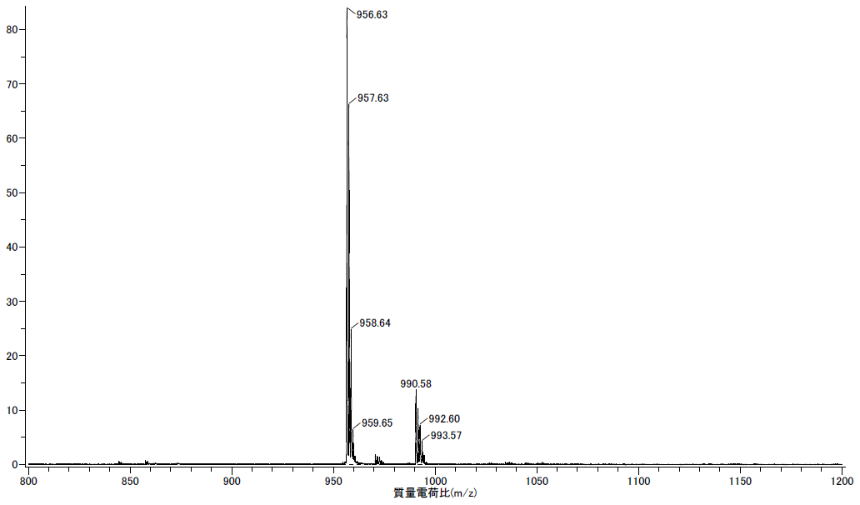

C. Reaction at 100 ºC in DME/H₂¹⁸O
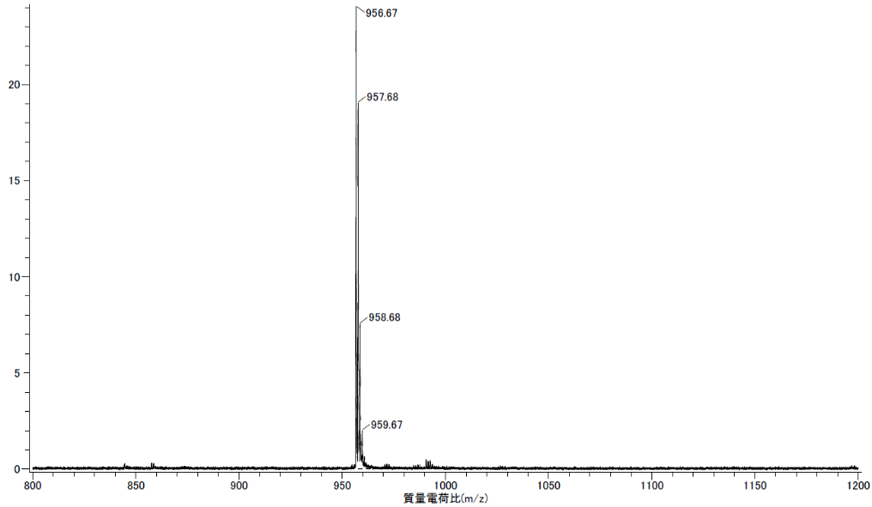

Figure S9. Mass spectra of the crude products in the synthesis of DOF-Phen-DOF triad model compound at 80 ºC in DME/H₂O [A], at 100 ºC in DME/H₂O [B], and at 100 ºC in DME/H₂¹⁸O [C]. [Mass mode = ESI in A, FD in B and C]

Figure S10. TGA of poly(DOF-alt-phen)s prepared at 100 ºC(a) and 60 ºC(b) from entry 5 and 2 in Table 1. [Heating at 10 ºC/min]

Poly(DOF-alt-Bz)
Figure S11. ¹H NMR spectrum of of poly(DOF-alt-Bz) from entry 5 in Table S1. [400MHz, r.t, CDCl₃]

Figure S12. IR spectrum of poly(DOF-alt-Bz) from entry 5 in Table S1. [KBr]

Figure S13. UV spectra (A) and fluorescence spectra (B) of poly(DOF-alt- Bz) from entry 5 in Table S1. [THF, rt, 10-mm cell; λ_{ex} = 350 nm for fluorescence]

Reference
1 Y. Saitoh, T. Koizumi, K. Osakada, T. Yamamoto, Preparation of symmetric dibromides of 1,10-phenanthroline, Can. J. Chem. 75 (1997) 1336-1339, https://doi.org/10.1002/chin.199817163.
2 M. Irfan, K. D. Belfield, A. Saeed, Carbazole/fluorene based conjugated small molecules: synthesis and comparative studies on the optical, thermal and electrochemical properties, RSC Adv. 5 (2015) 48760-48768, https://doi.org/10.1039/c5ra01141h.
3 D. Bondarev, J. Zedník, J. Vohlídal, K. Podhájecká, J. Sedláček, New fluorene-based copolymers containing oxadiazole pendant groups: Synthesis, characterization, and polymer stability, J. Polym. Sci. A Polym. Chem. 47 (2009) 4532-4546, https://doi.org/10.1002/pola.23506.

