Serological characterization of lineage II insect-specific flaviviruses compared with pathogenic mosquito-borne flaviviruses

Koshiro Tabataª, Yukari Itakuraª, Shinsuke Toba^{a,b}, Kentaro Uemura^{a,b,c}, Mai Kishimotoª, Michihito Sasakiª, Jessica J. Harrison^{g}, Akihiko Sato^{a,b}, William W. Hall^{d,e,f}, Roy A. Hall^{g}, Hirofumi Sawa^{a,d,e,h}, Yasuko Orba^{a,d,*}

Author affiliations:
ª Division of Molecular Pathobiology, International Institute for Zoonosis Control, Hokkaido University, Sapporo, Hokkaido, 001-0020, Japan
^{b} Shionogi & Co., Ltd., Osaka, 541-0045, Japan
^{c} Laboratory of Biomolecular Science, Faculty of Pharmaceutical Science, Hokkaido University, Sapporo, 060-0812, Japan
^{d} International Collaboration Unit, International Institute for Zoonosis Control, Hokkaido University, Sapporo, Hokkaido, 001-0020, Japan
^{e} Global Virus Network, Baltimore, Maryland, 21201, USA
^{f} National Virus Reference Laboratory, University College Dublin, Belfield, Dublin, 4, Ireland
^{g} Australian Infectious Diseases Research Centre, School of Chemistry and Molecular Biosciences, University of Queensland, St Lucia, Queensland, Australia
^{h} One Health Research Center, Hokkaido University, Sapporo, Hokkaido, 001-0020, Japan

*Corresponding author:
E-mail: orbay@czc.hokudai.ac.jp
Postal address: International Institute for Zoonosis Control, Hokkaido University, N20, W10, Kita-ku, Sapporo, 001-0020, Hokkaido, Japan

Supplementary Materials
2. Materials and Methods
2. 13. Western blotting
Cell lysates were collected as described in Section 2.9. The cell lysates were separated using SDS-PAGE and transferred onto PVDF membranes (Millipore, Burlington, MA, USA). The membranes were blocked with 5% skim milk-PBS with 0.01% Tween20. An equivalent volume of each serum was pooled and used. The membrane was blotted with non-immunized control pooled serum, anti-PSFV pooled serum, anti-BJV pooled serum, or a mixture of monoclonal antibodies [E: 4G2 antibody; prM: anti-DENV prM antibody (GeneTex, Irvine, CA, USA), anti-ZIKV prM antibody (GeneTex), anti-WNV prM antibody (Abcam, Cambridge, UK)] as primary antibodies. HRP-conjugated anti-β-actin antibody (MBL, Nagoya, Aichi, Japan) was used as an internal control. Each primary antibody was detected using an HRP-conjugated anti-mouse IgG antibody (Thermo Fisher Scientific, Waltham, MA, USA) or rabbit IgG antibody (Thermo Fisher Scientific) and Immobilon Western HRP Substrate (Millipore, Burlington, MA, USA). The signal was visualized using an ImageQuant 800 (Cytiva, Marlborough, MA, USA).

Results
Table S1. Comparison of amino acid sequences of the prME proteins.
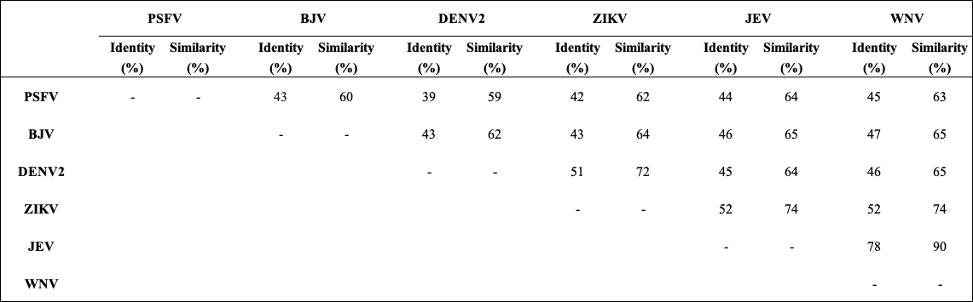

Fig S1. Comparison of the amino acid sequence of the fusion loop domain. Dots indicate the same amino acid residue with common flaviviruses.

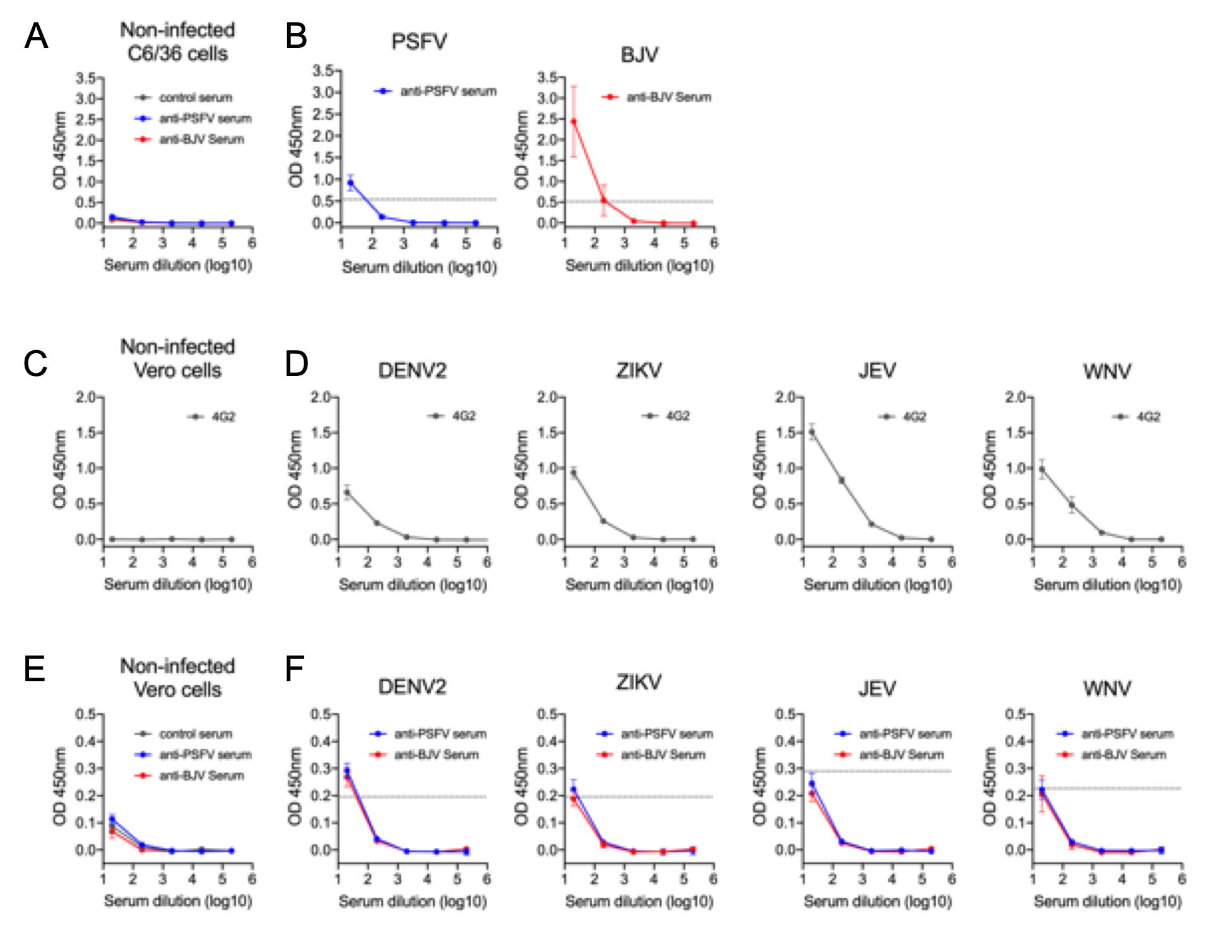
Fig. S2 Anti-PSFV or BJV serum were subjected to ELISA. (A) Binding activity of non-immunized control sera (control sera), anti-PSFV sera or anti-BJV sera to non-infected C6/36 cell lysates. (B) Binding of anti-PSFV or anti-BJV sera to PSFV or BJV-infected C6/36 cell lysates. (C and D) Binding of pan-flavivirus 4G2 monoclonal antibody as positive control to non-infected Vero cell lysates (C) and cell lysates infected with DENV2, ZIKV, JEV, and WNV (D). (E and F) Binding of control sera, anti-PSFV or anti-BJV sera to non-infected Vero cell lysate (E) and cell lysates infected with DENV2, ZIKV, JEV, and WNV (F). OD; optical density. Dotted line indicates cut-off value (mean plus three times the standard deviation of non-immunized control sera). The values in the graphs are expressed as the mean ± SD of seven serum samples (n = 7).
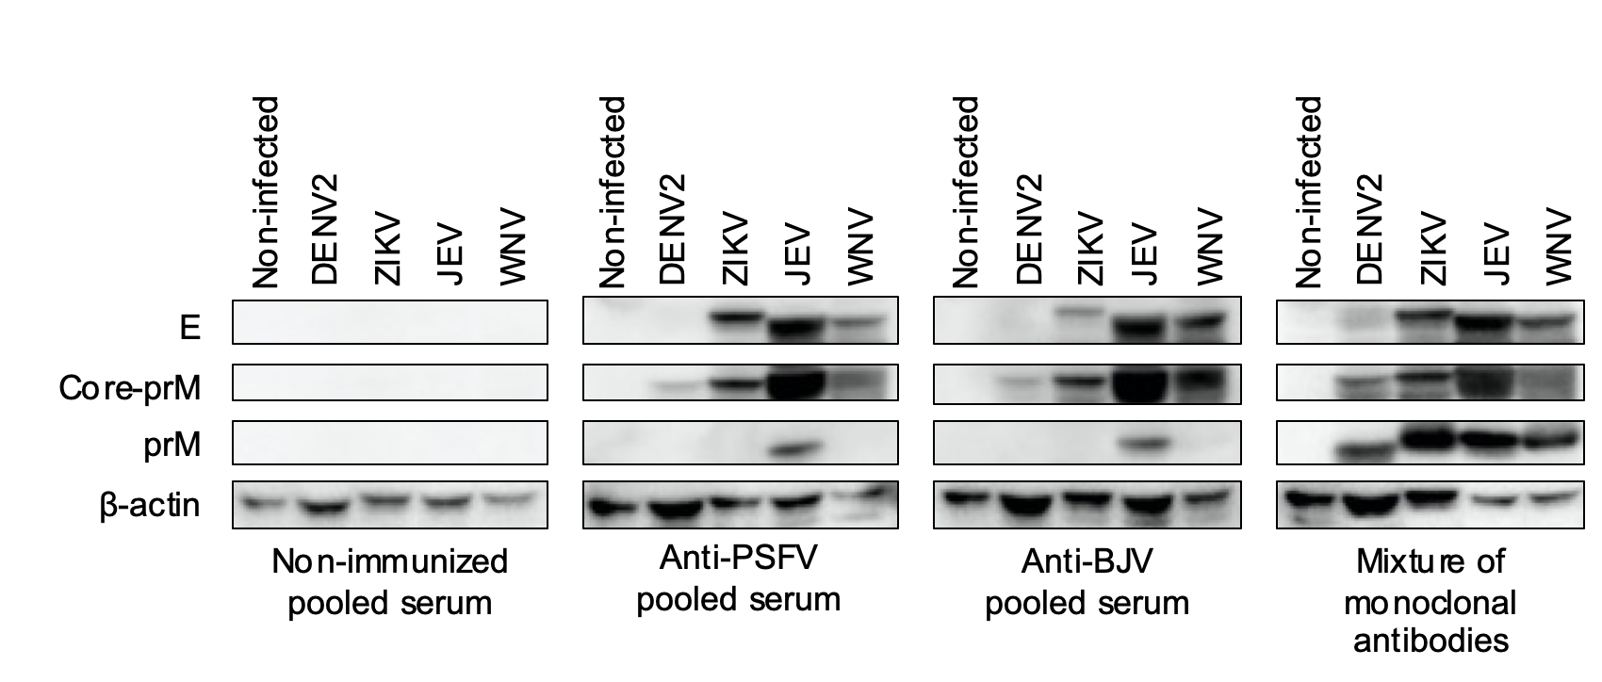
Fig. S3 Viral proteins recognized by anti-PSFV or BJV pooled serum as shown by western blotting of Vero cells infected or uninfected with DENV2, ZIKV, JEV, or WNV. Mixtures of monoclonal antibodies targeting the prM proteins of DENV2, prM proteins of ZIKV, prM proteins of WNV, and E protein, were used as positive control.

