Supplementary File

Supplementary Methods
Immunocytochemistry
Hippocampal astrocytes on coverslips were fixed with 4% paraformaldehyde for 20 min at room temperature (RT), and then permeabilized and blocked with 10% normal goat serum in PBS containing 0.1% Triton X-100 at RT for 30 min. Cells were then incubated with a primary antibody against GFAP (#11051, 1:50, Immuno-Biological Laboratories, Gunma, Japan) in PBS containing 0.1% Triton X-100 and 1% normal goat serum at 4 °C for at least 12 h. After washing in PBS, cells were incubated with Alexa Fluor 555-conjugated goat anti-mouse secondary antibody (#A21422, 1:500; Thermo Fisher Scientific, Waltham, MA, USA) in the dark at RT for 1 h. Coverslips were mounted onto glass slides with DAPI-Fluoromount G (SouthernBiotech, Birmingham, AL, USA). Fluorescence images were obtained using a laser scanning confocal microscope (LSM 700; Carl Zeiss, Oberkochen, Germany) equipped with a 40× lens objective.

Supplementary Table S1. The primer sequences used for real-time PCR

Target gene | Product  size  (bp) | Annealing temperature  (°C) | GenBank accession No. | Sequence  (upper: sense; lower: antisense)
interleukin 6 | 145 | 61 | NM_012589 | 5'-GATTGTATGAACAGCGATGATGC-3'
 |  |  |  | 5'-AGAAACGGAACTCCAGAAGACC-3'
interleukin 1beta | 150 | 63 | NM_031512 | 5'-TTGCTTCCAAGCCCTTGACT-3'
 |  |  |  | 5'-CTCCACGGGCAAGACATAGG-3'
tumor necrosis factor | 125 | 63 | NM_012675 | 5'-CATGAGCACGGAAAGCATGA-3'
 |  |  |  | 5'-CCACGAGCAGGAATGAGAAGA-3'
brain-derived neurotrophic factor | 55 | 63 | NM_001270638 | 5'-GGCCCAACGAAGAAAACCAT-3'
 |  |  |  | 5'-AGCATCACCCGGGAAGTGT-3'
nerve growth factor | 115 | 61 | NM_001277055 | 5'-CAACAGGACTCACAGGAGCA-3'
 |  |  |  | 5'-GTCCGTGGCTGTGGTCTTAT-3'
fibroblast growth factor 2 | 165 | 63 | NM_019305 | 5'-ATCACTTCGCTTCCCGCA-3'
 |  |  |  | 5'-TTTGACGTGTGGGTCGCT-3'
glyceraldehyde-3-phosphate dehydrogenase | 74 | 61 | NM_017008 | 5'-GCAAGAGAGAGGCCCTCAG-3'
 |  |  |  | 5'-TGTGAGGGAGATGCTCAGTG-3'

Supplementary Table S2. Primer sequences used for non-quantitative PCR

Target gene | Product  size  (bp) | Annealing temperature  (°C) | GenBank accession No. | Sequence  (upper: sense; lower: antisense)
dopamine receptor D1 | 136 | 68 | NM_012546 | 5'-GTCTGTCCTTATATCCTTCATCCC-3'
 |  |  |  | 5'-ATACGTCCTGCTCAACCTTG-3'
dopamine receptor D2 | 141 | 64 | NM_012547 | 5'-TGCCATTGTTCTCGGTGTGTTC-3'
 |  |  |  | 5'-TTGACGGCACTGTTGACATAGC-3'
dopamine receptor D3 | 270 | 68 | NM_017140 | 5'-TCTGCTCCATCTCCAACCCTGA-3'
 |  |  |  | 5'-TGTGCTCCATTTGTCCTGTGGC-3'
dopamine receptor D4 | 151 | 68 | NM_012944 | 5'-GGTGCTGGTGTTGCCTCTCTTTG-3'
 |  |  |  | 5'-AGCCACAAACCTGTCCACGCTG-3'
dopamine receptor D5 | 192 | 68 | NM_012768 | 5'-CGTGGAGCCTATGAACCTGACC-3'
 |  |  |  | 5'-GCTGACACAAGGGAAGCCAGTC-3'
adrenoceptor  beta 1 | 248 | 60 | NM_012701 | 5'-GCTCTGGACTTCGGTAGACG-3'
 |  |  |  | 5'-ACTTGGGGTCGTTGTAGCAG-3'
adrenoceptor  beta 2 | 208 | 60 | NM_012492 | 5'-AGCCACCTACGGTCTCTGAA-3'
 |  |  |  | 5'-GTCCCGTTCCTGAGTGATGT-3'
adrenoceptor  beta 3 | 150 | 60 | NM_013108 | 5'-TCGTCTTCTGTGCAGCTACG-3'
 |  |  |  | 5'-ATGGTCCTTCATGTGGGAAA-3'
beta-actin | 280 | 60 | NM_031144 | 5'-TGTCACCAACTGGGACGATA-3'
 |  |  |  | 5'-ACCCTCATAGATGGGCACAG-3'

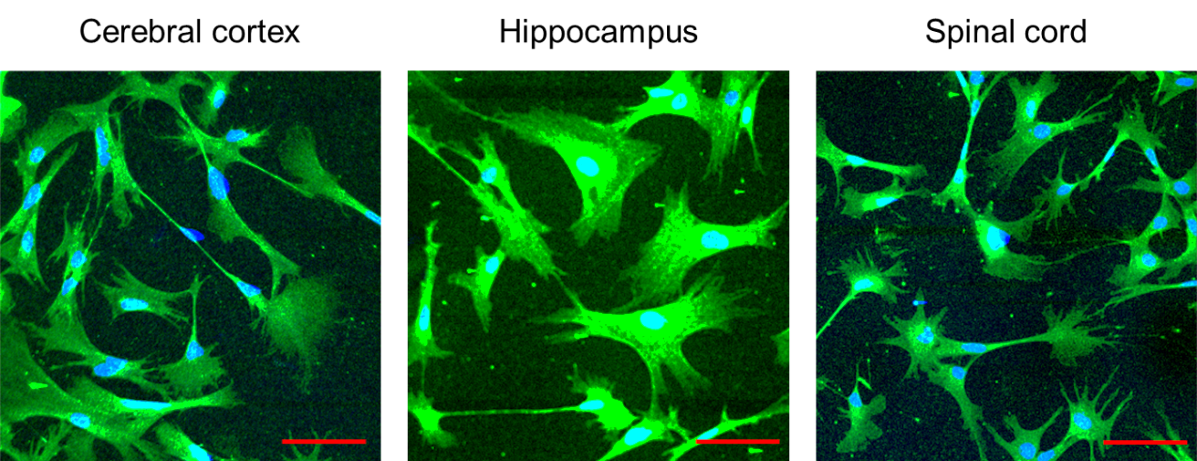
Supplementary Figure S1. GFAP expression in cerebral cortical, hippocampal, and spinal cord astrocytes.
Representative images of multicolor immunofluorescence staining for DAPI (blue) and GFAP (green) in cerebral cortical, hippocampal, and spinal cord astrocytes. Scale bars = 100 µm.

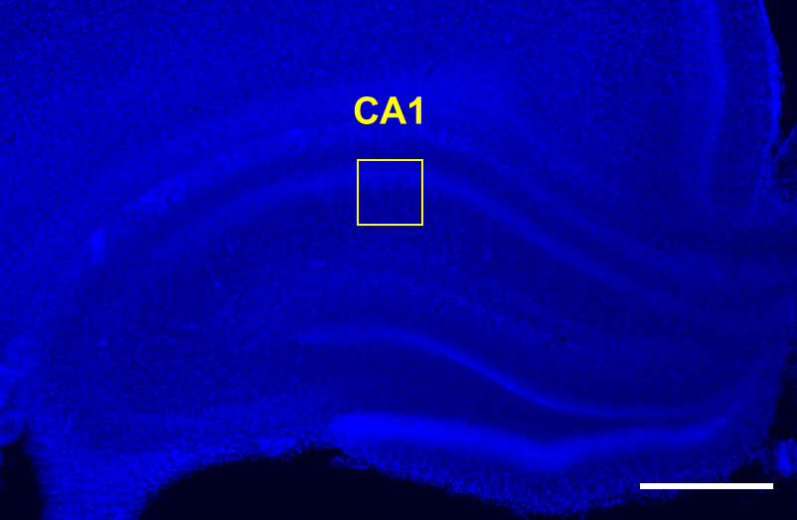
Supplementary Figure S2. The CA1 region of the hippocampus was used for the fluorescence intensity measurements and evaluation of astrocytic morphology.
The hippocampal slice was stained with DAPI. The CA1 area used for the fluorescence intensity measurements and evaluation of astrocytic morphology is shown (yellow frame). Scale bars = 500 µm.

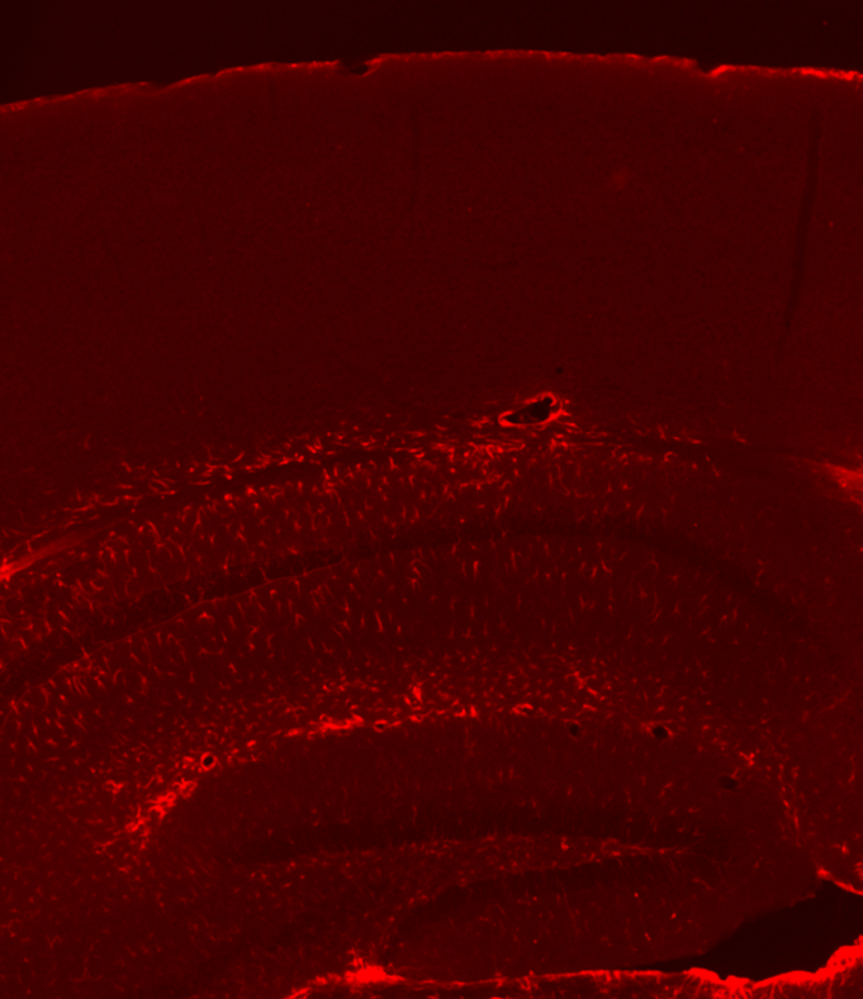
Supplementary Figure S3. The differences in GFAP-staining intensity between the hippocampus and cerebral cortex.
The cerebral cortex (upper) was not stained with GFAP and the hippocampus (lower) was well stained with GFAP. Scale bars = 500 µm.

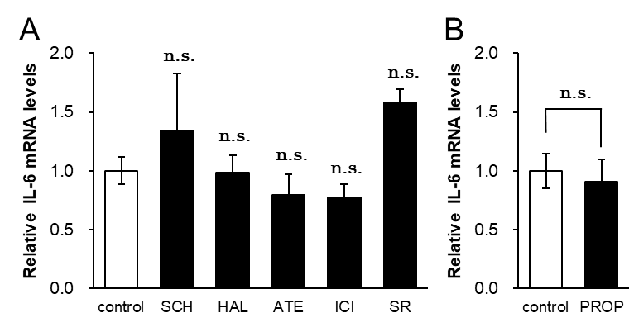
Supplementary Figure S4. The effects of dopamine receptor and adrenoceptor antagonists on IL-6 mRNA levels.
(A) IL-6 mRNA levels in cerebral cortical astrocytes treated with the D1-like receptor antagonist SCH23390 (SCH, 10 µM), D2-like receptor antagonist haloperidol (HAL, 10 µM), β1-adrenoceptor antagonist atenolol (ATE, 10 µM), β2-adrenoceptor antagonist ICI118551 (ICI, 1 µM), and β3-adrenoceptor antagonist SR59230A (SR, 1 µM) for 2 h. n.s.: not significant (Dunnett’s test vs. control), n = 6. (B) IL-6 mRNA levels in astrocytes treated with the β-adrenoceptor antagonist (PROP, 10 µM) for 2 h. These data were extracted from Figure. 3A. n.s.: not significant (unpaired Student’s t-test). All data are presented as means ± S.E.M. The cytokine mRNA levels were normalised to those of the control, which was arbitrarily set to a value of “1.0”.

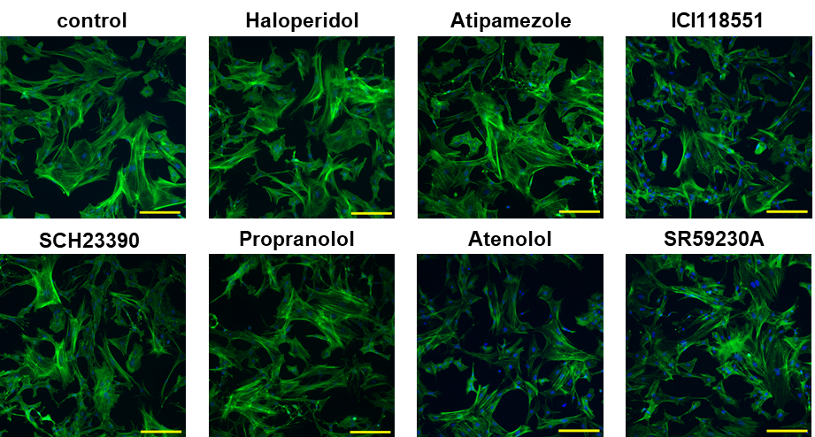

Supplementary Figure S5. The effects of dopamine receptor and adrenoceptor antagonists on astrocytic morphology.
Representative images of F-actin (green) and DAPI (blue) in hippocampal astrocytes treated with the D1-like receptor antagonist SCH23390 (10 µM), D2-like receptor antagonist haloperidol (10 µM), β-adrenoceptor antagonist propranolol (10 µM), α₂-adrenoceptor antagonist atipamezole (10 µM), β₁-adrenoceptor antagonist atenolol (10 µM), β₂-adrenoceptor antagonist ICI118551 (1 µM), and β₃-adrenoceptor antagonist SR59230A (1 µM) for 4 h. Scale bars = 100 μm.

