Supporting Information

X-ray Absorption Fine Structure Studies on Nickel Phosphide Catalysts for the Non-oxidative Coupling of Methane Reaction Using a Theoretical Model

Md Harun Al Rashidª , Arnoldus Lambertus Dipu^{b}, Yuta Nishikawa^{b}, Hitoshi Ogihara^{c}, Yuta Inami^{b}, Shoji Iguchi^{b}, Ichiro Yamanaka^{b}, Shinchi Nagamatsu^{d}, Daiki Kido^{d}, Bing Hu^{d}, Kiyotaka Asakura^{*d}

ª Graduate School of Engineering, Hokkaido University, Sapporo 060-8628, Hokkaido, Japan
^{b} School of Materials and Chemical Technology, Tokyo Institute of Technology, Tokyo 152-8552, Japan
^{c} Graduate School of Science and Engineering, Saitama University, Saitama 338-8570, Japan
^{d} Institute for Catalysis, Hokkaido University, Hokkaido 001-0021, Japan

* Corresponding author: Institute for Catalysis, Hokkaido University, Kita 21, Nishi 10, Kita-ku, Sapporo, Hokkaido, Japan, 001-0021
Email address: askr@cat.hokudai.ac.jp (Kiyotaka Asakura)

Contents of the supporting Information
Contents
Fig. S1(a). Bulk structures of NiP₃, NiP₂, NiP, Ni₅P₄, Ni₂P, Ni₁₂P₅, and Ni₃P.

Fig. S1(b). Two different Ni sites of bulk Ni₂P with different Ni-P and Ni-Ni bond distances.
Fig. S2. Comparison of Ni K-edge experimental and theoretical XANES spectra: a) Ni₂P (black line), b) Ni₂P FEFF (cluster size 3Å) (red line), and c) Ni₂P FEFF (cluster size 5Å) (blue line).
Fig. S3. Comparison of Ni K-edge experimental XANES spectra of Ni-P/SiO₂: a) Ni:P = 1:1 (black line), b) Ni:P = 2:1 (red line), and c) Ni:P = 3:1 (blue line).
Fig. S4. Comparison of Ni K-edge theoretical XANES spectra of reference compounds: a) FEFF NiP₃ (black line), b) FEFF NiP₂ (red line), c) FEFF NiP (blue line), d) FEFF Ni₂P (pink line), e) FEFF Ni₅P₄ (green line), f) FEFF Ni₁₂P₅ (navy line), and g) FEFF Ni₃P (violet line),
Fig. S5. Peak Position of Ni K-edge XANES spectra of Ref. Ni₂P, experimental samples Ni-P/SiO₂: Ni:P = 1:1, Ni:P = 2:1, Ni:P = 3:1, and theoretical Ni K-edge XANES spectra of Ni₂P, Ni₁₂P₅, Ni₃P, NiP₃, NiP₂, NiP, and Ni₅P₄ respectively.
Fig. S6. Pre-edge comparison of Ni K-edge theoretical XANES spectra of reference compounds: FEFF NiP₃ (black line), FEFF NiP₂ (red line), FEFF NiP (blue line), FEFF Ni₅P₄ (pink line), FEFF Ni₂P (green line), FEFF Ni₁₂P₅ (violet line), and FEFF Ni₃P (violet line) respectively.
Fig. S7. Second derivative of the experimental XANES spectra of Ni-P/SiO₂ (Ni:P = 3:1).
Table S1. Previous curve fitting results of the Ni K-edge EXAFS spectra for the Ni₂P reference and different samples with initial NiP ratios of 1:1, 2:1, and 3:1
Table S2. Some components of feff.inp input file for XANES of Ni₂P.

Table S3. Comparison of R-factors between the EXAFS simulation method and CF method.
Table S4. Peak positions of theoretical and experimental XANES spectra of different nickel phosphide with experimental Sample Ni-P/SiO₂ (Ni:P = 1:1).
Table S5. Peak positions of theoretical and experimental XANES spectra of different nickel phosphide with experimental Sample Ni-P/SiO₂ (Ni:P = 2:1).
Table S6. Peak positions of theoretical and experimental XANES spectra of different nickel phosphide with experimental Sample Ni-P/SiO₂ (Ni:P = 3:1).

1. Nickel phosphide has different phases, namely NiP₃, NiP₂, NiP, Ni₅P₄, Ni₂P, Ni₁₂P₅, and Ni₃P. Those compounds have very complicated structures with different sites and various Ni-Ni and Ni-P distances.
Bulk NiP₃  a=b=c=7.819  α=β= γ= ${90}^{°}$  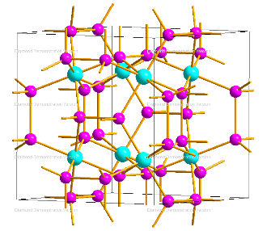 |  | Bulk NiP₂  a=6.368; b=5.617; c=5.631  α=β=${90}^{°}$; γ=${119.571}^{°}$  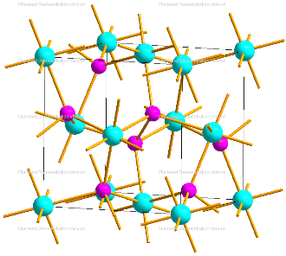 |  | 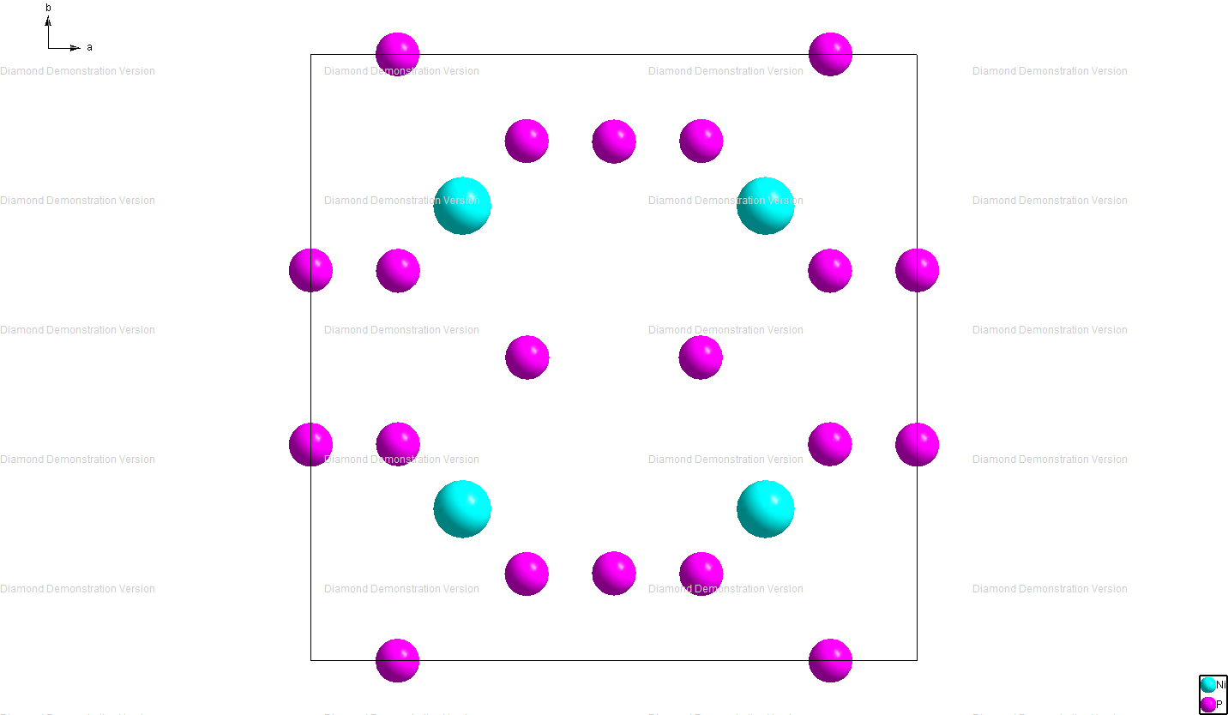  Bulk NiP  a=4.881;b=6.890; c=6.050  α=β= γ= ${90}^{°}$  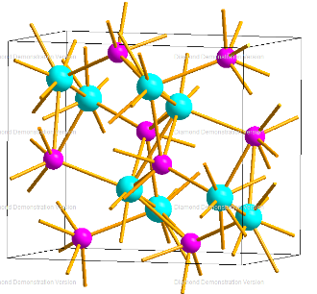
Bulk Ni₅P₄  a=b=6.789; c=10.989  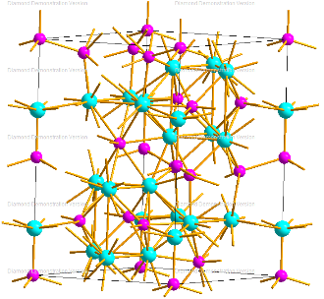  α=β=${90}^{°}$; γ=${120}^{°}$ | Bulk Ni₂P  a=b=5.865; c=3.387  α=β=${90}^{°}$; γ=${120}^{°}$  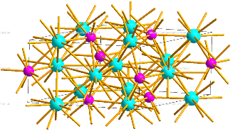 |  | Bulk Ni₁₂P₅  a=b=8.650; c=5.085  α=β= γ= ${90}^{°}$  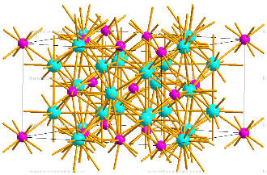 |  | Bulk Ni₃P  a=b=8.954; c=4.386  α=β= γ= ${90}^{°}$  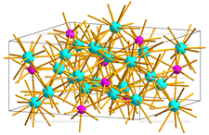

Fig. S1(a). Bulk structures of NiP₃, NiP₂, NiP, Ni₅P₄, Ni₂P, Ni₁₂P₅, and Ni₃P.

2.67Å
2.61Å

Fig. S1(b). Two different Ni sites of bulk Ni₂P with different Ni-P and Ni-Ni bond distances.

2. Figure S2 shows Ni K-edge XANES spectra of Ni₂P reference sample compared with the FEFF8 calculated spectra of Ni₂P with different FMS radius. The experimental and theoretical XANES spectra of Ni₂P showed the same three peak features A, B, and C.
Fig. S2. Comparison of Ni K-edge experimental and theoretical XANES spectra: a) Ni₂P (black line), b) Ni₂P FEFF (cluster size 3Å) (red line), and c) Ni₂P FEFF (cluster size 5Å) (blue line).

3. Figure S3 shows the Ni K-edge XANES spectra of the Ni-P/SiO₂ catalyst with different initial Ni:P ratios of 1:1, 2:1, and 3:1. Ni-P (1:1) shows the main three features A, B, and C in different eV, where the peak became small and blurred with the increase of initial Ni and P ratios.

Fig. S3. Comparison of Ni K-edge experimental XANES spectra of Ni-P/SiO₂: a) Ni:P = 1:1 (black line), b) Ni:P = 2:1 (red line), and c) Ni:P = 3:1 (blue line).

4. Theoretical XANES spectra of reference compounds: NiP₃, NiP₂, NiP, Ni₅P₄, Ni₂P, Ni₁₂P₅, and Ni₃P. The XANES spectra of different nickel phosphide catalysts are characterized by several peaks and shoulder at different eV.

Fig. S4. Comparison of Ni K-edge theoretical XANES spectra of reference compounds: a) FEFF NiP₃ (black line), b) FEFF NiP₂ (red line), c) FEFF NiP (blue line), d) FEFF Ni₂P (pink line), e) FEFF Ni₅P₄ (green line), f) FEFF Ni₁₂P₅ (navy line), and g) FEFF Ni₃P (violet line),
5. The XANES spectra of different nickel phosphide catalysts are characterized by several peaks and shoulder at different eV. Here we indicated the peak positions of experimental XANES spectra of the reference Ni₂P, Ni-P/SiO₂ catalyst with different initial Ni:P ratios of 1:1, 2:1, 3:1, and theoretical XANES spectra of Ni₂P, Ni₁₂P₅, Ni₃P, NiP₃, NiP₂, NiP, and Ni₅P_{4,} respectively.

Fig. S5. Peak Position of Ni K-edge XANES spectra of Ref. Ni₂P, experimental samples Ni-P/SiO₂: Ni:P = 1:1, Ni:P = 2:1, Ni:P = 3:1, and theoretical Ni K-edge XANES spectra of Ni₂P, Ni₁₂P₅, Ni₃P, NiP₃, NiP₂, NiP, and Ni₅P₄ respectively.

6. Pre-edge comparison of the theoretical XANES spectra of reference compounds: NiP₃, NiP₂, NiP, Ni₅P₄, Ni₂P, Ni₁₂P₅, and Ni₃P. The pre-edge peak intensity gradually changes concerning Ni:P ratios.

Fig. S6. Pre-edge comparison of Ni K-edge theoretical XANES spectra of reference compounds: FEFF NiP₃ (black line), FEFF NiP₂ (red line), FEFF NiP (blue line), FEFF Ni₅P₄ (pink line), FEFF Ni₂P (green line), FEFF Ni₁₂P₅ (violet line), and FEFF Ni₃P (violet line) respectively.

7. The second derivative peak positions of Ni-P/SiO₂ (Ni:P = 3:1) XANES spectra indicated three different peak features in the spectra.
Fig. S7. Second derivative of the experimental XANES spectra of Ni-P/SiO₂ (Ni:P = 3:1).

Table S1
Previous curve fitting results of the Ni K-edge EXAFS spectra for the Ni₂P reference and different samples with initial Ni:P ratios of 1:1, 2:1, and 3:1.
Samples |  |  |  | Ni-Ni |  |  |  |  | Ni-P |  |  |  | R(%)ª
 |  |  |  | CN | R (Å) | $$σ^{2}(Å^{2})$$ | $$∆E (eV)$$ |  | CN | R (Å) | $$σ^{2}(Å^{2})$$ | $$∆E (eV)$$ | R(%)ª
 | Fresh samples
Ni₂P ref. |  |  |  | 4.0$±$0.3 | 2.62$±$0.02 | 0.0084 | 5.4 |  | 1.0±0.3 | 2.21$±$0.02 | 0.0050 | -5.1 | 0.5
Ni-P(1:1, 0h) |  |  |  | 4.6$±$0.6 | 2.62$±$0.02 | 0.0072 | 3.4 |  | 1.3$±$0.3 | 2.19$±$0.02 | 0.0065 | -7.5 | 0.3
Ni-P(2:1, 0h) |  |  |  | 4.2$±$0.3 | 2.52$±$0.02 | 0.0086 | -1.1 |  | 0.6$±$0.3 | 2.18$±$0.03 | 0.0012 | -7.3 | 0.1
Ni-P(3:1, 0h) |  |  |  | 4.6$±0.$9 | 2.45$±$0.02 | 0.0134 | -7.2 |  | 2.0$±0.5$ | 2.28$±$0.02 | 0.0193 | -3.6 | 0.5
 | Spent samples
Ni-P(1:1, 3h) |  |  |  | 4.5$±$0.8 | 2.62$±$0.03 | 0.0067 | 3.5 |  | 1.5$±$0.5 | 2.18$±$0.03 | 0.0070 | -9.8 | 0.5
Ni-P(2:1, 3h) |  |  |  | 4.3$±$0.3 | 2.53$±$0.03 | 0.0090 | -0.7 |  | 0.7$±$0.3 | 2.17$±$0.03 | 0.0033 | -8.8 | 0.3
Ni-P(3:1, 3h) |  |  |  | 4.6$±1.0$ | 2.46$±$0.02 | 0.0136 | -6.6 |  | 2.1$±0.6$ | 2.28$±$0.03 | 0.017 | -2.3 | 0.4
Ref.: Al Rashid, M. H. et al. Active Phase Structure of the SiO₂-supported Nickel Phosphide Catalysts for Non-oxidative Coupling of Methane (NOCM) Reactions. e-Journal Surf. Sci. Nanotechnol. 18, 24–27 (2020).
ª $R\left(\%\right)=\frac{{Σ_{i} \left(χ_{cal}\left(k_{i}\right)-χ_{obs}\left(k_{i}\right)\right)}^{2}}{{Σ_{i} \left(χ_{obs}\left(k_{i}\right)\right)}^{2}}× 100$

Table S2

Some components of feff.inp input file for XANES of Ni₂P.

XANES Calculations
TITLE | Ni₂P
EXCHANGE | 0 0 0
SCF | 5.0 0 100 0.2
XANES | 5.0 0.07 0.0
FMS | 5.0 0
POTENTIALS | 0 28 Ni -1 -1 0  1 15 P -1 -1 1  2 28 Ni -1 -1 2

Table S3
Comparison of R-factors between the EXAFS simulation method and CF method.
Sample | R(%) ( EXAFS simulation) | R(%) (CF )
Ni₂P | 5.8 | 0.5
Ni:P = 1:1 | 4.0 | 0.3
Ni:P = 2:1 | 10.0 | 0.1
Ni:P = 3:1 | 7.2 | 0.5

Table S4
Peak positions of theoretical and experimental XANES spectra of different nickel phosphide with experimental Sample Ni-P/SiO₂ (Ni:P = 1:1).

Exp Ni:P = 1:1 (eV) | FEFF8 Ni₂P (eV) | ΔE (eV)
8332.7 | 8332.7 | 0.0
8339.7 | 8340.1 | -0.4
8354.7 | 8354.7 | 0.0
Exp Ni:P = 1:1 (eV) | FEFF8 NiP₂ | ΔE (eV)
8332.7 | 8332.5 | 0.2
8339.7 | 8339.6 | 0.1
8354.7 | 8344.0 | 10.7
Exp Ni:P = 1:1 (eV) | FEFF8 NiP | ΔE (eV)
8332.7 | 8332.8 | -0.1
8339.7 | 8342.3 | -2.6
8354.7 | 8355.8 | -1.1
Exp Ni:P = 1:1 (eV) | FEFF8 Ni₅P₄ | ΔE (eV)
8332.7 | 8332.6 | 0.1
8339.7 | 8343.5 | -3.8
8354.7 | 8356.0 | -1.3
Exp Ni:P = 1:1 (eV) | FEFF8 NiP₃ | ΔE (eV)
8332.7 | 8332.5 | 0.2
8339.7 | 8343.0 | -3.3
8354.7 | 8354.2 | 0.5
Exp Ni:P = 1:1 (eV) | FEFF8 Ni₁₂P₅ | ΔE (eV)
8332.7 | 8332.1 | 0.6
8339.7 | 8337.8 | 1.9
8354.7 | 8354.8 | 0.1
Exp Ni:P = 1:1 (eV) | FEFF8 Ni₃P | ΔE (eV)
8332.7 | 8332.8 | -0.1
8339.7 | 8343.7 | -4.0
8354.7 | 8354.9 | -0.2
* Peak position estimated error $±0.4$.

Table S5
Peak positions of theoretical and experimental XANES spectra of different nickel phosphide with experimental Sample Ni-P/SiO₂ (Ni:P = 2:1).

Exp Ni:P = 2:1 (eV) | FEFF8 Ni₁₂P₅ (eV) | ΔE (eV)
8331.7 | 8332.1 | -0.4
8337.7 | 8337.8 | -0.1
8346.7 | 8346.4 | 0.3
8354.7 | 8354.6 | 0.1
Exp Ni:P = 2:1 (eV) | FEFF8 Ni₅P₄ (eV) | ΔE (eV)
8331.7 | 8332.6 | -0.9
8337.7 | 8343.5 | -5.8
8346.7 | - | -
8354.7 | 8356.0 | -1.3
Exp Ni:P = 2:1 (eV) | FEFF8 Ni₂P (eV) | ΔE (eV)
8331.7 | 8332.7 | -1.0
8337.7 | 8340.1 | -2.4
8346.7 | - | -
8354.7 | 8354.7 | 0.0
Exp Ni:P = 2:1 (eV) | FEFF8 Ni₃P (eV) | ΔE (eV)
8331.7 | 8332.8 | -1.1
8337.7 | 8343.7 | -6.0
8346.7 | - | -
8354.7 | 8354.9 | -0.2
Exp Ni:P = 2:1 (eV) | FEFF8 NiP₂ (eV) | ΔE (eV)
8331.7 | 8332.5 | -0.8
8337.7 | 8339.6 | -1.9
8346.7 | 8344.0 | 2.7
8354.7 | 8355.5 | -0.8
Exp Ni:P = 2:1 (eV) | FEFF8 NiP | ΔE (eV)
8331.7 | 8332.8 | -1.1
8337.7 | 8342.3 | -4.6
8346.7 | - | -
8354.7 | 8355.8 | -1.1
Exp Ni:P = 2:1 (eV) | FEFF8 NiP₃ | ΔE (eV)
8331.7 | 8332.5 | -0.8
8337.7 | 8343.0 | -5.3
8346.7 | - | -
8354.7 | 8354.2 | 0.5
* Peak position estimated error $±0.4$.

Table S6
Peak positions of theoretical and experimental XANES spectra of different nickel phosphide with experimental Sample Ni-P/SiO₂ (Ni:P = 3:1).

Exp Ni:P = 3:1 (eV) | FEFF8 Ni₃P (eV) | ΔE (eV)
8332.7 | 8332.8 | -0.1
8343.7 | 8343.7 | 0.0
8354.7 | 8354.9 | -0.2
Exp Ni:P = 3:1 (eV) | FEFF8 Ni₂P (eV) | ΔE (eV)
8332.7 | 8332.7 | 0.0
8343.7 | 8340.1 | 3.6
8354.7 | 8354.7 | 0.0
Exp Ni:P = 3:1 (eV) | FEFF8 Ni₁₂P₅ (eV) | ΔE (eV)
8332.7 | 8332.1 | 0.6
8343.7 | 8337.8 | 5.9
8354.7 | 8354.6 | 0.1
Exp Ni:P = 3:1 (eV) | FEFF8 NiP₂ | ΔE (eV)
8332.7 | 8332.5 | 0.2
8343.7 | 8339.6 | 4.1
8354.7 | 8344.0 | 10.7
Exp Ni:P = 3:1 (eV) | FEFF8 NiP | ΔE (eV)
8332.7 | 8332.8 | -0.1
8343.7 | 8342.3 | 1.4
8354.7 | 8355.8 | -1.1
Exp Ni:P = 3:1 (eV) | FEFF8 Ni₅P₄ | ΔE (eV)
8332.7 | 8332.6 | 0.1
8343.7 | 8343.5 | 0.2
8354.7 | 8356.0 | -1.3
Exp Ni:P = 3:1 (eV) | FEFF8 NiP₃ | ΔE (eV)
8332.7 | 8332.5 | 0.2
8343.7 | 8343.0 | 0.7
8354.7 | 8354.2 | 0.5
* Peak position estimated error $±0.4$.

