Supporting Information

Uniaxial Negative Thermal Expansion Induced by Molecular Rotation in One-Dimensional Supramolecular Assembly with Associated Peculiar Magnetic Behavior

Kiyonori Takahashi,* Yuki Shirakawa, Hiroki Sakai, Ichiro Hisaki, Shin-ichiro Noro, Tomoyuki Akutagawa, Motohiro Nakano, and Takayoshi Nakamura*

E-mail: ktakahashi@es.hokudai.ac.jp (K. Takahashi), tnaka@es.hokudai.ac.jp (T. Nakamura)

Table of Contents
§1. Crystal data, Crystal Data, Data Collection, and Reduction Parameter.
§2. Crystallographically independent molecules with atom numbering
§3. Input and output file of PASCal Calculation
§4 Differential scanning calorimetry (DSC) for crystal 1
§5 Temperature-dependence of structural change between PD1B•••DB2 and PD1B•••PD2.
§6 Transfer integrals (t) between [Ni(dmit)₂]– anions and their temperature dependence.
§7 Expanded χ_{m}T versus T plot of Figure 5.

§1. Crystal data, Crystal Data, Data Collection, and Reduction Parameter.
The Flack parameter analyzed for P2₁ was 0.320(11) at 118 K. Relatively large Flack parameter suggests that the inverted domain, where dipole moment of PD2 are aligned anti-parallel to the first domain, are included in the crystal 1. It is because crystal structure of 1 can be refined by assuming inversion twin and BASF commands in shelx refinement, where volume ratio of twin domains were 0.680(11):0.320(11) at 118 K.
Table S1. Crystal Data, Data Collection, and Reduction Parameter for crystal 1.
 | 1
Temperature / K | 118 | 135 | 151 | 169
Crystal Dimensions / mm³ | 0.6×0.6×0.6
Chemical formula | C₉₂H₁₀₆N₄Ni₂O₂₄S₂₀
Formula weight | 2410.42
Crystal System | Monoclinic
Space group | P2₁
a / Å | 13.0944(2) | 13.1146(2) | 13.1390(2) | 13.1620(3)
b / Å | 21.8192(3) | 21.8149(3) | 21.8050(3) | 21.7862(3)
c / Å | 18.0486(3) | 18.0621(3) | 18.0856(3) | 18.1119(3)
β / deg | 94.6070(15) | 94.502(2) | 94.4155(16) | 94.3187(16)
V / Å³ | 5139.99(14) | 5151.51(14) | 5166.08(15) | 5178.82(15)
Z | 2 | 2 | 2 | 2
D_{calc} / g∙cm⁻³ | 1.557 | 1.554 | 1.550 | 1.546
μ(Mo Kα) / cm⁻¹ | 0.847 | 0.845 | 0.843 | 0.840
2θ_{max} / deg | 62.5200 | 61.8940 | 62.1320 | 61.586
Reflections measured | 77144 | 78128 | 77762 | 80139
Independent reflections | 26132 | 25961 | 25989 | 26243
Reflections used | 26132 | 25961 | 25989 | 26243
R₁ ª | 0.0350 | 0.0357 | 0.0364 | 0.0374
R_{w}(F²) ª | 0.0803 | 0.0833 | 0.0861 | 0.0888
GOF | 1.026 | 1.034 | 1.041 | 1.039
Flack Parameter | 0.320(11) | 0.334(11) | 0.318(11) | 0.315(11)
CCDC No. | 2163119 | 2163120 | 2163121 | 2163122
ª R₁ = Σ||F_{o}| - |F_{c}|| / Σ|F_{o}| and R_{w} = (Σω(|F_{o}| - |F_{c}|)² / ΣωF_{o}²)^{1/2}.

 | 1
Temperature / K | 177 | 186 | 194 | 202 | 221
Crystal Dimensions / mm³ | 0.6×0.6×0.6
Chemical formula | C₉₂H₁₀₆N₄Ni₂O₂₄S₂₀
Formula weight | 2410.42
Crystal System | Monoclinic
Space group | P2₁
a / Å | 13.19743(18) | 13.1936(3) | 13.2130(3) | 13.2325(3) | 13.2688(3)
b / Å | 21.7622(2) | 21.7511(3) | 21.7297(3) | 21.7185(3) | 21.6763(3)
c / Å | 18.1487(2) | 18.1553(3) | 18.1815(3) | 18.1943(3) | 18.2309(3)
β / deg | 94.1520(11) | 94.2038(17) | 94.1495(18) | 94.039(2) | 93.8703(18)
V / Å³ | 5198.74(11) | 5196.10(16) | 5206.48(17) | 5215.87(16) | 5231.59(17)
Z | 2 | 2 | 2 | 2 | 2
D_{calc} / g∙cm⁻³ | 1.540 | 1.541 | 1.538 | 1.535 | 1.530
μ(Mo Kα) / cm⁻¹ | 0.837 | 0.838 | 0.836 | 0.834 | 0.832
2θ_{max} / deg | 62.3520 | 61.878 | 60.702 | 61.526 | 61.938
Reflections measured | 97567 | 83480 | 79833 | 82353 | 87510
Independent reflections | 26744 | 26486 | 26365 | 26375 | 26468
Reflections used | 26744 | 26486 | 26365 | 26375 | 26468
R₁ ª | 0.0333 | 0.0381 | 0.0390 | 0.0379 | 0.0369
R_{w}(F²) ª | 0.0806 | 0.0900 | 0.0913 | 0.0895 | 0.0851
GOF | 1.018 | 1.042 | 1.031 | 1.021 | 1.027
Flack Parameter | 0.356(10) | 0.319(11) | 0.309(12) | 0.323(11) | 0.276(11)
CCDC No. | 2163123 | 2163124 | 2163125 | 2163126 | 2163127
ª R₁ = Σ||F_{o}| - |F_{c}|| / Σ|F_{o}| and R_{w} = (Σω(|F_{o}| - |F_{c}|)² / ΣωF_{o}²)^{1/2}.

 | 1
Temperature / K | 237 | 254 | 272 | 282
Crystal Dimensions / mm³ | 0.6×0.6×0.6
Chemical formula | C₉₂H₁₀₆N₄Ni₂O₂₄S₂₀
Formula weight | 2410.42
Crystal System | Monoclinic
Space group | P2₁
a / Å | 13.3027(3) | 13.3375(3) | 13.3760(3) | 13.3988(3)
b / Å | 21.6453(4) | 21.6167(4) | 21.5994(4) | 21.5792(4)
c / Å | 18.2686(4) | 18.3081(4) | 18.3362(4) | 18.3596(4)
β / deg | 93.655(2) | 93.505(2) | 93.373(2) | 93.338(2)
V / Å³ | 5249.58(19) | 5268.58(19) | 5288.40(19) | 5299.40(19)
Z | 2 | 2 | 2 | 2
D_{calc} / g∙cm⁻³ | 1.525 | 1.519 | 1.514 | 1.511
μ(Mo Kα) / cm⁻¹ | 0.829 | 0.826 | 0.823 | 0.821
2θ_{max} / deg | 61.4080 | 61.8740 | 61.9860 | 62.5520
Reflections measured | 82444 | 85675 | 84884 | 70798
Independent reflections | 26609 | 26960 | 26919 | 21627
Reflections used | 26609 | 26960 | 26919 | 21627
R₁ ª | 0.0382 | 0.0383 | 0.0391 | 0.0350
R_{w}(F²) ª | 0.0903 | 0.0879 | 0.1171 | 0.0839
GOF | 0.934 | 1.018 | 0.902 | 1.018
Flack Parameter | 0.321(12) | 0.337(11) | 0.299(12) | 0.248(13)
 | 2163128 | 2163129 | 2163130 | 2163131
ª R₁ = Σ||F_{o}| - |F_{c}|| / Σ|F_{o}| and R_{w} = (Σω(|F_{o}| - |F_{c}|)² / ΣωF_{o}²)^{1/2}.

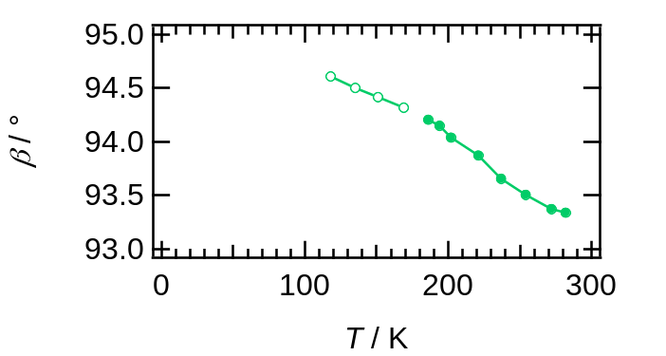
Figure S1. Temperature-dependence of β in unit cell.

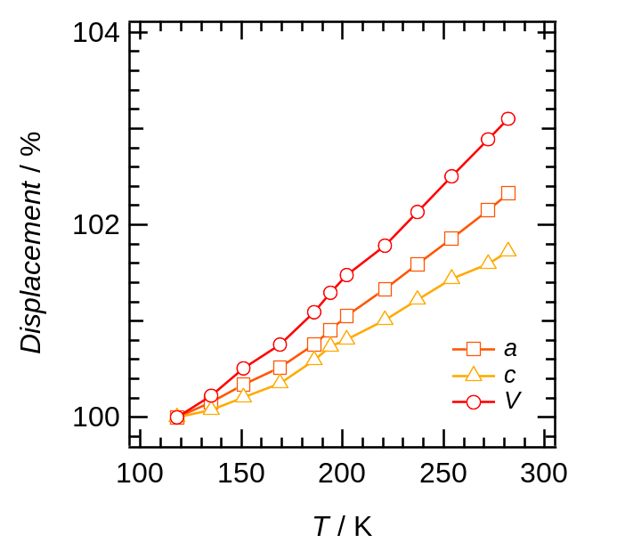
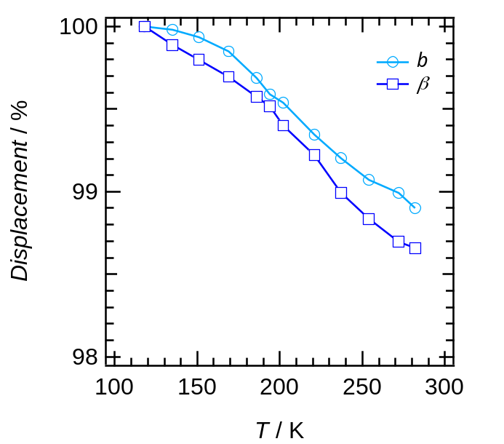

Figure S2. Temperature dependence of cell parameters normalized at 118 K.

§2. Crystallographically independent molecules with atom numbering
Figure S3. Crystallographically independent molecular structure in the crystal 1 at 118 K with atomic number. (a) Molecular structure of DB3. Disordered carbon atoms depicted as yellow and blue colors. (b) molecular structures of PD2 and DB2. (c) Molecular structures of DB1, PD1A, and PD1B. (d) Atom numbering for [Ni(dmit)₂] in the packing with crystallographically independent supramolecular cations.

The length of covalent bonds between the nitrogen atoms in the typical pdazH⁺ cations are longer than those between the nitrogen and carbon atoms. We could not assign nitrogen atoms next to N1A and N1B from the lengths of C-C and C-N bond within PD1A and PD1B due to the disorder of pdazH⁺. However, if we place the nitrogen atoms other than N2A and N2B, as described in Figure 2b, we could not solve the structure without using restrained commands for bond distance on Shelx refinement. On the other hand, the distance between N3 and N4 atoms in PD2 was 1.307(5) Å whereas those between N3 or N4 and adjacent carbon atoms were 1.302(6) and 1.276(6) Å, respectively. Therefore, we could safely assign the position of N4 atom of the PD2 in crystal 1. The assignment of N4 atom in PD2 is reasonable because N4 atom in PD2 contacts C-H bond in PD1A and PD1B and forms a C-H•••N interaction (Figure 2c, see also Table S3 for the details of C-H•••N4 interactions).

Table S2. Temperature-dependent C•••O distance and C-H•••O angles between PD1A•••DB3A, and PD1B•••DB3B.
 | PD1A•••DB3A |  | PD1B•••DB3B
T / K | C15A•••O16A  distance / Å | C15A-H@•••O16A  angle / ° | C13B•••O16B  distance / Å | C13B•••O16B  angle / °
118 | 3.154 | 134.16 | 3.322 | 153.76
135 | 3.126 | 136.24 | 3.418 | 152.91
151 | 3.132 | 134.01 | 3.409 | 154.05
169 | 3.101 | 135.80 | 3.392 | 155.84
186 | 3.089 | 133.53 | 3.410 | 152.97
194 | 3.037 | 135.47 | 3.445 | 153.81
202 | 3.031 | 134.52 | 3.451 | 154.01
221 | 3.031 | 132.98 | 3.438 | 151.70
237 | 3.035 | 132.29 | 3.364 | 141.17
254 | 3.025 | 131.19 | 3.400 | 142.78
272 | 3.084 | 130.60 | 3.380 | 139.94
282 | 3.047 | 128.51 | 3.337 | 139.23

Table S3. Temperature-dependent C•••N distances, and C-H•••N angles between PD1A•••PD2, and PD1B•••PD2.
 | PD1A•••PD2 |  | PD1B•••PD2
T / K | C13A•••N4  distance / Å | C13A-H@•••N4  angle / ° | C16B•••N4  distance / Å | C16B-H•••N4  angle / °
118 | 3.426 | 165.05 | 3.430 | 120.16
135 | 3.415 | 166.59 | 3.462 | 120.05
151 | 3.439 | 166.13 | 3.463 | 120.30
169 | 3.536 | 163.54 | 3.431 | 120.90
186 | 3.532 | 166.32 | 3.472 | 120.34
194 | 3.531 | 166.09 | 3.487 | 120.81
202 | 3.578 | 165.91 | 3.467 | 122.87
221 | 3.588 | 165.89 | 3.541 | 120.80
237 | 3.621 | 165.86 | 3.557 | 119.83
254 | 3.600 | 164.95 | 3.790 | 118.94
272 | 3.640 | 162.61 | 3.843 | 116.02
282 | 3.684 | 164.80 | 3.719 | 118.41

Table S3. Temperature dependence of the parameters for N-H•••O hydrogen bonds (N•••O distance and N-H•••O angle) between PD1A•••DB1, PD1B•••DB1, and PD2•••DB2.
 | N-H•••O hydrogen bond
 | PD1A•••DB1 |  | PD1B•••DB1 |  | PD2•••DB2
T / K | N1A•••O20  distance / Å | N1A-H1A•••O16  angle / ° | N1B-O24  distance / Å | N1B-H1B•••O24  angle / ° | N3•••O4  distance / Å | N3-H3•••O4  angle / °
118 | 2.806 | 172.03 | 2.932 | 170.89 | 2.814 | 170.45
135 | 2.804 | 171.12 | 2.914 | 171.28 | 2.814 | 169.79
151 | 2.831 | 171.57 | 2.911 | 171 | 2.816 | 169.85
169 | 2.793 | 168.83 | 2.912 | 172.16 | 2.818 | 168.57
186 | 2.798 | 169.97 | 2.912 | 170.83 | 2.827 | 167.07
194 | 2.806 | 169.38 | 2.92 | 168.51 | 2.83 | 166.68
202 | 2.81 | 167.66 | 2.916 | 174.45 | 2.832 | 165.48
221 | 2.81 | 168.14 | 2.922 | 172.7 | 2.847 | 164.54
237 | 2.806 | 168.41 | 2.919 | 166.59 | 2.853 | 163.28
254 | 2.817 | 169.19 | 2.983 | 171.32 | 2.865 | 161.69
272 | 2.813 | 169.66 | 2.955 | 166.01 | 2.884 | 161.11
282 | 2.824 | 168.64 | 2.907 | 166.33 | 2.88 | 160.99

Table S5. Temperature dependence of O•••π distances between DB1•••PD1A and DB2•••PD2.
 | DB1•••PD1A
 | Interatomic Distance / Å
T / K | O18•••C13A | O18•••C14A | O22•••C13A | O22•••C14A
118 | 2.999 | 3.022 | 2.908 | 3.057
135 | 2.969 | 3.038 | 2.941 | 3.036
151 | 2.984 | 3.038 | 2.936 | 3.048
169 | 2.979 | 3.039 | 2.929 | 3.058
186 | 3.021 | 3.054 | 2.902 | 3.054
194 | 3.027 | 3.016 | 2.901 | 3.112
202 | 3.026 | 3.045 | 2.901 | 3.083
221 | 3.048 | 3.053 | 2.894 | 3.081
237 | 3.031 | 3.019 | 2.92 | 3.124
254 | 3.052 | 3.022 | 2.93 | 3.132
272 | 3.091 | 3.019 | 2.91 | 3.143
282 | 3.055 | 3.028 | 2.937 | 3.125

 | DB2•••PD2.
 | Interatomic Distance / Å
T / K | O6•••C17 | O6•••N3 | O2•••C20 | O7•••C20
118 | 3.192 | 3.092 | 3.057 | 3.192
135 | 3.202 | 3.096 | 3.055 | 3.194
151 | 3.19 | 3.092 | 3.054 | 3.197
169 | 3.202 | 3.083 | 3.049 | 3.195
186 | 3.212 | 3.075 | 3.047 | 3.19
194 | 3.22 | 3.073 | 3.041 | 3.188
202 | 3.224 | 3.068 | 3.045 | 3.187
221 | 3.237 | 3.059 | 3.046 | 3.174
237 | 3.241 | 3.054 | 3.045 | 3.177
254 | 3.247 | 3.042 | 3.05 | 3.17
272 | 3.25 | 3.038 | 3.048 | 3.176
282 | 3.259 | 3.038 | 3.053 | 3.17

§3. Input and output file of PASCal Calculation, and indicatrix plots
Table S6. Input and output file of PASCal Calculation for structural data of 1 between 118 and 169 K.
input | T / K | σ_{T} | a / Å | b / Å | c / Å | α / ° | β / ° | γ / °
 | 169 | 5 | 13.162 | 21.7862 | 18.1119 | 90 | 94.3187 | 90
 | 151 | 5 | 13.139 | 21.805 | 18.0856 | 90 | 94.4155 | 90
 | 135 | 5 | 13.1146 | 21.8149 | 18.0621 | 90 | 94.502 | 90
 | 118 | 5 | 13.0944 | 21.8192 | 18.0486 | 90 | 94.607 | 90

output |  |  |  |  | Direction
 | Axes | α / MK^{–1} | σ_{α} / MK^{–1} | a | b | c
 | X₁ | -29.6503 | 4.1985 | 0 | 1 | 0
 | X₂ | 38.0421 | 3.9509 | -0.6675 | 0 | 0.7446
 | X₂ | 142.2858 | 1.4664 | 0.8931 | 0 | 0.4499
 | V | 151.2583 | 2.7976
 | % change in length
 | T / K | X₁ | X₂ | X₂ | X_{1,calc} | X_{2,calc} | X_{3,calc}
 | 118 | 0 | 0 | 0 | 0.0159 | -0.0179 | -0.0069
 | 135 | -0.0197 | 0.0215 | 0.2221 | -0.0345 | 0.0468 | 0.235
 | 151 | -0.0651 | 0.1047 | 0.4674 | -0.082 | 0.1077 | 0.4626
 | 169 | -0.1512 | 0.1865 | 0.72 | -0.1354 | 0.1761 | 0.7188
 | Volume
 | T / K | V / Å³ | Vlin / Å³
 | 118 | 5139.993 | 5139.4723
 | 135 | 5151.509 | 5152.6892
 | 151 | 5166.071 | 5165.1287
 | 169 | 5178.84 | 5179.1231

Table S7. Input and output file of PASCal Calculation for structural data of 1 between 186 and 282 K.
input | T / K | σ_{T} | a / Å | b / Å | c / Å | α / ° | β / ° | γ / °
 | 282 | 5 | 13.3988 | 21.5792 | 18.3596 | 90 | 93.338 | 90
 | 272 | 5 | 13.376 | 21.5994 | 18.3362 | 90 | 93.373 | 90
 | 254 | 5 | 13.3375 | 21.6167 | 18.3081 | 90 | 93.505 | 90
 | 237 | 5 | 13.3027 | 21.6453 | 18.2686 | 90 | 93.655 | 90
 | 221 | 5 | 13.2688 | 21.6763 | 18.2309 | 90 | 93.8703 | 90
 | 202 | 5 | 13.2325 | 21.7185 | 18.1943 | 90 | 94.039 | 90
 | 194 | 5 | 13.213 | 21.7297 | 18.1815 | 90 | 94.1495 | 90
 | 186 | 5 | 13.1936 | 21.7511 | 18.1553 | 90 | 94.2038 | 90

output |  |  |  |  | Direction
 | Axes | α / MK^{–1} | σ_{α} / MK^{–1} | a | b | c
 | X₁ | -81.2513 | 2.7 | 0 | 1 | 0
 | X₂ | 55.4528 | 3.149 | -0.738 | 0 | 0.6749
 | X₂ | 230.0634 | 3.3742 | 0.859 | 0 | 0.512
 | V | 204.178 | 1.9955
 | % change in length
 | T / K | X₁ | X₂ | X₂ | X_{1,calc} | X_{2,calc} | X_{3,calc}
 | 186 | 0 | 0 | 0 | -0.0324 | 0.018 | 0.028
 | 194 | -0.0984 | 0.1015 | 0.1967 | -0.0974 | 0.0624 | 0.2121
 | 202 | -0.1499 | 0.1152 | 0.4153 | -0.1624 | 0.1068 | 0.3961
 | 221 | -0.3439 | 0.2107 | 0.817 | -0.3168 | 0.2121 | 0.8333
 | 237 | -0.4864 | 0.2644 | 1.2529 | -0.4468 | 0.3008 | 1.2014
 | 254 | -0.6179 | 0.3778 | 1.6376 | -0.5849 | 0.3951 | 1.5925
 | 272 | -0.6974 | 0.4775 | 1.9988 | -0.7312 | 0.4949 | 2.0066
 | 282 | -0.7903 | 0.5935 | 2.1883 | -0.8124 | 0.5504 | 2.2367
 | Volume
 | T / K | V / Å³ | Vlin / Å³
 | 186 | 5196.1057 | 5196.7608
 | 194 | 5206.4888 | 5205.2482
 | 202 | 5215.8741 | 5213.7356
 | 221 | 5231.5855 | 5233.8933
 | 237 | 5249.5783 | 5250.8682
 | 254 | 5268.5849 | 5268.904
 | 272 | 5288.3999 | 5288.0008
 | 282 | 5299.4039 | 5298.6101

Figure S4. Indicatrix plots for structural data of 1 between (a) 118 and 169 K and (b) 186 and 282 K.

PASCal Indicatrix Plotter was used to plot the data. The software was obtained from the web site: https://cliffe.nottingham.ac.uk/programs/

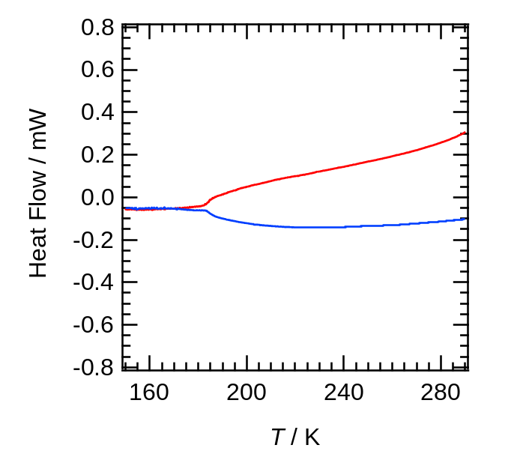
§4 Differential scanning calorimetry (DSC) for crystal 1
Figure S5. Differential scanning calorimetry from 150 to 290 K. Red and blue allows indicate the heating and cooling processes, respectively.

§5 Temperature-dependence of structural change between PD1B•••DB3B and PD1B•••PD2.
Figure S6. Schematic of selected parameters in supramolecular cation structure. The atoms are displayed using the thermal ellipsoid model. (a) Schematic of the interaction (purple) between C16B in PD1B and N4 in PD2 (d_{C-N}). (b) Temperature dependences of Ψ_{PD1B} (Green), and d_{C-N} (purple). The dashed line corresponds to the phase transition temperature of 183 K.

§6 Transfer integrals (t) between [Ni(dmit)₂]– anions and their temperature dependence.

Figure S7. Transfer integrals (t) between [Ni(dmit)₂]– anions and their temperature dependence. (a) Arrangement of [Ni(dmit)₂]– and corresponding t (t_{intra}, t₂, t₃, and t₄), where t_{intra} represents t in intradimer. (b) Temperature-dependent t. Each t corresponds to those in (a).

§6 Expanded χ_{m}T versus T plot of Figure 5.
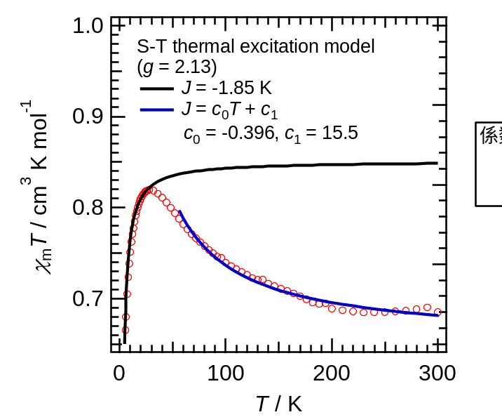
Figure S8. Expanded χ_{m}T versus T plot of Figure 5 with the left axis expanded from 0.65 to 1.0 cm³ K mol^{–1}. Black and blue lines represent the singlet-triplet (S-T) thermal excitation models explained in the main text.

Singlet-triplet (S-T) thermal excitation model is described as follows ^{S1}:
$${}_{m}=\frac{2N_{A}{μ_{B}}^{2}g^{2}}{k_{B}T}\frac{1}{[3+exp⁡(-2J/k_{B}T)]}$$
where N_{A}, μ_{B}, g, and k_{B} are Avogadro number, Bohr magneton, Landé g-factor, and Boltzmann constant, respectively. In the modified model, J/k_{B} = c₀ T + c₁ are used, where c₀ and c₁ are constant.

References
[S1] B. Bleaney, K. D. Bowers, Proc. R. Soc. Lond. A, 1952, 214, 451–465.

