List of Supporting Information
Figure S1. Schematic illustration of a formula to use GC-MS system. ….. P3
Synthesis of (±)-MeJA-d6, (±)-4,5-ddh-MeJA-d6 and 3,7-ddh-MeJA-d6 …. P4-6
NMR & FD-MS Chart …. P7-12

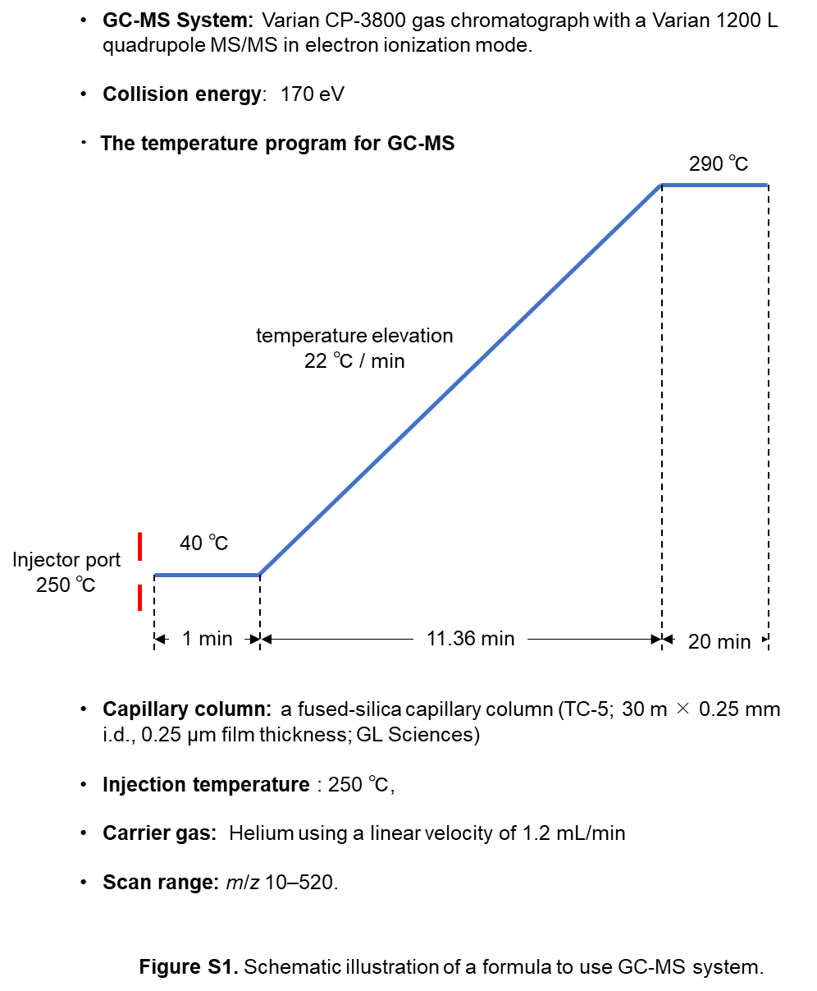
Figure S1. Schematic illustration of a formula to use GC-MS system.

General Experimental Procedures
NMR spectra were recorded using a JNM-ECZ400 FT-NMR spectrometer (JEOL, Tokyo, Japan; 400 MHz for ¹H-NMR and 100 MHz for ¹³C-NMR) and JNM-EX270 FT-NMR spectrometer (JEOL, Tokyo, Japan; 270 MHz for ¹H-NMR). FD-MS spectra were recorded using a JMS-T100GCV (JEOL).

Synthesis of (±)-MeJA-d6, (±)-4,5-didehydroMeJA-d6 and 3,7-didehydroMeJA-d6
・(±)-Methyl 2-[3-oxo-2-(2-oxoethyl)cyclopentyl]acetate
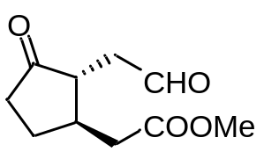
3.5 M RuCl₄ aq. (10 mL) and NaIO₄ (13.5 g, 10.1 mmol) were added to a stirred solution of (±)-MeJA (1) (5.0 g, 22.3 mmol) in 1,2-dichloroethane (53 mL) and water (42 mL), and the mixture was stirred for 1 h at room temperature. The reaction was quenched by sat. Na₂S₂O₃, and the reaction mixture was separated with water and CHCl₃. The organic layer was washed with brine and dried with Na₂SO₄. Evaporation and purification of column chromatography (EtOAc:n-hexane=4:6) provided (±)-methyl 2-[3-oxo-2-(2-oxoethyl)cyclopentyl]acetate (4.0 g, 20.2 mmol, 91%). ¹H-NMR (CDCl₃, 270 MHz) δ_{H}: 9.73 (1H, s), 3.74 (3H, s), 2.94-2.19 (10H, m)

・Triphenyl(propyl-d7) phosponium iolide
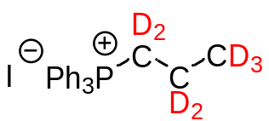
1-Iodepropane-d7 (5.0 g, 28.2 mmol) and triphenyl phosphine (11.0 g, 42.0 mmol) were dissolved in 100 mL of CH₃CN and heat-reduced for 16 hours. The organic solvent was concentrated by rotary evaporator and the resulting concentrate was dissolved in a small amount of CHCl₃. The precipitate formed by adding n-hexane to this solution was collected by suction filtration to afford triphenyl(propyl-d7) phosphonium iodide (19.0 g, 79%).

・(±)-MeJA-d6
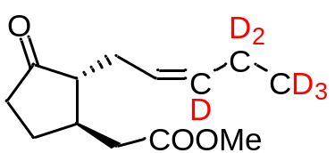
Under an atmosphere of N₂, triphenyl(propyl-d7) phosphonium iodide (1519 mg, 3.5 mmol) was dissolved in CH₂Cl₂ (100 mL). 0.6 M NaHMDS (5.9 mL) was added to the reaction solution at −78 °C, and the mixture was stirred for 30 min at the same temperature. (±)-Methyl 2-[3-oxo-2-(2-oxoethyl)cyclopentyl]acetate (652 mg, 3.3 mmol) in CH₂Cl₂ (10 mL) was added to the reaction solution, and the reaction solution was stirred for 20 h. The temperature was gradually increased from −78 °C to room temperature. The reaction was quenched by adding sat. NH₄Cl, and the reaction mixture was extracted with CHCl₃. The organic layer was washed with brine and dried with Na₂SO₄. Evaporation and purification of column chromatography (EtOAc:n-hexane = 2:8) provided (±)-MeJA-d6 (467 mg, 2.0 mmol, 60%). ¹H-NMR (CDCl₃, 400 MHz) (Figure S2) δ_{H}: 5.24 (1H, m), 3.68 (3H, s), 2.70 (1H, m), 2.40-1.40 (9H, m). ¹³C-NMR (CDCl₃, 100 MHz) (Figure S3) δ_{C}: 209.1, 172.6, 124.8, 54.0, 51.7, 38.8, 38.0, 37.8, 27.3, 25.5. HRFD-MS (Figure S4): m/z [M]⁺ calcd. for ¹²C₁₃¹H₁₄²H₆¹⁶O₃: 230.17890. Found: 230.17812.

・(±)-4,5-ddh-MeJA-d6
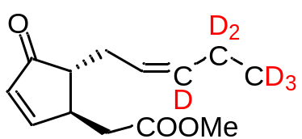
Under an atmosphere of N₂, diethyl allyl phosphate (711 μL, 4.0 mmol), Na₂CO₃ (508 mg, 4.8 mmol), and palladium(Ⅱ) acetate (55 mg, 0.24 mmol) were added to a stirred solution of (±)-MeJA-d6 (467 mg, 2.0 mmol) in N,N-dimethylformamide (40 mL), and the reaction mixture was stirred for 48 h at 80 °C. After dilution with EtOAc, the organic layer was washed with sat. NaHCO₃ and brine and dried with Na₂SO_{4.} Evaporation and purification of column chromatography (EtOAc:n-hexane = 3:7) provided (±)-4,5-ddh-MeJA-d6 (176 mg, 0.77 mmol, 38%). ¹H-NMR (CDCl3, 400 MHz) (Figure S5) δ_{H}: 7.61 (1H, dd, J=5.6, 2.4 Hz), 6.16 (1H, dd, J=5.6, 2.0 Hz), 5.24 (1H, m), 3.68 (3H, s), 2.99 (1H, m), 2.62-2.40 (3H, m), 2,29 (1H, m), 2.07(1H, m). ¹³C-NMR (CDCl₃, 100 MHz) (Figure S6) δ_{C}: 210.3, 171.9, 165.4, 133.9, 124.4, 51.9, 51.1, 43.3, 38.2, 27.7. HRFD-MS (Figure S7): m/z [M]⁺ calcd. for ¹²C₁₃¹H₁₂²H₆¹⁶O₃: 228.16325. Found: 228.16274.

・3,7-ddh-MeJA-d6
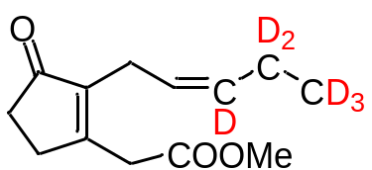
Under an atmosphere of N₂, CH₃ONa (54.2 mg, 1.0 mmol) in dry MeOH (15 mL) was dropped to a stirred solution of (±)-4,5-ddh-MeJA-d6 (92.6 mg, 0.41 mmol) in dry MeOH (15 mL), and the reaction mixture was stirred for 6 h at 80 °C. The reaction was quenched by sat. NH₄Cl. After evaporation, reaction product was extracted with EtOAc. The organic layer was washed with brine and dried with Na₂SO₄. Evaporation and purification of column chromatography (EtOAc:n-hexane = 3:7) provided 3,7-ddh-MeJA-d6 (55.3 mg, 59%). ¹H-NMR (CDCl₃, 400 MHz) (Figure S8) δ_{H}: 5.18 (1H, m), 3.70 (3H, s), 3.45 (2H, s), 2.95 (2H, m), 2.60 (2H, m), 2.40 (2H, m).¹³C-NMR (CDCl₃, 100 MHz) (Figure S9) δ_{C}: 208.7, 169.6, 164.1, 141.9, 124.3, 52.4, 36.7, 34.3, 30.0, 21.3. HRFD-MS (Figure S10): m/z [M]⁺ calcd. for ¹²C₁₃¹H₁₂²H₆¹⁶O₃: 228.16325. Found: 228.16355.

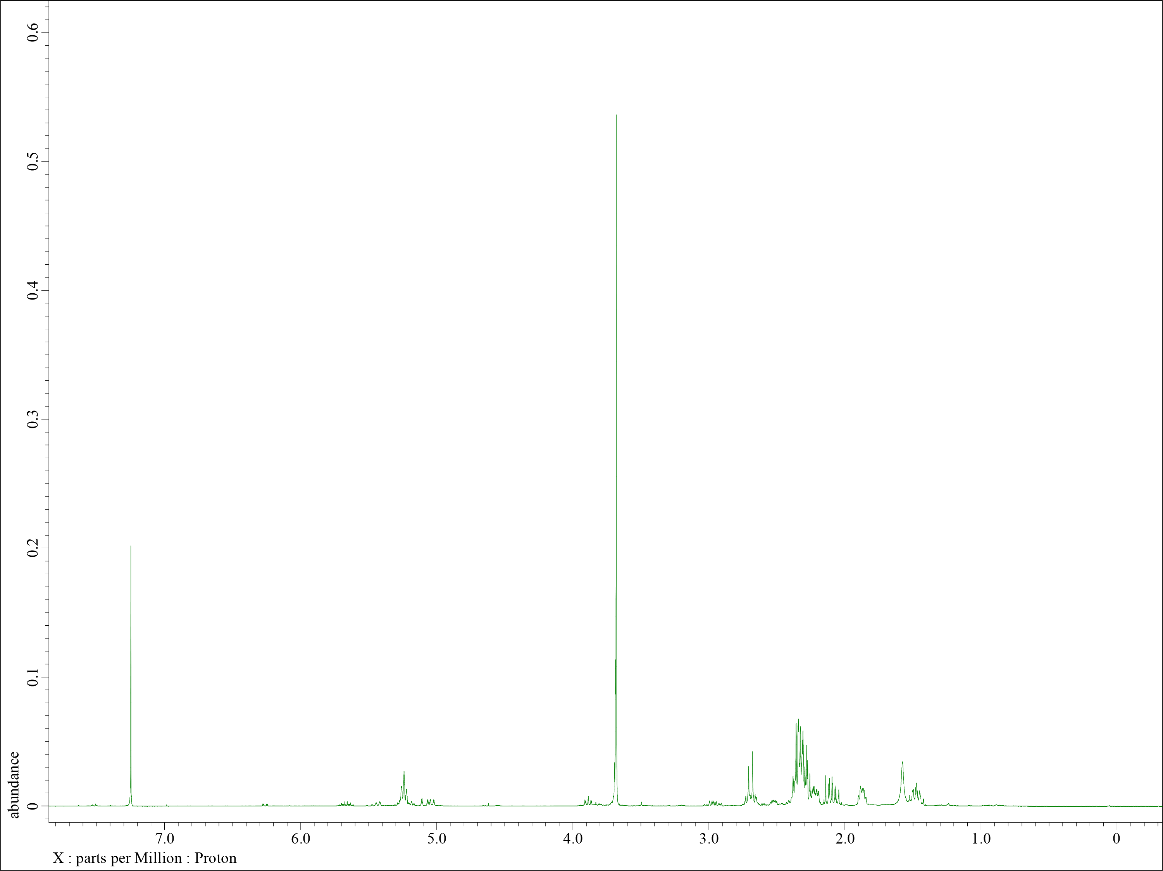
v
v
v
Figure S2. ¹H-NMR spectrum of (±)-MeJA-d6 (400 MHz, CDCl₃).
v
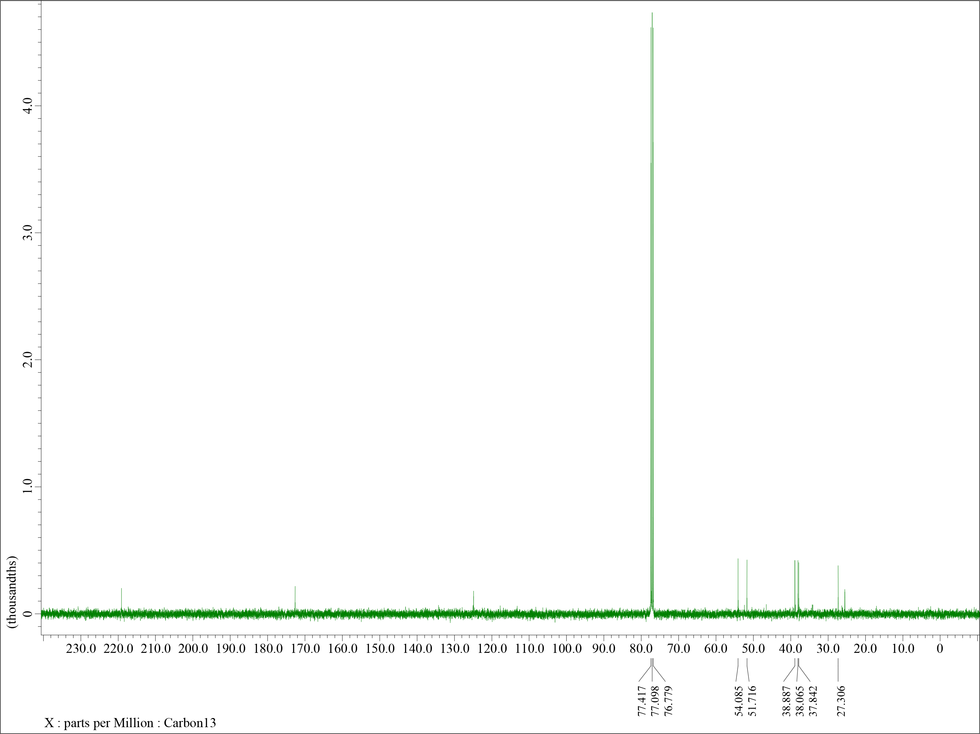
v
Figure S3. ¹³C-NMR spectrum of (±)-MeJA-d6 (100 MHz, CDCl₃).
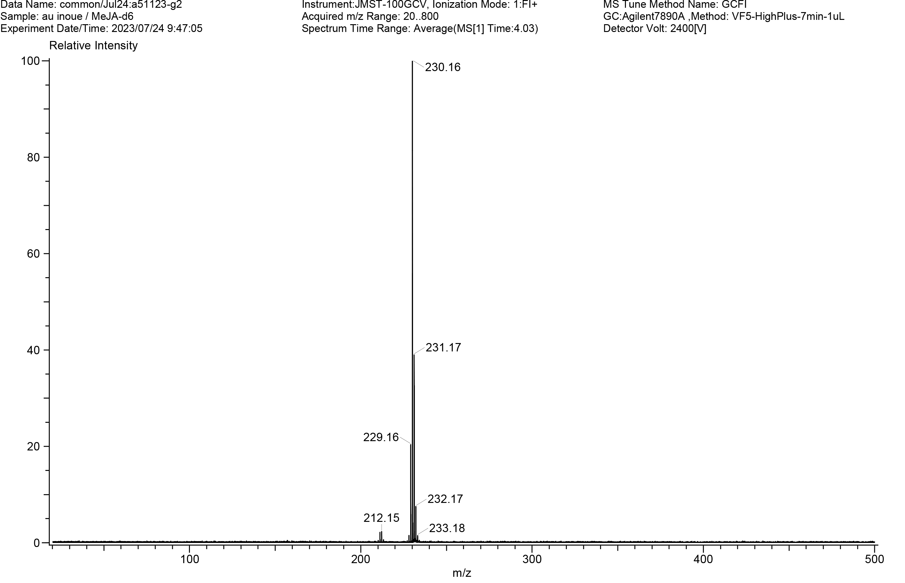
Figure S4. FD-MS spectrum of (±)-MeJA-d6.

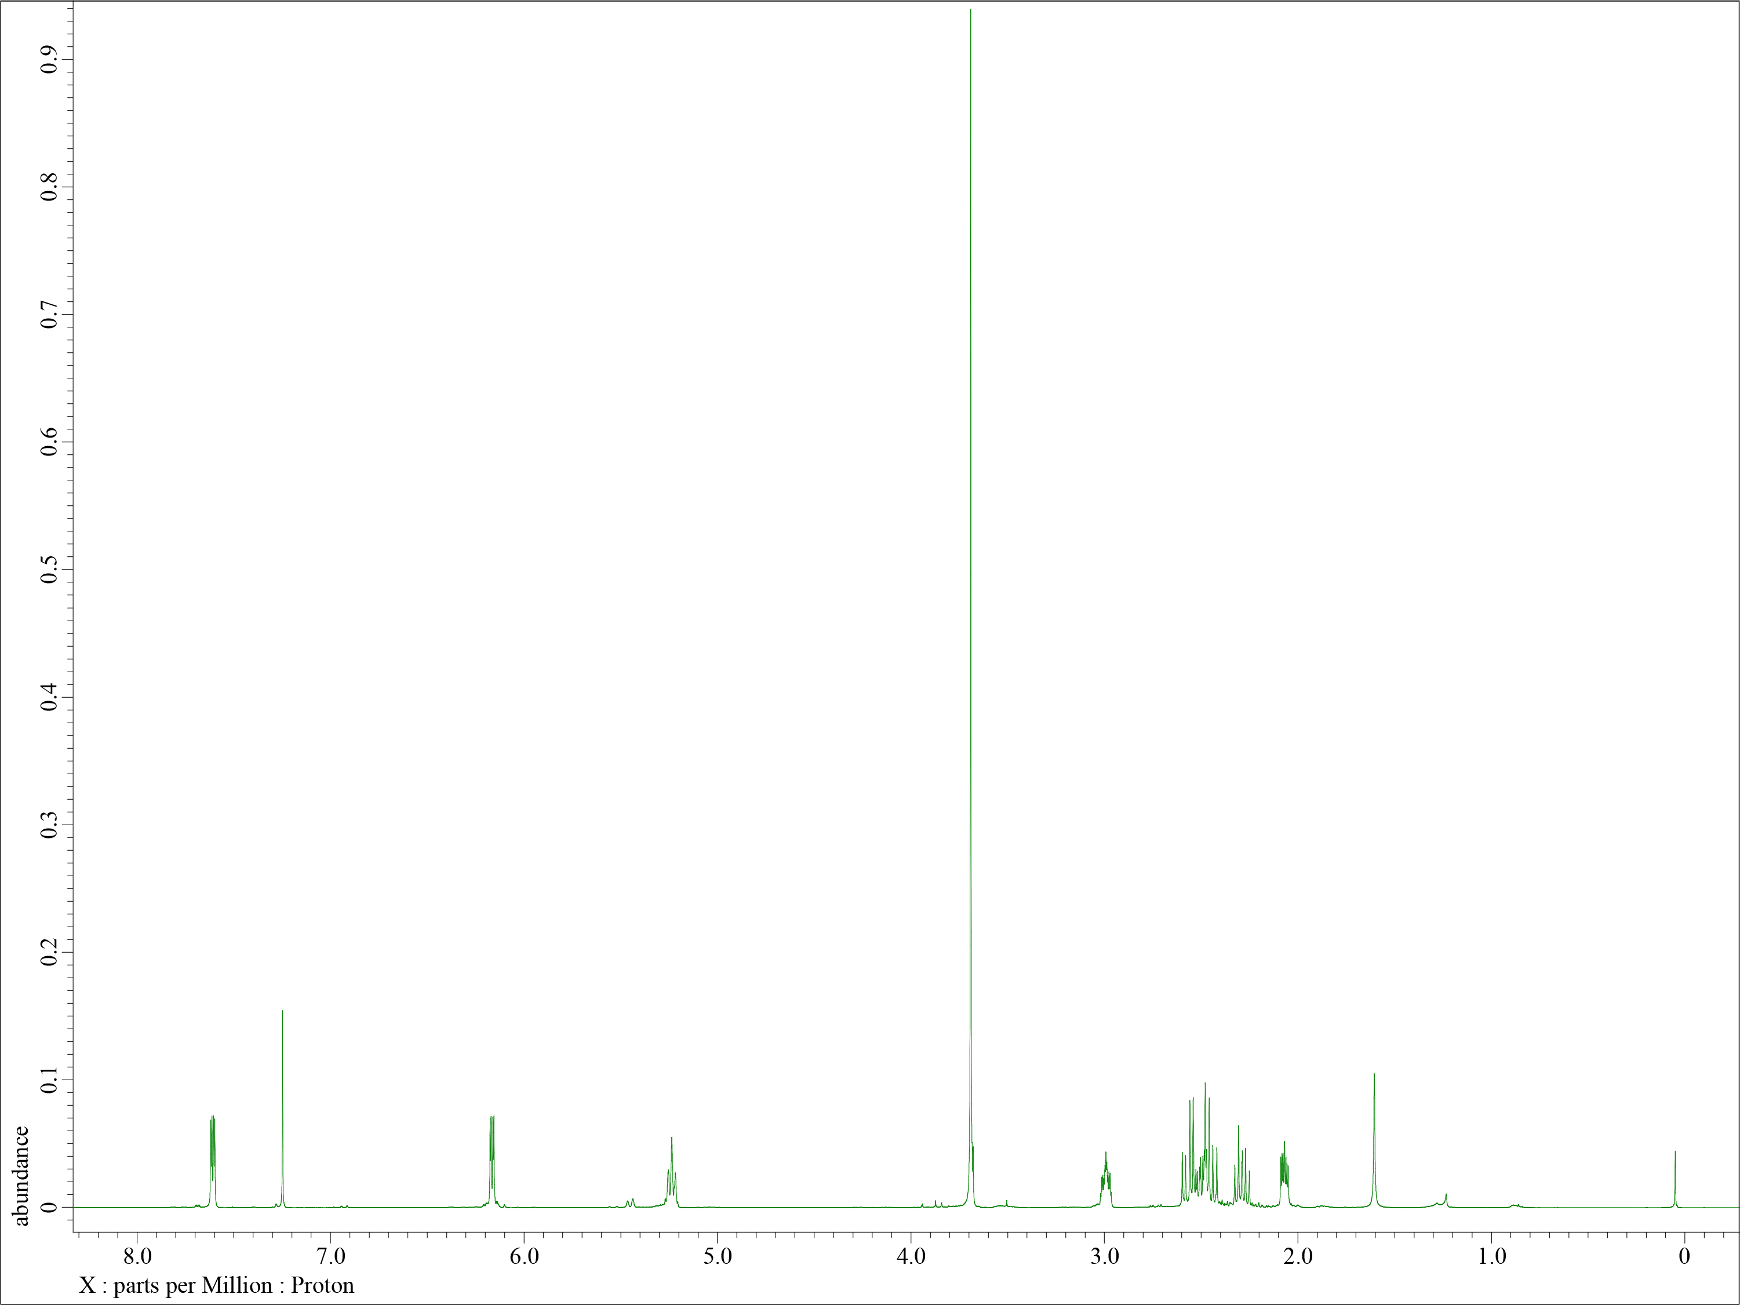
Figure S5. ¹H-NMR spectrum of (±)-4,5-ddh-MeJA-d6 (400 MHz, CDCl₃).

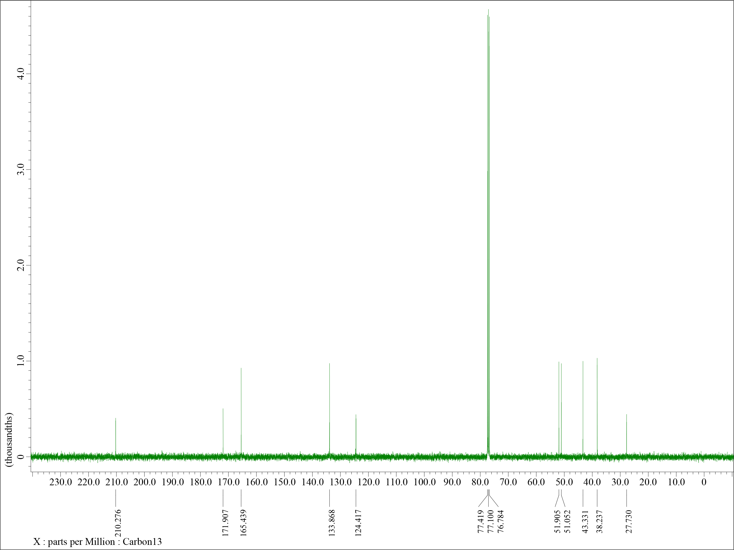
Figure S6. ¹³C-NMR spectrum of (±)-4,5-ddh-MeJA-d6 (100 MHz, CDCl₃).
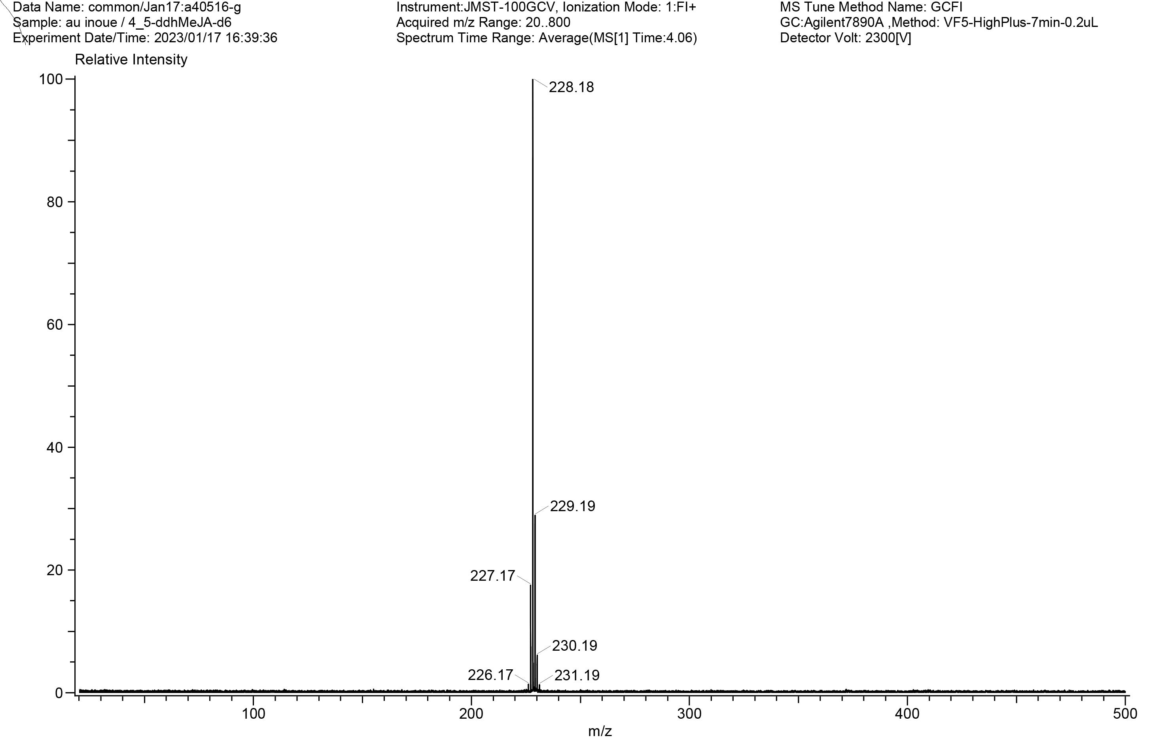
Figure S7. FD-MS spectrum of (±)-4,5-ddh-MeJA-d6.

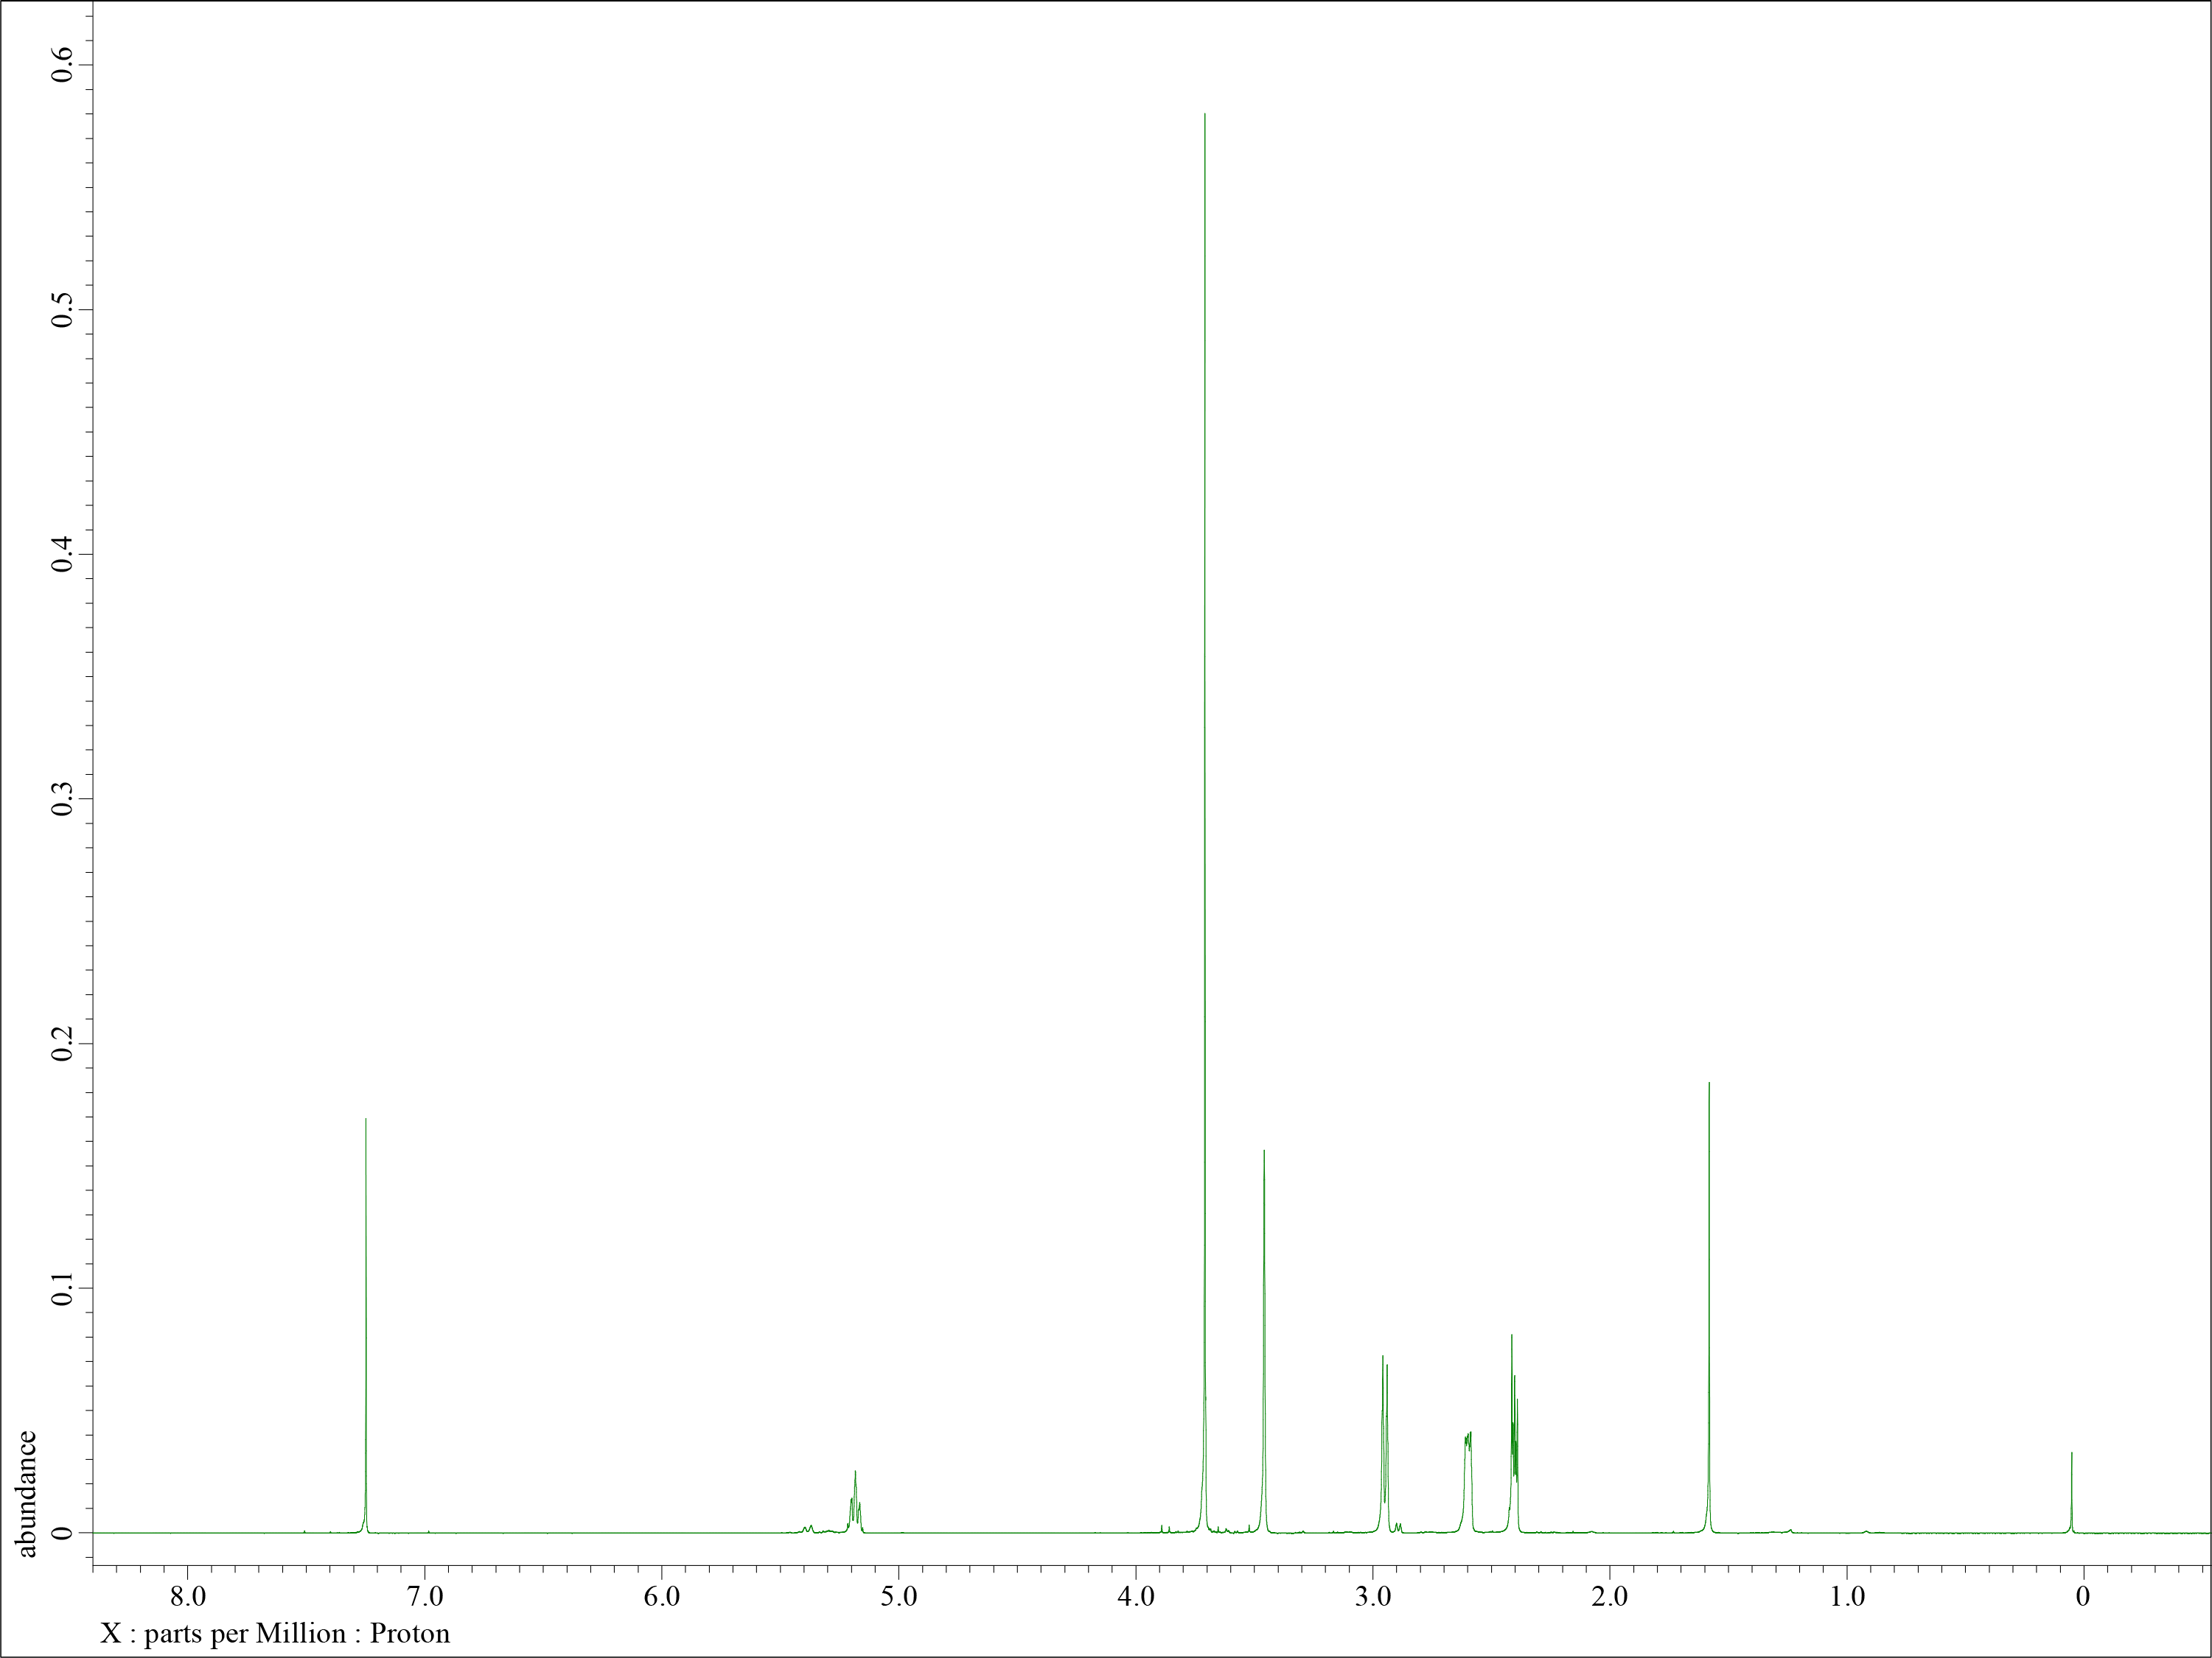
Figure S8. ¹H-NMR spectrum of 3,7-ddh-MeJA-d6 (400 MHz, CDCl₃).

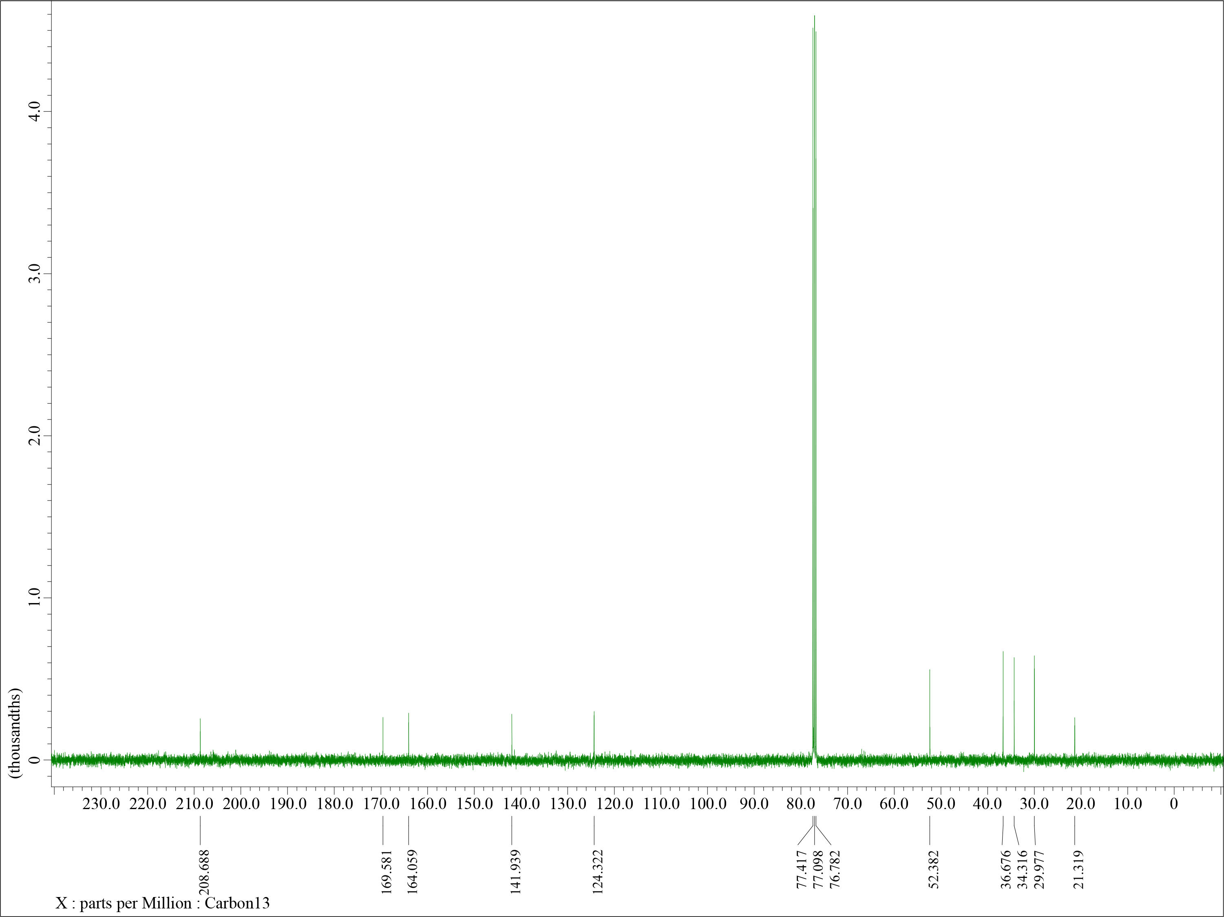
Figure S9. ¹³C-NMR spectrum of 3,7-ddh-MeJA-d6 (100 MHz, CDCl₃).
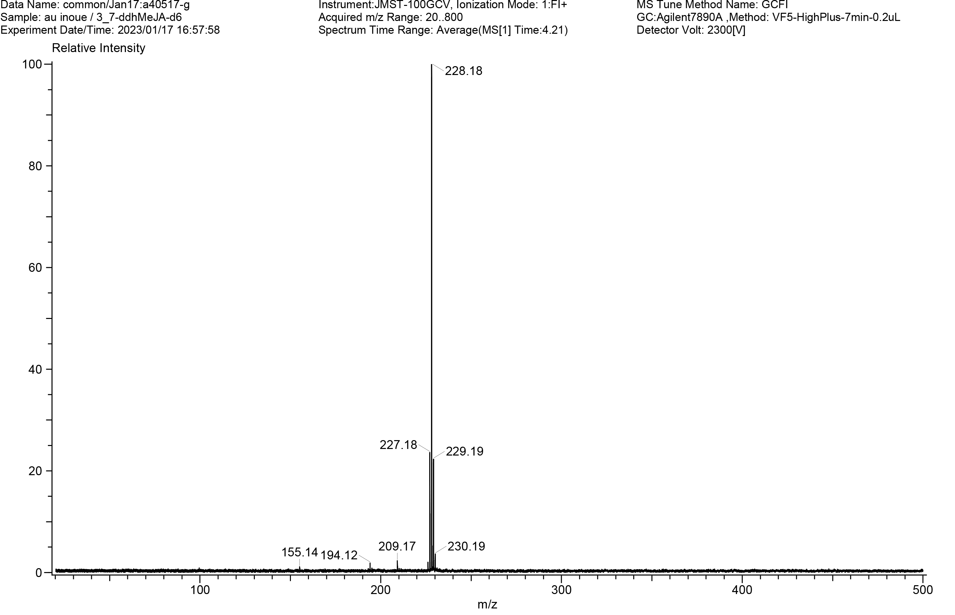
Figure S10. FD-MS spectrum of 3,7-ddh-MeJA-d6.

