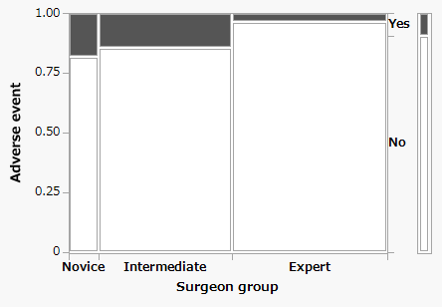
B
A
Supplemental Digital Content 3. Postoperative stroke and the rate of adverse event occurrence
A: Postoperative diffusion-weighted magnetic resonance imaging signal abnormality found in 8 patients, all of which could be considered to originate from the embolus during carotid endarterectomy.
B: A mosaic graph on adverse event occurrence rate among surgeon groups

