Insights from Managing Clinical Issues in Distal Pancreatectomy with En Bloc Celiac Axis Resection: Experiences from 626 Patients
Toru Nakamura^{1*}, MD, PhD; Ken-ichi Okada², MD, PhD; Masayuki Ohtsuka³, MD, PhD; Ryota Higuchi⁴, MD, PhD; Hidenori Takahashi⁵, MD, PhD; Kazuyuki Nagai⁶, MD, PhD; Michiaki Unno⁷, MD, PhD; Yoshiaki Murakami⁸, MD, PhD; Atsushi Oba⁹, MD, PhD; Moriaki Tomikawa¹⁰, MD, PhD; Atsushi Kato¹¹, MD, PhD; Akihiko Horiguchi¹², MD, PhD; Masafumi Nakamura¹³, MD, PhD; Shintaro Yagi¹⁴, MD, PhD; Sohei Satoi¹⁵, MD, PhD; Itaru Endo¹⁶, MD, PhD; Ryosuke Amano¹⁷, MD, PhD; Ippei Matsumoto¹⁸, MD, PhD; Yoichi M. Ito¹⁹, PhD; Takukazu Nagakawa¹⁴, MD, PhD; and Satoshi Hirano¹, MD, PhD

¹Department of Gastroenterological Surgery II, Hokkaido University Faculty of Medicine, Sapporo, Japan ²Second Department of Surgery, Wakayama Medical University, Wakayama, Japan
³Department of General Surgery, Graduate School of Medicine, Chiba University, Chiba, Japan ⁴Department of Surgery, Institute of Gastroenterology, Tokyo Woman's Medical University, Tokyo, Japan ⁵Department of Gastroenterological Surgery, Osaka International Cancer Institute, Osaka, Japan
⁶Division of Hepato-Biliary-Pancreatic Surgery and Transplantation, Department of Surgery, Graduate School of Medicine Kyoto University, Kyoto, Japan
⁷Department of Surgery, Tohoku University Graduate School of Medicine, Sendai, Japan
⁸Department of Advanced Medicine, Hiroshima University, Hiroshima, Japan
⁹Division of Hepatobiliary and Pancreatic Surgery, Cancer Institute Hospital, Japanese Foundation for Cancer Research, Tokyo, Japan
¹⁰Department of Hepato-Biliary-Pancreatic Surgery, Tochigi Cancer Center, Utsunomiya, Japan ¹¹Department of Hepato-Biliary-Pancreatic Surgery, Chiba Cancer Center, Chiba, Japan
¹²Department of Gastroenterological Surgery, Fujita Health University Bantane Hospital, Nagoya, Aichi, Japan
¹³Department of Surgery and Oncology, Graduate School of Medical Sciences, Kyushu University, Fukuoka, Japan
¹⁴Department of Hepato-Biliary-Pancreatic Surgery and Transplantation, Kanazawa University, Kanazawa, Ishikawa, Japan
¹⁵Department of Surgery, Kansai Medical University, Osaka, Japan
¹⁶Department of Gastroenterological Surgery, Yokohama City University Graduate School of Medicine, Yokohama, Japan
¹⁷Department of Hepato-Biliary-Pancreatic Surgery, Osaka Metropolitan University Graduate School of Medicine, Osaka, Japan
¹⁸Department of Surgery, Kindai University Faculty of Medicine, Osaka-sayama, Japan
¹⁹ Data Science Center, Promotion Unit, Institute of Health Science Innovation for Medical Care, Hokkaido University Hospital, Sapporo, Japan

Corresponding author. Toru Nakamura, MD, PhD
Department of Gastroenterological Surgery II, Hokkaido University Faculty of Medicine
Address: N-15 W-7, Kita-Ku, Sapporo 060-8638, Japan
Tel: +81-11-706-7714; Fax: +81-11-706-7158; E-mail address: torunakamura@med.hokudai.ac.jp

ORCID ID; 0000-0003-3999-9627

Supplementary Materials - Index

Supplementary Figures and Tables
Fig. S1 | Results section, page 8, line 5
Fig. S2 | Results section, page 9, line 13 and line 15
Fig. S3 | Results section, page 10, line 2
Table S1 | Patients and methods section, page 7, line 13
Table S2 | Patients and methods section, page 7, line 13
Table S3 | Results section, page 8, line 9
Table S4 | Results section, page 8, line 24
Table S5 | Results section, page 9, line 6
Table S6 | Results section, page 9, line 6

Supplementary Figures and Tables

Fig. S1

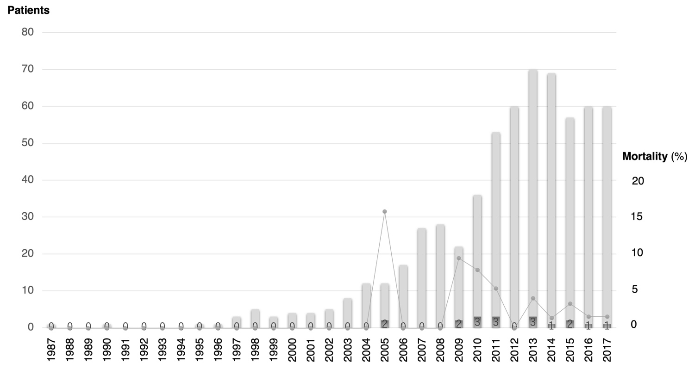

Fig. S2
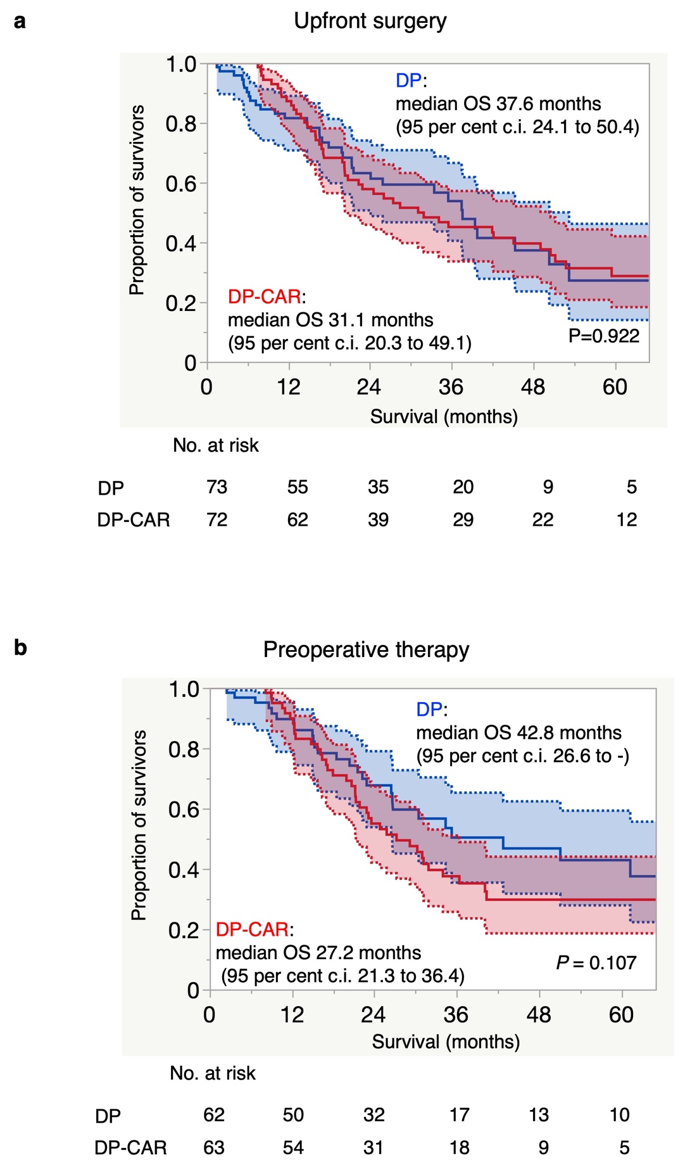

Fig. S3
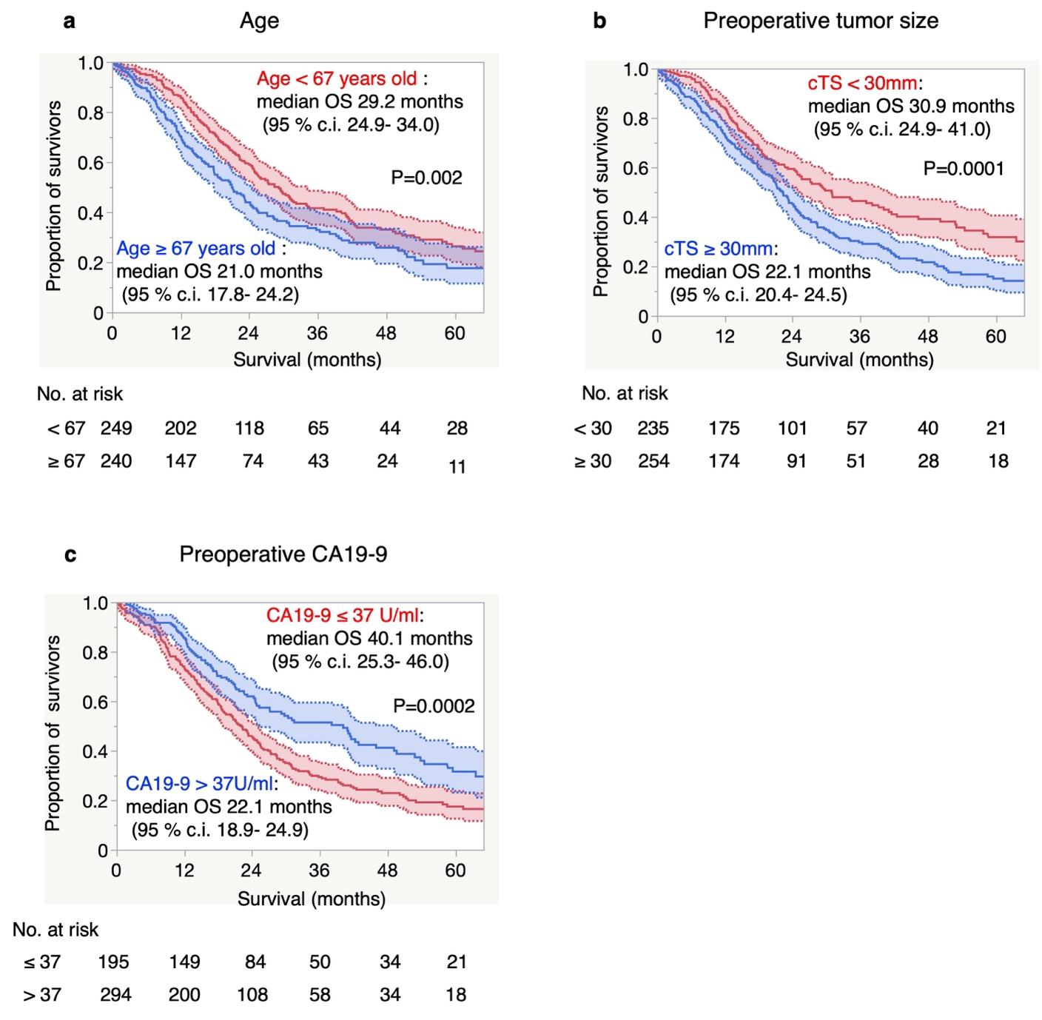

TABLE S1. Treatment detail
Factor | DP-CAR (n=626) | DP (n=1325)
Preoperative therapy
No | 269 (43.0) | 993 (74.9)
Yes | 357 (57.0) | 332 (25.1)
Systemic therapy
Gemcitabine | 41 | 113
S-1 | 48 | 39
Gemcitabine+S-1 | 147 | 118
Gemcitabine+nab-PTX | 91 | 54
FOLFIRINOX | 24 | 3
Others | 6 | 5
Radiation therapy* | 160 (25.6) | 176 (13.3)
Adjuvant therapy
No | 139 (22.2) | 260 (19.6)
Yes | 486 (77.6) | 1057 (79.8)
Unknown | 1 (0.2) | 8 (0.6)
Systemic therapy
Gemcitabine | 150 (30.9) | 248 (23.5)
S-1 | 236 (48.6) | 618 (58.5)
Gemcitabine+S-1 | 60 (12.4) | 62 (5.9)
Others | 38 (7.8) | 123 (11.4)
Unknown | 2 (0.4) | 6 (0.6)
Radiation therapy | 0 (0.0) | 0 (0.0)
Values are n (%) unless otherwise indicated. * Radiation therapy usually performed with chemotherapy.
S-1: Oral fluoropyrimidine agent containing tegafur, gimeracil, and oteracil potassium. PTX: paclitaxel.
FOLFIRINOX: folinic acid, fluorouracil, irinotecan, and oxaliplatin

TABLE S2. Pathological findings
UICC (7th) | DP-CAR (n=626) | DP (n=1325)
T0-T1 | 32 (5.1) | 191 (14.4)
T2 | 9 (1.4) | 85 (6.4)
T3 | 359 (57.0) | 1010 (76.2)
T4 | 226 (36.0) | 39 (3.0)
N0 | 248 (40.0) | 632 (48.0)
N1 | 376 (60.0) | 690 (52.0)
NX | 2 (0.3) | 3 (0.2)
M0 | 588 (94.0) | 1275 (96.0)
M1 | 38 (6.0) | 50 (4.0)
Stage
0 | 7 (1.1) | 27 (2.0)
IA | 17 (2.7) | 133 (10.0)
IB | 6 (1.0) | 52 (3.9)
IIA | 140 (22.4) | 403 (30.4)
IIB | 205 (32.8) | 624 (47.1)
III | 212 (33.9) | 35 (2.6)
IV | 38 (6.1) | 51 (3.9)
Residual tumor status
R0 (0mm rule) | 474 (75.7) | 1145 (86.2)
R1 (microscopic positive) | 144 (23.0) | 157 (11.9)
R2 (macroscopic positive) | 7 (1.1) | 17 (1.3)
RX | 1 (0.2) | 6 (0.5)
Values are n (%) unless otherwise indicated. UICC: Union for International Cancer Control

TABLE S3. DP-CAR mortality in 8 centers
 | 90-day mortality | DP-CAR* | Volume | Annual pancreatectomy
Center 1 | 4 (14.3) | 28 | high | >100
Center 2 | 5 (11.4) | 44 | high | >100
Center 3 | 1 (8.3) | 12 | low | >100
Center 4 | 1 (7.7) | 13 | high | >100
Center 5 | 1 (6.7) | 15 | high | >80
Center 6 | 2 (4.4) | 45 | high | >100
Center 7 | 1 (4.2) | 24 | high | >100
Center 8 | 1 (3.0) | 33 | high | >100
Other  54 centers | 0 (0.0) | 306 | high 14,  low 40 | >100, 9 centers  99-50, 20 centers  <50, 25 centers
Values are n (%) unless otherwise indicated. The centers with an annual patient volume of one or more in 2015 to 2017 were considered high-volume DP-CAR centers, and others were considered low-volume DP-CAR centers¹².
*Total number of patients in the past Decade (2008-2017).

TABLE S4. Preoperative embolization and ischemic complications
Complication | No embolization (n=177) | CHA embolization (n=88) | CHA and LGA embolization (n=177) | LGA preservation (n=109) | LGA reconstruction (n=49)
Ischemic gastropathy | 14 (7.9) | 17 (19.3) | 34 (19.2) | 1 (0.9) | 5 (10.2)
Grade B/C DGE | 23 (1.3) | 17 (19.3) | 29 (16.4) | 12 (11.0) | 7 (14.3)
Hepatic ischemia | 9 (5.1) | 4 (4.5) | 36 (20.3) | 13 (11.9) | 1 (2.0)
Ischemic cholecystitis | 2 (1.1) | 1 (1.1) | 6 (3.4) | 1 (0.9) | 0 (0.0)
Gastroduodenal perforation | 4 (2.3) | 4 (4.5) | 6 (3.4) | 1 (0.9) | 3 (6.1)
Any reoperation | 8 (4.5) | 5 (5.7) | 11 (6.2) | 4 (3.7) | 7 (14.3)
Ischemia related reoperation | 3 (1.7) | 3 (3.4) | 8 (4.5) | 0 (0.0) | 5 (10.2)
Values are n (%) unless otherwise indicated.
CHA: common hepatic artery, LGA: left gastric artery, DGE: delayed gastric emptying.

TABLE S5. Before propensity score matching
 | DP-CAR (n=137) | DP (n=414) | P value
Age (years), median (i.q.r.) | 66 (63-72) | 70 (63-76) | <0.001
Sex ratio (M:F) | 73 : 64 | 218 : 196 | 0.899
Upfront surgery | 72 (52.6) | 279 (67.4) | 0.002
Preoperative therapy | 65 (47.5) | 135 (32.6)
Tumor size (mm), median (i.q.r.) | 24 (18-33.5) | 22 (16-30) | 0.028
CA19-9 (U/ml), median (i.q.r.) | 58.2 (14.6-365.5) | 38.6 (13.0-161.0) | 0.043
Adjuvant therapy (yes/ no) | 118 / 19 | 343 / 69 | 0.426
modified GPS, 0 / 1 or 2 | 118 / 12 | 346 / 57 | 0.263
PNI, ≥45 / <45 | 89 / 48 | 259 / 138 | 0.953
LNR, ≥3 / <3 | 55/ 77 | 119 / 276 | 0.015
PLR, ≥150 / <150 | 70 / 67 | 203 / 192 | 0.952
Hospital stay days, median (i.q.r.) | 29.5 (19- 52) | 21 (14-35) | <0.001
Resectable | 93 (67.9) | 363 (87.7) | <0.001
Borderline resectable | 27 (19.7) | 32 (7.7)
Unresectable | 17 (12.4) | 19 (4.6)
UICC (7th)
T0-T1/T2/T3/T4 | 9 /4 / 101 / 23 | 71 / 21 / 305 / 17 | <0.001
N0/N1 | 57 / 79 / 1 | 203 / 209 / 2 | 0.311
Stage 0/ IA/ IB/ IIA/ IIB/ III /IV | 3/5/2/42/55/22/7 | 9/51/13/126/184/15/16 | <0.001
R0/R1/R2/RX | 114 / 21 / 2 / 0 | 314 / 63 /5 / 5 | 0.633
Values are n (%) unless otherwise indicated. i.q.r., interquartile range; CA19-9, carbohydrate antigen 19-9; m GPS, modified Glasgow prognostic score; PNI, prognostic nutritional index; NLR, neutrophil lymphocyte ratio; PLR, platelet lymphocyte ratio; DGE, delayed gastric emptying; UICC, Union for International Cancer Control.
Tumor size and CA19-9 measured right before surgery.

TABLE S6. After propensity score matching
 | DP-CAR (n=135) | DP (n=135) | P value
Age (years), median (i.q.r.) | 66 (59-72) | 66 (61-72) | 0.953
Sex ratio (M:F) | 73 : 62 | 70 : 65 | 0.715
Upfront surgery | 72 (53.3) | 73 (54.1) | 0.903
Preoperative therapy | 65 (46.7) | 135 (32.6)
Tumor size (mm), median (i.q.r.) | 24 (18-33) | 24 (17-34) | 0.699
CA19-9 (U/ml), median (i.q.r.) | 55.0 (14.2-344.6) | 60.1 (17.0-232.0) | 0.945
Adjuvant therapy (yes/ no) | 117 / 18 | 116 / 19 | 0.860
modified GPS, 0 / 1 or 2 | 116 / 12 | 110 / 21 | 0.108
PNI, ≥45 / <45 | 88 / 47 | 88 / 40 | 0.539
LNR, ≥3 / <3 | 55/ 75 | 36 / 91 | 0.019
PLR, ≥150 / <150 | 67 / 68 | 59 / 69 | 0.566
Hospital stay days, median (i.q.r.) | 29.5 (19-52) | 22 (14-35) | <0.001
Resectable | 92 (68.2) | 109 (80.7) | 0.060
Borderline resectable | 26 (19.3) | 16 (11.9)
Unresectable | 17 (12.6) | 10 (7.4)
UICC (7th)
T0-T1/T2/T3/T4 | 9 / 4 / 101 / 21 | 24 / 9 / 95 / 7 | 0.003
N0/N1 | 57 / 77 / 1 | 57 / 76 / 2 | 0.844
Stage 0/ IA/ IB/ IIA/ IIB/ III /IV | 3/5/2/42/55/20/7 | 4/17/6/30/66/5/7 | 0.002
R0/R1/R2/RX | 112 / 21 / 2 / 0 | 109 / 23 / 2 / 1 | 0.769
Values are n (%) unless otherwise indicated. i.q.r., interquartile range; CA19-9, carbohydrate antigen 19-9; m GPS, modified Glasgow prognostic score; PNI, prognostic nutritional index; NLR, neutrophil lymphocyte ratio; PLR, platelet lymphocyte ratio; DGE, delayed gastric emptying; UICC, Union for International Cancer Control.
Tumor size and CA19-9 measured right before surgery.

