Pink salmon productivity is driven by watershed hydrogeomorphology and can decline under a changing climate

Taihei Yamada, Hirokazu Urabe, Futoshi Nakamura

SUPPORTING INFORMATION

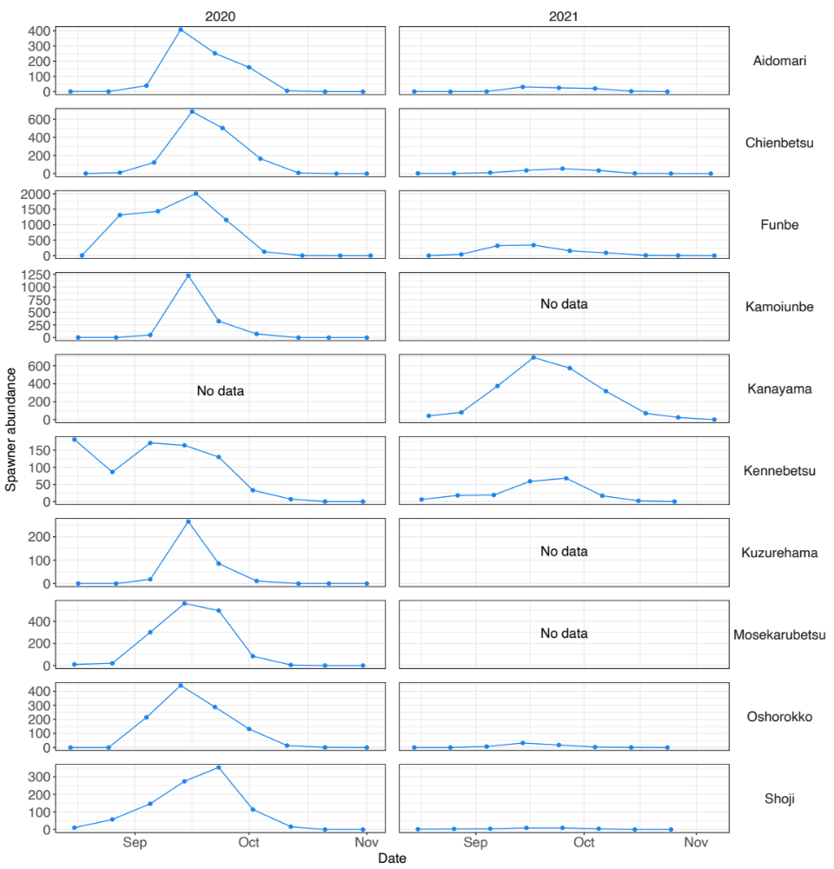
Figure S1. Temporal changes in spawner abundance in each stream.
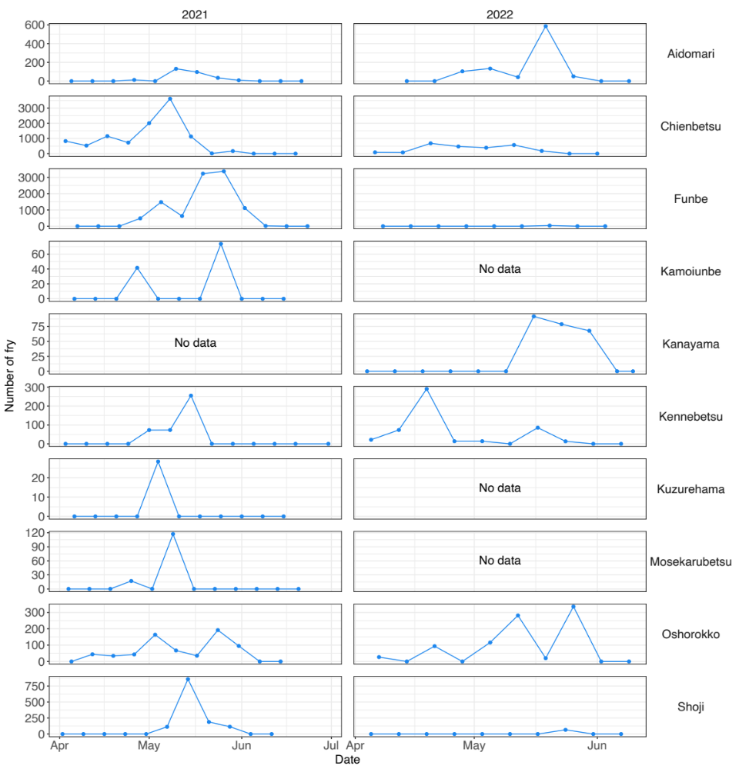
Figure S2. Temporal changes in the daily number of fry in each stream.
Figure S3. Stream temperature in relation to air temperature as predicted by generalized additive models. The shaded area indicates the 95% confidence interval.

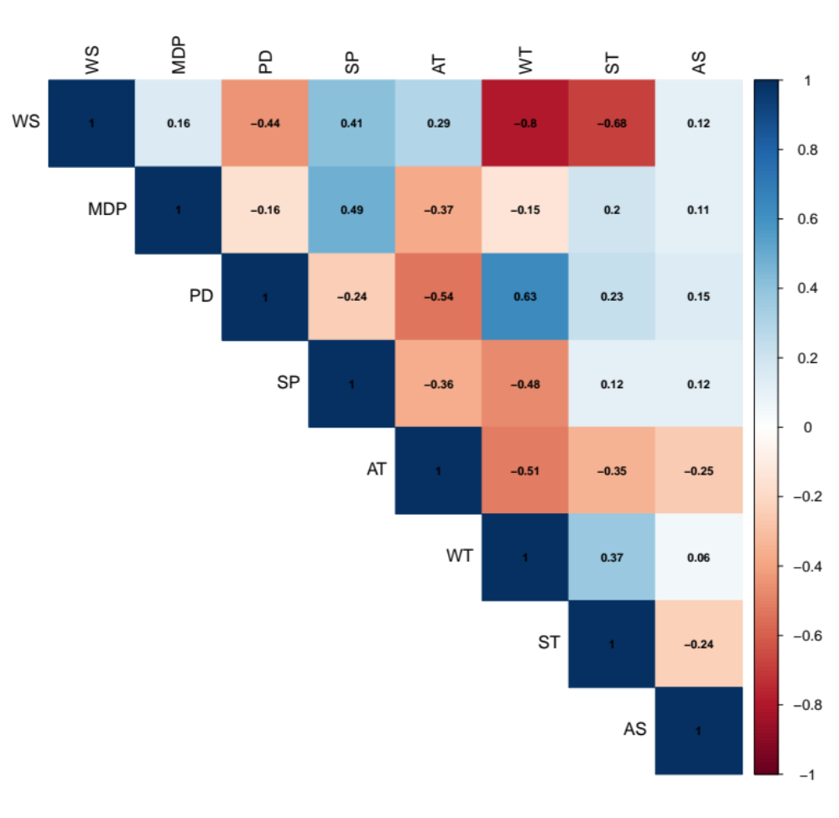
Figure S4. Pearson correlation coefficients between explanatory variables. WS, average watershed slope; MDP, maximum daily precipitation; PD, predator density; SP, stream power; AT, average autumn temperature; WT, average winter temperature; ST, average spring temperature; AS, area available for spawning per individual.

Table S1. Results of generalized additive models testing the effects of air temperature on stream temperature for each stream.
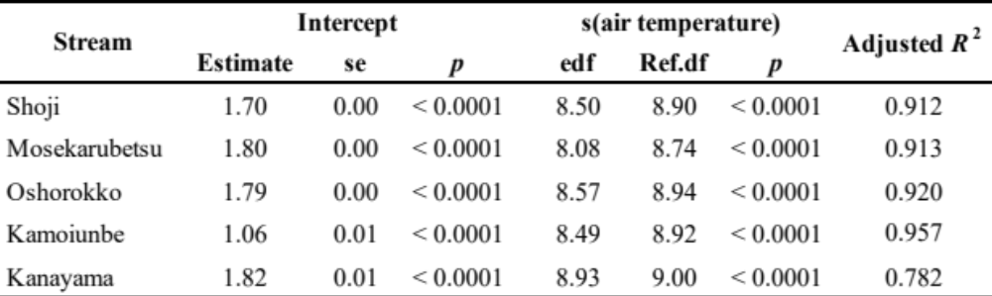

Table S2. Mean ± SD (range) autumn (September - October), winter (December - February), and spring (April - May) water temperatures (°C). Year, the year of spawning.
