Calcification rates in the lower photic zone and their ecological implications
Sam Kahng^{1,2*}, Takumi Kishi², Ryohei Uchiyama², Tsuyoshi Watanabe²

¹University of Hawaii at Manoa, Department of Oceanography, Honolulu, Hawaii U.S.A
²Hokkaido University, Faculty of Science, Sapporo, Hokkaido, Japan

*kahng@hawaii.edu
ORCID 0000-0001-8299-8908

Keywords: Mesophotic, calcification, growth rate, trophic ecology

Abstract
Photosymbiotic corals inhabit depths 0-170+ m and form the foundation of coral reef ecosystems by creating complex habitats with their calcium carbonate skeletons. While well studied in shallow waters, almost nothing is known about their basic biology & ecology at depths >60 m. Here we report on the first measurements of skeletal density and coral calcification rates from Leptoseris spp. growing at depths of 70-111 m in Hawaii. These corals have very thin, nonporous, skeletons that are considerably denser (2.7 g cm⁻³) than most shallow water corals. Their calcification rates (0.042-0.085 g cm⁻² yr⁻¹) are the lowest ever reported for a photosymbiotic scleractinian coral and ~20-40 times lower than the dominant shallow water corals in Hawaii. Given their colony geometry, calcification rate and tissue biomass productivity (per unit area) are tightly coupled, and a constant calcification rate leads to an increasing radial extension rate with colony size. These growth parameter relationships contrast sharply with hemispheroidal colonies in shallow water. Despite their extremely low calcification rates, these corals are very productive at increasing planar area over time, which is consistent with their phototrophic strategy at depth.
Introduction
The calcium carbonate (CaCO₃) skeletons of reef building corals provide the complex structural framework of coral reef ecosystems in which many associated organisms live. In the Anthropocene, these foundation species have been subject to many stressors and are declining globally (e.g., De’ath et al. 2012; Eddy et al. 2021). The decline in calcification rates in coral reef ecosystems is forecasted to continue in the face of global climate change threatening these diverse ecosystems (e.g., De’ath et al. 2009; Cornwall et a. 2021; Davis et al. 2021; Souter et al. 2021). Most of what is known about the biology and ecology of coral reef ecosystems have been based on shallow water studies and limited in large part by safety-related SCUBA diving limits. For example, the normoxic SCUBA diving depths limits are ~40 m for recreational no decompression diving and 58 m for oxygen toxicity (pO₂ = 1.4) (Pyle 2019). However, light-dependent coral reef ecosystems extend far beyond these depths in warm oligotrophic waters where light available to fuel photosynthetic benthic communities can reach extreme depths (reviewed in Kahng et al. 2010, 2014). Communities with high coral cover have been reported at multiple locations at depths > 100 m with the deepest in situ record of an obligate a photosymbiotic coral at 172 m (Rouze et al. 2021; Pérez-Rosales et al. 2022). In some regions, the potential coral reef ecosystem habitat area, which exists at depths beyond the reach of no-decompression SCUBA diving, may exceed that of shallow water coral reefs (reviewed in Kahng et al. 2014). At these depths, little is known about the effects of climate change, and very few baselines for measuring change have been established (Loya et al. 2016).
The productivity and energetics of photosymbiotic corals at depths >60 m remains largely unknown. Given the exponential attenuation of light with depth, the potential for photosynthesis declines accordingly. Conventional wisdom on trophic ecology assumes that reliance on (chemoorgano-) heterotrophy to fuel metabolic demand must increase relative to the decreases in (photolitho-) autotrophy. However, almost nothing is known about metabolic demand including rates of calcification and biomass production, and whether they are proportionally reduced at these depths. Below 60 m, only a few studies have measured growth rates, and no measurements of calcification exist (Fricke et al. 1987; Kahng 2013; Bongaerts et al. 2015; Kahng et al. 2020). In Hawaii, the growth rates (radial extension) of deep-water (70-110 m) obligate photosynthetic corals from the genus Leptoseris were recently demonstrated to be surprisingly robust (0.8-2.5 cm yr⁻¹) despite the low light in situ environment (Kahng 2013; Kahng et al. 2020). Leptoseris spp. are the dominant photosymbiotic coral species in the lower photic zone in Hawaii and possibly throughout the Indo-Pacific (Kahng et al. 2012b; Englebert et al. 2017; Pérez-Rosales et al. 2022). Given their colony morphology, these extension rates enable the corals to increase planar surface area relatively rapidly. Their strictly radial growth pattern and thin skeletons suggest that their calcification rates are low compared to most shallow water corals, but no quantitative measurements for exist corals at these depths.
In this study, deep-water Leptoseris calcification rates were measured and growth of tissue biovolume estimated to provide insights into their productivity and metabolic demand. Calcification and biomass production comprise major components of overall energy and resource allocation. These metrics were compared to their shallow-water counterparts, massive Porites spp. which are the dominant reef-building corals in shallow waters throughout the Hawaiian Archipelago (Grigg 1983, Fletcher et al. 2008; Rodgers et al. 2015) and well-studied across gradients of depth and latitude (Grigg 2006; De’ath et al. 2009; Lough et al. 2011, 2014, 2016). These comparisons provide indirect but important insights into energetics of deep-water Leptoseris spp. which in turn has important implications for their trophic ecology in their low light environment.
Materials and Methods
The bleached skeletons of three deep water Leptoseris samples (Leptoseris sp. 1 at 70 m, Leptoseris cf. foliosa at 95 m, and Leptoseris hawaiiensis at 111 m) were previously collected from Maui, Hawaii and measured for linear extension rates using Uranium-Thorium radiometric dating (Kahng et al. 2020). To measure for planar area, mass, and density, two fragments (on average ~28 cm² each) of each coral sample were cut to remove any portion that was non-living at the time of sampling, subject to secondary calcification from epiphytic and epifaunal organisms, or subject to bioerosion. In some cases, small isolated calcareous epifauna were carefully removed with a metal file with care not to remove original coral skeleton. At depths >80 m in Hawaii, some flat Leptoseris colonies can form a layered pattern caused by partial mortality and subsequent recolonization with slightly elevated overgrowth. In these cases, only the top layer of most recent growth of the colony were sampled. Each skeletal fragment was dried in an oven at 70°C for 12 hours prior to measuring mass on a scale. Density was calculated from specific gravity (±0.01 g cm⁻³) which was measured using a densimeter (AlfaMirage E-300SG). Fragments were treated with ethanol to eliminate air bubbles. Volume was calculated from mass and density using Archimedes' principle. Planar area was measured using a calibrated photo and ImageJ software (Schneider et al. 2012). In order to account for surface features and varying skeletal thickness including the low areal density of calices, an effective average skeleton thickness was calculated by dividing volume by planar area.
Since the skeletons are non-porous, tissue thickness was estimated based on the average septocostae height for each sample. Thin cross-sections of the coral samples were cut perpendicular to the septocostae and between the calices. Each sample was viewed under Keyence VHX-2000 digital microscope, and the mean height was calculated from a minimum of 10 consecutive septocostae.
Calcification rate and growth modeling
Using the size of the Leptoseris colonies originally measured for extension rate (Kahng et al. 2020), the length of the radial growth axis was used to project how the radial extension rate increases mass (new area * effective thickness * density) per unit surface area. Standard propagation of uncertainty was calculated for calcification rate using the uncertainty and partial derivative for each variable. The growth of horizontally flat Leptoseris (95 m and 111 m) was modeled using the geometry of a flat circular disk. For the foliose Leptoseris (70 m), the geometry of a hollow inverted 45° cone (radius = height) was used based on in situ observations of its orientation relative to the vertical axis. This simplistic modelling assumes that there are no space constraints inhibiting growth and no partial mortality (i.e., favorable growth conditions). Since the radial extension rates calculated in Kahng et al. (2020) are actual long-term averages over the life span of each colony, these assumptions are deemed reasonable. Likewise, the growth parameters for massive Porites colonies used for comparisons reflect long-term averages from mature colonies growing in their natural habitat (Grigg 1982, 2006; Lough and Barnes 2000).
For comparative purposes, the calcification rates calculated for the deep-water Leptoseris species was scaled as a percentage of the calcification rate for P. lobata at 5 m in Maui, Hawaii (Grigg 1982). Similarly, the downwelling PAR at 70 m, 95 m, and 111 m (downwelling PAR data from Kahng et al. 2012b) was scaled a percentage of the downwelling PAR experienced by P. lobata at 5 m in Maui. If calcification rate is driven only by available light energy and decreases proportionally to it with depth, these two parameters should be comparable at each depth. The ratio between them indicates higher/lower than expected calcification rates given the relative available downwelling PAR.
Assuming a constant calcification rate per unit surface area and the geometry of a circular disc and cone, the annual growth in mass for each sample was projected forward for 10 yrs and backwards for 10 yrs from its size at time of original sampling. Under optimal conditions, maximum rates of resource acquisition can be expected to be a function of their surface area (i.e., surface area for photosynthesis and feeding polyps). Therefore, maximum rates of growth normalized to surface area (e.g., calcification) can be expected to be isometric (but see Carlot et al. 2022) unless constrained by other factors. Future projections were based on colony area and calcification rate. Backwards projections of radial extension rate (i.e., previous year’s radius) were calculated using the mass (M) and calcification rate (G).
- M_{(n+1)} = M_{n} + G*A_{n} , where M_{n} = A_{n}*t* ρ is mass for year n (units = g), A_{n} = π r_{n}² is surface area for year n (units = cm²), G is calcification rate (units = g cm⁻² yr⁻¹), t is skeleton thickness (units = cm), ρ is density (units = g cm⁻²), and r_{n} is disc radius for year n (units = cm)
- Therefore, r_{n} = ((M_{(n+1)}/(π * ( t * ρ + G)))^{0.5}
- for a 45° cone (radius = height), the surface area is increase by a factor of 2^{0.5}
Whether the disc is a complete circle or a fraction of a circle (circle sector) does not change the relationship between radial extension rate and calcification rate per unit area.
The same modeling was used to estimate the annual increase in tissue bioviolume (area * tissue thickness) normalized per unit surface area. Since this biovolume estimate does not measure actual tissue biomass, composition, or caloric content, it is only intended as a biomass proxy given the dearth of biological data at depth. This crude proxy is used to illustrate the relationship between calcification and biomass productivity and the potential for large differences between colonies of equivalent size (i.e., radii) but contrasting colony geometry.
For comparison, the analogous growth in tissue biovolume was modeled for a shallow water massive Porites colony using an equivalent equatorial radius (and planar area). The growth of massive Porites was modeled using a prolate hemispheroid with the polar radius 1.64 times higher than the equatorial radius (eccentricity = 0.63) using average dimensions from massive Porites colonies (n=245) across 29 reefs (Lough and Barnes 2000). Calcification rate, density, and tissue thickness were assumed to be constant and used to calculate annual increases mass, volume, equatorial and polar radii, and tissue biovolume as a function of colony size (equatorial diameter). Using data from Lough and Barnes (2000), an average between vertical and horizontal axes for calcification rate (1.5 g cm⁻² yr⁻¹) and tissue thickness (4.95 mm) were used. Using data from Grigg (1982), an average density (1.4 g cm⁻³) from Maui was used (same location of deep-water Leptoseris sampling). Density is consistent between vertical and horizontal axes in massive Porites (Lough and Barnes 2000). Rate of tissue bioviolume growth were normalized per unit surface area. Given the more flattened shape on the top of larger massive Porites colonies as well as surface undulations, this model likely underestimates surface area and tissue biovolume for a given equatorial radius. However, assuming surface area remains a function of radius squared (r²) (i.e., proportional offset), the areal rate of change (A_{(t+1)}-A_{t}) with r is a linear function regardless of any proportional surface area offset. To demonstrate the relationships between calcification, radial extension rate, and growth rate of planar area for a hemispheroid, the geometric equations for each were written with respect to each other, and their limits were calculated as colony size increases (r→∞).
In the lower photic zone, planar area (perpendicular to the vertical axis) dictates the maximum potential for harvesting downwelling solar irradiance due to the narrow angular distribution of usable light at depth (Kahng et al. 2019). Annual growth in planar area (cm² yr⁻¹) was normalized to surface area (cm²) for both massive Porites and Leptoseris to calculate their normalized rate of planar area growth (yr⁻¹) and illustrate this productivity with colony size.
In order to help reconcile the prior reports of allometric and isometric coral growth in various metrics. Standard geometric equations for a circular hemispheroid (surface area = 2πr²; planar area = πr²; volume = ⅔πr³ where r is radius) and flat disc (surface area = πr²; volume = πr²h where h is height) were derived to demonstrate the relationships between the different growth metrics: planar area increase, calcification rate (G), radial extension rate (C). Constant skeletal density (ρ) was assumed in the calculations. The effects of constant radial extension rate (C), constant calcification rate (G), and constant percentage increase in planar area (i.e., isometric growth in planar area) were derived.
Results
The skeletal densities for the Leptoseris colonies were consistent regardless of depth and species with a mean value of 2.7 g cm⁻² yr⁻¹ (Table 1). Calcification rates were very low (0.042-0.085 g cm⁻² yr⁻¹) with no apparent depth trend. When the Leptoseris calcification rates are scaled relative to P. lobata at 5 m, they are 2.7-5.5% of the shallow water value. When the downwelling PAR experienced by these corals at 70-111 m are scaled relative to downwelling PAR experienced by P. lobata at 5 m, they are 0.7-4.8% of the shallow water value. If calcification rate is driven by available light energy and decreases proportionally to it with depth, the calcification rate for Leptoseris sp. 1 at 70 is 1.2 times higher; L. cf. foliosa at 95 m is 1.9 times higher; and L. hawaiiensis at 111 m is 5.5 times higher than expected in this regard (Table 1).
Per unit surface area (cm⁻²), the rates of tissue biovolume growth for Leptoseris were 0.81 mm³ yr⁻¹, 0.34 mm³ yr⁻¹, and 0.70 mm³ yr⁻¹at 70 m, 95 m, and 111 m, respectively. For P. lobata colonies of equivalent size at 5 m depth, the same rates were 0.43 mm³ yr⁻¹, 0.38 mm³ yr⁻¹, and 1.08 mm³ yr⁻¹, respectively.
For a flat disc with only two-dimensional radial growth, calcification rate and biovolume growth per unit surface area are constant with respect to each other. A constant calcification rate causes radial extension rate to increase linearly with increasing colony size and exponentially with time (Figure 1). The percentage increase in area remains constant (see derivation below).
For a prolate hemispheroid, volume is a function of r³ and surface area (and tissue biovolume) is a function of r². Assuming a constant density, tissue thickness, and eccentricity, a constant calcification rate per unit area for a hemispheroid leads to an exponential decay in biovolume growth per unit surface area and an asymptotic increase in extension rate (Figure 2). During early colony growth (<10 cm in diameter) there are rapid ontogenetic increases in extension rate and decreases in biovolume growth per unit surface area with colony size. For larger colonies, both extension rate and biovolume growth per unit surface area reach an asymptotic value and are nearly constant across time.
Since areal measurements (i.e., planar area and surface area) are exponential functions of the radius squared (i.e., r²), a constant annual radial extension rate (C) causes the percentage change in area between two time points (at fixed intervals) to become a function of r with a linear over quadratic function which decreases as r increases with a horizontal asymptote of zero.
- Percentage increase = f(r_{t}) = (A_{(t+1)}-A_{t})/ A_{(t+1)} = [(r_{t}+C)²-r_{t}²]/(r_{t}+C)² = (2Cr_{t}+C²)/(r_{t}²+2Cr_{t}+C²), where A_{t} is planar area at time t and r_{(t+1)}=r_{t}+C

- The limit as r_{t}→∞ causes the percentage increase to approach zero
For a circular hemisphere, a constant radial extension rate (C) causes calcification rate (G) to decrease asymptotically with colony size towards a constant value equivalent of Cρ.
- G = △Vρ/S_{t} = ρ(V_{(t+1)}-V_{t})/S_{t} = ρ[r_{(t+1)}³-r_{t}³]/3r_{t}² = ρ(3Cr_{t}²+3C²r_{t}+C³)/3r_{t}² , where V_{t} and S_{t} are the volume and surface area of a hemispheroid at time t respectively

- The limit as r_{t}→∞ causes G→Cρ
Similarly, for a circular hemisphere with a constant calcification rate, the radial extension rate increases asymptotically to a constant value of G/ρ as colony size increases. From the calcification equation above,
- G = ρ(3C_{t}r_{t}²+3C_{t}²r_{t}+C_{t}³)/3r_{t}² which can be rewritten as C_{t} (3r_{t}²+3C_{t}r_{t}+C_{t}²)/3r_{t}² = G/ρ
- The limit as r_{t}→∞ causes the term (3r_{t}²+3C_{t}r_{t}+C_{t}²)/3r_{t}² → 1, therefore C_{t}→ G/ρ
For a flat disc with constant thickness/height (h), a constant calcification rate causes isometric growth in planar area (i.e., the percentage change in area per unit time) to be constant with a value of G/(ρh). From the calcification mass relationship
- GA_{t} = ΔM = M_{(t+1)}-M_{t} = ρh(A_{(t+1)}-A_{t}), where M_{t} and A_{t} are the mass and surface area of a flat disc at time t respectively and h is height

- This equation can be rewritten as (A_{(t+1)}-A_{t})/ A_{(t+1)} = G/(ρh). By definition, the left term is the percentage increase in surface area.
Discussion
Geometric implications for growth rates and productivity
Given the two-dimensional radial growth of deep-water Leptoseris (flat disc or open cone), both volume and area are coupled as a function of the radius squared (r²). Assuming a constant tissue thickness and composition, a constant calcification rate per unit area leads to a constant production of tissue biovolume per unit area (biomass productivity) and a constant increase in planar area per unit surface area. In the absence of disturbance, a constant calcification rate enables radial extension rates to increase linearly as a function colony radius (and exponentially with time) as more surface area is available to fuel growth along the outer margins of the colony. Leptoseris colonies only grow by extending their outer margins radially outward and do not appear to thicken over time once they have reached a standard thickness (Kahng et al. 2020). The exception to this general growth pattern is at the central basal attachment to the substrate which may thicken over time. The limited data in Kahng et al. (2020) are not able to resolve any ontogenetic changes in extension rate and only provides an average for each colony which may underestimate the actual “final” extension rate for each coral colony at time of sampling. Therefore, the calcification rates and biovolume growth rates estimated in this study for Leptoseris may be underestimated. While deep water Leptoseris colonies can grow to at least 1.5 m in diameter (pers. obs. HURL P4-223), mechanical stability may limit maximum colony size due to their single point of attachment to the substrate (Madin and Connolly 2006; Madin et al. 2014).
For massive Porites colonies, their hemispheroidal colony geometry causes growth rates in terms of volume and surface area to be decoupled which has important implications for the relative allocation of energy and elemental resources to the anabolic processes of calcification and biomass production. Assuming a relatively constant skeletal density and tissue thickness/composition, growth in skeletal CaCO₃ mass is proportional to △volume while growth in tissue biomass is proportional to △surface area. A constant calcification rate (per unit area) causes radial extension rate to increase asymptotically with colony size. (Figure 2). For initial growth in smaller colonies, slower linear extension rates are consistent with empirical observations for massive Porites (Lough 2008; but see Carlot et al. 2022). If tissue thickness and composition per unit area is constant, a constant calcification rate would require an unrealistically high productivity of tissue biovolume for the smallest colonies due to the fast initial growth in surface area. During early colony growth, tissue thickness is probably thinner and colony growth is most likely constrained by biomass production (versus calcification). Therefore, calcification rates may be lower during early growth and/or colony growth deviates from a hemispheroid shape (e.g., more flattened to lower the initially high △A/△V ratio).
For large, massive Porites colonies, calcification rate and radial extension rates are tightly coupled, and growth is likely constrained by calcification and not tissue biomass production which declines quickly with colony size (Fig. 2). Energetically, this relationship suggests a strategy that prioritizes energy utilization for calcification over biomass production. This decoupling also suggests a growing biomass production surplus available for allocation to other anabolic processes (e.g., gamete development, tissue repair, mucus production, etc.). This relationship is consistent with the increase in polyp fecundity with colony size that is observed in massive corals with similar geometric growth forms (Babcock 1988; Alvarez-Noriega et al. 2016). Alternatively, with an emphasis on calcification, the growth of these large colonies may be less constrained by nutrient assimilation. Within increasing depth and less light availability, massive corals become more flattened/oblate (reviewed in Kahng et al. 2019). Assuming constant density and tissue thickness/composition, this change in colony morphology results in a disproportionate reduction in skeletal volume and mass (calcification) versus surface area and tissue biomass (production).
Across a range of coral taxa (including massive Porites), some growth rate metrics (e.g., planar area) have recently been reported as allometric with decreasing growth rates as colony size increases while other (e.g., linear extension rate) has been reported as isometric/constant (Lough and Barnes 2008; Dornelas et al. 2017; Madin et al. 2021; Medellín-Maldonado et al. 2022; Carlot et al. 2022). Depending on colony geometry, individual growth metrics (e.g., area, radius, calcification) on the same individual colony can behave differently (allometry vs isometry) with colony size. For hemispheroidal colonies, allometric growth in planar area (decrease in annual growth with increasing size) can occur despite other growth rate metrics (i.e., either radial extension rate or calcification rate) remaining constant (isometric). Excluding partial mortality, areal measurements (i.e., planar area and surface area) are an exponential function of the radius (i.e., r²). Therefore, a constant annual radial extension rate (C) causes the percentage change in area across time to towards zero as r increases. This relationship holds true for any colony geometry where the surface area is a function of r². Concurrently, calcification rate (G) decrease asymptotically to a constant of Cρ, where ρ is density because increase in volume is a function of r³ while area is a function of r².
Analogously, a constant calcification rate also causes the increase in planar area per unit surface area to decrease asymptotically to zero with increasing colony size (Fig. 3) because the radial extension rate increases asymptotically to a constant value of G/ρ. The potential decoupling of growth area (and tissue biomass) from volume (and CaCO³ mass) depends on the colony geometry (i.e., functions of r, r², or r³) and has important implications regarding whether growth and productivity for a species are constrained by surface area (i.e., tissue biomass) or volume (i.e., calcification) across time. For a flat disc of constant thickness (h) like deep-water Leptoseris, both ΔA and ΔV are functions or r². Therefore, a constant calcification rate leads to isometric growth in surface area (constant % increase across time) while radial extension rate (C_{t}) increases exponentially across time.
Density and calcification rate
For Leptoseris, the skeletal densities were considerably higher than density values reported for massive Porites in shallow water (Lough and Barnes 2000) including slow growing colonies from high latitudes (Grigg 1982) (Table 1). Analogously high skeletal densities (up to 2.46 g cm⁻³) have been previously been reported for foliose corals including Agaricidae (Hughes 1987). The high-density nature of Leptoseris skeletons makes them non-porous so that tissue is not able to recede into the skeletal matrix. Instead, the parallel rows of septocostae create linear crevices into which the tissue can recede for protection when disturbed. This response can be elicited by repeated touching the surface of the coral (pers. obs.). The high-density nature of the skeleton also makes them less susceptible to breakage despite their very thin nature.
For mature, healthy colonies, these long-term calcification rates are by far the lowest ever reported for a photosymbiotic scleractinian coral (reviewed in Pratchett et al. 2015). These calcification rates and those reported in Table 2 represent long-term averages of mature colonies growing in their native environment. By virtue of their longevity, these large colonies are located in a favorable environment and have consistently escaped lethal stress/disturbance over many years. Therefore, they may not be representative of conspecifics in less favorable habitats that will not or cannot grow to comparable size/age. The deep-water Leptoseris calcification rates are roughly 20-40 times slower than analogous rates from massive Porites species in shallow water in Hawaii and the GBR (Grigg 1982; Lough and Barnes 2000) (Table 2). Compared to corals at 5 m, the downwelling light (PAR) available to Leptoseris corals at 70 m, 95 m, and 111 m is 21, 69, and 148 lower respectively (Table 1). However, these large differences in PAR may be overestimated. The calculated light regime at 5 m (K_{d}=0.056) is based on K_{d}(PAR) measurements made in nearshore coastal waters at 35 m (1.6 km from shore) while the water closer to shore at 5 m will likely have a higher K_{d} value on average (Kahng et al. 2012). Similarly, the ambient light regime for deep water Leptoseris (K_{d}=0.0475) is based on a single day near the deep-water coral collection site, and lower K_{d} values (K_{d}=0.032) have been reported in nearby open ocean waters (Bienfang et al. 1984).
Considering this potential for underestimating the relative light regime at depth, the calcification rates at 70 m and 95 m appear to be reasonable for a coral with equivalent physiological capabilities to P. lobata at 5 m. However, the calcification rate at 111 m suggests a very different physiological capability (e.g., light utilization capabilities, growth efficiency, metabolic costs, etc.) and/or a trophic ecology less dependent on light. Superior photophysiology (i.e., light absorbance efficiency) has been demonstrated in some deep water photosymbiotic corals (including Leptoseris spp.) relative to their shallow water counterparts (Kahng et al. 2012b; Kramer et al. 2022).
The rates of tissue biovolume growth for Leptoseris in the lower photic zone are comparable to those of P. lobata colonies at 5 m with equivalent equatorial diameter. Considering the vastly different light regimes, this result may seem surprising. However, due to the geometric constraints and potential nutrient limitation for massive Porites in shallow water, their biomass productivity is probably not constrained by available light energy. Therefore, a relative comparison of biomass production or nutrient assimilation between these types of corals across depths must be interpreted in this context.
Unlike shallow water massive Porites, deep water Leptoseris colonies may be able to more evenly match both aspects of growth (calcification and biomass production) by virtue of their geometry. From a comparative perspective, there are two potential depth related implications. In shallow, oligotrophic waters, light energy, calcium and carbonate alkalinity (calcification components) are generally not limiting but essential elemental resources (e.g., bioavailable nitrogen and soluble reactive phosphorous) for tissue biomass production often are (Falkowski et al. 1993; Atkinson 2011). At depth, both calcification and biomass production are almost certainly energy limited due to lower light availability. However, biomass productivity may be less constrained by limiting elemental resources due to proximity to the nutricline (Kahng et al. 2019). For the deepest colonies of Leptoseris, their flat circular colony morphology maximizes planar surface area to adapt to the narrow angular distribution of usable light at depth. Despite their very low rates of calcification, these colonies can have a higher normalized rate of planar surface area growth (per unit surface area) than large shallow-water massive Porites (Figure 3). In the lower photic zone, prioritizing growth in planar surface area (as opposed to vertical growth) increases potential resource acquisition (i.e., downwelling light) as efficiently as possible (Kahng et al. 2019).
Additional metabolic considerations
Additional factors may cause metabolic costs to characteristically differ between these deep and shallow-water habitats. In shallow water, photosymbiotic corals are subject to a variety of stressors and higher metabolic costs by virtue of their environment. In high light, photosynthetic organisms must invest in repairing photo-damage, photoprotective pigments, heat shock proteins, and antioxidants (reviewed in Dubinsky and Falkowski 2011; Lesser 2011). Likewise, physical stress and damage from corallivores, wave stress, sedimentation and episodic disturbance from storms and thermal events are more frequent in shallow water and can attenuate with depth (Bongaerts et al. 2010; Pérez-Rosales et al. 2021). Corals in well-lit shallow-water do not retain all the carbon fixed from photosynthesis as excess mucus production and excretion of dissolved organic carbon (DOC) are common (e.g., Ferrier-Pages et al. 1998; Nauman et al. 2012).
By inhabiting deeper waters further offshore, corals in the lower photic zone are arguably less impacted by these potential stressors metabolically. In Maui, Hawaii, the average temperature at depths 70-111 m is ~2-3°C cooler than at 5 m and likely affect the relative calcification rates and basal metabolism. At equivalent depths, lower temperature is correlated with lower rates of calcification seasonally (Crossland 1984; Barnes and Lough 1993), at higher latitude (Grigg 1982; Lough 2008) and change in climate across time (Cooper et al. 2012). This temperature effect on calcification can be independent of light (Marshall and Clode 2004). At these depths, the lower average temperature (within their aerobic thermal range) may facilitate lower rates of respiration and therefore higher growth efficiencies (Portner et al. 2006). Based on tissue thickness, Leptoseris has less tissue biomass than Porites per unit surface area which should also lower basal metabolism per unit area. The low light regime itself may also lower effects of light enhanced dark respiration (LEDR) (Levy et al, 2004; Rodriguez and Grotolli 2007). For deep habitats exposed to the nutricline via internal tides interacting with the insular island shelf, access to elevated inorganic nutrient concentrations may facilitate more efficient conversion of primary productivity to tissue biomass due to less nutrient limitation (Kahng et al. 2019). While mucus and DOC excretion has not been measured on these corals, they would have to be substantially reduced in a light limited environment.
Implications for trophic ecology in the lower photic zone
Given the scarcity of available data, the assumptions on trophic ecology for deep-water obligate photosymbiotic corals have been largely influenced by the exponential attenuation of downwelling light (and the decreasing potential photosynthetic contribution) with depth (i.e., the input side of the energetic balance). However, the output side of the energy balance is of equal importance. The calcification comparisons in this study provide some insight into the potential energetic balance and growth strategy for deep water Leptoseris and helps lend some perspective on how these corals are able to thrive in the lower photic zone. Compared to shallow water corals, the relative calcification rates of deep-water Leptoseris are greatly reduced. However, considering the potential for lower metabolic demand at depth, the relative rates of calcification at 70 m and 95 m appear to be consistent with the quantitative reduction of available light in deep water as obligate photosynthetic organisms. The dogma that an increased heterotrophy is required with depth to compensate for reduced light is not supported by these results.
For L. hawaiiensis at 111 m, the calcification rate at depth are several times higher than what would be expected when considering light regime alone. However, greater light harvesting efficiency in these dominant, depth-specialist corals compared to their shallow-water counter parts Porites spp. (e.g., Kahng et al. 2012) and depth-related reductions in metabolic demand almost certainly play a role in facilitating calcification at depth. Whether these efficiency gains are sufficient to fuel their calcification autotrophically has not yet been quantified. The conspicuous presence of endolithic green algae in these deep corals has been suggested as an additional potential source of photosynthate to the coral host (Rouzé et al. 2021). While the possibility of a shift in trophic ecology toward heterotrophy has not yet been investigated, these deep-water species Leptoseris generally have relatively few polyps (low areal densities) that completely lack functional tentacles for capturing food (Kahng et al. 2020). While mucus feeding has been demonstrated in many shallow-water corals (reviewed in Goldberg 2018), such a strategy would be a energetically expensive proposition in the lower photic zone.
Acknowledgements
This research was made possible by funding from the JSPS Invitational Fellowship for Research in Japan (Fellowship ID L20527) and by the Hawai’i Undersea Research Laboratory (HURL). Special thanks to T. Kirby, M. Cremer and the HURL staff for operational support with the Pisces IV/V submersibles.
Conflict of Interest Statement
On behalf of all authors, the corresponding author states that there is no conflict of interest.

References
Álvarez-Noriega M, Baird AH, Dornelas M, Madin JS, Cumbo VR, Connolly SR (2016) Fecundity and the demographic strategies of coral morphologies. Ecology 97:3485–3493
Atkinson MJ. 2011. Biogeochemistry of nutrients. In: Dubinsky Z, Stambler N, Eds. Coral reefs: an ecosystem in transition. Netherlands: Springer. p 199–206.
Babcock RC (1988) Age-structure, survivorship and fecundity in populations of massive corals. Proc 6th Int Coral Reef Symp 2:625–633
Barnes DJ, Lough JM (1993) On the nature and causes of density banding in massive coral skeletons. Journal of Experimental Marine Biology and Ecology 167:1:91–108
Bongaerts P, Frade PR, Hay KB, Englebert N, Latijnhouwers KR, Bak RP, Vermeij MJ, Hoegh-Guldberg O (2015) Deep down on a Caribbean reef: lower mesophotic depths harbor a specialized coral-endosymbiont community. Sci Rep 5:7652
Bongaerts P, Ridgway T, Sampayo EM et al (2010) Assessing the “deep reef refugia” hypothesis: focus on Caribbean reefs. Coral Reefs 29:309–327
Carlot J, Rouzé H, Barneche DR, Mercière A, Espiau B, Cardini U, Brandl SJ, Casey JM, Pérez-Rosales G, Adjeroud M, Hédouin L, Parravicini V (2022) Scaling up calcification, respiration, and photosynthesis rates of six prominent coral taxa, Ecol. Evol., 12, e8613, https://doi.org/10.1002/ece3.8613.
Cooper TF, O’Leary RA, Lough JM (2012) Growth of Western Australian corals in the Anthropocene. Science 335: 593–596.
Cornwall, C. E., Comeau, S., Kornder, N. A., Perry, C. T., van Hooidonk, R., DeCarlo, T. M., et al. (2021). Global declines in coral reef calcium carbonate production under ocean acidification and warming. Proc. Natl. Acad. Sci. U.S.A. 118:e2015265118.
Crandall JB, Teece MA, Estes BA, Manfrino C, Ciesla JH (2016) Nutrient acquisition strategies in mesophotic hard corals using compound specific stable isotope analysis of sterols. J Exp Mar Biol Ecol 474:133–141
Crossland CJ (1984) Seasonal variations in the rates of calcification and productivity in the coral Acropora formosa on a high-latitude reef. Mar Ecol Prog Ser 15:135–140
Davis, K. L., Colefax, A. P., Tucker, J. P., Kelaher, B. P., & Santos, I. R. (2021). Global coral reef ecosystems exhibit declining calcification and increasing primary productivity. Communications Earth & Environment, 2, 105
De’ath, G., Fabricius, K. E., Sweatman, H. & Puotinen, M. The 27-year decline of coral cover on the Great Barrier Reef and its causes. Proc. Natl Acad. Sci. USA 109, 17995–17999 (2012).
De’ath G, Lough JM, Fabricius KE (2009) Declining coral calcification on the Great Barrier Reef. Science 323:116–119
Dornelas M, Madin JS, Baird AH, Connolly SR (2017). Allometric growth in reef-building corals. Proceedings of the Royal Society B-Biological Sciences, 284, 20170053. https://doi.org/10.1098/rspb.2017.0053
Dubinsky Z, Falkowski PG (2011) Light as a source of information and energy in zooxanthellate corals. In: Dubinsky Z, Stambler N (eds) Coral reefs: an ecosystem in transition. Springer, Dordrecht, pp 107–118
Eddy TD, Lam VWY, Reygondeau G, Cisneros-Montemayor AM, Greer K, Palomares MLD, Bruno JF, Ota Y, Cheung WWL (2021). Global decline in coral reefs to provide ecosystem services. OneEarth, 4, 1278– 1285
Englebert N, Bongaerts P, Muir PR, Hay KB, Pichon M, Hoegh-Guldberg O (2017) Lower mesophotic coral communities (60–125 m depth) of the Northern Great Barrier Reef and Coral Sea. PLoS ONE 12:e0170336
Falkowski PG, Dubinsky Z, Muscatine L, McCloskey L (1993) Population control in symbiotic corals. Bioscience 43:606–611
Ferrier-Pagès C, Gattuso JP, Cauwet G, Jaubert J, Allemand D (1998) Release of dissolved organic carbon and nitrogen by the zooxanthellate coral Galaxea fascicularis. Mar Ecol Prog Ser 172:265–274
Fletcher C, Bochicchio C, Conger C, Engels M and others (2008) Geology of Hawaii reefs. In: Riegl B, Dodge R (eds) Coral reefs of the USA. Springer, p 435−488
Franklin EC, Jokiel PL, Donahue MJ (2013) Predictive modeling of coral distribution and abundance in the Hawaiian Islands. Marine Ecological Progress Series 481:121-132
Goldberg WM (2018) Coral food, feeding, nutrition, and secretion: A Review. In Kloc M, Kubiak J (Eds). Marine Organisms as Model Systems in Biology and Medicine. Results and Problems in Cell Differentiation. Springer, Cham. 65:377–421
Grigg RW (1982) Darwin Point: A threshold for atoll formation. Coral Reefs 1: 29–34.
Grigg RW (1983) Community structure, succession and development of coral reefs in Hawaii. Mar Ecol Prog Ser 11:1–14
Fricke HW, Vareschi E, Schlichter D (1987) Photoecology of the coral Leptoseris fragilis in the Red Sea twilight zone (an experimental study by submersible). Oecologia 73:371–381
Houlbrèque F, Ferrier-Pagès C (2009) Heterotrophy in tropical scleractinian corals. Biol Rev 84:1–17
Hughes TP (1987) Skeletal density and growth form of corals. Mar Ecol Prog Ser 35:259–266
Kahng SE (2013) Growth rate for a zooxanthellate coral (Leptoseris hawaiiensis) at 90 m. Galaxea J Coral Reef Stud 15:39–40
Kahng SE, García-Sais JR, Spalding HL, Brokovich E, Wagner D, Weil E, Hinderstein L, Toonen RJ (2010) Community ecology of mesophotic coral reef ecosystems. Coral Reefs 29:255–275
Kahng SE, Wagner D, Lantz C, Vetter O, Gove J, Merrifield M (2012a) Temperature related depth limits of warm-water corals. In: Proceedings of the 12th International Coral Reef Symposium, Cairns, Australia, 9C
Kahng SE, Hochberg EJ, Apprill A, Wagner D, Luck DG, Perez D, Bidigare RR (2012b) Efficient light harvesting in deep-water zooxanthellate corals. Mar Ecol Prog Ser 455:65–77
Kahng SE, Copus JM, Wagner D (2014) Recent advances in the ecology of mesophotic coral ecosystems (MCEs). Curr Opin Environ Sustain 7:72–81
Kahng SE, Akkaynak D, Shlesinger T, Hochberg E, Wiedenmann J, Tamir R, Tchernov D (2019) Light, temperature, photosynthesis, heterotrophy, and the lower depth limits of mesophotic coral ecosystems (MCEs). In Loya Y, Bridge T, Puglise K (Eds). Mesophotic Coral Ecosystems. Springer Publishing, p 799-826
Kahng SE, Watanabe TK, Hu H-M, Watanabe T, Shen C-C (2020) Moderate zooxanthellate coral growth rate at mesophotic depths. Coral Reefs 39:1273–1284
Kramer N, Tamir R, Ben‐Zvi O, Jacques SL, Loya Y, Wangpraseurt D (2022) Efficient light‐harvesting of mesophotic corals is facilitated by coral optical traits. Functional Ecology 36:406-41
Lesser MP (2011) Coral bleaching: causes and mechanisms. In: Dubinsky Z, Stambler N (eds) Coral reefs: an ecosystem in transition. Springer, Berlin, pp 405–420
Levy O, Dubinsky Z, Schneider K, Achituv Y, Zakai D, Gorbunov MY (2004) Diurnal hysteresis in coral photosynthesis. Mar Ecol Prog Ser 268:105–117
Lough JM (2008) Coral calcification from skeletal records revisited. Mar Ecol Prog Ser 373:257–264.
Lough JM, Barnes DJ (2000) Environmental controls on growth of the massive coral Porites. J Exp Mar Biol Ecol 245:225–243
Lough JM, Cantin NE (2014) Perspectives on massive coral growth rates in a changing ocean. Biol. Bull. 226: 187–202.
Lough JM, Cantin NE, Benthuysen JA, Cooper TF (2016) Environmental drivers of growth in massive Porites corals over 16 degrees of latitude along Australia’s northwest shelf. Limnol Oceanogr 61:684–700
Loya Y, Eyal G, Treibitz T, Lesser MP, Appeldoorn R (2016) Theme section on mesophotic coral ecosystems: Advances in knowledge and future perspectives. Coral Reefs 35:1–9
Madin JS, Connolly SR (2006) Ecological consequences of major hydrodynamic disturbances on coral reefs. Nature 444:477–480.
Madin JS, Baird AH, Dornelas M, Connolly SR (2014). Mechanical vulnerability explains size dependent mortality of reef corals. Ecology Letters 17:1008–1015.
Madin JS, Baird AH, Baskett ML, Connolly SR, Dornelas MA (2020). Partitioning colony size variation into growth and partial mortality. Biology Letters, 16, 20190727. https://doi.org/10.1098/rsbl.2019.0727
Marshall AT, Clode P (2004) Calcification rate and the effect of temperature in a zooxanthellate and an azooxanthellate scleractinian reef coral. Coral Reefs 23:218–224
Medellín-Maldonado F, López-Pérez A, Ruiz-Huerta L, Carricart-Ganivet JP (2022) Understanding corallite demography to comprehend potential bias in sclerochronology: Analysis of coral modular growth by micro-computed tomography. Oceanography and Limnology 67:12:2665-2676. https://doi.org/10.1002/lno.12229
Naumann MS, Richter C, Mott C, el-Zibdah M, Manasrah R, Wild C (2012) Budget of coral-derived organic carbon in a fringing coral reef of the Gulf of Aqaba, Red Sea. J Mar Syst 105:20–29
Pérez-Rosales G, Rouzé H, Torda G, Bongaerts P, Pichon M, Pole, Consortium Under The, Parravicini V, Hédouin L, (2021) Mesophotic coral communities escape thermal coral bleaching in French Polynesia. R Soc Open Sc 8:210139
Pérez-Rosales G, Hernández-Agreda A, Bongaerts P, Rouzé H, Pichon M, Carlot J, Torda G, Consortium Under The Pole, Parravicini V, Hédouin L (2022) Mesophotic depths hide high coral cover communities in French Polynesia, Science of the Total Environment 844:157049
Pérez-Rosales G, Pichon M, Rouzé H, Villéger S, Torda G, Bongaerts P, Carlot J, Parravicini V, Hédouin L (2022) Mesophotic coral ecosystems of French Polynesia are hotspots of alpha and beta generic diversity for scleractinian assemblages. Diversity and Distributions 28:1391–1403.
Portner HO, Bennett AF, Bozinovic F, Clarke A, Lardies MA, Lucassen M, Pelster B, Schiemer F, Stillman JH (2006) Trade-offs in thermal adaptation: the need for a molecular to ecological integration. Physiol Biochem Zool 79:295–313
Pratchett MS, Anderson KD, Hoogenboom MO, Widman E, Baird AH (2015) Spatial, temporal and taxonomic variation in coral growth—implications for the structure and function of coral reef ecosystems. Oceanogr Mar Biol Annu Rev 53:215–295
Pyle RL (2019) Advanced Technical Diving. In Loya Y, Bridge T, Puglise K (Eds.). Mesophotic Coral Ecosystems. Springer Publishing, pp. 959–972.
Rodgers KS, Jokiel PL, Brown EK et al (2015) Over a decade of change in spatial and temporal dynamics of hawaiian coral reef communities. Pac Sci 69:1–13. doi:10.2984/69.1.1
Rodrigues LJ, Grottoli AG (2007) Energy reserves and metabolism as indicators of coral recovery from bleaching. Limnol Oceangr 52:1874–1882
Rouzé H, Galand PE, Medina M, Bongaerts P, Pichon M, Pérez-Rosales G, Torda G, Moya A, Bardout G, Périé-Bardout E, Marivint E, Lagarrigue G, Leblond J, Gazzola F, Pujolle S, Mollon N, Mittau A, Fauchet J, Paulme N, Pete R, Peyrusse K, Ferucci A, Magnan A, Horlaville M, Breton C, Gouin M, Markocic T, Jubert I, Herrmann P, Raina JB, Hédouin L (2021) Symbiotic associations of the deepest recorded photosynthetic scleractinian coral (172 m depth). ISME J 15:1564–1568
Schneider CA, Rasband WS, Eliceiri KW (2012) NIH Image to ImageJ: 25 years of image analysis. Nature Methods, 9(7), 671–675. doi:10.1038/nmeth.2089
Souter D, Serge P, Wicquart J, Logan M, Obura D, Staub F (2021) Status of coral reefs of the world: 2020 Executive Summary, (Townsville, Australia: Coral Reef Initiative, Global Coral Reef Monitoring Network).

Table 1
Linear extension rates, density, calcification rates, and tissue thickness of deep-water Leptoseris and shallow-water Porites in Maui, Hawaii. Temperature and light regime in their respective habitats. Porites data from Grigg (1982, 2006), Lough and Barnes (2000). Leptoseris data from Kahng et al. (2012a, 2020) and this study. PAR data from Kahng et al. 2012b.

**relative to the values for P. lobata at 5 m depth

Table 2
Calcification rates for massive Porites in shallow water, deep water, and high latitude compared to deep water Leptoseris. These include both the deepest and highest latitude calcification measurement for massive Porites species as well as representative rates of Maui, Hawaii where the deep water Leptoseris was sampled. Calcification rates for Porites come from the vertical growth axis representing natural long-term growth averages from large colonies growing in situ.

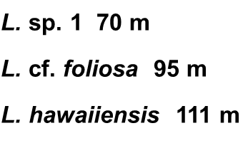
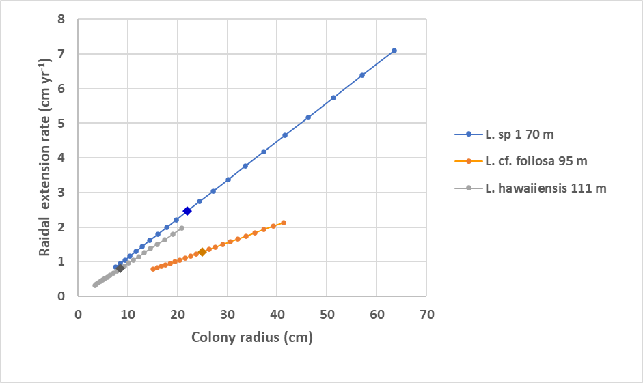
Figure 1
Radial extension rates as a function of colony size modeled for deep-water Leptoseris colonies based on their calculated calcification rates. Each data point represents annual increments. Projections (forward and backward) based a constant calcification rate (Table 1). Colony size at time of sampling is denoted as a large diamond within each series. Extension rate and calcification rate uncertainties shown on Table 1.

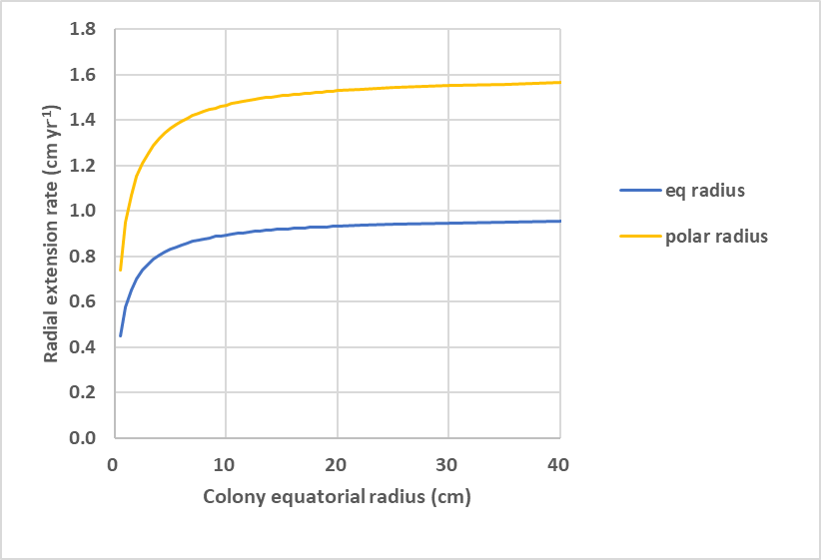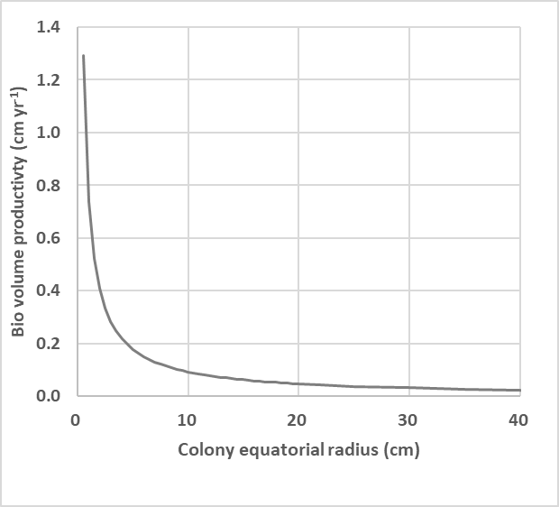
Figure 2
Radial extension rates of equatorial (eq) and polar radii (left) and biovolume productivity (right) as a function of colony size modeled for a massive Porites colony using a prolate hemispheroid with constant calcification rate, eccentricity, density, and tissue thickness. Extension rates are cm yr⁻¹. Biovolume productivity is cm yr⁻¹ (new volume added per unit surface area per year). Note the opposing rends with colony size and the asymptotic nature of these metrics for larger colony sizes.

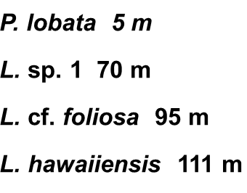
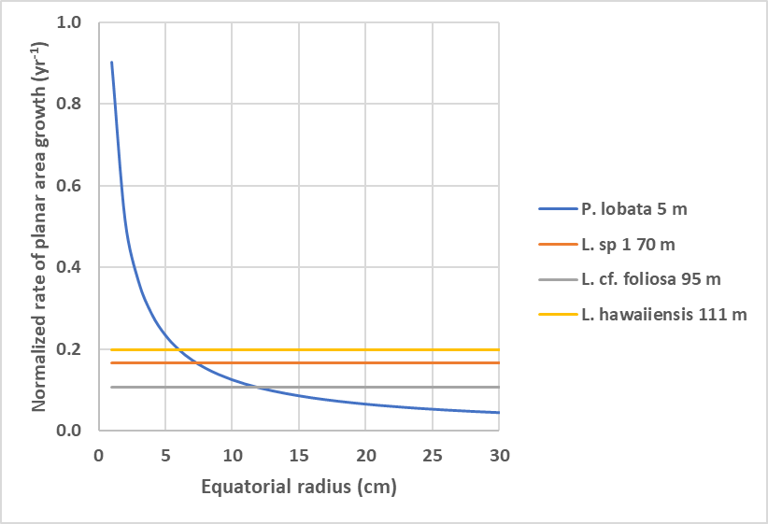
Figure 3
The rate at which planar area (cm²) is increased per unit surface area (cm²) per year (yr⁻¹) assuming a constant rate of calcification (g cm⁻² yr⁻¹) for each colony. For flat or cone shaped laminar colonies, the increase in planar area per unit surface area is constant. For a hemispheroid colony, this productivity decreases rapidly with colony size.

