SUPPORTING INFORMATION

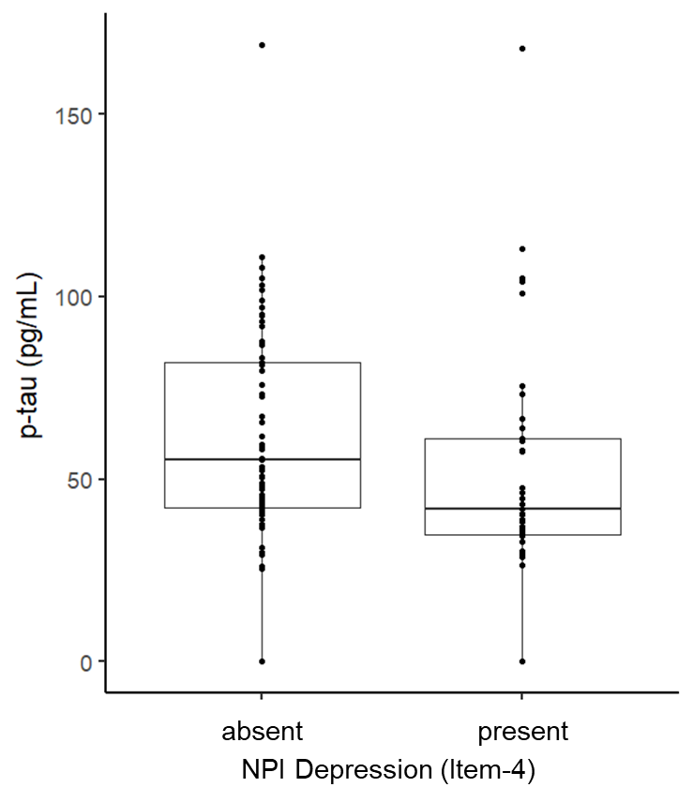
NPI Depression (Item-4)
present
absent
Figure S1. Box plots showing the relationship between phosphorylated tau (p-tau) (pg/mL) and neuropsychiatric domains of depression (item 4) (present or absent). NPI: neuropsychiatric inventory
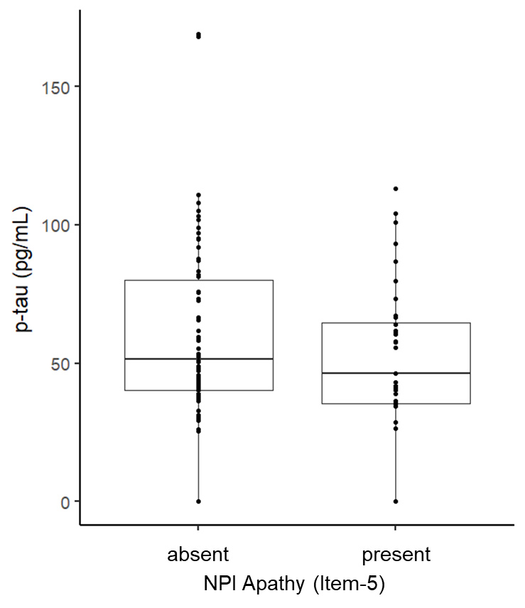
Figure S2. Box plots showing the relationship between phosphorylated tau (p-tau) (pg/mL) and neuropsychiatric domains of apathy (item 5) (present or absent).
NPI: neuropsychiatric inventory

