Supplementary information

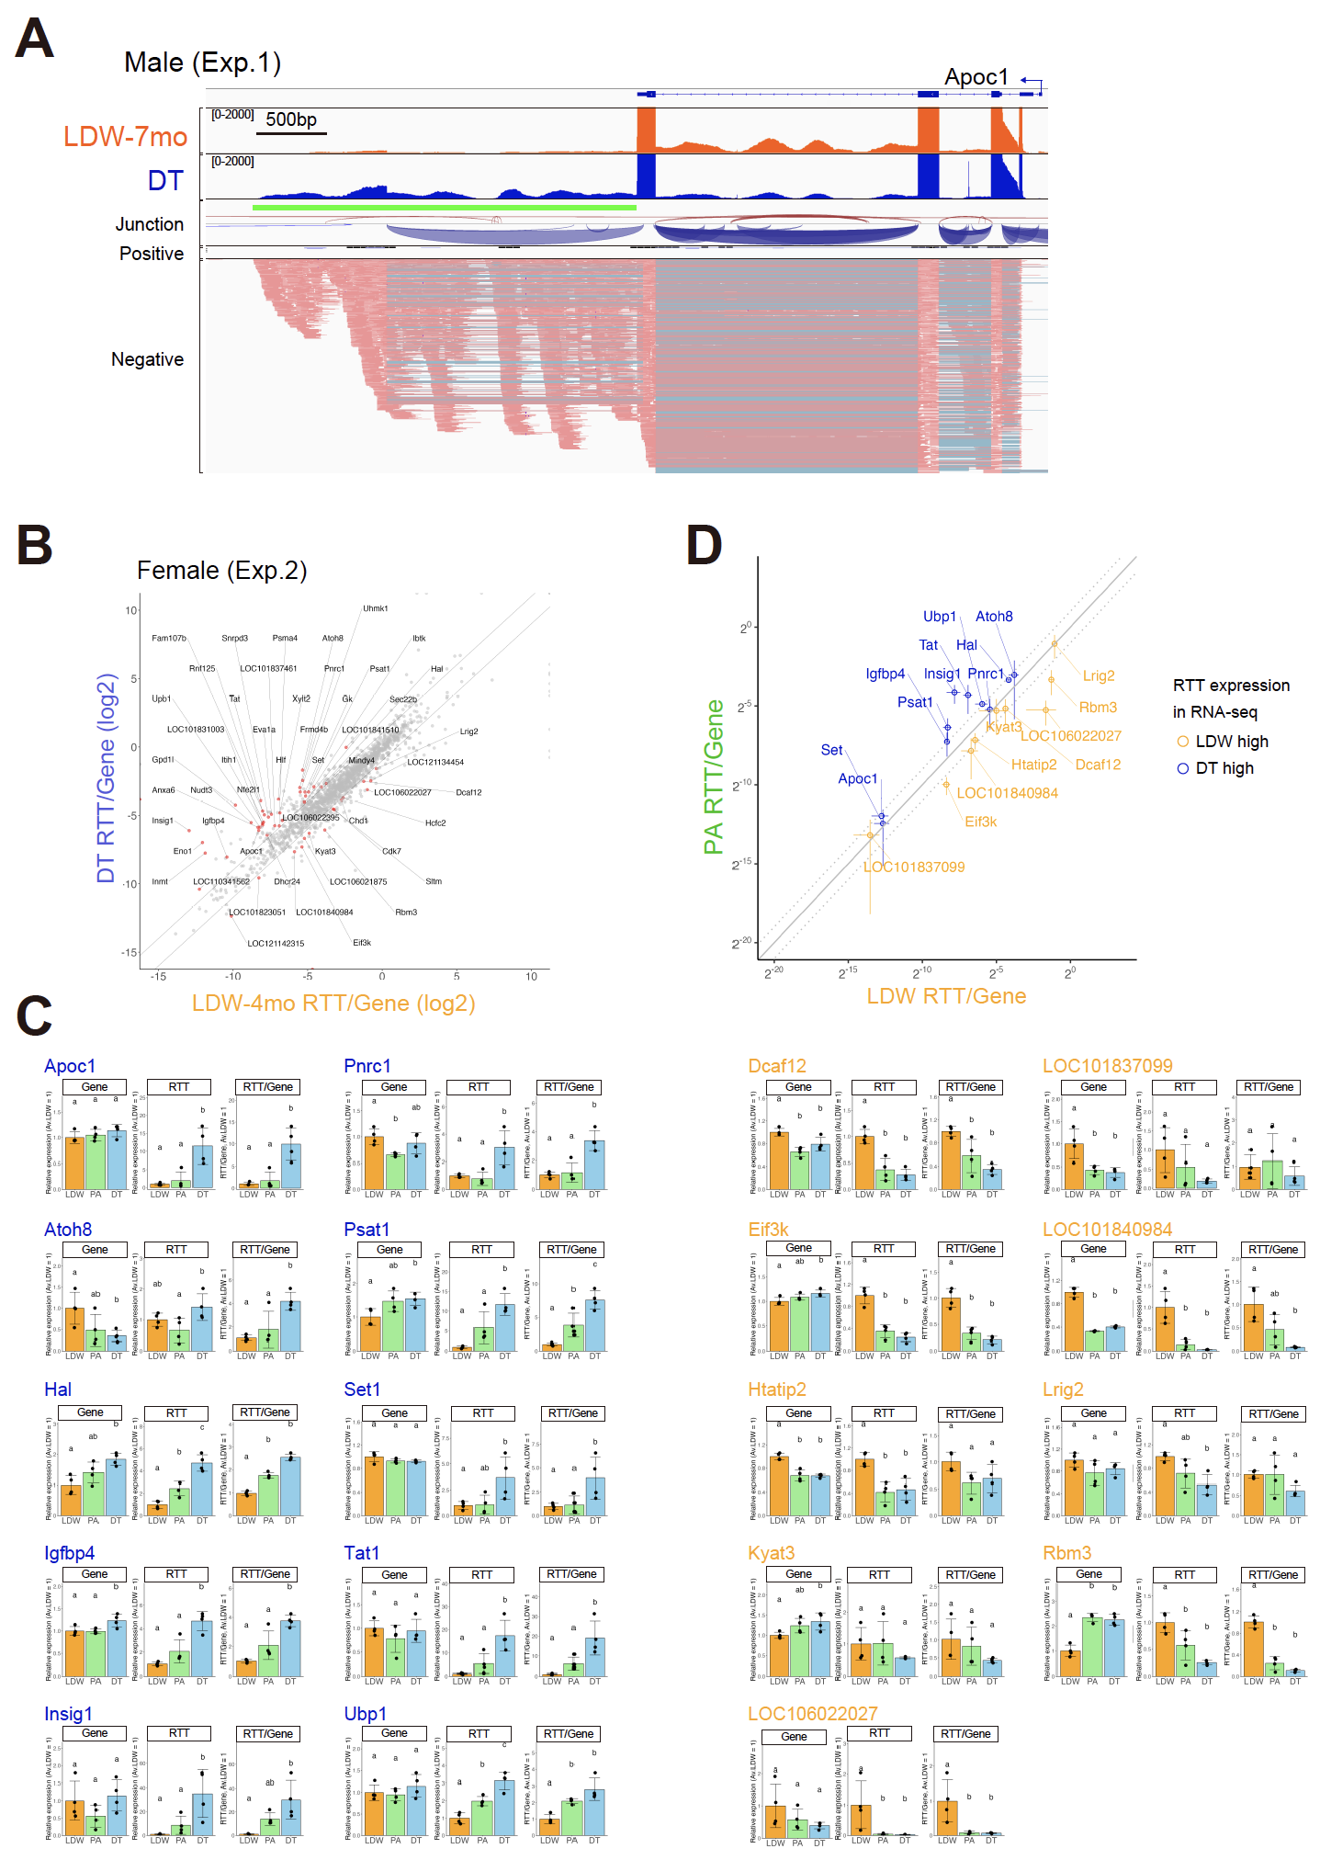
Fig. S1. RTTs are produced from more gene loci in DT than in LDW. Related to Fig. 1.
(A) Genome browser view of Apoc1 locus of male liver RNA-seq data of an representative individual for each condition. RTT expressed in DT animals is underlined with green. Junctional reads and reads in positive (rightward) direction and negative (leftward) direction are represented. (B) Female hamster liver RNA-seq data of genes with RTTs that are > 0.5 FPKM are shown as ratios of FPKM between RTT and gene regions. Genes significantly different in both experiments (see main text) are shown in red. (C) qRT-PCR analysis of indicated genes in male livers. Gene and RTT expression are normalized to Hprt1 as an internal control (one-way ANOVA with the Tukey’s multiple comparison test, p < 0.05). (D) qRT-PCR analysis of male livers. Data is represented as ratios between RTT and gene regions of LDW animals in x axis and those of PA animals in y axis, mean±SD, n=4.

Table S1. Sequences of primers for qPCR

Target | Fwd Primer sequence | Rev Primer sequence
Hprt1_Gene | TTTATCAGACTGAAGAGCTACTG | CCAGTTAAAGTTGAGAGATC
Apoc1_Gene | ACACCTTGGAAGACAAGGCC | CCTTCAATTTGCCGAATGTCTC
Apoc1_RTT | TGTAGTAGGGTCACCAGCCT | AATGGACTGAAGGTCGTCCG
Tat_Gene | AGCGGTTAGTTGCGGAGCAG | CTTGGGGACCGTGATGACAAC
Tat_RTT | CCAGACGTGGAGAATGCTGG | GTCTTACCCGATAATGCCCCA
Ubp1_Gene | CACCGAGCTCAACCTCAACC | AGTTCCCGGGCATACATCTC
Ubp1_RTT | ATCCATAACCGGTGTGCCTG | CAAACAATGGCTGGCGTCTC
Atoh8_Gene | AGCAACCTCAGTTTCTCCGAG | TGGCAGGTCACTCCTTACGC
Atoh8_RTT | TCTTTCCCAGTTCCAACGCA | CTCAGTGGATTCCCTTCCCC
Igfbp4_Gene | GTGACCGCAACGGCAACTTC | GTCTTCCGATCCACACACCA
Igfbp4_RTT | GTTTTGGGTCCAGTCAGCCA | ACCCATCTTCAAGGGTGCAA
Psat1_Gene | ACAAGGCGGTGGAACTCAAC | GGCAGCCAGCTTCTCAACATC
Psat1_RTT | AAGCCCAGCTACATCTCTGC | CTCATTGGCTGGGATTGAACC
Hal_Gene | CCCACAGGCTACTCCTGGAG | GGAGAAAGCGGCCTGGATTC
Hal_RTT | TGGTTAGAGAGGCTGCAGTTG | TCATCTTGGGCCCCTGTAGT
Set_Gene | GGAAGATATCGATGAAGAAGGGGATG | AGTCATCCTCGCCTTCATCC
Set_RTT | AACTGAAGCGTTTAGCCACCT | GTGACTGCAGACTCCCATCC
Pnrc1_Gene | TGGCCACAGCCCTGCTACAC | GGGAAGGGCAATTCTCTCCG
Pnrc1_RTT | CTGCAGAGGCCAGAGAAGGG | CCATTTCCATCACCCACCTGG
LOC101840984_Gene | CCGGGACATTGAAGTTCAGG | TTCTCCCAGACGGTCTCGTC
LOC101840984_RTT | CCACTCTACTGCTCTCCAGAG | GTGGAGTGTTGCATGTGGGC
Htatip2_Gene | GAGAAGTGGAAGCCAAGGTTGC | GGCGAGACTCTTGCCTGTCA
Htatip2_RTT | CATGAAGGAGAGAACCCACACTC | CTTGGGCATCGGCTACTTTT
Kyat3_Gene | ACTATAAGTTTGTGAAGTGGATGACG | GACTCCGAGTCACAGAATGC
Kyat3_RTT | ATGTCTACACACAGGATTGTCCC | CCAATAGGAGGTCTGTAGGTGAC
Rbm3_Gene | ATGCCTCAGATGCCATGAGAG | CAGACTTGCCTGCATGGTCC
Rbm3_RTT | GGCTAGCTCTATAGTCCAGG | CAAGTCCCACCCTTCTCATCC
Eif3k_Gene | GCATAAAGCCCAAGAACATCGTGG | GTCTTTATTAAAGGCACAGTTACTGGG
Eif3k_RTT | CAGAACACAGTAGTGGGCGG | GGATTACAAGTGTATGCTACATTCCC
Target | Fw Primer sequence | Rv Primer sequence
LOC101837099_Gene | GTCTTTGGTGCCATTCCCAG | GGCACACGGGCTCCTATACA
LOC101837099_RTT | ATGCTACCTGCCGGAAGAAG | GTCTGGACAGAGATGGAACACGG
Dcaf12_Gene | CAAGTCTGTCTGCTCCAGGG | CTGTGCCCACAGTGATAATG
Dcaf12_RTT | CTGTCCTAGTGCAGTGCTGTTT | ACAAATCCCAGCATGCCCTC
LOC106022027_Gene | GCTTCAAGGAGGGGGATGTG | GGCTGGATTCTTCTCCACGT
LOC106022027_RTT | CCCTGTAACTACCCCCTCAT | ACTGTCCCAACACATGGCTG
Lrig2_Gene | GAAGCTTCCCTTCTCACAGATGAG | CAAGGACAGGCTGCTGGGAA
Lrig2_RTT | AGGGTAAGGAGTAGCAACAGG | CTCAGTGAGACATTCACAGAGC
Insig1_Gene | CAGTGGGAAACATAGGACGACAG | GCTCTGAACCATGTCCTGAAGC
Insig1_UTR | TAAAAGTCTTCCCTTGCTCACCC | CCCCTACCCCACTCTCACAT
Insig1_RTT#0 | AGGAGAATGGCACCTTTGTCTAGG | CTCAAAGGGCATTTCCCAAAGG
Insig1_RTT#1 | GACCAGAACTGAGGCTGGGG | CACGAGGTATATCCTGTTATCCTC
Insig1_RTT#2 | TTCTGTGGACTGCACATCGG | CAATTGTTTCTTGGACATGACATCAG
Insig1_RTT#3 | GGACATAGAACACAGGATGCG | CCATGCTCCTGCCAAGATGC
Insig1_RTT#4 | GAAGGGACGACACAGATGGG | CCCCGACACAGTGATCGCTA

