Supplementary materials

Manuscript: Meat and bone meal biochar can effectively reduce chemical fertilizer requirements for crop production and impart competitive advantages to soil

This supplementary document includes 5 tables and 1 figure.
Table S1. Physicochemical properties of the soil used in two separate experiments.
Table S2. Experimental setup for first pot trial.
Table S3. Experimental setup for second pot trial.
Table S4. Properties of post-harvest soil collected after first pot experiment. Letters next to each value indicate statistically significant differences at p < 0.05 (n = 3).
Table S5. Properties of post-harvest soil in the second experiment. Different letters next to each value indicate statistically different values among the same application rate of chemical fertilizer at p < 0.05 (n = 3).
Figure S1. Sorghum growth in second pot experiment as affected by the treatments.

Table S1. Physicochemical properties of the soil used in two separate experiments.
Soils used | pH | NO₃-N | NH₄-N | Av. P | Ex. K
Soil for Exp. 1 | 5.9 | 0.03 | 0.004 | 0.273 | 0.568
Soil for Exp. 2 | 6.2 | 0.021 | 0.006 | 0.313 | 0.586
Average | 6.05 | 0.0255 | 0.005 | 0.293 | 0.577
*Av. P: available phosphorus; Ex. K: exchangeable potassium

Table S2. Experimental setup for first pot trial.
Treatment | Application dose |  |  |  |  | Total amount of nutrients
Treatment | Soil | N Fert. | P Fert. | K Fert. | MBMC | TN | TP | TK
Treatment | (g/pot)
CF | 350 | 0.37 | 0.54 | 0.11 | 0.00 | 0.74 | 0.48 | 0.56
CF + 1000℃ MBMC (3.5 t ha⁻¹) | 350 | 0.37 | 0.54 | 0.11 | 3.50 | 0.79 | 0.66 | 0.57
CF + 800℃ MBMC (3.5 t ha⁻¹) | 350 | 0.37 | 0.54 | 0.11 | 3.50 | 0.85 | 0.63 | 0.57
CF + 500℃ MBMC (3.5 t ha⁻¹) | 350 | 0.37 | 0.54 | 0.11 | 3.50 | 0.88 | 0.63 | 0.57
CF + 500℃ MBMC (1.75 t ha⁻¹) | 350 | 0.37 | 0.54 | 0.11 | 1.75 | 0.81 | 0.55 | 0.57
CF + 500℃ MBMC (7.0 t ha⁻¹) | 350 | 0.37 | 0.54 | 0.11 | 7.00 | 1.02 | 0.77 | 0.59
*Fert.: fertilizer; TN: total nitrogen; TP: total phosphorus; TK: total potassium

Table S3. Experimental setup for second pot trial.
Treatment | Application dose |  |  |  |  |  |  | Total amount of nutrients
Treatment | Soil | N Fert. |  | P Fert. |  | K Fert. | MBMC | TN | TP | TK
Treatment | (g/pot)
100% CF | 350 | 0.37 | 0.54 |  | 0.11 |  | 0.00 | 0.74 | 0.44 | 0.59
80% CF | 350 | 0.30 | 0.43 |  | 0.09 |  | 0.00 | 0.73 | 0.43 | 0.58
60% CF | 350 | 0.22 | 0.32 |  | 0.07 |  | 0.00 | 0.71 | 0.42 | 0.57
40% CF | 350 | 0.15 | 0.22 |  | 0.04 |  | 0.00 | 0.70 | 0.40 | 0.56
20% CF | 350 | 0.07 | 0.11 |  | 0.02 |  | 0.00 | 0.68 | 0.39 | 0.55
0% CF | 350 | 0.00 | 0.00 |  | 0.00 |  | 0.00 | 0.67 | 0.38 | 0.54
100% CF + MBMC | 350 | 0.37 | 0.54 |  | 0.11 |  | 7.00 | 1.02 | 0.73 | 0.62
80% CF + MBMC | 350 | 0.30 | 0.43 |  | 0.09 |  | 7.00 | 1.01 | 0.72 | 0.61
60% CF + MBMC | 350 | 0.22 | 0.32 |  | 0.07 |  | 7.00 | 0.99 | 0.71 | 0.60
40% CF + MBMC | 350 | 0.15 | 0.22 |  | 0.04 |  | 7.00 | 0.97 | 0.69 | 0.59
20% CF + MBMC | 350 | 0.07 | 0.11 |  | 0.02 |  | 7.00 | 0.96 | 0.68 | 0.58
0% CF + MBMC | 350 | 0.00 | 0.00 |  | 0.00 |  | 7.00 | 0.94 | 0.67 | 0.57
*Fert.: fertilizer; TN: total nitrogen; TP: total phosphorus; TK: total potassium

Table S4. Properties of post-harvest soil collected after first pot experiment. Letters next to each value indicate statistically significant differences at p < 0.05 (n = 3).
Treatment | Soil properties
Treatment | pH | TN | NH₄-N | NO₃-N | Av-P | Ex-K | Ex-Ca | Ex-Mg | CEC
Treatment | (-) | (%) | (mg/g) |  |  |  |  |  | cmol_{c} kg⁻¹
CF | 5.0 a | 0.19 a | 0.031 b | 0.016 a | 0.344 a | 0.547 a | 5.679 a | 0.910 a | 30.87 a
CF + MBMC1000 (3.5 t ha⁻¹) | 5.3 b | 0.20 ab | 0.014 ab | 0.016 a | 1.956 bc | 0.599 a | 6.319 ab | 0.981 b | 30.97 a
CF + MBMC800 (3.5 t ha⁻¹) | 5.4 c | 0.23 bc | 0.024 ab | 0.017 a | 2.413 c | 0.587 a | 6.962 ab | 0.961 b | 31.20 ab
CF + MBMC500 (3.5 t ha⁻¹) | 5.5 d | 0.25 cd | 0.018 ab | 0.020 a | 2.021 bc | 0.604 a | 7.504 b | 0.964 b | 32.03 bc
CF + MBMC500 (1.75 t ha⁻¹) | 5.3 b | 0.21 ab | 0.019 ab | 0.015 a | 1.282 b | 0.554 a | 7.397 b | 0.921 a | 31.73 ac
CF + MBMC500 (7.0 t ha⁻¹) | 5.7 e | 0.29 d | 0.010 a | 0.021 a | 3.302 d | 0.626 a | 7.754 b | 0.981 b | 32.43 c
TN: total nitrogen, Av: available, Ex: Exchangeable, CEC: cation exchange capacity

Table S5. Properties of post-harvest soil in the second experiment. Different letters next to each value indicate statistically different values among the same application rate of chemical fertilizer at p < 0.05 (n = 3).

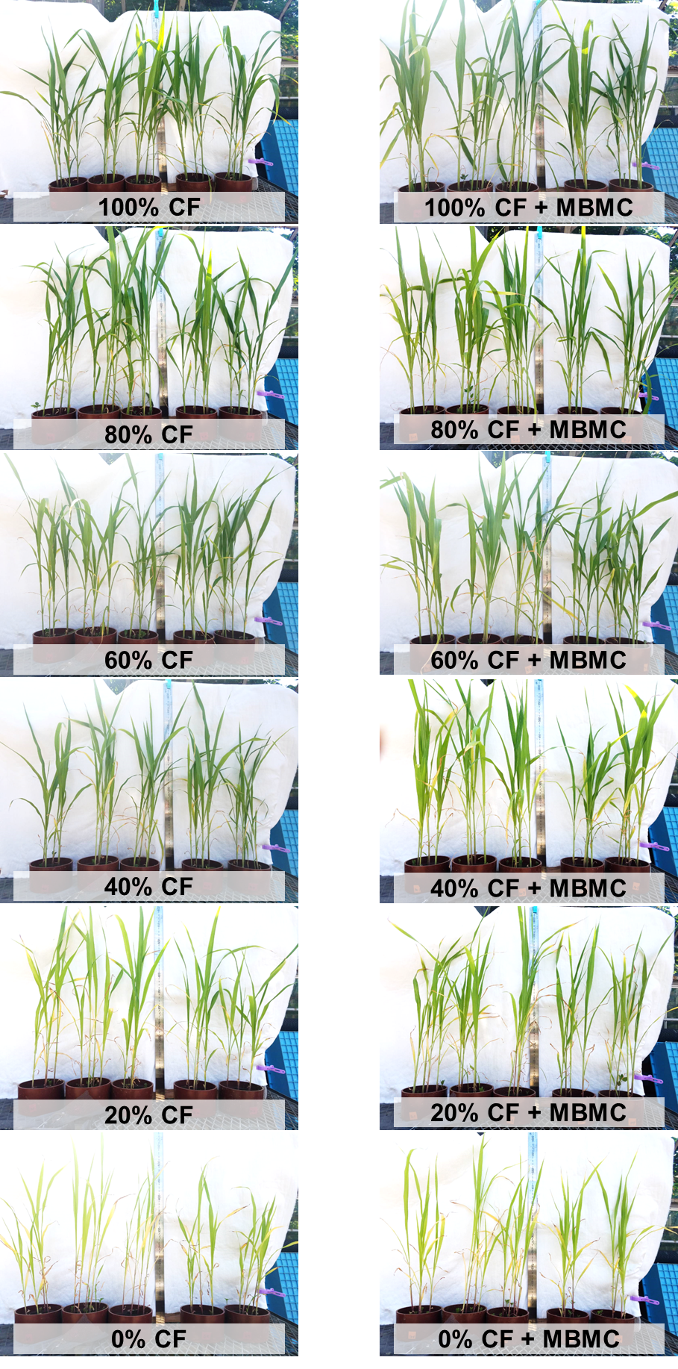
Figure S1. Sorghum growth in second pot experiment as affected by the treatments.

