Supplementary Material
Target fragments were successfully amplified from the positive controls of AiV-D1 to AiV-D4 using the self-designed primers (Fig.S2). Sequencing confirmed that the amplified fragments were 118 bp in length, matching the expected size, with 100% similarity to the AiV-D 3D sequences available in GenBank.
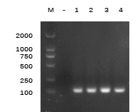
Fig. S1. Gel electrophoresis of amplification fragment by specific primers.
M, Marker DL 2000; -, Negative control; 1, AiV-D1 positive control; 2, AiV-D2 positive control; 3, AiV-D3 positive control; 4, AiV-D4 positive control.

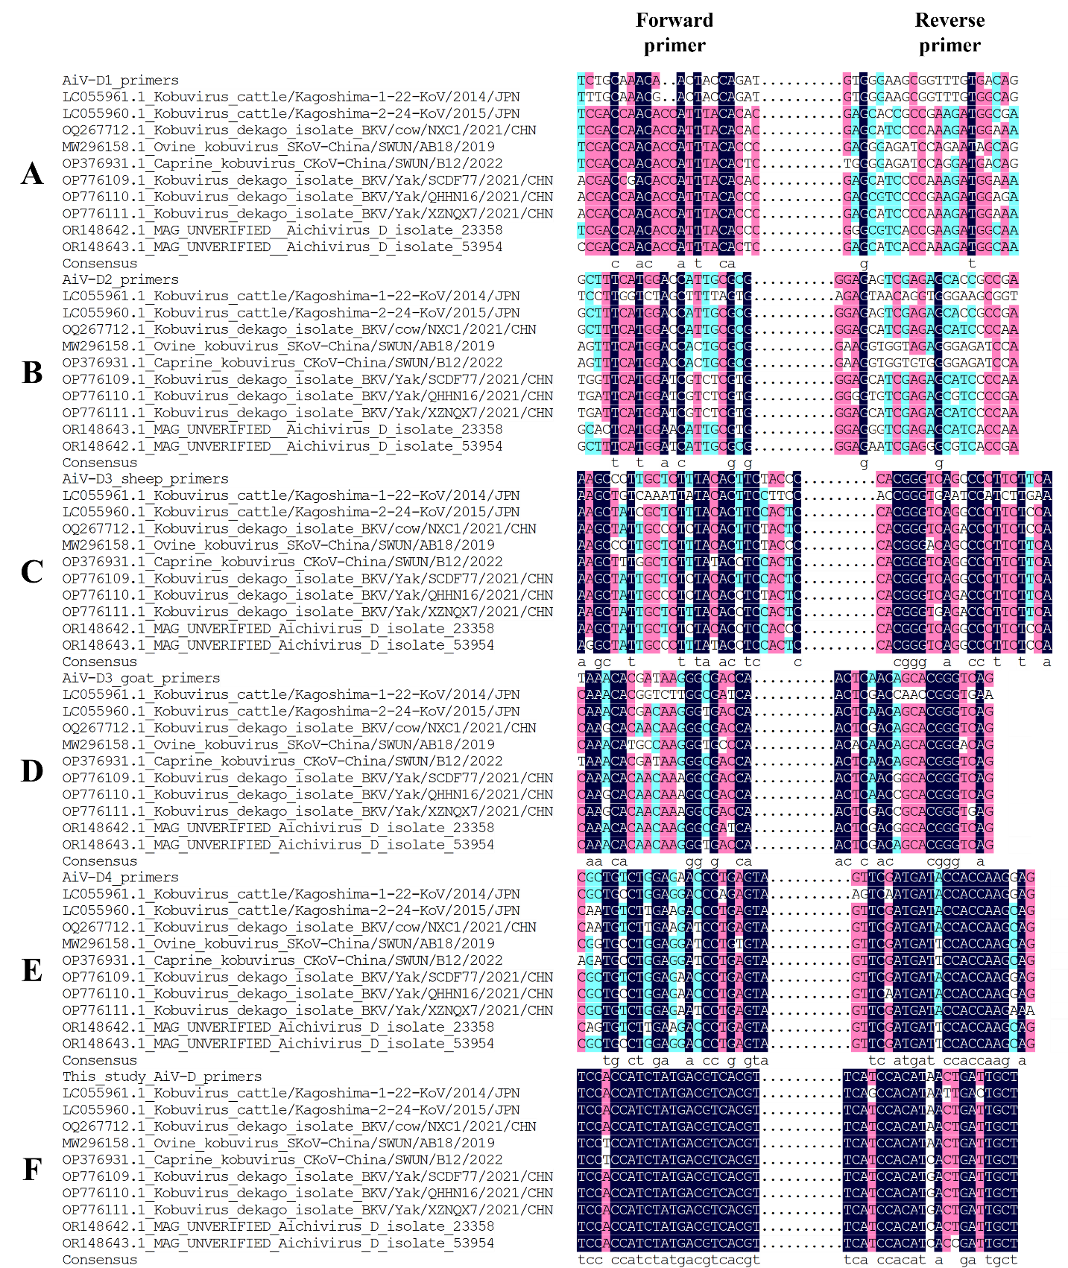
Fig.S2. Analysis of primers sites for six detection assays of AiV-D.
A: primers analysis for detecting AiV-D1; B: primers analysis for detecting AiV-D2; C: primers analysis for detecting AiV-D3 from sheep; D: primers analysis for detecting AiV-D3 from goats; E: primers analysis for detecting AiV-D4; F: primers analysis for detecting all genotypes of AiV-D in this study

The concentrations of the AiV-D1 to AiV-D4 plasmids were 79.8, 104.1, 89.3, and 129.5 ng/µL, respectively, using Nanodrop spectrophotometer. The molecular masses of these plasmids were calculated based on their respective lengths using the formula: molecular mass = 660 × plasmid length (base pairs). Consequently, the molecular masses of plasmids AiV-D1 to AiV-D4 were 2,170,080, 1,311,420, 1,311,420, and 1,311,420, respectively. The copy numbers of these plasmids were further calculated using the formula: copies/µL = (6.02×10²³ copies/mol) × (concentration ng/µL) × 10⁻⁹ / (molecular mass g/mol). The resulting copy numbers for plasmids AiV-D1 to AiV-D4 were 2.21×10¹⁰, 4.78×10¹⁰, 4.10×10¹⁰, and 5.94×10¹⁰ copies/µL, respectively.
Under the optimized reaction conditions, a strong linear relationship was observed between 10³ and 10⁹ copies/µL. The standard curves for AiV-D1 to AiV-D4 were y = -3.276x + 43.99 (R² = 0.998, Eff% = 101.94%), y = -3.254x + 43.207 (R² = 0.998, Eff% = 102.93%), y = -3.112x + 42.396 (R² = 0.997, Eff% = 109.59%), and y = -3.51x + 40.537 (R² = 0.999, Eff% = 103.04%) (Fig. S3 A1–A4). The melting curves obtained showed a Tm of 82.5°C ± 0.5°C (Fig. S3 B1–B4).

Fig. S3. Standard curve and melting curve of fluorescent RT-PCR for AiV-D1 to AiV-D4.
A1–A4, standard curve for AiV-D1 to AiV-D4; B1–B4, melting curve for AiV-D1 to AiV-D4.

Fig. S4. Specificity test of fluorescent RT-PCR for AiV-D.
1–4: AiV-D1 to AiV-D4 positive controls; 5–16: BCoV, BRVA, BVDV, IBRV, NeV, BNoV, BToV, BAoV, CAoV, BEV, ETEC, and Salmonella enterica; NC: negative control; NTC: non-template control.

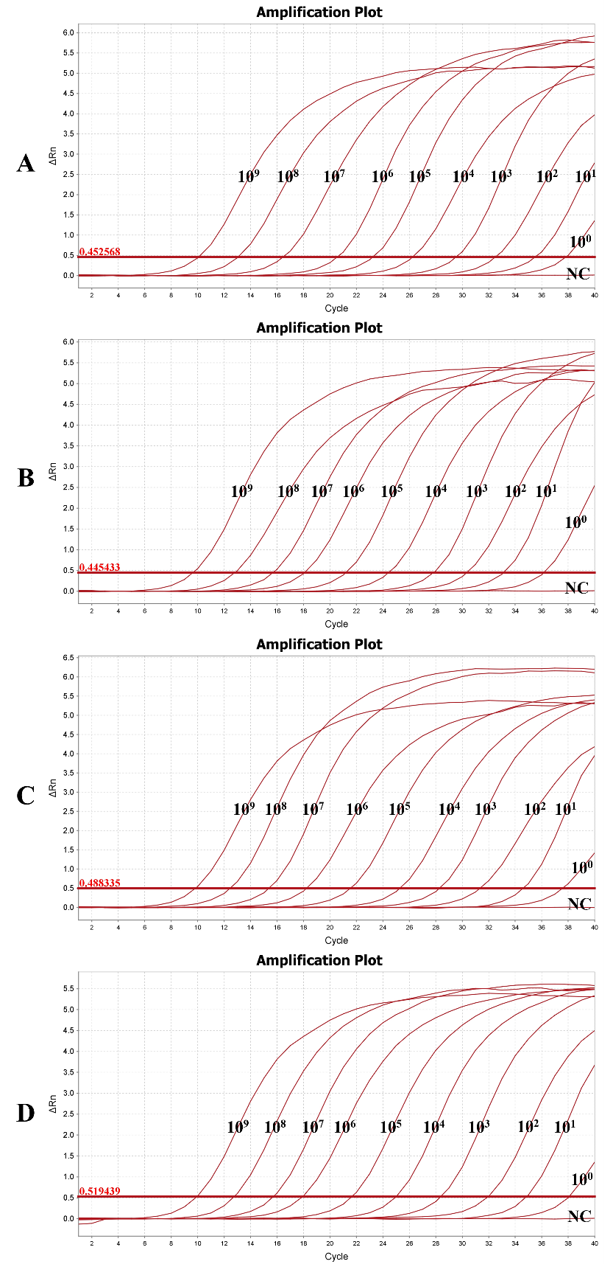
Fig. S5. Sensitivity of the fluorescent RT-PCR for AiV-D1 to AiV-D4.
A: AiV-D1,10⁹-10⁰: 2.21×10⁹-2.21×10⁰ copies/µL; B: AiV-D2,10⁹-10⁰: 4.78×10⁹-4.78×10⁰ copies/µL; C: AiV-D3,10⁹-10⁰: 4.10×10⁹-4.10×10⁰ copies/µL; D: AiV-D4,10⁹-10⁰: 5.94×10⁹-5.94×10⁰ copies/µL; NC: Negative control.

Fig. S6. Mutation analysis of nucleotide sites and amino acid sites in complete 3D gene of AiV-D from yaks.
The boxed figures indicate the amino acid change sites within the RNA-dependent RNA polymerase motif.

Table S1. Stability test of intra-assay variability
Concentration of standard plasmid（copies/µL） | Intra-assay variability
Concentration of standard plasmid（copies/µL） | Ct value |  |  |  | CV（%）
Concentration of standard plasmid（copies/µL） | AiV-D1 | AiV-D2 | AiV-D3 | AiV-D4 | AiV-D1 | AiV-D2 | AiV-D3 | AiV-D4
10⁴ | 26.203 ± 0.102 | 24.470 ± 0.133 | 25.142 ± 0.295 | 24.741 ± 0.058 | 0.39 | 0.54 | 1.17 | 0.23
10⁵ | 23.210 ± 0.104 | 21.211 ± 0.134 | 21.378 ± 0.096 | 21.465 ± 0.127 | 0.45 | 0.63 | 0.45 | 0.59
10⁶ | 20.539 ± 0.099 | 18.026 ± 0.062 | 18.077 ± 0.123 | 17.880 ± 0.177 | 0.48 | 0.34 | 0.68 | 0.99

Table S2. Stability test of inter-assay variability
Concentration of standard plasmid（copies/µL） | Inter-assay variability
Concentration of standard plasmid（copies/µL） | Ct value |  |  |  | CV（%）
Concentration of standard plasmid（copies/µL） | AiV-D1 | AiV-D2 | AiV-D3 | AiV-D4 | AiV-D1 | AiV-D2 | AiV-D3 | AiV-D4
10⁴ | 26.155 ± 0.149 | 24.533 ± 0.183 | 25.216 ± 0.219 | 24.968 ± 0.318 | 0.57 | 0.75 | 0.87 | 1.27
10⁵ | 23.236 ± 0.094 | 21.094 ± 0.170 | 21.014 ± 0.401 | 21.410 ± 0.265 | 0.40 | 0.81 | 1.91 | 1.24
10⁶ | 20.664 ± 0.202 | 18.034 ± 0.390 | 17.801 ± 0.232 | 17.846 ± 0.143 | 0.98 | 2.16 | 1.30 | 0.80

