(a) (b) (c)
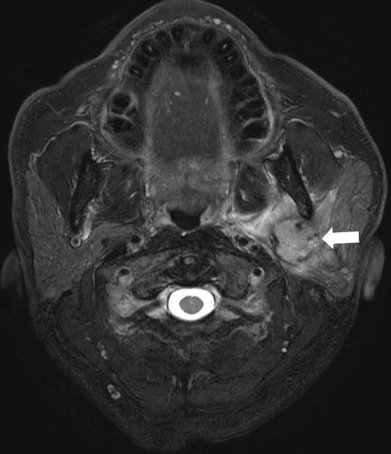

Supplemental Material 1. A case of a parotid gland tumor showed only slight improvement in tumor depiction with the model-based DL reconstruction.

Fat-suppressed T2WI shows the left parotid gland tumor (a: arrow). The tumor lesion is clearly visualized in DWI with PI-based reconstruction (b), though there is slight overall image noise. This overall noise was effectively removed in DWI with DL-based reconstruction (c); however, the visibility of the tumor remained largely unchanged.

