(a) (b) (c)
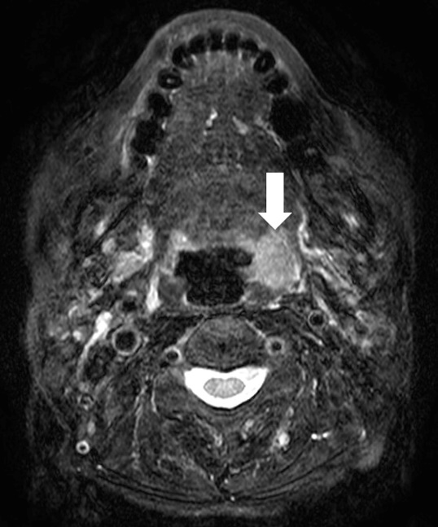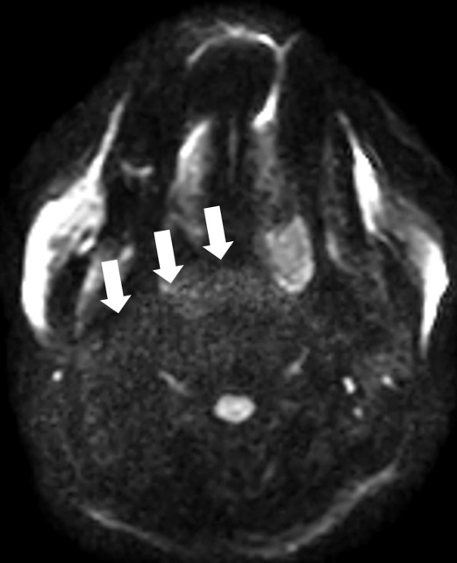

Supplemental Material 2. A case of oropharyngeal cancer exhibited various types of noise/artifacts.

Fat-suppressed T2WI highlights the left oropharyngeal tumor lesion (a: arrow). In the PI-based DWI, image noise close to the primary tumor was noticeably present (b: arrow). In the DL-based DWI, the image noise near the tumor was significantly reduced; however, a large metallic artifact remained (c: arrow). Such prominent artifacts might be challenging to address, even with model-based DL reconstruction.

