Supplementary Figure 1. Representative images of the CT features for PVOD. Mediastinal lymph node enlargement (A), ground glass opacity (B), and thickened interlobular septal wall (C).

A.
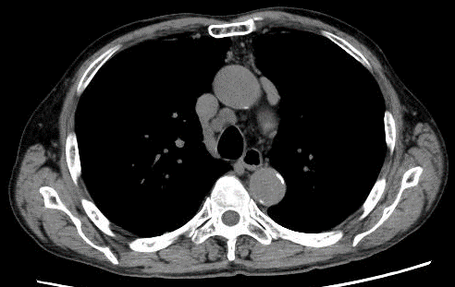

B.
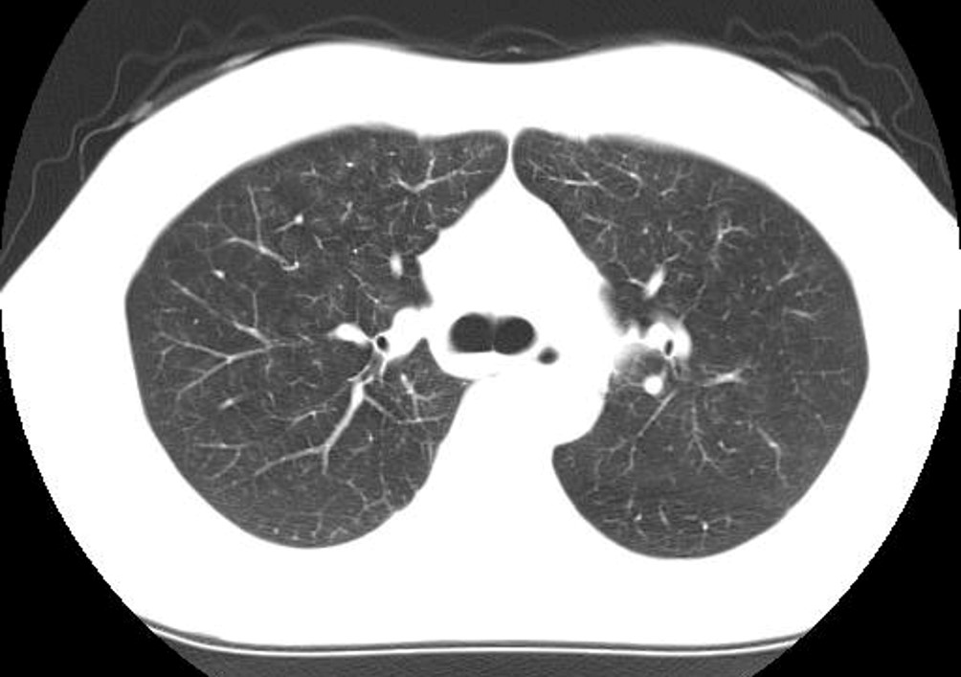

C.
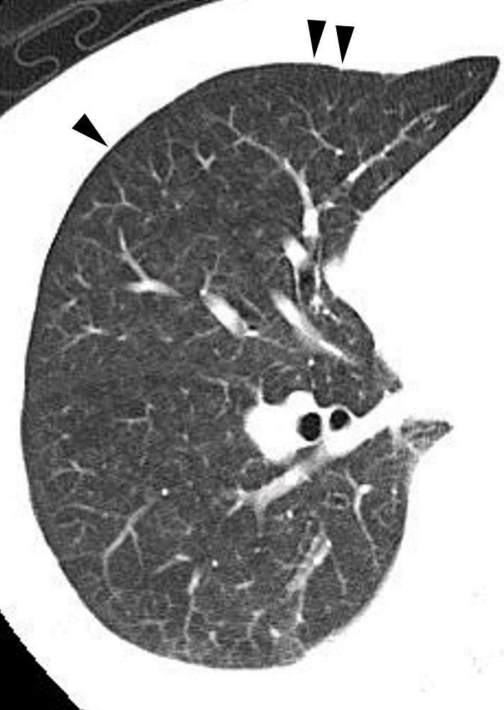

Supplementary Figure 2. Pulmonary function test including DLco, DLco/VA, and FVC/DLco in patients with and without ILD (upper); in patients with and without a restrictive ventilatory defect (VC of <80%) (lower).

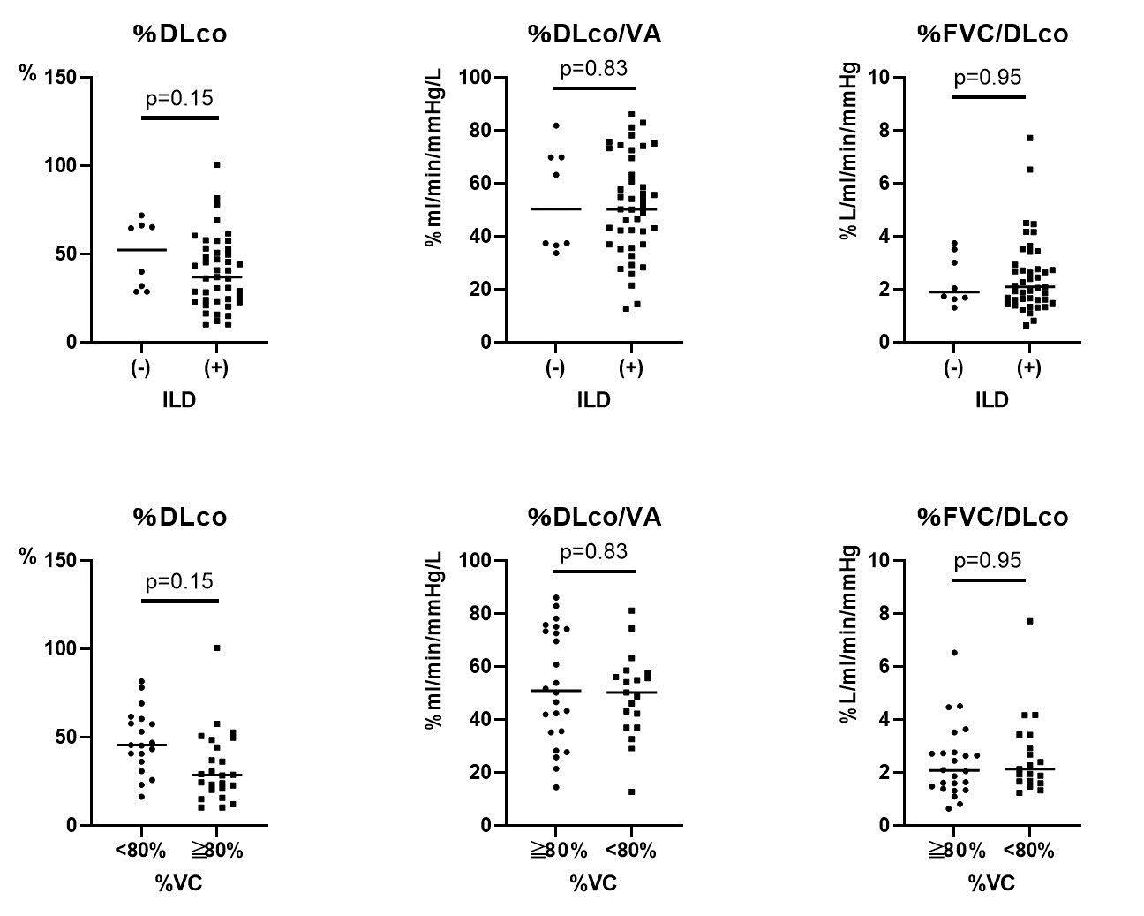

Supplementary Figure 3. Survival of patients according to the number of features for PVOD.

