Supplementary materials and methods

Detailed description of the model used in this study
In this study, a transformer-based deep neural network (DNN) model was used to differentiate between Parkinson’s disease (PD) and spinocerebellar degeneration (SCD) based on the coordinates of key points extracted from gait videos. We used the transformer encoder architecture described in an original transformer-related study [1]. This section describes the architecture of the DNN model used in this study. An overview of the model architecture is shown in Supplementary Figure S1.
The time series data of the joint coordinates in 5-s clips (150 frames) were input to the DNN model. Each frame contained the values of the X and Y coordinates of 25 key points, resulting in a total of 50 values. Therefore, the input to the DNN model was a 150 × 50 matrix. First, each vector containing 50 coordinate values for each frame was input into a fully connected layer to obtain a new 128-dimensional vector. The following formula was used:

$u_{t}=Wx_{t}+b$ (1)

where W ∈ ℝ^{128×50} and b ∈ ℝ¹²⁸ are learnable parameters, x_{t} is a vector containing 50 coordinate values for an arbitrary frame (t = 1, …, 150), and u_{t} is the output of the fully connected layer in the corresponding frame and is a 128-dimensional vector. On inputting the vectors for all 150 frames, U ∈ ℝ^{150×128} = (u₁, u₂, …, u₁₅₀) is the output of this layer.
Next, a 128-dimensional vector was prepended as a classification token to the output of the fully connected layer. In addition, because the transformer architecture itself is insensitive to the ordering of the input, positional embedding is added to make it aware of the sequential nature of the time series. These operations generate a new matrix, U’ ∈ ℝ^{151×128}, as follows:

U’ = [cls, u₁, u₂, …, u₁₅₀] + W_{pos} (2)

where cls ∈ ℝ¹²⁸ is the classification token, and W_{pos} ∈ ℝ^{151×128} is the positional embedding. The classification token and positional embedding are learnable parameters with initial values of 0. This matrix is input into the transformer encoder.
The transformer encoder consists of alternating layers of a multiheaded self-attention (MSA) block and multilayer perceptron (MLP) block. Layer normalization (LN) [2] is applied before the MSA of the MLP block, and residual connections are applied after the MSA of the MLP block. This process is illustrated in Supplementary Figure S2. Self-attention is a technique used to capture the internal correlations between input features. The calculation process of self-attention is as follows. First, input U’ is applied to fully connected layers to generate a set of query matrices Q and K and value matrix V. The weight coefficients are calculated by Q and K, and the generated weight coefficients are then used to calculate the weighted sum of the vectors in V. As shown in Supplementary Figure S3, self-attention was calculated as follows:
$Self Attention (Q, K, V)=Softmax\left(\frac{QK^{T}}{\sqrt{d_{k}}}\right)V$ (3)
where d_{k} is the dimension of the feature vector of matrix K (i.e., d_{k} = 128 in this study), and Softmax is the softmax function, which rescales the elements of an input vector in the range of 0 to 1 and sums to 1.
MSA is an operation that generates h groups (called h heads) of Q, K, and V matrices using the input matrix and calculates self-attention with each group of Q, K, and V matrices. Finally, the outputs of the h-heads are concatenated. As shown in Supplementary Figure S4, the MSA is calculated as follows:

${head}_{i}=Self Attention (QW_{i}^{Q}, KW_{i}^{K}, VW_{i}^{V})$ (4)
$MSA \left(Q, K, V\right)=concat ({head}_{1}, …, {head}_{h})W_{o}$ (5)

where $W_{i}^{Q}$, $W_{i}^{K}$, $W_{i}^{V}$, and W_{o} are trainable parameter matrices, and h is the number of MSA heads. In this study, h was set to 4. Ultimately, combined with LN and residual connection, the output of the MSA block for input x is as follows:

$MSA block \left(x\right)= MSA\left(LN\left(x\right)\right)+x$ (6)

where LN is layer normalization.
The MLP block follows the MSA block. The MLP block consists of two fully connected layers, and the activation function, GELU [3], is used in the first fully connected layer. The dimensionality of the input and output of the MLP block is 128, and the inner layer has a dimensionality of 512. Combined with the MSA and MLP blocks, the final output of the transformer encoder for input x is as follows:

$Transformer encoder (x)=MLP(LN\left(MSA block\left(x\right)\right)+MSA block(x)$ (7),

where MLP denotes the operation of the MLP block. The final output of the transformer encoder is the same size as the input matrix (151 × 128). The same operation was repeated six times, with the output of the previous transformer encoder as the input into the next transformer encoder. After repeating the operation of the transformer encoder, the vector of the classification token was fed to the classification head and linearly projected onto a 2-dimensional vector. Inputting the 2-dimensional vector into the softmax function, two values are finally obtained: the probability that the input data are from a patient with PD and the probability that they are from a patient with SCD.

Data augmentation
In this study, we applied following data augmentation techniques.

Rotation
The target gait video was rotated at a predetermined angle, and OpenPose was applied to the rotated video. We set the angles of rotation to ±1º, ±2º, and ±3º.

Horizontal flip
A horizontal flip is an operation in which a video is generated with the left and right sides reversed. OpenPose was applied to the flipped videos.

Translation
Random values were added to the x- and y-coordinates of the key point coordinates extracted using OpenPose. One value was randomly selected in the range from -50 to 50 in the x-coordinate and from -25 to 25 in the y-coordinate to perform the translation for each training epoch.

Mixup
Mixup is an operation in which the features and labels of different training samples are combined to generate new samples [4]. The mixup is performed by the following steps:
- Two samples (a matrix of the coordinates of the key points and their corresponding labels) are randomly selected from the training data.
- A random weight between 0 and 1 is chosen from beta distribution.
- A weighted average is calculated using randomly generated weights for the coordinate data and corresponding label.

Calculations are performed as follows:
$Mixed coordinates= λx_{1}+(1- λ)x_{2}$ (8)
$Mixed label= λy_{1}+(1- λ)y_{2}$ (9)

where x₁ and x₂ are the two randomly selected matrices of coordinate data, y₁ and y₂ are the labels associated with the corresponding data, and $λ$ ~ Beta (α ＝ β = 10) is a sampled value.
We applied the mixup with a probability of 0.5 per training dataset.

References
[1] A. Vaswani, N. Shazeer, N. Parmar, J. Uszkoreit, L. Jones, A.N. Gomez, L. Kaiser, I. Polosukhin, Attention is all you need. Presented at: Proceedings of the Advances in Neural Information Processing Systems, 2017, pp: 1–11
[2] R. Xiong, Y. Yang, D. He, K. Zheng, S. Zheng, C. Xing, H. Zhang, Y. Lan, L. Wang, T. Liu, On layer normalization in the transformer architecture. Presented at: Int. Conf. Mach Learn (ICML), 2020, pp: 10524–10533.
[3] D. Hendrycks, K. Gimpel, Gaussian error linear units (gelus). arXiv preprint arXiv:1606.08415. 2016.
[4] H. Zhang, M. Cisse, Y.N. Dauphin, D. Lopez-Paz, Mixup: beyond empirical risk minimization. arXiv preprint arXiv 2017:1710.09412

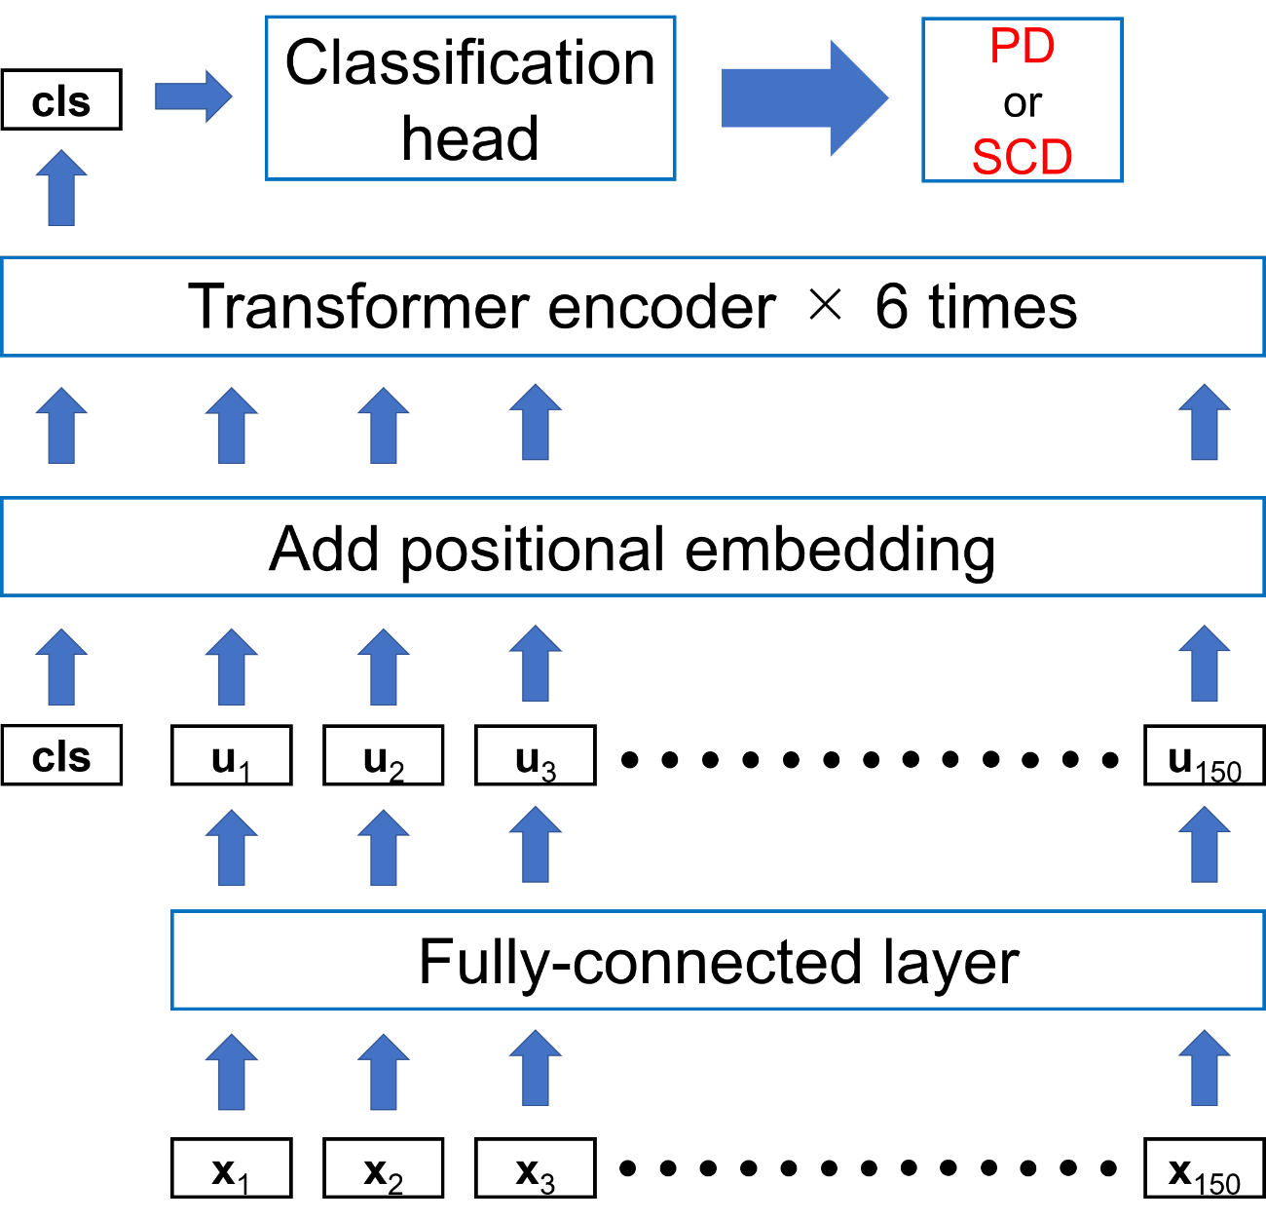
Supplementary Figure S1. Overview of the deep neural network model
PD, Parkinson’s disease; SCD, spinocerebellar degeneration; cls, classification token

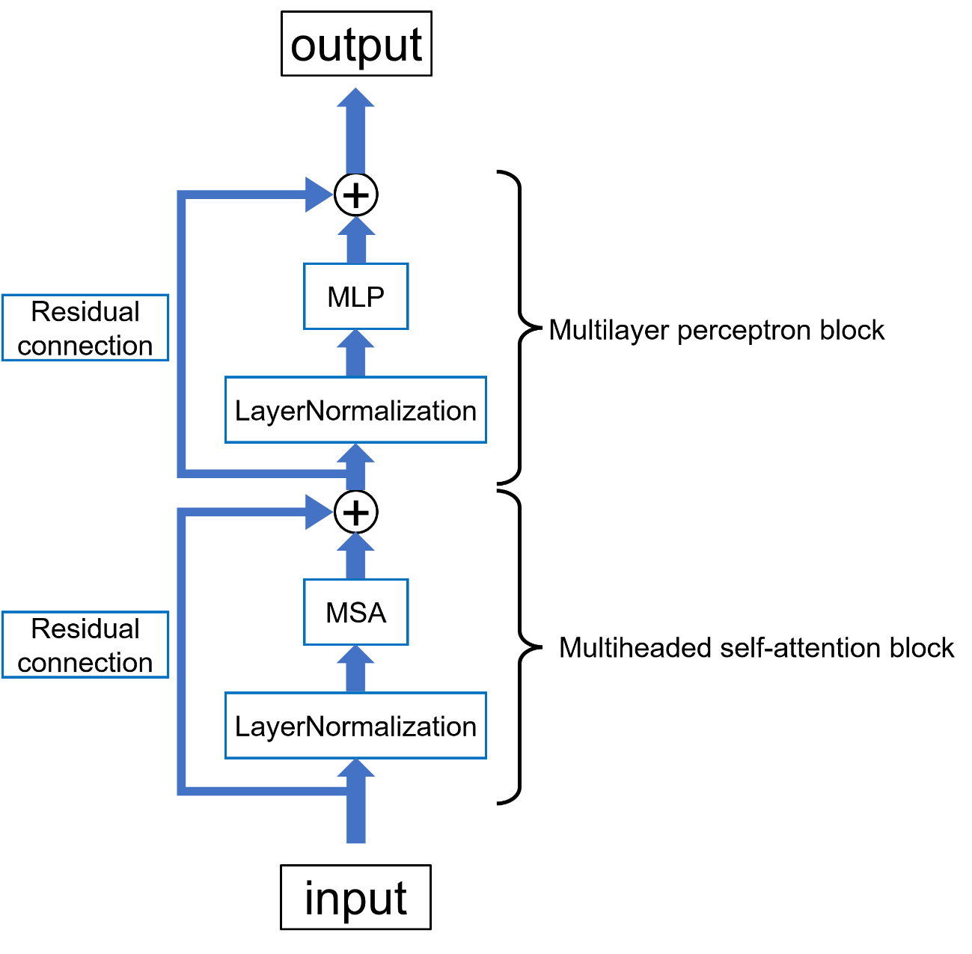
Supplementary Figure S2. The architecture of the transformer encoder block
MSA, multiheaded self-attention; MLP, multilayer perceptron

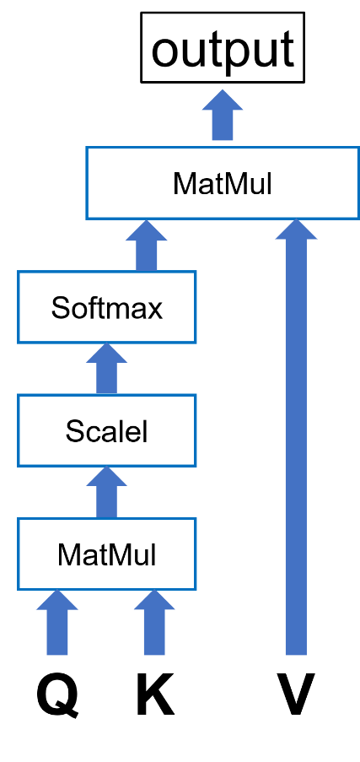
Supplementary Figure S3. Process of self-attention calculation
Here, Q, K, and V represent the query, key, and value matrices, respectively.

Supplementary Figure S4. Process of multiheaded self-attention calculation

